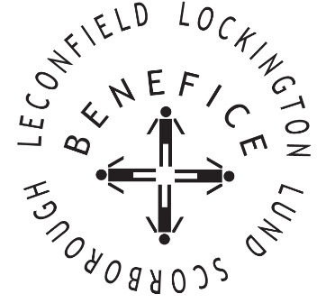

Church Services for
MAY 2026
Wherever you are from, you are welcome to join us for any of these services

Sunday 3rd 9:30am Holy Communion St Leonard’s Scorborough

11:00am Morning Worship St Mary’s Lockington

Sunday 10th 9:30am Holy Communion St Leonard’s Scorborough

11:00am Morning Worship All Saint’s Lund

Saturday 16th 11:00am Festival Service St Catherine’s Leconfield
St Brendan the Navigator

Sunday 17th 9:30am Holy Communion St Mary’s Lockington

Wednesday 20th 9:30am Mid Week Service
With healing prayers St Catherine’s Leconfield

Sunday 24th 9:30am Holy Communion All Saints Lund

11:00am Contemporary Worship St Mary’s Lockington

Thursday 28th 7:00pm Celtic Evening Prayers St Catherine’s Leconfield

Sunday 31st 10am Benefice Holy Communion St Mary’s Lockington

Service times, events and Messenger can also be found at:
http://www.achurchnearyou.com for the four churches

