PAROCHIAL CHURCH COUNCIL OF FROXFIELD WITH PRIVETT

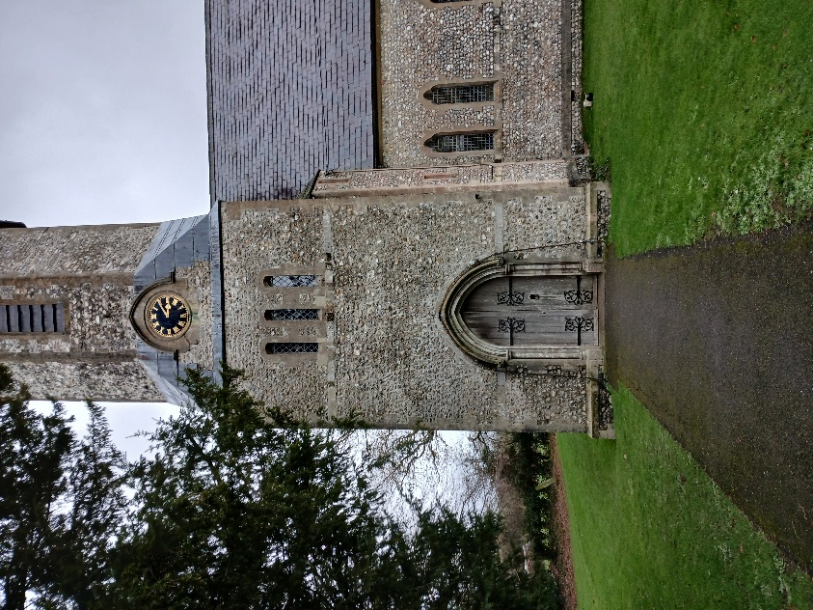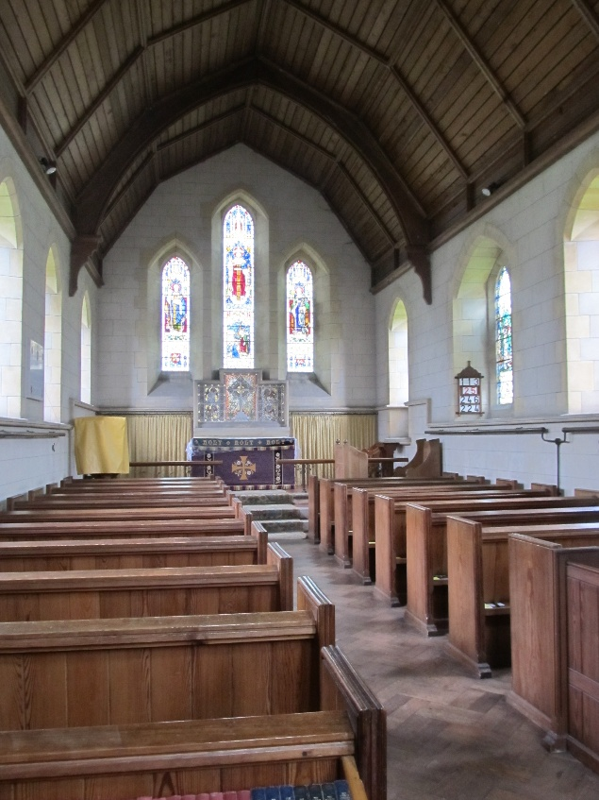

St Peter’s, High Cross St Peter’s-on-the-Green
GU32 1EQ GU32 1DQ

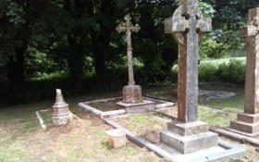

Holy Trinity Churchyard, Privett
GU34 3PE

ANNUAL REPORT for the year ended 31st December 2025

Charity Registration Number: 1214135

AIM and PURPOSE

The Parochial Church Council of Froxfield with Privett (the PCC) has the responsibility of cooperating with the Incumbent, Canon Dr Susie Collingridge, in promoting in the ecclesiastical parish and wider benefice, the whole mission of the Church, pastoral, evangelistic, social and ecumenical.

The parish of Froxfield with Privett and the parish of Steep are distinct parishes comprising the combined benefice of Steep and Froxfield with Privett.

The PCC is responsible for maintaining two churches in the parish, St Peter’s High Cross and St Peter’s-on-the-Green, both of which are grade II listed buildings and their respective churchyards and lychgates. It is also responsible for the maintenance of the churchyard and lychgate at Holy Trinity Privett although the church is in the care of the Churches Conservation Trust.

OBJECTIVES and ACTIVITIES

The PCC is committed to enabling as many people as possible to worship at our churches and become involved in activities in the parish.

Our Benefice Mission Action Plan prepared in 2022 states that:

Our churches will be warm, thankful, praying, inclusive Christian communities embedded in the life of our beautiful area. As members of the Body of Christ, we will all be active participants in the life of the church, with a committed and skilled lay leadership team partnering our clergy. Our strong benefice partnership helps us better to share Christ’s love in word and action. We will work fruitfully with other parishes wherever we can and be active in the Petersfield Deanery. We will grow in faith and number, welcoming all, caring for neighbours and communities.

ACHIEVEMENTS and PERFORMANCE

Year in Brief
2025 was a full year with many activities.
- The number of people on our electoral roll was 76 at the Annual Parochial Church Meeting in April 2025 of which 62 are resident in the parish. This was a full revision of the roll and included 8 people who were not on the previous roll. Sadly, several people have either passed away or moved out of the parish and are no longer eligible. See appendix 2
- Froxfield School held their Easter service at High Cross
- In May members of the church congregation took part in an event at High Cross with the school called Experience Eucharist in collaboration with Rev Claire Wellham.
- Messy church was held in Froxfield Village Hall to celebrate Mothering Sunday.
- Three people were baptised during the year and one wedding was celebrated.
- Three funerals were held, along with a committal and two burials of ashes. Our clergy also officiated at three services at our local crematoria.
- Portsmouth Cathedral Choir (Boys) visited Privett to sing Choral Evensong in May.
- Remembrance Sunday service was held at St Peter’s-on-the-Green church and at the war memorial outside.
- In November we witnessed the installation of our Priest in Charge, Canon Dr Susie Collingridge as Vicar of our benefice at a service at All Saints church in Steep.
- A Christmas Tree Festival was held at St Peter’s, High Cross with trees decorated by many village organisations.
- Froxfield School and Pre-School held their nativity services in St Peter’s, High Cross.
- The Carol service at Holy Trinity Privett with Froxfield Choir and Spectacle Brass had a congregation of over 300 people.
- Carols on the Green was celebrated at Froxfield Green, including switching on the lights around the Green.

Services
Our regular pattern of communion services at St Peter’s, High Cross on the first and third Sunday of each month, followed by Morning Prayer at St Peter’s-on-the-Green on the fourth Sunday continued throughout the year. These services combined with those provided in Steep gave all worshipers in the benefice access to a wide range of services.

The services have been led by our clergy team of Canon Dr Susie Collingridge, Rev Sue Jones, Rev Dr Pippa Madgwick, and Rev Joanna Farrell, assisted by Caroline Hilton, Graham Madgwick and Lindsay Clegg.

As well as our regular services we held special services to celebrate Easter, Harvest and Christmas where we welcomed many visitors to our churches.

Evolution Group
The PCC submitted a faculty application to the Diocese for the installation of a toilet and a servery in the church. We are now waiting for approval for the planning application for the sewage treatment aspect of the project from South Downs National Park.

During the year, it became apparent that our oil-fired hot air heating system was at the end of its life. Approval was received in the Autumn for the removal of the old system and the installation of a new infra-red system of chandeliers. This also involved the upgrading of the electricity supply to three phases. The installation of the new system was completed in March 2026.

A series of fundraising events started in March with a quiz and continued with a stall at the village fete, the sale of notelets and Christmas cards, an afternoon of cream teas, a harvest supper, a talk on the embroiderer Louisa Pesel and a Christmas Tree festival to raise funds for these projects.

Flowers in church
A team of flower arrangers, led by Gillian Hollis, work throughout the year providing floral decorations for regular services and the Church’s special seasonal services of Easter, Harvest and Christmas.

Church School and Pre-School
The School is led by the Head, Vickie Farrow supported by her team. There is a full complement of governors, led by Gillian Hollis, the Chair. The Foundation Governors are Edward Sadler and Rev Sue Jones. The School has just over 100 pupils ranging in age from 4 years old to 11.

The School uses High Cross church three times each week for Collective Worship, twice led by Vickie Farrow and the other by one of our clergy. They also use the church for special services, nativity plays and end of year plays.

In December, they take the lead on the Parish/School joint Reverse Advent Calendar to supply the Petersfield Foodbank at Christmas.

Drop In
Our monthly Drop In events continue, on the second Saturday of each month, at Froxfield Village Hall with a rota of volunteers under the organisation of Suzanne Tong. It provides a warm welcome, tea, coffee and cake to anyone from the parish and surrounding areas. Good company, friendship and plenty of chat is enjoyed by all who come along.

Deanery Synod
Two members of the PCC sit on the Petersfield Deanery Synod. This provides the PCC with a link to the other churches around us, and with the Diocese as a whole. It also receives reports from the General Synod, (see appendix below)

FINANCIAL REVIEW

The Statement of Financial Activities for 2025 shows increases in unrestricted funds over the year of £3,749 and in restricted funds of £7,582.

Unrestricted income has been broadly similar to previous years except for a reduction in the level of voluntary income following the loss of two donors early in the year and a decrease in the number of funerals held in the parish leading to lower fees derived from church activities.

2024 saw the receipt of two legacies which were placed on deposit whilst projects were planned. This resulted in the significant increase in interest received in the year by the restricted funds.

Regular expenditure has also been similar to previous years except that the costs of running and operating St Peter’s-on-the-Green are now borne by the Froxfield Green restricted fund.

Expenditure from the High Cross fund includes the payment on account for the installation of the three-phase supply, as well as the fees for various faculty applications.

Near the end of the year the PCC agreed that the High Cross legacy could be used to finance the installation of the new heating and the associated three phase electricity supply. Subsequent to the year end, the receipt of a grant from Archbishops Council’s boiler replacement scheme and generous donations from parishioners for this specific project has reduced the amount that will be needed from the legacy to complete the work.

The remaining legacy for St Peter’s High Cross will be split between the installation of the disabled toilet and servery, future work that will be required as a result of the 2025 quinquennial inspection and investing to pay the future running costs of the church. Due to uncertainties in ascertaining the precise amounts that will be used for each project the money has been placed on deposit with CCLA until it is required.

In respect of the legacy for St Peter’s on the Green, the PCC has decided to split it between future work that will be required as a result of the 2025 quinquennial inspection and investing to pay future running costs of the church. This legacy is currently on deposit with CCLA, but a proportion of it will be invested with them in equities to provide capital growth and protect its value until such time as it is needed for major projects at that church.

The total unrestricted reserves at the year-end were £37,432, which is just above the level of 6 – 12 months general running costs stated in the policy. Given that voluntary income is likely to be reduced in the future and running costs, particularly energy costs, are likely to increase, the PCC will review the position again later in 2026.

The policy on reserves is shown in note 2 of the accounts.

SAFEGUARDING

The benefice safeguarding officer is Helen Muir-Davies, supported by Dr Fiona Heaton in Froxfield with Privett and also by Rev Sue Jones throughout the benefice.

The PCC has complied with the duty under Section 5 of the Safeguarding and Clergy Discipline Measure 2016 (duty to have regard to House of Bishops’ guidance on safeguarding children and vulnerable adults).

VOLUNTEERS

The PCC would like to thank everyone who assists in the organisation and running of the church. Without their help, the activities noted in this report would not be possible.

STRUCTURE, GOVERNANCE and MANAGEMENT

The method of appointment of PCC members is set out in the Church Representation Rules. The Council comprises the Incumbent, the Churchwardens, those elected to the Deanery Synod, and other members who are elected at the Annual Parochial Church Meeting, by those on the Electoral Roll. Members of the congregation are always encouraged to join the Electoral Roll, and to consider standing for election to the PCC.

The PCC members are responsible for making decisions on all matters of general concern and importance in the parish, and for all financial matters. The full PCC met six times during the year, and has several sub committees, each dealing with a particular aspect of parish life. These include Standing, Worship, Evolution and Financial Resources and Investments Committees. Each committee reports to the full PCC.

ADMINISTRATIVE INFORMATION

The PCC is a body corporate (PCC Powers Measure 1956, and the Church Representation Rules 2022) and was registered with the Charity Commission with effect from 16th July 2025.

PCC members who have served from 1st January 2025 until the date this report was approved were Canon Dr Susie Collingridge (Chairman), Lindsay Clegg (Churchwarden) from 6th April 2025 and also Vice Chairman, Lay Pastoral Assistant and Deanery Synod Rep), Rob Hollis (Churchwarden – resigned 6th April 2025), Ian Hughes (Deanery Synod Rep and Deputy Church Warden), Dr Fiona Heaton, Caroline Hilton, Charles Holroyde (Fabric Officer),The Rev Sue Jones (Assistant Curate), Alex Matcham, Christine Stephens (Treasurer) and Suzanne Tong (Secretary and Deputy Church Warden).

The Benefice Secretary supports the Clergy and our communications, including compiling our weekly News Sheet, among many other tasks. At the start of the year this was Anne Grove who retired in early May. The PCC wishes to thank Anne for her hard work over the past 11 years and wish her a long and happy retirement. Her replacement is Helen Muir-Davies.

The PCC holds a bank account with NatWest Bank. Most funds are held by the CCLA in interest bearing deposit accounts and in Central Board of Finance Investment Fund Accumulation units.

The independent examiner of the PCC accounts is Cornelius Halladay-Garrett.

The Church Commissioners are responsible for funding any refurbishment or repairs to the chancels of the two churches.

The appointed architect is Julian Vallis of Vallis and Hall, Architects.

Correspondence on church matters should be sent to either Canon Dr Susie Collingridge at The Vicarage, Steep or to the PCC Secretary.

Approved by the PCC on April 2026 and signed on their behalf

Lindsay Clegg

Deanery Synod report
THE PETERSFIELD DEANERY SYNOD – REPORT FOR APCMs – 2025 for 2026 APCMs
The Deanery Synod is part of the way the Church of England gives people at different levels a chance to discuss key issues and organise the church's ministry and mission. It sits between the parishes with their Parochial Church Councils (PCCs) and the full diocese, with its Diocesan Synod. It is convened by an Area Dean and Lay Chair and consists of all the licensed clergy in the Deanery and lay people elected by the parishes at their Annual Parish Church Meeting. The lay members serve for three years. The most recent elections took place at APCMs in 2023, so the current 3-year term is ending now, and Deanery Synod representatives for the 2026 – 2029 term are to be elected at the 2026 APCMs.
The Lay Chair is Vanda Leary of St Peter’s Petersfield. Rev’d Dr Susie Collingridge (Steep & Froxfield with Privett) is Area Dean. Amanda Greenlee is Deanery Secretary, and David Normington is Deanery Treasurer.
The main work of the Deanery Synod over the past year has continued to be working together to support growth. Over the last year this has included:
- Employment (via St Peter’s Petersfield) of a half-time Children & Families worker for the deanery, Rebecca Parkyn. This role is grant-funded for 3 years.
- Petersfield Deanery Chapter continuing to work together in a Diocesan pilot of “Cairns” – Benedictine style networks to support clergy wellbeing and further develop collaborative working for mission.
Deanery Synod met 3 times in 2025, and welcomed guest speakers on Carbon Net Zero, and Stewardship.
Deanery Synod acts as the electorate to General Synod (elections due in 2026) and Diocesan Synod (elections due in 2027).
I would like to thank everyone who has been involved in the continuing life of this deanery, in particular the Standing Committee which in 2025 consisted of Vanda Leary, Neil Chrimes, David Normington, Amanda Greenlee, Lynn Carter, Rev’d Dr Susie Collingridge, Rev’d Peter Sutton, Rev’d Valentine Inglis-Jones.

Vanda Leary, Lay Chair, Petersfield Deanery Synod
1st March 2026

Electoral Roll: Report to Annual Parochial Church Meeting 3 May 2026

The Electoral Roll for the Parish of Froxfield with Privett was revised on 15 April 2026 when there were 77 persons enrolled on the Roll. Of those 77 persons, 63 are resident within the Parish.

The Roll was previously revised in a full revision on 21 March 2025 when there were 76 persons enrolled on the Roll. In the course of the 2026 Revision, 2 names were was added to the Roll and 1 name was removed from the Roll.

I would like to mention the person whose name was removed from the Roll in the Revision: Margaret Hall from Coles, Privett is remembered with gratitude and affection for her faithfulness and Christian witness to this church and parish, despite her age: Margaret, who died aged 102 probably bears the record for the oldest person to live in the parish and to worship in this church.

Pat Sadler, Electoral Roll Officer: 3 May 2026

