The Rector's Ramblings
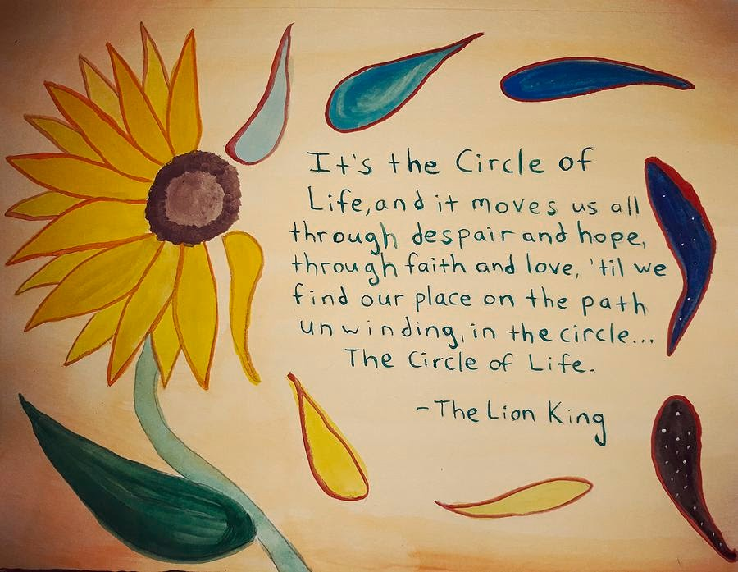
Last weekend I had the joy and the sorrow of the full circle of life. On Sunday morning the congregation welcomed baby Rose as the newest Christian in the world as we celebrated her baptism. It was an extra special service as I had married her parents and so it was wonderful to see them and their family and friends again. In the afternoon I joined the family of Margaret Walter, daughter of a former Estate Manager at West Dean, for the internment of her ashes in West Dean Garden of Remembrance. Although Margaret had left West Dean many years ago, the 10 years she spent here, in her late teens and early 20’s, had had a positive and long-term effect on her and it was the wish of her family that her remains be buried in the place she loved, joining her father in the Garden of Remembrance.
At the baptism service, we gave little Rose some gifts to remember the day (although as she is only 3 months old, they are memories her parents will have to share with her). As well as her certificate of baptism we gave her a candle, reminding us of Jesus’ call to be a light in the world, a copy of the Gospel of Luke, and a holding cross, something that as she grows will, I pray, be a source of comfort and hope. After the short service in West Dean, Margaret’s niece shared with me some of the things that Margaret had kept with her all her life. They included a reference letter written by the then Vicar of West Dean in support of a job application, but which Margaret had kept and used many times not just for jobs but also for other aspects of her life, and a prayer book given to her by the same Vicar when she was confirmed. Katie, Margaret’s niece, said that there were many other letters, cards and mementoes that Margaret had held on to all her life, reminders of good time and sad times, and that the family were going to hold on to them and share them with their children and grandchildren.
Now last week I Rambled on clearing stuff out, on getting rid of stuff, and as the year progresses and I get my wardrobe sorted, we will move on to the boxes of photos, cards and letters (many of them really, really old) that have been sitting in lofts and cupboards for years, moving from house to house with us. We will, as with my clothes, be ruthless but also careful, because there are some things that may be old, that may be of little use these days, but that carry with them memories of people and places that will tell future generations about the lives and experiences of people in the past.
I have been reflecting on this because an advert popped up on my phone for yet another cloud storage system to keep documents and photos electronically. Now I am all for using less paper, although I still prefer hardcopy rather than reading from a phone or laptop, but I also know that once ‘in the cloud’ things will be forgotten and possibly never seen again. Where would we be if instead of writing to the people of Rome St Paul had been able to send an email, a text, or even a twitter post, lost in the 101 other emails and texts we receive? Without the Dead Sea Scrolls what would we know about the lives of the people of Qumran. If instead of writing to Theophilus, and through him to a wider audience, St Luke had simply blogged or tweeted about Jesus? Yes, electronic correspondence is around for ever, as some have found to their cost, but it needs to be searched for. A letter, a scroll, even a stone tablet, can be passed around, can be shared, and more importantly, can be kept.
So if, like us at the Rectory, you are planning a cull of surplus paper, photos, cards etc, remember that without the written word, we wouldn’t be able to read about Jesus’ life. Without letters we wouldn’t know about the lives of our ancestors. Without Margaret keeping her prayer book and reference letter, Katie and her family wouldn’t know what was important to her, and what other people thought of her. The people of Qumran kept their important documents in caves, the people of Rome, Corinth, Ephesus kept Paul’s letters in safe places, ready to share them with others, ready to pass them on through the generations. We don’t have caves, or unlimited room, or anyone in the family to pass our old letters, our ancestors’ memories, on to, so they will be offered to the record office. Without knowing about our past, we can’t really know who we are. Without learning from the past, we can’t stop ourselves making the same mistakes again.
I hope that as Rose grows up the candle, the holding cross and the gospel book will become as important to her as her prayer book was to Margaret, and that they will in time become a memory that she will pass on to future generations as a sign of the faith that I pray will grow and will support and comfort her in the years to come.
Rev Sarah
Worship in the Valley Parish

19th April

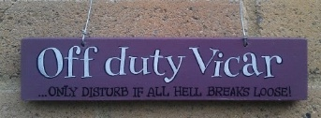
Holy Communion with Baptism 10am West Dean
Please note that I am on annual leave from Monday 20th April - Monday 27th April.
Next Sunday's service at West Dean will be led by Fr Charles Howard, and there will be Children's Church as usual.
Rev Sarah Manouch
07468 854864 priestvalleyparish@gmail.com
Please note that I am part-time. My principal working days are Friday and Saturday as well as Sunday. I am not available on a Thursday.

