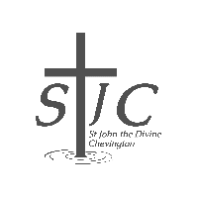

St John’s Review

March 2026



Serving the villages of Hadston, Red Row and North and South Broomhill
Services March 2026

SUNDAY | 1st March | 10:30am | Holy Communion
FRIDAY | 6th March | 5pm | Stations of the Cross
SUNDAY | 8th March | 10:30am | Holy Communion
FRIDAY | 13th March | 5pm | Stations of the Cross
SUNDAY | 15th March | 10:30am | Holy Communion
THURSDAY | 19th March | 2pm | Third Thursday
FRIDAY | 20th March | 5pm | Stations of the Cross
SUNDAY | 22nd March | 10:30am | Holy Communion
FRIDAY | 27th March | 5pm | Stations of the Cross
SUNDAY | 29th March | 10:30am | Holy Communion

Remember that our sister parish, St Cuthbert in Amble, has a service every Sunday at 9:00am and you are welcome there at any time.


Dear Friends
What a joy it is to start seeing signs of new life in the garden. A few of us were chatting recently and saying despite the rather soggy weather we’ve been having a late it is such a delight to see crocus, snowdrop, primrose and hellebores peeking out around the edges where everything still looks a bit grim. It is so easy to look at the seemingly bare twigs on the trees and the waterlogged grassy patches, and feel as though we’re never going to move past this particular season! Of course we know that’s not true, spring is definitely on the way and with it many church activities as we are at the start of Lent. As I write this letter I am planning on how many eggs I’m going to need to make pancakes in both Amble and Chevington for Shrove Tuesday (there will be a lot I suspect!)… There is always something to be thinking about and planning for, isn’t there?

In the church around the world, this is a season where we spend time reflecting on our lives and our attitudes. It is very traditional to give things up during this time of Lent as a way of walking alongside Jesus during his time in the wilderness, but also a great opportunity to strip away some of the excesses in life that we seem to get drawn into, without even knowing it sometimes. This period of Lent is also an opportunity to take up something new, like a new spiritual discipline. That sounds terribly pompous, doesn’t it?… It’s not meant to. What I mean by that is that sometimes we can ‘try out’ doing things a little differently during this time. For example, setting aside time each day to reflect on those things we are grateful for, lighting a candle at the same time each day and saying a prayer for peace, reading a book that encourages us in our spiritual journey, taking a gentle walk around our neighbourhood and praying for those who live there or simply sitting in the quiet and stilling yourself to hear the ‘still small voice of God’.

‘Giving up’ and ‘taking up’ something could be right for you this Lent, or it might not hit the spot. There are many different ways to respond to this time of year as we lead up to Holy Week and Easter Day. This is a very special time of year and as we notice the changes in the natural world around us, so we can also notice the changes in our own lives and this may bring up questions. If you have any questions about faith, life, Lent and Easter please know that I, and many others, would be very happy to have a chat over a coffee.

Do please have a look at our various services and activities that we have on a Sunday but also during the week. On any of these occasions there are folk who will happily welcome you and have a conversation about anything that is on your mind. When I look at the number of people who attend our coffee mornings, bingo, cafe church, Third Thursday service and all our different events, I can see that company and conversation is so valuable and appreciated. We don’t all have the same views and tastes but we can all spend time together sharing experiences and walking along life’s journey side by side. We can learn together, understand each other better and enjoy each other’s company.

This Lent may you find time to reflect, ask questions, seek some answers and above all draw closer to God who made you and loves you, even on your worst days!

God bless you,
Rev Rachael



How many words does it take?
Pythagorean Theorem – 24 words
Lord’s Prayer – 66 words
Archimedes’ Principle – 67 words
Ten Commandments – 179 words
Shakespeare’s ‘To be, or not to be’ soliloquy – 260 words
Churchill’s speech ‘We Shall Fight on the Beaches’- 308 words
US Constitution with all 27 Amendments – 7,818 words
EU regulations on the sale of cabbages – 26,911 words

Puts things into perspective, doesn’t it?

Come and join us ….

 | Wednesday 11th March at 7.00 pm  in Druridge Bay Community Centre, Hadston
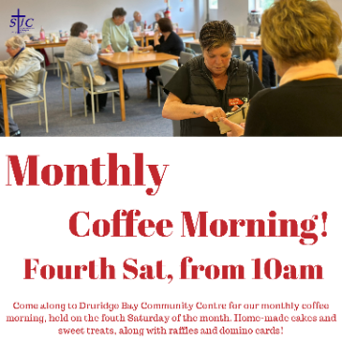 | Saturday 21st March from 10am  in Druridge Bay Community Centre, Hadston.
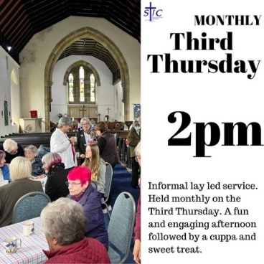

Thursday 19th March at 2pm in church

Crossword for March


Across
1 Arouse (Song of Songs 2:7) (6)
4 Extinguish (Isaiah 1:31) (6)
8 ‘“They — — ,” you will say, “but I’m not hurt!”’ (Proverbs 23:35) (3,2)
9 Unhappiness (Nehemiah 2:2) (7)
10 Jewish (7)
11 Dirge (anag.) (5)
12 ‘A truthful witness gives honest — , but a false witness tells lies’ (Proverbs 12:17) (9)
17 Paul quoted from the second one in his address in the synagogue at Pisidian Antioch (Acts 13:33) (5)
19 ‘Do not use your freedom to — the sinful nature’ (Galatians 5:13) (7)
21 ‘As you can see, he has done nothing to — death’ (Luke 23:15) (7)
22 Name applied by Isaiah to Jerusalem (Isaiah 29:1) (5)
23 ‘All the people — — one man, saying, “None of us will go home”’ (Judges 20:8) (4,2)
24 Lazarus, who was carried by angels to Abraham’s side when he died, was one (Luke 16:20) (6)

Down
1 Appalled (Job 26:11) (6)
2 ‘In an — to escape from the ship, the sailors let the lifeboat down into the sea’ (Acts 27:30) (7)
3 Expel (Acts 18:16) (5)
5 ‘But I have a baptism to — , and how distressed I am until it is completed!’ (Luke 12:50) (7)
6 ‘Of the increase of his government and peace there will be — — ’ (Isaiah 9:7) (2,3)
7 Hurry (Psalm 119:60) (6)
9 ‘For I desire mercy, not — , and acknowledgement of God rather than burnt offerings’ (Hosea 6:6) (9)
13 One of its towns was Sychar, where Jesus met a woman at Jacob’s well (John 4:5) (7)
14 Shouting (Acts 7:57) (7)
15 Arachnid (Isaiah 59:5) (6)
16 One of Paul’s first converts in Philippi was Lydia, a — in purple cloth (Acts 16:14) (6)
18 Donkeys (5)
20 Raked (anag.) (5)

How many church members does it take to change a light bulb?
What do you mean CHANGE??? That light bulb was given in memory of my grandmother! My father installed it with his bare hands! He donated his time AND the use of his ladder to do it, too! My family’s been members of this church for four generations! And if you think you’re going to come in here and make a bunch of changes all of a sudden, vicar, you’ve got another think coming!

The March Night Sky
The vernal equinox (also called the spring equinox by us northerners) occurs at 2.45pm on March 20th. More about the significance of this below.
British Summer Time begins on Sunday March 29th , when clocks “spring forward” by 1 hour at 1am.
Bright planets
Jupiter is visible within an hour of sunset high in the southern sky. It is unmistakeably bright!
Venus is still emerging from the glare of the Sun and might be seen low in the west about an hour after sunset.

Phases of the moon

Mar 3 Mar 11 Mar 19 Mar 25

The March Equinox – a turning point of the year
Each March, the northern hemisphere reaches a quiet but important milestone in its journey around the Sun: the equinox. The word comes from Latin, meaning “equal night”, and on this day daylight and darkness are almost the same length across the globe. More importantly for us, it marks the official beginning of astronomical spring.

The equinox happens because Earth’s axis is tilted by about 23.5 degrees. For most of the year, this tilt causes one hemisphere to lean toward the Sun while the other leans away, giving us the familiar seasons. At the March equinox, however, neither hemisphere has the advantage. The Sun sits directly above Earth’s equator, and its light is shared evenly between north and south.

For those of us in the UK and elsewhere in the northern hemisphere, this moment signals a change we can feel. Days are now getting noticeably longer than nights, sunrise creeps earlier, and sunset stretches later into the evening. Although the weather may lag behind, the balance has tipped: from now until September, daylight will dominate.
Astronomically, the equinox also has a precise definition. It is the instant when the Sun crosses the celestial equator moving northward. This exact moment can be timed to the minute, even though we usually celebrate the equinox as a whole day.

Ancient cultures were keen observers of this event. Monuments such as Stonehenge are thought to have been aligned to mark seasonal turning points, reflecting how closely human life was once tied to the sky. There is also a pleasing symbolism to the equinox. Balance, renewal, and fresh beginnings are natural themes at this time of year.

In the Christian calendar, the equinox plays a practical role too: the date of Easter is defined relative to the full Moon following the March equinox.

So next time you notice the lighter evenings or a hint of spring in the air, remember that it all traces back to a simple piece of cosmic geometry. The March equinox is a reminder that our daily lives are still quietly shaped by the graceful motions of Earth through space.

If you’d like to learn more about astronomy, then consider contacting your local astronomy club – the Northumberland Astronomical Society (NASTRO) - see www.nastro.org.uk for further details.

Dr Adrian Jannetta MSc CMath FRAS


Wordsearch for March
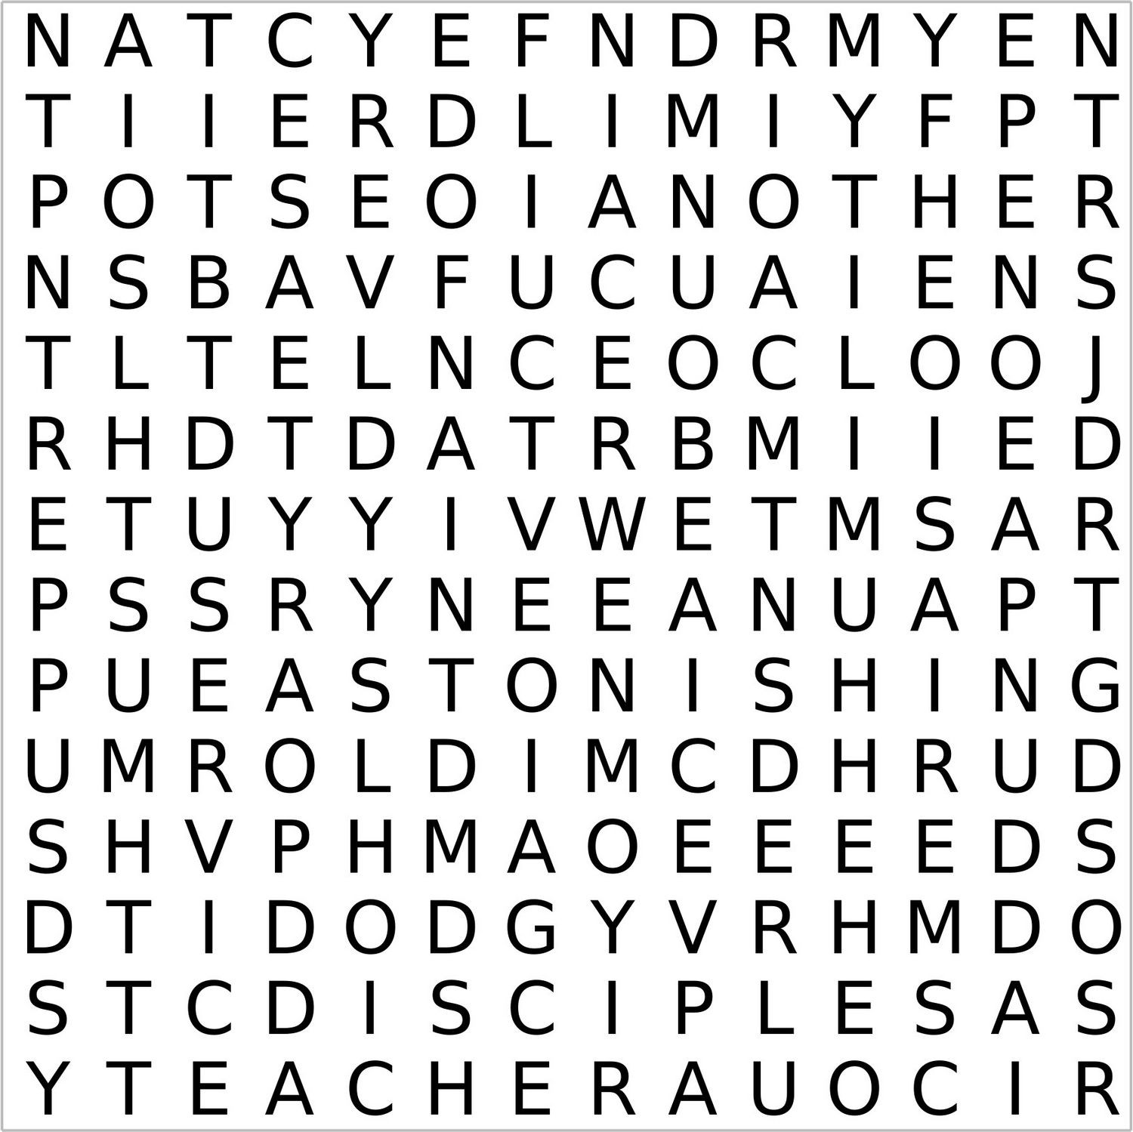

Love and serve one another
On Maundy Thursday we recall the final command that Jesus gave to his disciples before his death. After the Last Supper, He rose and washed his disciples’ feet. This was astonishing for a ‘teacher’ to do, but He had a firm purpose in mind: “A new command I give you: Love one another. As I have loved you, so you must love one another.” His disciples were to love through service, not domination, of one another.
In Latin, the opening phrase of this sentence is ‘mandatum novum do vobis’. The word ‘mundy’ is thus a corruption of the Latin ‘mandatum’ (or command). The ‘washing of the feet’ ceremony was an important part of the medieval church’s liturgy, symbolising the humility of the clergy, in obedience to the example of Christ.
Maundy | Thursday | Final | Command
Jesus | Disciples | Death | Last
Supper | Washed | Feet | Astonishing
Purpose | Teacher | As | Loved
You | Must | One | Another
Service | domination | Latin | Ceremony
Medieval | Humility | Obedience

How God works
A grandmother was taking her young grandson for a walk in the park. The daffodils were in bloom, and it was a beautiful Spring day. Wanting to encourage her grandson’s spiritual understanding of the world, she said: “Doesn’t it look like an artist painted this scenery? Did you know God did all this?”
Her grandson replied: “Oh yes, and God did it left-handed, too.” In astonishment, the grandmother asked what he meant. “Well, He must have done,” said her grandson, “because we learned at church last week that Jesus sits on God’s right hand.”

Mothering Sunday – March 15th
Mothering Sunday – the fourth Sunday of Lent- offers families an opportunity to honour the women who have nurtured them. Lots of different streams and traditions have come together to make today’s Mothering Sunday the special day that it is.
In the Middle Ages it was an occasion for everyone to visit their ‘mother’ church – the place where they had been baptised. Later, an opportunity for those who worked away from home to visit their mothers became added to the mix of reasons to make it a special day.

Today we honour all women who have in one way or another been special to us, and in church this is usually signalled by small bunches of flowers for every woman present.
Treating mums and grans to Sunday lunch, chocolates and flowers is also part of the present mix.

Not everyone has enjoyed a wonderful or enduring relationship with their mum, so lest we get carried away on a wave of love and sentimentality, there is usually space in the Mothering Sunday church service to reflect on and pray for those whose relationships with their mother were not all they might have been.

Also, there are the families blighted by the lack of, or death of a child; families remembering a mum who died tragically young; women who never had a child but would have dearly loved the opportunity; all these and more are a recognition of the imperfections of human love, human life.

These imperfections can be brought in prayer to the God who mothers us. In the Old Testament, Isaiah speaks of God comforting His people like a mother hen. In the New Testament, both Matthew and Luke bear witness to Jesus expressing His desire to gather His people as a mother hen gathers her chicks under her wings. Yes, God has strong maternal qualities which He invites us to discover and enjoy!

Poet’s Corner by John Robertson

Saturday Night and Mam and Dad home from the Club

Mam and Dad home from the club,
Friends, supper and such a hub a bub.
Mackeson stout, and India pale ale,
Gonna be a night, so full of laughs and tales.

Tommy’s in the mood for a Matt Monro song,
Dad and Walk Away, he just can’t go wrong.
Good moods and happy loud voices fill the air,
It’s the 1960s! A live your life, love, love affair.

Click and the drop of the 45s, I remember?
Carol King and ‘It might as well rain until September’.
With Chubby Checker twisting the night away,
Smoke fills the air, clouding the nightly party sway.

Friends and family together, the buzz is immense,
Love was in the air, such a spiritual all-round incense.
Who’s up for a dance, and a quick twirl around?
It’s twilight hour, and the vibes are still doing the rounds.

Corn-beef, cheese and onion pasties, and that famous ‘broth’
Bacardi, Baby Chams and that familiar Broon Ale froth!
‘Bye, what a grand night’, Irene and Tom,
Aye those were the nights! Full of goodness, full of passion!
War years gone, happiness in full throttle, and it didn’t matter where you were from.


Saints in March
There are many saints in March, here are just two ….

1st March – St David (Dewi Sant)
On 1st March Wales celebrates its patron saint, David – or, in Welsh, Dewi or Dafydd. He is revered wherever Welsh people have settled. As with most figures from the so-called ’Dark Ages’ (he lived in the sixth century), reliable details about his life are scarce, but there are enough for us to form a picture of a formidably austere, disciplined, and charismatic leader, who led the Church in Wales through turbulent years and fought tenaciously for the faith.

He founded a monastery at Menevia, in Pembrokeshire. It later became the site of St David’s cathedral and the settlement which is now the smallest city in the United Kingdom. From Menevia, David embarked on preaching and teaching missions across Wales, and probably beyond. His eloquence was legendary.

The date of David’s death is disputed – either 589 or 601. It wasn’t until the 12th century that he was generally accepted as the patron saint of Wales.

It’s traditional for Welsh people to wear daffodils on St David’s Day (Gwyl Dewi Sant in Welsh) – but there seems no particular reason for it, beyond the fact that they tend to make their early Spring appearance round about his day – oh, and they look nice!
(St David’s flower – the daffodil)

2nd March – Chad, the recycled bishop
Chad should be the patron saint of any modern bishop whose consecration is questioned by another bishop. Chad was consecrated a bishop, then deposed – and then re-consecrated!

It all began about the middle of the 7th century, when Oswiu, King of Northumbria, made Chad the bishop of the Northumbrian see. But due to a scarcity of appropriate bishops, two dubious bishops did the job of consecrating him. This led to Theodore, Archbishop of Canterbury, deciding to depose him about three years later.

Chad took his dismissal with good heart, and peacefully retired. But then Theodore had second thoughts: Chad was of excellent character: humble, devout, and zealous. So, Theodore re-consecrated him – to be the first bishop of the Mercians. Second time around, Chad was a great success – again.

When Chad died in about 672AD, he was quickly venerated as a saint. People took a great fancy to his bones, believing that they would bring healing. Even today, four large bones, dating from the 7th century, and believed to be Chad’s, are in the R.C. cathedral in Birmingham.
Bishops today may still argue about consecration, but they are unlikely to have their bones disturbed.


(The crocus is sometimes known as St Chad’s flower)

MARCH Memoriams

DUNN
Treasured memories of my Mam and Nana Violet Dunn died 11th March 2002. Remembered always by Ken, Elizabeth and family

Violet
Treasured memories of our Mam and Nana died 11th March 2002. Sadly missed, remembered always Pauline, Roy and family

MAVIN
Paul Stephen Mavin died 29th March 2009. In loving memory of our dear son. Always in our hearts and in our thoughts. Sadly missed Mam and Dad.
Treasured memories of our dear Grandson.
Forever in our thoughts. Miss you, love Nana Eileen and Granda Jim.
Fond memories of our dear brother Paul. Forever in our thoughts. David, Marc, Kevin and families.
Precious memories of a much loved Grandson Paul. Always in my thoughts. Nanna Jean.
We love and miss you Uncle Paul. Gone but not forgotten Ellia, Heidi and Lola.

SHANKS
In loving memory of a dear husband, Dad and Grandad Wilf Shanks died 20th March 1992.

TODD
In loving memory of a dear sister-in-law, so kind and full of life, who died 22nd March 2023. Always in our thoughts. Denise and family

BIRTHDAY MEMORIES

MORSE
Jimmy Morse. A loving husband and my best friend. I miss you with all my heart. You are one in a million; a kind, gentle and loving man. I wouldn’t wish for anyone better. Thelma xx
A note from the editors
As we explained in January’s magazine, we have reduced the memoriams printed for March to those which have been confirmed to us. We hope you understand that we need to make sure we include the memoriams people want to see and if you would like to reinstate any March memoriams, just get in touch.

We will continue to refine our memoriams throughout the year so if you haven’t already done so, please make sure you contact us before the month your loved ones’ memoriam is due to appear.

Thank you
stjohnchevington@gmail.com or text Sheila on 07484 825203.


Crossword Answer
ACROSS: 1, Awaken. 4, Quench. 8, Hit me. 9, Sadness. 10, Semitic. 11, Ridge. 12, Testimony. 17, Psalm. 19, Indulge. 21, Deserve. 22, Ariel. 23, Rose as. 24, Beggar.

DOWN: 1, Aghast. 2, Attempt. 3, Eject. 5, Undergo. 6, No end. 7, Hasten. 9, Sacrifice. 13, Samaria. 14, Yelling. 15, Spider. 16, Dealer. 18, Asses. 20, Drake.

Wordsearch Answer



Gift Shop, Home Interiors, Painted Furniture, Furniture painting commissions & Frenchic Paint stockist.


10 The Precinct. Hadston. NE65 9YF

Facebook The Furniture Painter

Email keith.brooks2@btconnect.com Mobile 07437853665.




Politicians welcome
At the pearly gates, St Peter greeted a church minister and member of Parliament and gave them their room keys. “Vicar, here are the keys to one of our nice single rooms. And for you, Mr MP, the keys to our finest penthouse suite.”
“This is unfair!” cried the minister.
“Listen,” St Peter said, “ministers are a ten a penny up here, but this is the first MP we’ve ever seen.”

Cleaned out
“Just cleared out some space in the freezer” sounds so much more productive than “I just polished off another pint of ice cream.”

HADSTON NEWSAGENCY

PROPRIETOR – Stephen Paton

HADSTON SHOPPING CENTRE

Tel: 760233

Post Office Now in Shop
Newspapers Magazines
Stationery Cigarettes
Tobacco Alcohol
Pet Corner Household Goods
Groceries





T. DAWSON Ltd

ELECTRICAL CONTRACTOR

- Renewables
- EICR
- Domestic, Commercial, Industrial

T. Dawson Ltd
Bradley House
23 Togston Road
North Broomhill
NE65 9UZ

Tel: 01670761921/07955911720

Email: trevortoggy@icloud.com



John S Lunn & Sons
Artsmith, Blacksmith
Stephen Lunn
Est 1921
Tel: Red Row 01670 760246



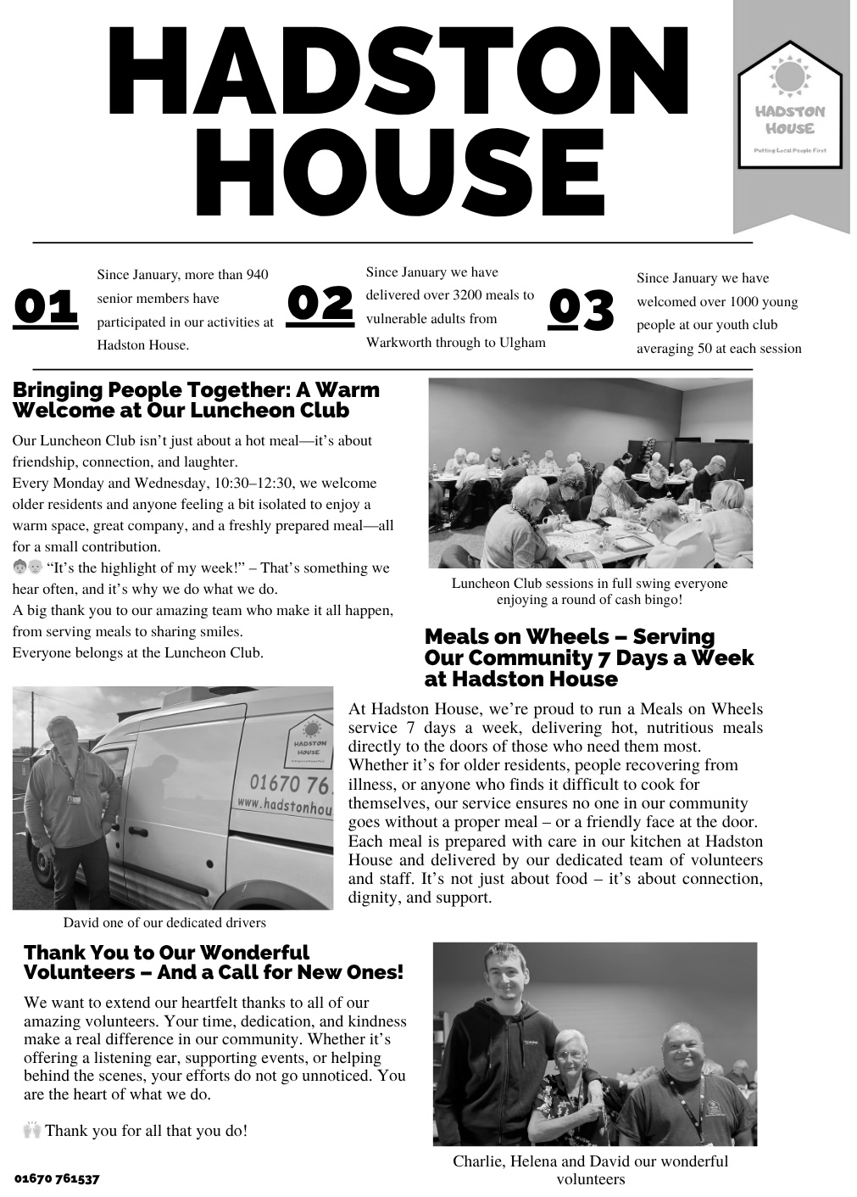




HEATHERDALE RESIDENTIAL
CARE HOME
Broomhill, Morpeth

01670 760796

Our aim is simply ‘Care Without Compromise’, which fundamentally means
we believe in Privacy, Dignity, Independence, Choice, Rights and Fulfilment
for the client. High standards of comfort, providing ‘First Class Quality Care’

Our home has:
- Ambience – “Truly a Hom, in the warmest sense.”
- Social Activities and Outings – “Daily with various outings”
- A Tip-top team – “Warm, cheerful, reassuring and caring”
- Virtually all single rooms, the majority of which are en-suite.
- Lovely Gardens, which have won Britain in Bloom Competitions
- Excellent Home Cooking - Great choice – 5 Star”
- Qualified Staff – “Training from day one”
Call any time for a brochure!

Helpline | Phone | Cost
Samaritans | 116 123  Open 24/7  jo@samaritans.org | Free
Mind Mental health support | 0300 123 3393 Open 9am-6pm except bank holidays.  Text 86463  info@mind.org.uk | Local rates from landline  Mobile charges vary
FRANK  Need advice about drugs – talk to Frank | 0300 123 6600 Open 24/7  Text 82111  frank@talktofrank.com | Local rates from landline  Mobile charges vary
Alcoholics Anonymous | 0800 9177 650  help@aamail.org | Free
Rape Crisis | 0808 802 9999  12noon-2.30 & 7-9.30 daily | Free
Switchboard LGBT+ helpline | 0300 330 0630  10am-10pm daily  chris@switchboard.lgbt | Local rates from landline  Mobile charges vary
National Domestic Violence  Run by Women’s Aid and refuge | 0808 2000 247 Open 24/7  0808 801 0327 Male advice & enquiry  0808 802 4040 Helpline for men worried they may be harming someone else | Free
ManKind Initiative domestic abuse helpline for men | 01823 334244 weekdays 10am to 4pm | Local rates from landline  Mobile charges vary
Farming Community Network | 03000 111 999  7am-11pm every day of the year  chris@fon.org.uk | Local rates from landline  Mobile charges vary
Dementia Helpline | 0800 888 6678  Open 9am-9pm Mon-Fri  helpline@dimentiauk | Free
Silver Line  Helpline for older people | 0800 470 80 90  Open 24/7 | Free
Action for Elder Abuse | 0808 808 8141  Open 9am-5pm Mon-Fri | Free
Childline | 0800 1111 open 24/7 | Free
PARISH CONTACTS
Priest in Charge: Rev’d Rachael Dines
revd.rachael.dines@gmail.com
Churchwardens: Sheila Orgill (07484 825203) and Anthony Reay (07429 929537)
Magazine Editors: contact Sheila or Anthony or email stjohnchevington@gmail.com
Safeguarding Officer Sheila Orgill

Please contact Rev’d Rachael Dines, 07763 211901 / 01665 497631
or email stjohnchevington@gmail.com with any enquiries about baptisms, weddings and funerals or if there is anything St John’s can do to help you.

Find us on Facebook  - St John the Divine, Chevington

Also: A Church Near You website https:/www.achurchnearyou

Dates and times are correct at the time of going to press.
Copies of this magazine can be obtained from St John’s Church or by contacting the magazine editors

The magazine committee is not responsible for the content of articles submitted and also reserves the right to exercise editorial discretion.

