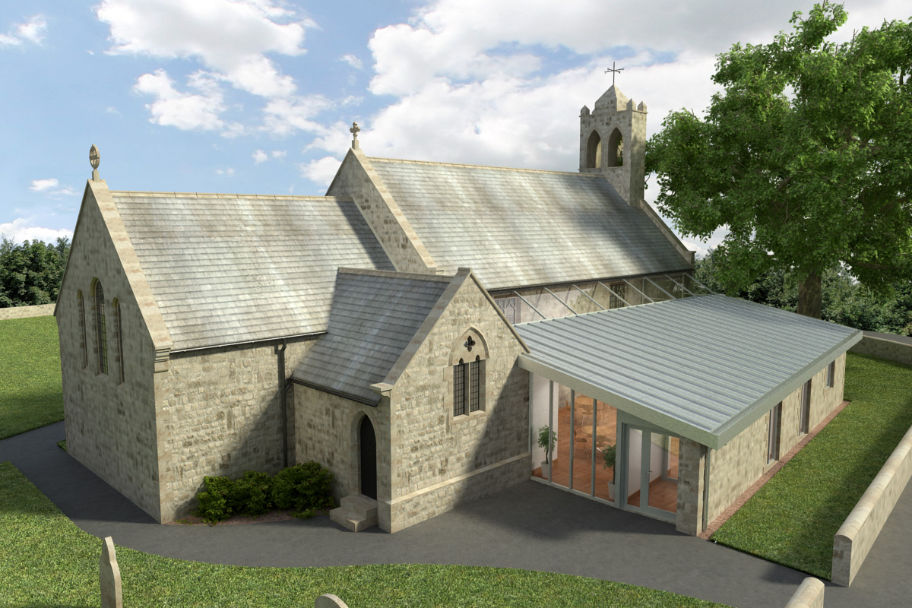
St Mary’s Parish Church, Longframlington

Welcome to our Sunday Morning Prayer. On Sunday 19 April, which is Third Sunday of Easter, when our Officiant will be Rev Gabby and Steve playing the organ. Next week, Fourth Sunday of Easter our Officiant will be Rev Rich and Michael playing the music.
Coming up at St Mary’s and our sister parishes+- Morning Prayer in St Mary’s – and on Zoom – usually every Wednesday morning at 9.30 am followed by coffee in the Community Room. The Link can be made using Meeting ID889 6133 2870, Password 093043. New people always welcome either on screen or in church.
Please note the refreshments following the Installation as Vicar at Whittingham on Thursday 23rd April the refreshments will be in the form of a Faith Supper, small finger buffet from all.
ANNUAL PAROCHIAL CHURCH MEETING – The APCM will be held on Sunday 26 April 2026, commencing at 11 am in the Community Room. Nominations are invited for two members to serve on the PCC for three years. This year we also need to elect two representatives to serve on the Alnwick Deanery Synod for three years, nominations are sought for these posts. Nomination forms are available from Veronica Thomson today and should be completed and signed by the nominee and proposer and seconder before the meeting. Nominees will have to sign a declaration that they are not disqualified from being a “trustee”. Copies of the Annual Report and Accounts for 2025 are also available. If you would like a copy emailed to you, please speak to Veronica.
URC Clearance Items – Please get in touch with Aileen on norskwood.aileen@gmail.com or Pat, telephone 01665 570 820. Various items include tables, chairs, bookshelves, electronic piano/organ, large White board, hymn books varied, crockery, cutlery, wine glasses, and many more. From church, kitchen and hall.
Confirmation – There will be a Confirmation on the 10th May at 5 pm in St Michael and All Angels, Alnwick and anyone interested please contact Rev Rich, email at foot of page.
URC Coffee Morning – This will be held on Bank Holiday Monday 25th May 10 am – 12 Noon in St Mary’s Community Room. All welcome.
Thank you for your giving to the life and work of our church. Our offering is taken during the third hymn, and there is a collection giving point at the back of the church for use after the service if you prefer. Regular giving by Standing Order with Gift Aid is particularly valuable to the church – speak to Audrey (01665 570 922) for more information and blank forms. All our news and much more available on our Facebook page https:www.facebook.com/SMCLongfram/?ti=as and You Tubechannelhttps:www.youtube.com/@stmichaelsfeltonstmaryslonPriest in Charge: Rev Rich Townend Phone 01670 719470 Email:revrichtea@gmail.com Regular day off is Monday, for St Mary’s information contact Veronica Thomson (01665 570 807) or Audrey Truman (01665 570922).

