SUNDAY 22nd March 2026.




Loving God and Loving our Neighbour

Although we are currently without a permanent Rector, services in the Benefice continue with the assistance of visiting clergy. Please do join us – you will be made very Welcome!!


Sunday 22nd March Lent 5.
9.30am Watton Prayer and Praise
11.00am Watton Contemporary Service
11.15am Bramfield Prayer and Praise
11.15am Stapleford Holy Communion

Sunday 29th March Palm Sunday
11.00am Watton Contemporary Service
11.00am Aston Benefice Holy Communion service



MIDWEEK
Fortnightly MONDAY 2pm ASTON Bible Study Fellowship 3 Long Ridge Aston with tea and biscuits. All are welcome. Next meeting Monday 30th March Contact Pauline at pauline.manley1966@gmail.com

NIGHT PRAYER Alternate WEDNESDAYS at 7.30pm on ZOOM. Next meeting Wednesday 1st April. Contact Tim Alexander for link tim_alexander3@hotmail.com

Looking ahead

Quiz Night, Waterford Village Hall Saturday 21st March 6.30pm for 7pm start. Tel.:07775337270 or email sarahebaldwin59@hotmail.com for details. Cost is £10.00 per person.

Sunday 12th April St Mary’s Aston APCM 12noon after the family service.
Sunday 17th May Waterford APCM
Friday 15th May Bramfield APCM 2pm in Church

Collect Prayer for Sunday 22nd March Lent 5
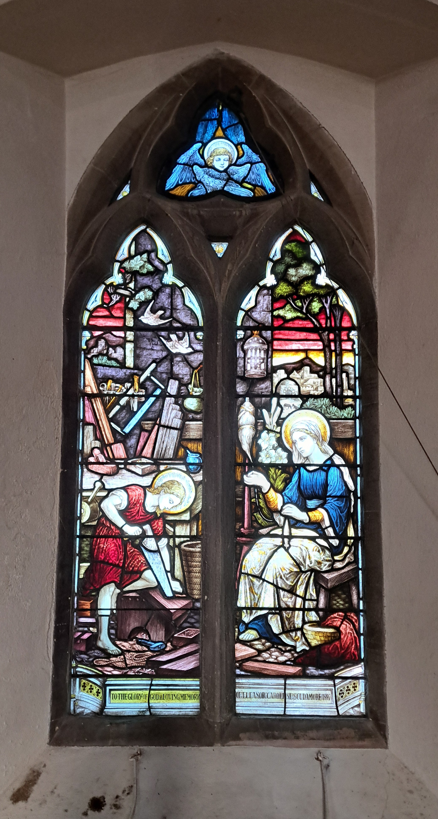
Most merciful God, who by the death and resurrection of your Son Jesus Christ delivered and saved the world: grant that by faith in him who suffered on the cross we may triumph in the power of his victory; through Jesus Christ your Son our Lord, who is alive and reigns with you, in the unity of the Holy Spirit, one God, now and for ever. Amen.

Lent is a time for


Another north west facing window in St Mary’s Church, Aston, showing Jesus learning the trade of a carpenter. Also showing his mother Mary, carpentry tools and doves of peace.

Hymn 63 HAM. My song is love unknown. Author: Samuel Crossman
Crossman, Samuel , B.D. From A. Wood's Athenae Oxonienses (1720, vol. ii. p. 730) we gather all that is known of this hymn writer. Wood says concerning him:— "Samuel Crossman, Bachelor of Divinity of Cambridge, and Prebendary of Bristol, son of Samuel Crossman, of Bradfield Monachorum, in Suffolk.
1 My song is love unknown–  my Saviour's love to me;  love to the loveless shown,  that they might lovely be.  Oh, who am I, that for my sake  my Lord should take frail flesh and die?  2 He came from His blest throne  salvation to bestow;  but men made strange, and none  the longed for Christ would know.  But oh, my Friend, my Friend indeed,  who at my need His life did spend! | 6 In life, no house, no home  my Lord on earth might have;  in death, no friendly tomb  but what a stranger gave.  What may I say? Heaven was His home;  but mine the tomb wherein He lay.  7 Here might I stay and sing–  no story so divine!  Never was love, dear King,  never was grief like Thine.  This is my Friend, in whose sweet praise  I all my days could gladly spend.

PRAY for PEACE in The Middle East, UKRAINE and all areas of conflict


Lord God, though peace seems humanly impossible,

we continue to pray for an end to violence and bloodshed.

We pray your comfort for the fearful and broken – hearted.


Change the hearts of those set on revenge and destruction.

Give wisdom to world leaders as they respond to aggression.

Bless all who work for understanding, reconciliation and justice which alone bring lasting peace. Amen.

‘God give us peace that lasts, not through the fear of might, but through the force of love, and love of life and right’. Amen

We believe that responding to the climate crisis is an essential part of our responsibility to safeguard God's creation and achieve a just world. Climate change hits hardest the poorest countries and poorest people of the world. Meantime, the widespread destruction of the natural world is a crisis for creation.

Our Environment Programme exists to enable the whole Church to address this — in faith, practice and mission. This includes tackling our own carbon emissions (aiming for Net Zero Carbon by 2030) and our wider work. More information can be found using the following web-link: http://www.churchofengland.org/about/church-england-environment-programme#na

Energy Hub Funded by UK Government: Find out how to:

1. Save energy

2. Save money. Reduce energy bills

3. Reduce carbon. Improve energy footprint

4.Increase comfort

For useful resources and guidance on where to get started visit: linktr.ee/energy_hub



https://app.ecochurch.org/user/21703/summary

EcoChurch - Tip for February Let's try to buy fewer things. Could you borrow, or hire instead? Do you have garden tools, or DIY equipment that you would happily share with friends and family? Neighbours leant us a car roof box, as it was only needed for a week at a time.

NEW RECTOR RECRUITMENT UPDATE – Rector for the Beane Valley Benefice
Vacancy advert is now on the St Albans website
https://www.stalbansdiocese.org/vacancies/rector-for-the-beane-valley-benefice/

I am sorry to say that, on this occasion, we have had no applications so we will need to re advertise, again. Closing date was 17th March.

CARING for our CHURCHYARDS

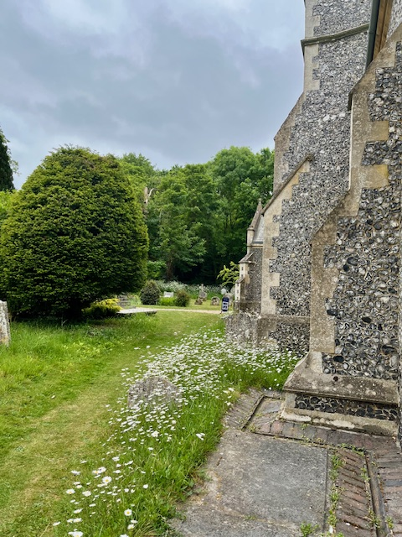
TUESDAYS Waterford Working Parties – Contact Churchwarden Malcolm Wandrag to offer help m.t.wandrag@gmail.com
To help in Stapleford or Watton or Bramfield please contact the Churchwardens.ASTON church open Sundays 12.00-16.00 and Wednesdays 10.00 -17.00 Church and churchyard working parties first Tuesday of month 10am to 12 noon. Contact Churchwarden Sara wardenstmarys@gmail.com
All our churchyards are cared for by volunteers.
Donations and offers of help are welcomed.
To include a loved one in the Book of Remembrance contact the churchwardens

Prayer for Growth for Aston, Bramfield, Stapleford, Waterford and Watton at Stone
Jesus teaches us to pray for our churches to grow. Jesus says: ‘Ask the Lord of the harvest, therefore, to send out workers into his harvest field’ (Matthew 9:38). In ways we don’t understand, God uses all our prayers.

Heavenly Father, you call us to sow seeds of faith in our communities. We ask you to fill us with your Holy Spirit that our lives may show the joy and new life we have in you. Guide our speaking and actions that others may be drawn to know your love. Lord Jesus, bless our churches that we may grow in numbers, love and service. We ask this in your name. Amen.

We pray for others to know God’s love. Tie 5 knots in a piece of string - let each knot represent a friend or family member. Keep the string in your pocket and, as you feel the string, pray for those people to know God’s love. Set an alert on your phone to remind you to pray for those 5 people every day.
A prayer for those who seek to know God.
Lord Jesus, when your followers walked the Emmaus road wondering what was true and what was not, you came alongside them and revealed yourself in Scripture and in broken bread. Come alongside those we know and love who may wonder or seek at this time. Reveal yourself in your love and make us ready to walk alongside them too, until they see your face and know your presence. Amen.
Heavenly father we pray for guidance for our Beane valley benefice churches during the vacancy. Amen.
Good news. Downing Street has announced that the Rt Revd Dr Andrew Rumsey, currently Bishop of Ramsbury in the Diocese of Salisbury, is to be the next Bishop of St Albans. Bishop Andrew returns to the Diocese in which he was born and baptised, describing the appointment as “a homecoming” and saying he is thrilled to be joining a “fine team”.
Looking ahead - Dates for your diary.


In Touch Age UK Hertfordshire
offer confidential, non-judgemental emotional and practical support on bereavement, physical & mental health issues, cancer, end of life, a partner with dementia or any other problem. Call 01992 634964/630623 or email intouch@ageukherts.org.uk Web page Age UK Hertfordshire | Our Services











Bereavement Support You can access online help at griefshare.org thebereavementjourney.org cruse.org.uk teardropgrief.co.uk ataloss.org
’s
afternoon
Tea

rty
at 64 Rivershill
Sunday 24th July 2.00-5.oopm

Bring & Buy <> Raffle <> Jams
Proceeds to Both

TAKE AWAY AVAILABLE

