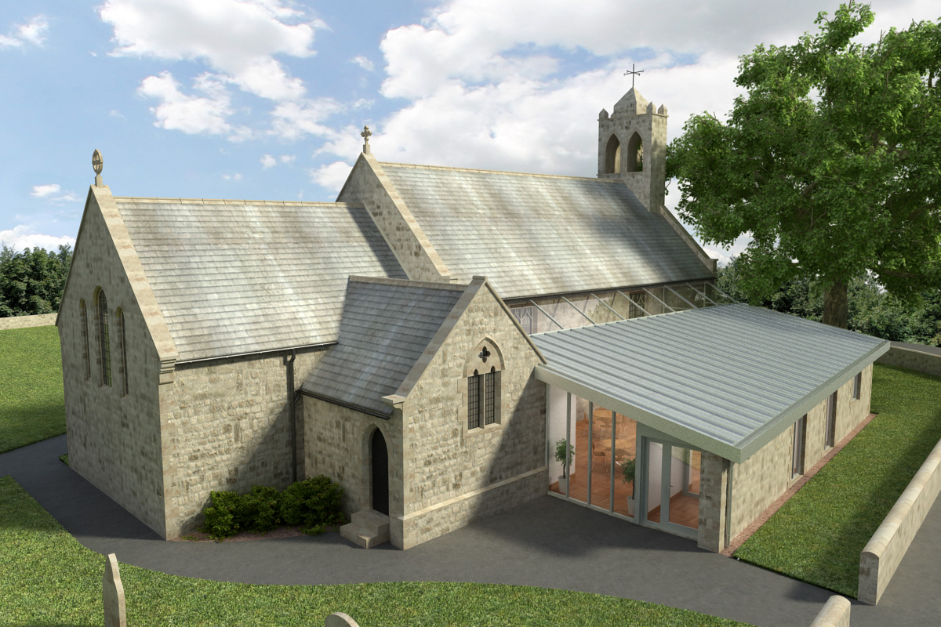
St Mary’s Parish Church, Longframlington

Welcome to our Sunday Morning Prayer. On Sunday 8 March, which is Sunday Lent 3, when our Officiant will be the Rev Rich and Tony playing the organ. Next week our Officiant will be Rev Gabby and Steve playing the organ. We continue to welcome our friends from the URC at coffee and their service at 11.15 am and wish them a very happy settling in and look forward to working with them over the coming years.
Coming up at St Mary’s and our sister parishes+- Morning Prayer in St Mary’s – and on Zoom – usually every Wednesday morning at 9.30 am followed by coffee in the Community Room. The Link can be made using Meeting ID889 6133 2870, Password 093043.
ALPHA – The ALPHA Mini Course continues on 11th March 11 am – 12 pm.
Confirmation – There will be a Confirmation in May and anyone interested or any member of the family who wish to be confirmed should contact Rev Rich email at bottom of notice sheet.
From Rev Rich – a notice to share (taken from the diocesan Facebook page). I think this is a great idea, and might appeal to the walkers among us! From the Diocesan Webpage – Save the Date! We’re delighted to be launching our very own pilgrimage route, St Aidan’s Way. From the `first cathedral` on Holy Island, to the `new cathedral` in Newcastle, we’re looking forward to walking in the footsteps of St Aidan, with opportunities en route to reflect on his role as peacemaker. The journey will be split into eight legs, the first of which will take place on 7 March 2026. We’ll walk from Holy Island to Belford following a short 10 am Eucharist Service at St Mary’s Church, Holy Island of Lindisfarne where +Helen-Ann will preside. All are very welcome to join for service, walk or both. Due to tide times, please meet at 9.30 am at St Mary’s, Belford, leaving your own car there. Lifts will be organised to take you to Holy Island. Snacks, water, lunch, sensible clothes and a small towel are advised. Due to travel arrangements, it would be really helpful to know numbers in advance. Please contact the Revd. Sarah Hills to confirm your attendance or to ask any questions. incumbentholyisland@gmail.com Details of dates, places, and mileages are on a separate piece of paper at the back of the church.
Thank you for your giving to the life and work of our church. Our offering is taken during the third hymn, and there is a collection giving point at the back of the church for use after the service if you prefer. Regular giving by Standing Order with Gift Aid is particularly valuable to the church – speak to Audrey (01665 570 922) for more information and blank forms. All our news and much more available on our Facebook page https:www.facebook.com/SMCLongfram/?ti=as and You Tubechannelhttps:www.youtube.com/@stmichaelsfeltonstmaryslonPriest in Charge: Rev Rich Townend Phone 01670 719470 Email:revrichtea@gmail.com Regular day off is Monday, for St Mary’s information contact Veronica Thomson (01665 570 807) or Audrey Truman (01665 570922).

