


St John’s Review

FEB 2026



Serving the villages of Hadston, Red Row and North and South Broomhill
Services Dec 2025

SUNDAY | 1st Feb | 10.30am | Holy Communion  Rev Rachael Dines
SUNDAY | 8th Feb | 10:30am | Holy Communion  Rev Rachael Dines
SUNDAY | 15th Feb | 10.30am | Holy Communion  Rev Rachael Dines
THURSDAY | 19th Feb | 2.00pm | Third Thursday  Sheila & Cynthia
SUNDAY | 22nd Feb | 10.30am | Holy Communion  Rev Rachael Dines

FUNERALS Jan 2025
A Prayer to remember those whom we love.
Almighty and eternal God,
we give thanks for all those whom we love but see no longer. Hold them in your everlasting arms of mercy and peace, and grant us grace to cherish their memory with love and thanksgiving. As we remember them in our hearts, comfort us with the hope of your eternal kingdom, where every tear shall be wiped away and all shall be made new in Christ our Lord.
Amen.
Dear Friends,

In these first few months of the year it can seem a bit dreary can’t it? The nights are still long and the weather is very unpredictable. During these times it is good to have something to look forward to. In February we traditionally think of Valentines Day but for those who have lost a beloved partner this can be a difficult season of adjustment and grief. For others it can be a time of year when you avoid the cards as it seems to highlight the difficulty of being single.

All of this got me thinking about love and how we show, those we love, what they mean to us. I’m not talking about partners in particular but anyone we love and care for. Apparently there are five ‘love languages’ and one of these is Words of Affirmation. These can be things said or written that affirm the other person. Within friendships this is a valuable way of letting someone know how important that they are to us. We all know that when the post arrives, if you have a bunch of typed envelopes and one that is hand written, we open the hand written one first. It just seems more personal, especially if you
recognise the handwriting as that of a loved one or friend.

Personal notes are so important and can be very up-lifting, especially when we are feeling in need of support or even simply a recognition of ‘being seen’. An email or a card, with carefully chosen words, can convey much more than just the words of thanks or appreciation. They are something to look back on when times are a bit tougher than usual or we a feeling a bit down. I find the same thing when I read my Bible and read words, written many hundreds or thousands of years ago, that speak to me about how much I am loved by God and my efforts to serve Him are recognised.

Here are some Bible passages that I find helpful, despite being taken out of context.

Isaiah 41 verse 13: For I, the Lord your God, hold your right hand; it is I who say to you, ‘Do not fear, I will help you.’

Jeremiah 29 verses 11-13 For surely I know the plans I have for you, says the Lord, plans for your welfare and not for harm, to give you a future with hope. Then when you call upon me and come and pray to me, I will hear you. When you search for me, you will find me.

John 14 verse 18 Jesus said “I will not leave you orphaned; I am coming to you.”

In just these few passages we are reminded that we are loved and precious to God and that Jesus is with us as we journey through life’s ups and downs. We are not promised an easy life if we have faith, we have not been told that we will avoid hurt and upset, grief and pain. However we are reminded so many times that we are treasured by God, who loves us, and that he IS with us though all of life, even when we feel rock bottom.

If you would like to have a chat at any time about life and faith do drop me a line. I’m here to help and listen. In the meantime, why not write a note or email to someone you know and care about and lift their spirits? Those words of affirmation make such a difference.

God bless you all,

Rev Rachael
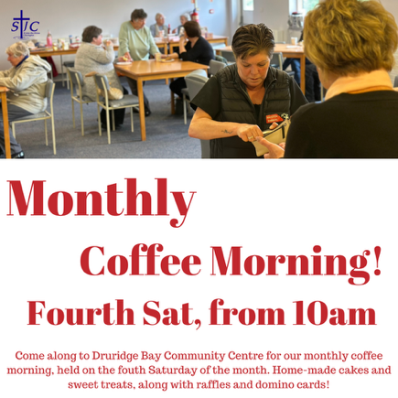

MONTHLY EVENTS

Bingo night – Wed, 11th Feb Coffee Morning – Sat, 28th Feb

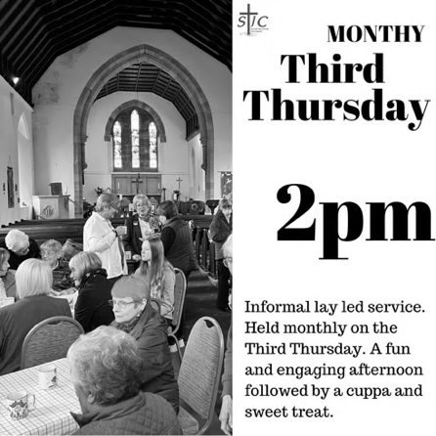
Third Thursday – August
Everyone is welcome to Third Thursday, 19th Feb at 2 pm in the Church.
A short informal service enjoyed by all, led by Cynthia or Sheila.
Refreshments and sweet treats are served afterwards.

MEMORIAMS FOR FEBRUARY

DUNN
Mick Dunn died on 3rd February 2023, brother-in-law and uncle.
The world changes from year to year. Our lives from day to day but love and memories of you Mick will never go away. Love from Lilian, Davida and all the family.

Uncle Mick, 3rd February 2023.
A beautiful memory dearer than gold, of an uncle whose worth can never be told. There’s a place in my heart no one can fill. I miss you, Uncle Mick, and always will.
Love Alice, Liam, Aleiah & Reuben.
JONES
Winnifred Mary Jones died 1st February 2006. Mam we love you so much, we miss you every day. It’s not the same without you. You were the best mother anyone could have. We will miss you always. ‘Til we meet again, your loving family – sons Charlie, David, Kenneth & Trevor, daughters Marg and Glennys, grandchildren and great-grandchildren. Rest in peace our darling mother.

Twinkle Twinkle little star - Mam I’m wondering where you are, I look up above the sky at night And see you shining so bright. I know it’s you Mam. Your loving daughter Margaret Lucy Jones.

HARROLD
To my sister in heaven, I hide my tears when I say your name, but the pain in my heart is still the same. Although I smile and seem carefree, there is no one who misses me more than my family.
From Andrew, Alice, Liam, Harvey, Lincoln, Elivia, Aleiah & Reuben.
Beth – 1st February 2023
Beth – 1st February 2023
They say there is a reason. They say time will heal. Neither time nor reason will change the way I feel. Gone are the days we used to share, but in my heart, you are always there. The gates of memories will never close, I miss you more than anybody knows…
Love and miss you every day, always and forever—love from Mam.

Beth Harrold 1st February 2023
Time for me to go now; I won’t say goodbye; look for me in rainbows, way up in the sky. In the morning sunrise, when all the world is new, just look for me and love me as you know I loved you.
Time for me to go now; I won’t say goodbye; look for me in rainbows, high up in the sky. In the evening sunset, when all the world is through. Just look for me and love me, and I’ll be close to you. It won’t be forever. The day will come, and then my long arms will hold you when we meet again.
Time for us to part now; we won’t say goodbye; look for me in rainbows, shining in the sky. Every waking moment and all your whole life through just look for me and love me as you know I loved you.

Just wish me to be near you, and I’ll be there with you.
Mam missed every single day. Lola, Vinny, Roman, Dolly & Letty.

ROBERTSON
In loving memory of a dear husband, dad and granda Ken Robertson, who died 2nd February 2015. Gone but never forgotten by his loving family.
TAIT
Treasured memories of a dear mam and nana Nan ait who died 9th February 2006, who will never be forgotten. Loved with all our hearts. Miss you always. Ron, Doreen, Dawn & Ian

TAIT
In loving memory of our dear mother Joyce Tait died 16th February 2008. Dearly loved and remembered by Drew, Lorna, Eileen and grandsons Richard, Matthew, Lewis and Elliott.

Fond memories of our sister Joyce who died 16th February 2008. She was always loved and is missed so much by her brothers Tommy, and Norman, her sisters-in-law, nieces and nephews.
BESWICK
In loving memory of a dear Mother and Nanna Elizabeth Beswick (Betty) who died 22nd February 1997. Sadly missed by her daughter Joan and family.

SMITH
In loving memory of a dearly loved mum Nora died February 2004 and a dearly loved dad Matt died October 2011. Loved and remembered always Dorothy and family.


BIRTHDAY MEMORIES
Birthday memories of Joan Butler 11th February. I’m sending a dove to heaven, with a parcel on its wing, be careful when you open it as it’s full of beautiful things. Inside are a million kisses wrapped up in a million hugs, To say, “Happy Birthday Mum” and we miss you so much. From your loving daughter Diane, Roger and family x
Happy Birthday for 12th February to Mary Mack and Mick Dunn, Love from Lilian, Davida and all the family.

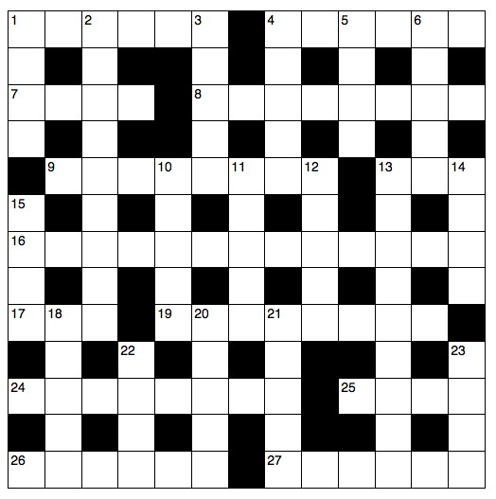
Crossword for February

Across

1 ‘If you love those who love you, what — is that to you?’ (Luke 6:32) (6)
4 ‘They threw the ship’s — overboard’ (Acts 27:19) (6)
7 The first murderer (Genesis 4:8) (4)
8 He was the head Levite in charge of the singing when the ark of God was brought back to Jerusalem (1 Chronicles 15:22) (8)
9 Samson was noted for this (Judges 16:6) (8)
13 Solicit money or food from passers by (Acts 3:2) (3)
16 What William Booth’s Christian Mission became in 1878 (9,4)
17 Alliance of Religions and Conservation (1,1,1)
19 ‘I will praise your name for ever and ever. — — I will praise you’ (Psalm 145:1–2) (5,3)
24 Simon had (anag.) (8)
25 Desperate (Deuteronomy 28:48) (4)
26 Elisha witnessed the boy he was seeking to resuscitate do this seven times before opening his eyes (2 Kings 4:35) (6)
27 The belly and thighs of the statue in Nebuchadnezzar’s dream were made of this (Daniel 2:32) (6)

Down

1 ‘Before the — crows, you will disown me three times’ (Matthew 26:75) (4)
2 Relating to the books of the Bible between Acts and Revelation (9)
3 ‘They have — the Lord out of the tomb, and we don’t know where they have put him!’ (John 20:2) (5)
4 Belief (5)
5 ‘Take the following fine spices: ... 250 shekels of fragrant — ’ (Exodus 30:23) (4)
6 ‘Do not — Jerusalem, but wait for the gift’ (Acts 1:4) (5)
10 A seer (anag.) (5)
11 ‘Even there your hand will — me’ (Psalm 139:10) (5)
12 The wild variety was part of John the Baptist’s diet (Mark 1:6) (5)
13 A non-Greek speaker who was looked down on by civilized people (Colossians 3:11) (9)
14 Famous 1950s musical whose characters included members of
16 Across, — and Dolls (4)
15 The province from which Paul wrote to the Corinthians (1 Corinthians 16:19) (4)
18 ‘He was standing in the gateway with a linen cord and a measuring — — his hand’ (Ezekiel 40:3) (3,2)
20 ‘Today, if you hear his — , do not harden your hearts as you did in the rebellion’ (Hebrews 3:15) (5)
21 The Jericho prostitute who hid two Israelite spies on the roof of her house (Hebrews 11:31) (5)
22 ‘And now these three remain: faith, — and love. But the greatest of these is love’ (1 Corinthians 13:13) (4)
23 ‘God has numbered the days of your reign and brought it to an end’ (Daniel 5:26) (4)
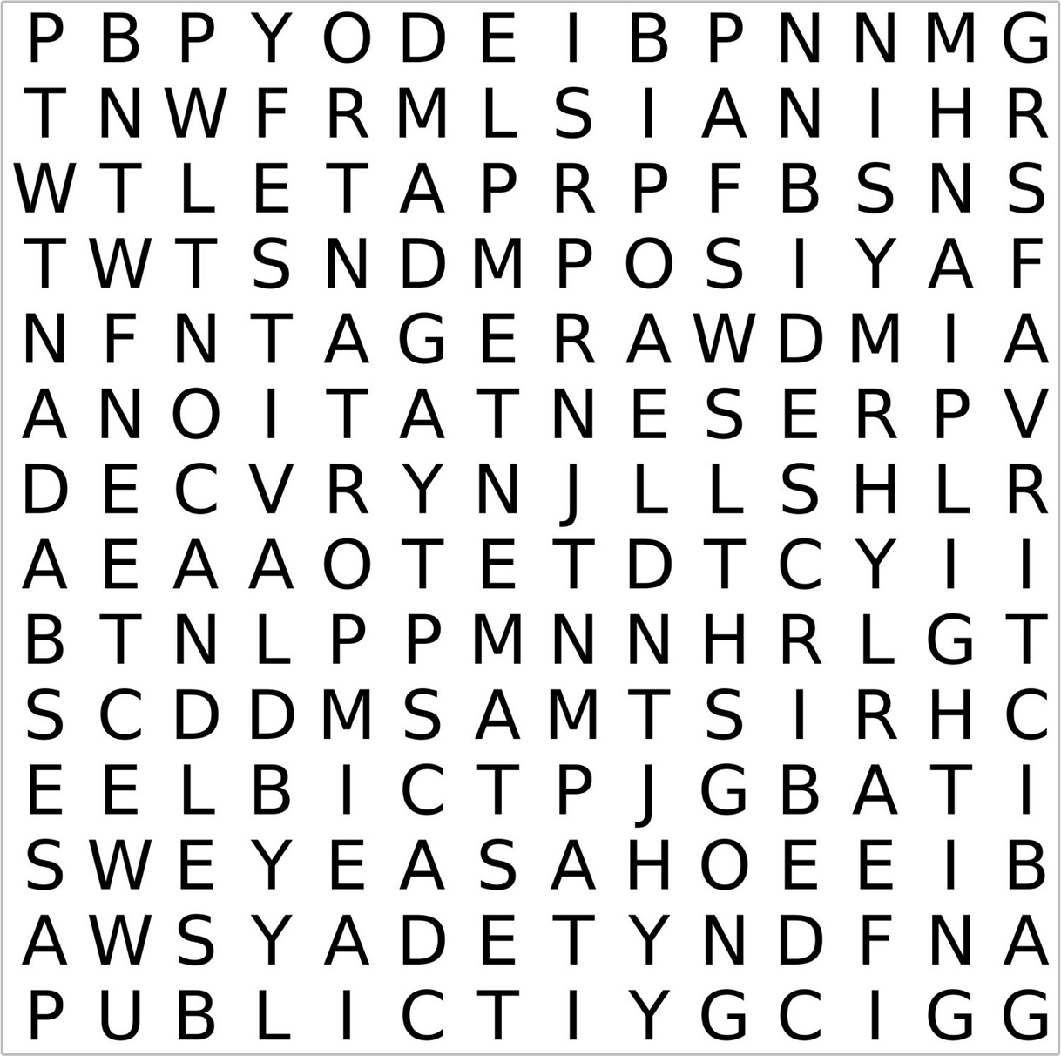
Wordsearch for February

Candlemas | New | Boy | Jewish | Light
Forty | Testament | First | Temple | World
Days | Important | Public | Festival | Candles
After | Age | Appearance | Presentation | Lighting
Christmas | Baby | Mary | Described | Early

Bonus Maze for February

All in the month of February

It was:

300 years ago, on 20th Feb 1726 that William Prescott, an American colonel in American Revolutionary War was born. Famous for giving the order: “Don’t fire until you see the whites of their eyes.”

175 years ago, on 1st Feb 1851 that novelist Mary Shelley died, aged 53. Best known for her Gothic novel Frankenstein.

125 years ago, on 2nd Feb 1901 that the funeral of Queen Victoria took place.

80 years ago, on 11th Feb 1946, that the Revised Standard Version of the New Testament was published. It was the first major English-language update of the Bible since the King James version was published in 1611.

Also 80 years ago, on 14th Feb 1946 that the Bank of England was nationalised.

70 years ago, on 11th Feb 1956 that two members of the Cambridge spy ring, British diplomats Guy Burgess and Donald Maclean, announced that they had defected to the Soviet Union. They had both vanished in mysterious circumstances in 1951.

65 years ago, on 9th Feb 1961 that the Beatles played at the Cavern Club in Liverpool for the first time.

50 years ago, on 11th Feb 1976 that John Curry won Britain’s first-ever Olympic gold medal in figure skating.

30 years ago, on 1st Feb 1996 that US President Bill Clinton met Sinn Fein President Gerry Adams at the White House, to discuss the Northern Ireland Peace Process.

25 years ago, on 12th Feb 2001 that the Human Genome Project announced the publication of the first complete working draft of the human genome.

20 years ago, on 18th Feb 2006 that the Rolling Stones played the world’s largest free rock concert on Copacabana beach, Rio de Janeiro. An estimated 2 million people attended.

Poet’s Corner
The Red Tin Box

I slowly unclip the lid of Mam’s faded red tin biscuit box,
A time capsule of our family…so let’s turn back the clocks.
That stale nicotine smell takes me by surprise, as I sift the contents of old!
My eyes stare at the layers of family history, so, so much to behold.

A family treasure box of sorts, to save and put family memories aside,
This secret, coveted and most important tin, permission needed to see inside
I peruse and gently fumble through my family’s historical evidence,
Hand written letters, from a young sailor boy, gives the contents…such credence

TB and Dad, letters giving one sentence comments of his progress,
A life of pre-NHS, The Tin Pots, disease and death…a real-life process.
Photos, newspaper clips, such an emotional ride, a kaleidoscope of our family life
My eyes well up, a glimpse of happy times, and yet evidence of real strife.

We’ve all got an old ‘red tin’ box, layer upon layer, giving that family timeline,
Birth certificates, funeral bills and even an old family divorce…not everything was family fine.
That Tutankhamen effect happens each time as I unclip and open the dented lid
Family ‘relics’ they are; our roots, not secrets of times gone by, but deserving of some hoity place, not ever to be hid!

Smile Line -
God made us

A little girl sitting on her grandfather's lap reached up to touch his wrinkled cheek. “Grandpa, did God make you?" "Yes, sweetheart," he answered,
"God made me a long time ago."
"Oh," she paused. "Grandpa, did God make me too?"
Her grandfather assured her that He had.
Feeling his wrinkled cheek again, she observed,
"God's getting better at it, isn't He?"

The February Night Sky
Bright planets

Four planets can be found in the evening sky after sunset this month. The planet Venus is emerging from conjunction with the Sun and may be glimpsed an hour after sunset over the western horizon. The innermost planet Mercury is a little higher in the sky at around the same time. More about Mercury to follow! Saturn is higher still and likely the easiest to spot in that region. As the month ends – these three planets move to form a small triangle of points as darkness falls after sunset. Jupiter is high and bright in the south by late evening.

Phases of the moon





Feb 1 Feb 9 Feb 17 Feb 24

Mercury – a planet with a violent past
Mercury is the innermost planet of the solar system and the fastest, completing an orbit of the Sun every 88 Earth days. Because it never appears far from the Sun in our sky, Mercury is best seen shortly after sunset or before sunrise, making it one of the more elusive planets for observers.
Its surface bears a strong resemblance to the Moon: heavily cratered, ancient, and largely unchanged for billions of years. Vast plains of frozen lava hint at an early period of intense volcanic activity, while enormous impact scars testify to a violent youth. The most famous of these is the Caloris Basin, a colossal impact crater about 1,500 km wide, formed when a large asteroid struck the young planet. Shockwaves from that impact reshaped terrain on the opposite side of Mercury, producing strange, jumbled landscapes.
Mercury is also a world of extremes. Daytime temperatures can exceed 400 °C, while nighttime temperatures can fall below –180 °C. With almost no atmosphere to redistribute heat, the planet experiences some of the largest temperature swings in the solar system. Adding to the strangeness, a single day on Mercury (sunrise to sunrise) lasts 176 Earth days - longer than its year.
One of Mercury’s biggest puzzles is its unusually large iron core, which makes up most of the planet’s volume. This gives Mercury a surprisingly high density and even a global magnetic field, something once thought unlikely for such a small world. How Mercury ended up this way is still debated. One idea suggests that Mercury was originally larger, but a colossal early collision stripped away much of its rocky outer layers. Another hypothesis proposes that intense radiation from the young Sun boiled off lighter material.
More recently, computer simulations have suggested a dramatic alternative: Mercury may not have formed where it is today at all. In the early solar system, gravitational interactions with the giant planets – particularly Jupiter – could have scattered Mercury inward from a more distant orbit. Such encounters might explain both its odd composition and its present location close to the Sun.
Far from being a simple, barren rock, Mercury turns out to be a key witness to the chaotic early history of our solar system: a small planet with an outsized story to tell.
If you’d like to learn more about astronomy, then consider contacting your local astronomy club – the Northumberland Astronomical Society (NASTRO) - see www.nastro.org.uk for further details.

Dr Adrian Jannetta MSc CMath FRAS

Smile Line -
It hurts
A little girl told her mother one day before lunch that her stomach was hurting.
Her mother replied: "That's because it's empty, you have to put something into it!"
That evening the minister and his wife came for dinner. The minister looked a bit rough and explained that his head was hurting him. The little girl gave him a sweet smile and said encouragingly: "That's because it's empty, you have to put something into it!"

Crossword Answer Wordsearch Answer
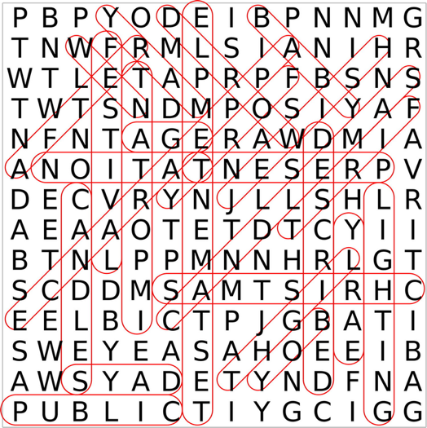
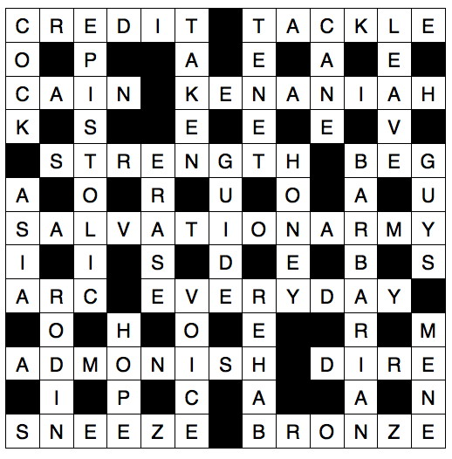

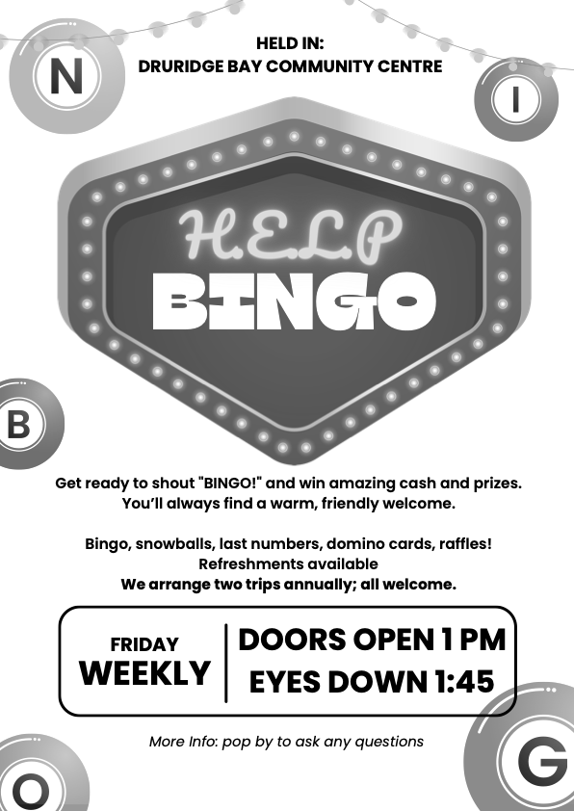

Gift Shop, Home Interiors, Painted Furniture, Furniture painting commissions & Frenchic Paint stockist.


10 The Precinct. Hadston. NE65 9YF

Facebook The Furniture Painter

Email keith.brooks2@btconnect.com Mobile 07437853665.




ADVERTISE HERE!

If you would like to advertise your business, please contact the editors via stjohnchevington@gmail.com for more

HADSTON NEWSAGENCY

PROPRIETOR – Stephen Paton

HADSTON SHOPPING CENTRE

Tel: 760233

Post Office Now in Shop
Newspapers Magazines
Stationery Cigarettes
Tobacco Alcohol
Pet Corner Household Goods
Groceries





T. DAWSON Ltd

ELECTRICAL CONTRACTOR

- Renewables
- EICR
- Domestic, Commercial, Industrial

T. Dawson Ltd
Bradley House
23 Togston Road
North Broomhill
NE65 9UZ

Tel: 01670 761921 / 07955 911720 Email: trevortoggy@icloud.com



John S Lunn & Sons
Artsmith, Blacksmith
Stephen Lunn
Est 1921
Tel: Red Row 01670 760246



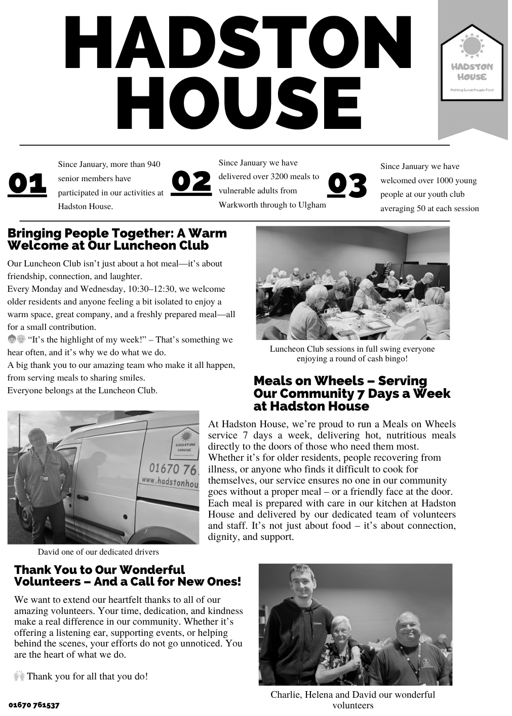

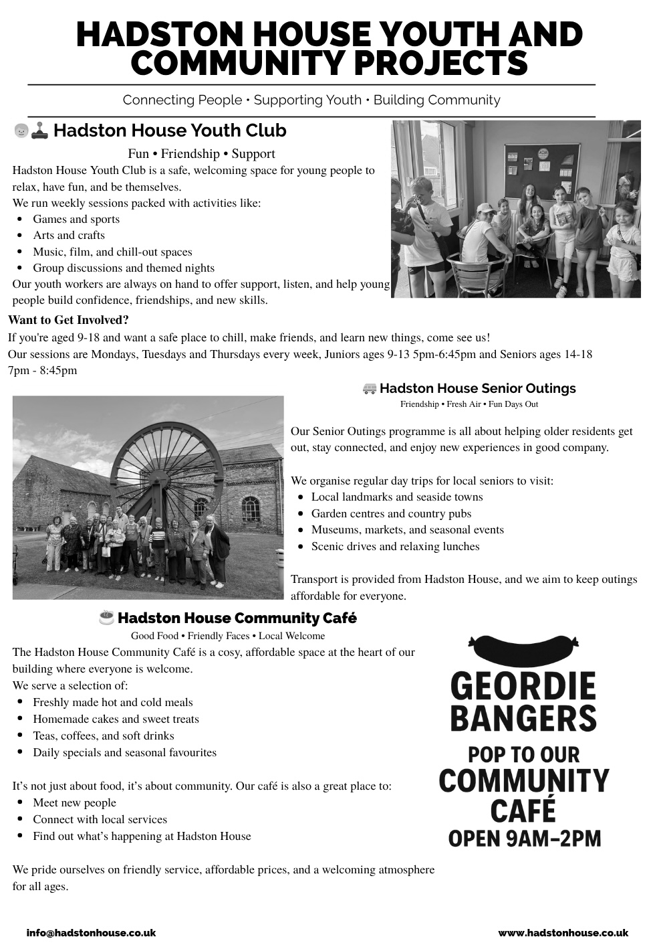

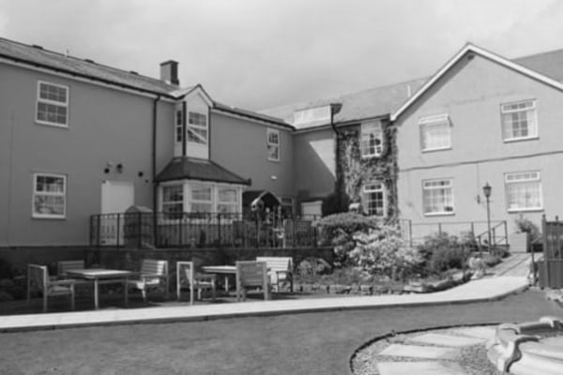
HEATHERDALE RESIDENTIAL
CARE HOME
Broomhill, Morpeth

01670 760796

Our aim is simply ‘Care Without Compromise’, which fundamentally means
we believe in Privacy, Dignity, Independence, Choice, Rights and Fulfilment
for the client. High standards of comfort, providing ‘First Class Quality Care’

Our home has:
- Ambience – “Truly a Hom, in the warmest sense.”
- Social Activities and Outings – “Daily with various outings”
- A Tip-top team – “Warm, cheerful, reassuring and caring”
- Virtually all single rooms, the majority of which are en-suite.
- Lovely Gardens, which have won Britain in Bloom Competitions
- Excellent Home Cooking - Great choice – 5 Star”
- Qualified Staff – “Training from day one”
Call any time for a brochure!

Helpline | Phone | Cost
Samaritans | 116 123  Open 24/7  jo@samaritans.org | Free
Mind Mental health support | 0300 123 3393 Open 9am-6pm except bank holidays.  Text 86463  info@mind.org.uk | Local rates from landline  Mobile charges vary
FRANK  Need advice about drugs – talk to Frank | 0300 123 6600 Open 24/7  Text 82111  frank@talktofrank.com | Local rates from landline  Mobile charges vary
Alcoholics Anonymous | 0800 9177 650  help@aamail.org | Free
Rape Crisis | 0808 802 9999  12noon-2.30 & 7-9.30 daily | Free
Switchboard LGBT+ helpline | 0300 330 0630  10am-10pm daily  chris@switchboard.lgbt | Local rates from landline  Mobile charges vary
National Domestic Violence  Run by Women’s Aid and refuge | 0808 2000 247 Open 24/7  0808 801 0327 Male advice & enquiry  0808 802 4040 Helpline for men worried they may be harming someone else | Free
ManKind Initiative domestic abuse helpline for men | 01823 334244 weekdays 10am to 4pm | Local rates from landline  Mobile charges vary
Farming Community Network | 03000 111 999  7am-11pm every day of the year  chris@fon.org.uk | Local rates from landline  Mobile charges vary
Dementia Helpline | 0800 888 6678  Open 9am-9pm Mon-Fri  helpline@dimentiauk | Free
Silver Line  Helpline for older people | 0800 470 80 90  Open 24/7 | Free
Action for Elder Abuse | 0808 808 8141  Open 9am-5pm Mon-Fri | Free
Childline | 0800 1111 open 24/7 | Free
PARISH CONTACTS
Priest in Charge: Rev’d Rachael Dines
revd.rachael.dines@gmail.com
Churchwardens: Sheila Orgill and Anthony Reay
Editor: stjohnchevington@gmail.com
Magazine Secretary: contact Sheila or Anthony or email stjohnchevington@gmail.com
Safeguarding Officer Sheila Orgill

Please contact Rev’d Rachael Dines, 07763 211901 / 01665 497631
or email stjohnchevington@gmail.com with any enquiries about baptisms, weddings and Funerals or if there is anything St John’s can do to help you.

Find us on Facebook  - St John the Divine, Chevington
Also: A Church Near You website https:/www.achurchnearyou
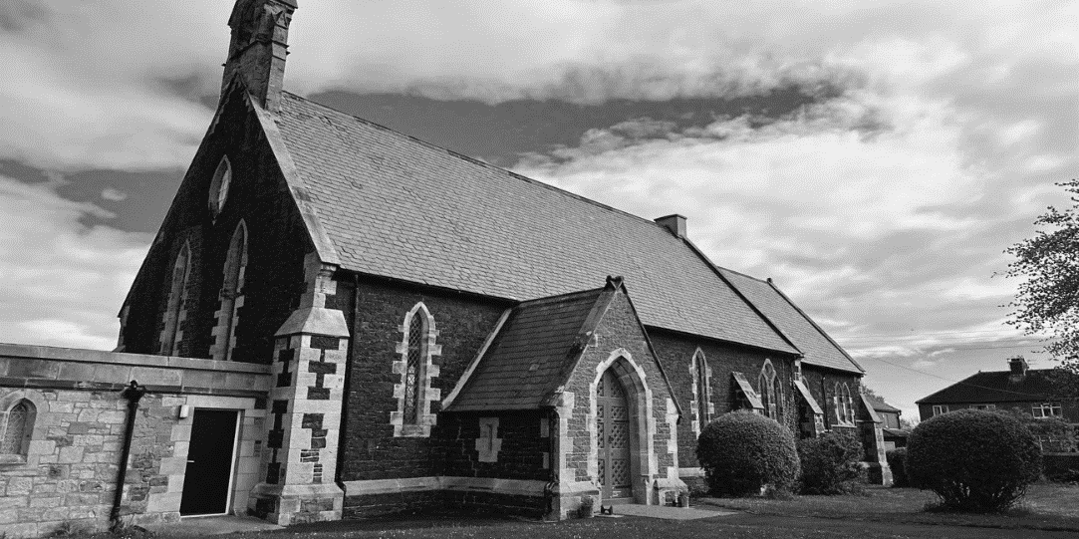

Dates and times are correct at the time of going to press.
Copies of this magazine can be obtained from St John’s Church or by contacting the magazine secretary

The magazine committee is not responsible for the content of articles submitted and also reserves the right to exercise editorial discretion.

