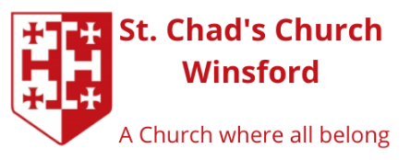
TO BOOK AND ENQUIRIES
If you have any questions don’t hesitate to contact
Fr. Callum Boothroyd e: revcallum@outlook.com or tel. 01606 593222.
To book a space for your decorated tree please complete the form below and return it with your
payment as soon as possible to:
Fr. Callum Boothroyd
The Vicarage
1 Over Hall Drive
Winsford
CW7 1LW
______________________________________________________________________________
BOOKING FORM
(Block capitals please)
Organisation / Business _______________________________________________________________
Contact Name ________________________________________________________________
Address ______________________________________________________________________
Postcode _______________ Phone _____________________________
Email _______________________________ Mobile ________________________________________
Please indicate your preferred time to bring your tree to St Chad’s Church on Friday 27th November
between 12.00pm and 2.00 pm or between 6.00 pm and 8.00 pm
Your tree can be collected from church on Monday 7th December
between 12.00 and 2.00pm or 6.00 pm and 8.00pm
Please circle your preferred times.
Donation
You are requested to send a minimum donation of £20 with your booking. Cheques should be made payable to St Chad’s PCC or donate by bacs to: (Using ref: CTF followed by your name/organisation)
Bank details
Account name. St Chad's Church PCC, Over
Sort Code. 40-52-40
Account No. 00030626

I enclose a donation / made donation by bacs, of £ _____________ (delete as appropriate)
Important
I consent to the church contacting me by 󠆲 post 󠆲 phone 󠆲 email
By signing this form you are confirming that you are consenting to St. Chad’s PCC, Winsford holding and processing your personal data for the purposes of keeping you informed about the Christmas Tree Festival. You can withdraw or change your consent at any time, and all processing of your personal data will cease.

Signature ------------------------------------------------------- Date ---------------------------------------------

