The Rector's Ramblings
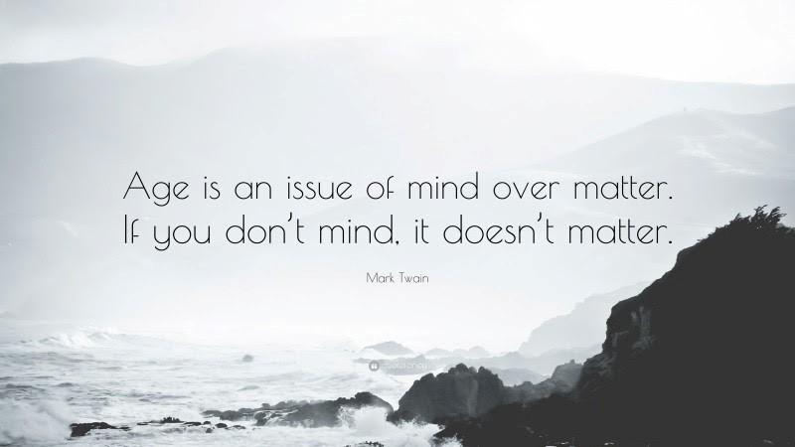
I’ve rambled before on some of the interesting, and sometimes controversial, conversations I’ve had with people in St Olav’s and this week was no different, from the conflict in the Middle East to the state of the weather. But one of the more interesting conversations was on the subject of age, and where that conversation took me. Now the customer is question is a reluctant 82-year-old. Although her birth certificate, and the aches and pains, tells her she is 82, for most of the time she doesn’t think of herself that way. She wants to still be doing all the things she did in her 40s and 50s, with the same enthusiasm and stamina, but her body won’t let her.
Now I won’t bore you with all that was said, but the gist of it was that she firmly believes in Mark Twain’s assertion that ‘Age is an issue of mind over matter. If you don’t mind, it doesn’t matter.’ She still goes swimming twice a week. She still does the flowers in church, helps serve the coffee, is a regular reader, and helps out at Sunday School. She comes into Chichester at least once a week, and does shopping for her ‘elderly’ neighbours. She accepts that her body may be slower, but it won’t slow her mind and her attitude down. After she left it got me thinking about my thoughts on age, and especially whether my age affects my attitude. Now my birth certificate, and my aches and pains, tell me that I am 60, and I admit that sometimes I am a grumpy old woman, but for most of the time I don’t think that I am actually old enough to get free prescriptions and sight tests. I don’t think I am still a teenager, but like the customer I still think of myself as being in my 40’s, or at a push maybe 50, so it comes as a surprise when Saga send me their brochure, or I qualify for a discount because of my age!
But I guess there is another way of looking at age, and that isn’t in terms of the number of years, but in the experiences we have had. The world events we have lived through, the changes in society we have seen, most good but some not so good, and the personal experiences we have been through. From the Queens Silver Jubilee, the Falklands War, and Live Aid through to 9/11, the Gulf Wars, and of course Covid. I remember the first mobile phones in the 1970, and my first ever ‘brick’ in the mid-1980s. I remember when we got our own desktop computer at work, and had to type all our own letters (which still went by post because there was no email!). Now I can speak to anyone anywhere in the world, and send emails from my phone.
But in thinking about age, and experiences, and starting to plan for this Sunday, Mothering Sunday, my thoughts turned to Mary, the mother of Jesus, and what she experienced in her life. Although most images we see of Mary as she stood at the foot of the cross show her as an old woman, she would have been younger than I am now, in her early 50s. She had been a teenager when Jesus was born, probably around 18, and so as she watched her son die, she knew that she had many years ahead of her to remember, reflect, and yes, grieve. As she stood at the cross, I can’t help but wonder if she remembered the words of Simeon ‘and a sword will pierce your own soul, too.’ (Luke 2: 35). I wonder if she thought about the visit of the magi, and the shepherds. I wonder if she remembered the time Jesus had seemed to disown her ‘Who is my mother, and who are my brothers?’ (Matt 12: 48). And I wonder if she remembered her words to the angel, when told that she had been chosen to be the mother of the Son of God ‘‘Here am I, the servant of the Lord; let it be with me according to your word.’ (Luke 1: 38).
As we age it is natural for us to look back over our lives and think about the choices we made, the decisions we took, the roads we have travelled. I suspect that, most of us, can’t help but wonder what our lives would have been like if we had chosen a different career, or travelled more, or said no when we said yes, and vice versa.
As I think about Mary, I hope and pray that as she stood at the foot of the cross she didn’t regret the path her life had taken, that she knew God was with her, that her Son would be the Saviour of the world, and I hope she remembered her words to her cousin Elizabeth, and I hope she knew them to be true. Thank you, Mary, for trusting God and for sharing your Son with us all.
‘My soul magnifies the Lord,
and my spirit rejoices in God my Saviour,
for he has looked with favour on the lowliness of his servant.
Surely, from now on all generations will call me blessed;
for the Mighty One has done great things for me,
and holy is his name. (Luke 1: 46-49)
Rev Sarah
Worship in the Valley Parish
15th March
Mothering Sunday
Holy Communion
10am
West Dean
Rev Sarah Manouch
07468 854864 priestvalleyparish@gmail.com
Please note that I am part-time. My principal working days are Friday and Saturday as well as Sunday. I am not available on a Thursday.

