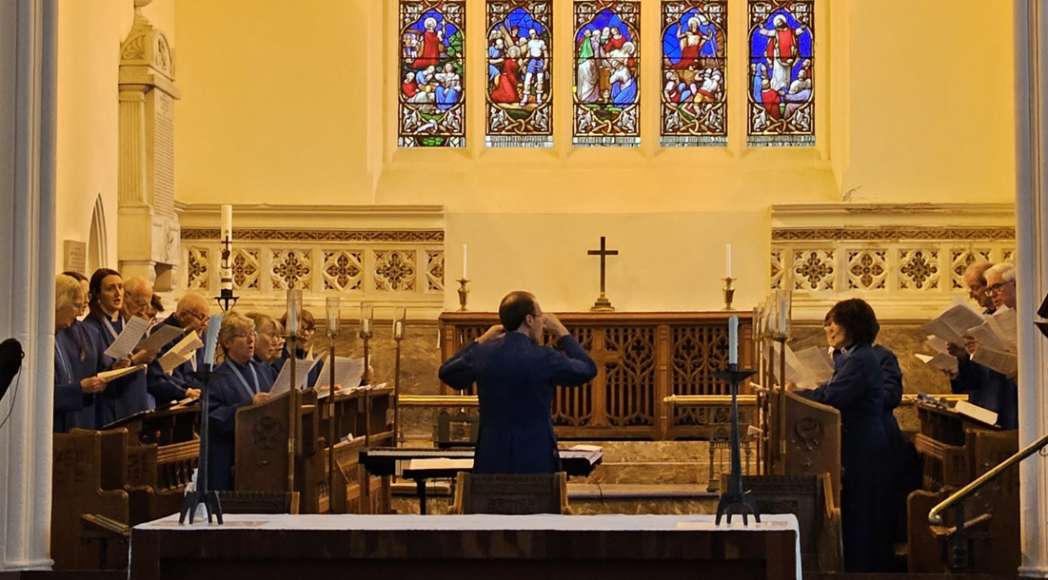  - St Mary’s Church Choir is recruiting  Are you between 8 and 18?  Do you love to sing?  Look closely at picture of St Mary’s amazing Church Choir.  What is missing?  YOU!  We’re missing young voices and we’d love to put that right so we’d like to invite you to think about joining St Mary’s Church Choir.  Starting next term (April 2026) you are invited to join us to:  Develop your singing * learn to read music * improve your music reading * learn loads of amazing music * meet new people * sing for services * contribute to the musical life of our community * learn new leadership skills * make new friends * earn some pocket money * and have a lot of fun along the way.  Being a chorister is a commitment AND it can open up all sorts of opportunities for now and the future.  COME AND FIND OUT MORE
  St Mary’s Church Choir
  ____
  Pick up a letter in school to find out more
  ____
  Or email music@stmarysware.co.uk
  ____
  “Being part of the choir improved my confidence, taught me new skills and I made new friends”
  ____
  Over 18s welcome too!
  St Mary’s Ware
  Church Street
  Ware, SG12 9EH
  07423812238
  stmarysware.org.uk

