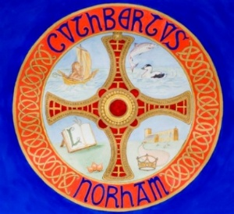 | The St Cuthbert’s Project  Bulletin No. 11  March 2026

The St Cuthbert’s Project aims to improve the heating, lighting, seating and heritage interpretation at Norham Church, to make the church building more user-friendly and more useful to the wider community.

The grant of £245,000 from the National Lottery Heritage Fund has been formally accepted, and we have recently received additional grants from:

- The Catherine Cookson Charitable Trust
- The William Leech Charitable Trust
- The Benefact Trust

Further grant applications are in progress or being planned.

Unfortunately, despite the best efforts of the Standing Committee, we have missed out on the opportunity to reclaim VAT from the Listed Places of Worship Grant Scheme. This is because the scheme is due to close at the end of this month; it is only possible to reclaim VAT on payments that have already been made; and the limited funds available have already been allocated. Thus, we now need to find an additional £15,500 to cover the cost of VAT.

Despite this, the Standing Committee have agreed in principle that we should ‘aim high’ where the heating provision is concerned (in the expectation that where there’s a will, the funding will follow), rather than scale back our ambitions. The current aspiration is to complete the building works by the middle of July.

We are in the process of recruiting an advisor to help with developing the heritage interpretation at Norham Church, in partnership with other groups and organisations in the wider community. The cost of this role is covered by the grant from the National Lottery Heritage Fund.

For more information, please contact:
- Churchwarden, Lucy Carroll, 07974 416692
- Churchwarden, Nick Ellis, (01289) 382754
- The Vicar, the Revd Rob Kelsey, (01289) 382325

