The Rector's Ramblings
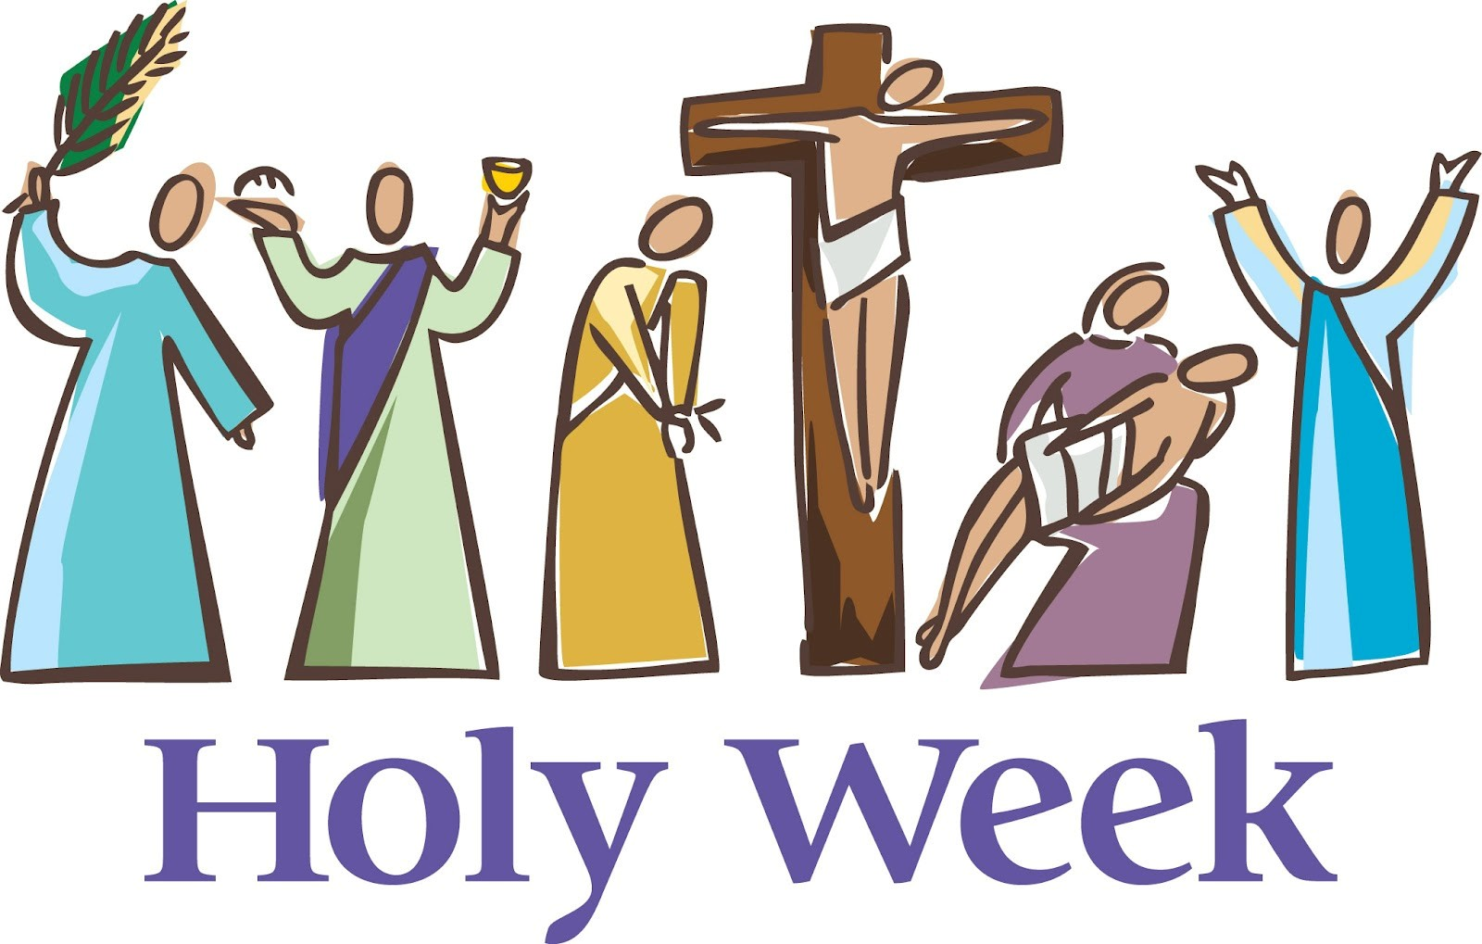
‘Why can’t Easter be a fixed day like Christmas!’. It’s an exasperated cry that we hear in St Olav’s several times every year. The last-minute rush to buy ash for the Ash Wednesday service, because of the sudden realisation that there isn’t time to burn the palm crosses from last year. This week it has been the need for palm crosses for this Sunday, after a stock take in the vestry revealed there weren’t enough left over from last year, and next week no doubt we will have priests and churchwardens rushing to buy their Paschal Candle and/or the transfer to go on it ready for the Greatest Day, Easter Day. It is also a question that I know many teachers and head teachers ask – the moving of Easter from its earliest possible date, 22nd March, to its last possible date, 24th April, makes for very confusing term lengths and also, especially for Church Schools, difficulties in how to teach the Easter Story, and when to celebrate what.
Now I have to be honest, having Christmas on the same day every year doesn’t stop people forgetting to buy their Advent Candles, or missing the deadline for posting out Christmas cards, so I’m not sure fixing Easter would solve the problem of ash, palm crosses, and paschal candles, although it would help teachers, hospitality and retail.
The reason for the date moving is all to do with the Spring Equinox, the new moon, and nowadays a slightly tenuous link to the Jewish Passover. I won’t try and go into the ins and outs of how it is calculated because I don’t really understand it, but for me, with apologies to everyone who wants a set date, I am glad it moves around, because it stops Easter becoming more like Christmas to the wider world. Easter, although (almost) everyone gets Easter Monday off, is still predominantly a Christian Festival. Yes, you can buy Easter cards with bunnies and chicks and eggs on with no reference to Jesus, and Easter Eggs, for the most part, have no Christian message, but it isn’t a full-blown secular event, in the way that sadly Christmas has become. We don’t buy Easter cards to send to everyone we know as we do at Christmas. We don’t see Easter parties advertised in all the pubs and clubs, and whilst we might buy Easter Eggs for the children, or our nearest and dearest, we don’t give them in the same way we do Christmas presents.
There is another reason why I am glad the date of Easter moves, and that is because it stops us getting complacent about it. We need to keep an eye on the calendar to remind us when to mark the beginning of Lent. Clergy need to be, hopefully, on the ball in getting our palm crosses and paschal candles at the right time. In having to keep reminding ourselves when the events of Lent and Holy Week happen, we are also hopefully reminding ourselves again and again why we celebrate, and most importantly, what we are celebrating. For many people Christmas just happens, and although in church we celebrate the birth of Jesus, for a lot of people it is just a day, or week, off. I don’t want that to happen to Easter. It is too important to just become another day off, another chance to eat and drink too much, another pressure cooker of spending too much money.
Before writing this Ramble, I welcomed West Dean school into St Andrew’s for a Palm Sunday on Friday service, and after I have finished, I will be joining Singleton School as they ‘recap’ on all they have learnt about Lent and Easter. For both schools I had palm crosses to give to all the pupils and adults as a reminder not just of this Sunday, but also of the fact that Jesus died for us, and rose again from the dead to give us the promise of eternal life. That message, that hope, that promise, is too important to get lost in commercialism. Too important to get swallowed up in the busyness of life. Too important to be just a date in the calendar.
There won’t be a Ramble next Friday, Good Friday, and so I would like to take this opportunity to wish you all a Blessed Easter, full of the joy and hope of the Resurrected Christ.

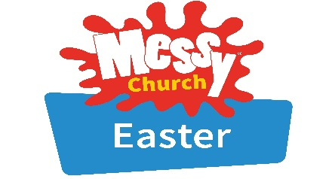
Rev Sarah
Worship in the Valley Parish
29th March

Palm Sunday
Holy Communion
10am
East Dean
Palm Sunday Messy Church
29th March
3pm - 5pm
East Dean Village Hall

Rev Sarah Manouch
07468 854864 priestvalleyparish@gmail.com
Please note that I am part-time. My principal working days are Friday and Saturday as well as Sunday. I am not available on a Thursday.

