Storage
Storage
Entrance
Toilets
Kitchen

Location of Hall

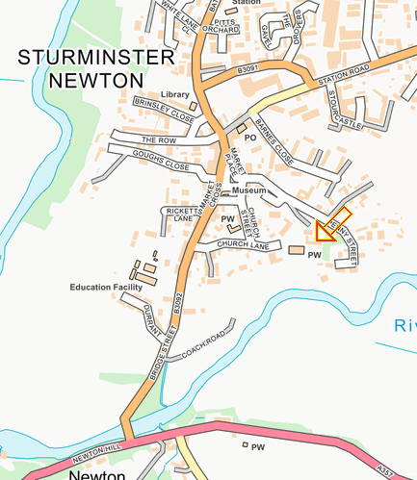

St Mary’s Church Hall
Church Street
Sturminster Newton
Dorset
DT10 1DB

HALL FOR HIRE
St Mary’s Church Hall
2026
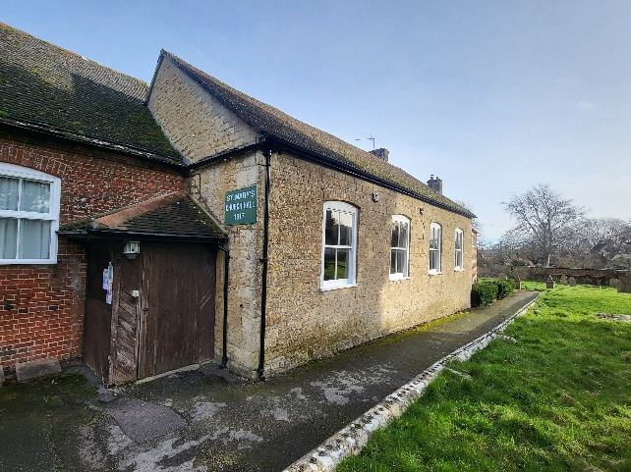

St. Mary’s Church Hall is available for hire. It has a fully equipped kitchen and seating facilities for up to 60 people.

Beside St Mary's Church in Sturminster Newton is its Grade II listed Church Hall. Originally a school built in 1817. This Historic building is a pleasant, multi-purpose hall of a very useful size, available for hire as well as for church use. It is close to the town centre where accommodation is available.
In addition to church groups and meetings of all sorts, it is regularly hired out for children's parties, other private functions such as baptisms, wedding and funeral refreshments, and to other organisations for meetings and for training purposes. There are local companies that can provide catering services, please ask for details.
It can accommodate 60 people seated for a special lunch or dinner and has tables and chairs for that number.
Anyone interested in finding out more about hiring the hall, please contact:
Sue at stmaryshallbook@btinternet.com
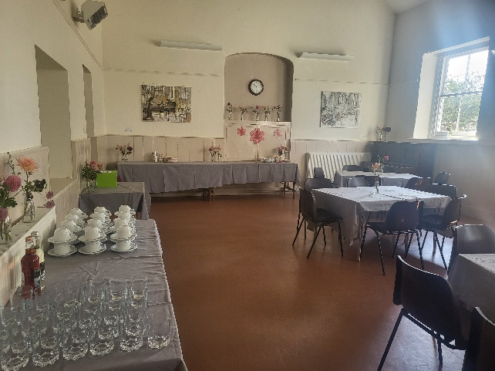
The hall is modern, clean, light and airy with a floor space of 17m x 33m with electric heating if required.
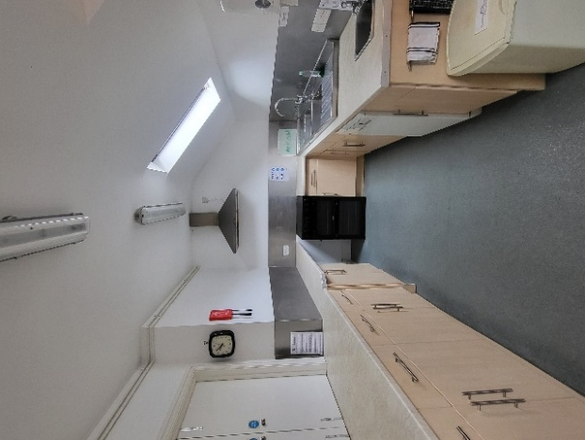
The kitchen is well equipped with a 4-ring electric cooker, microwave, fridge and dishwasher, crockery, cutlery and glasses.
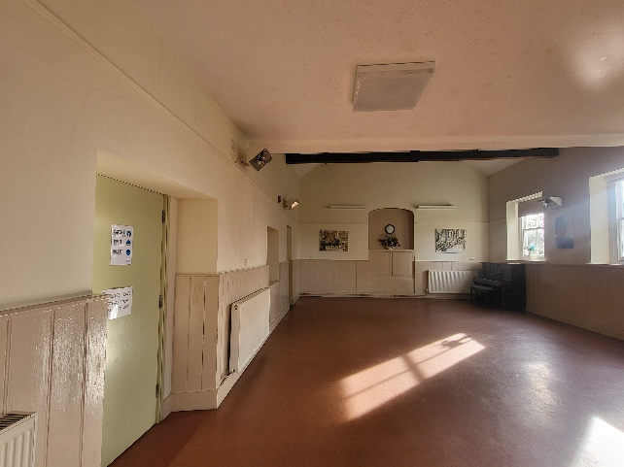

Charges

Per session: £85.00
(morning, afternoon or evening)
Per hour: £30.00
Charges include the use of the kitchen facilities

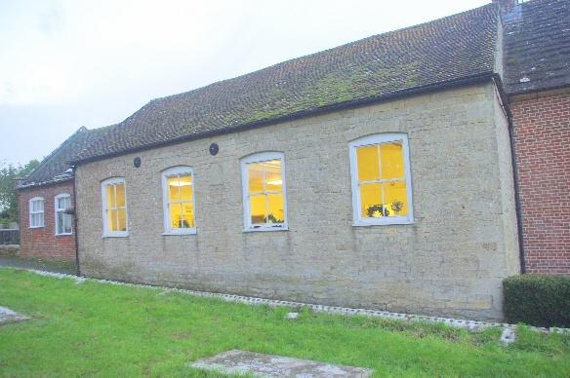

St Marys Hall Leaflet v1 Feb 2026

