Your Wedding

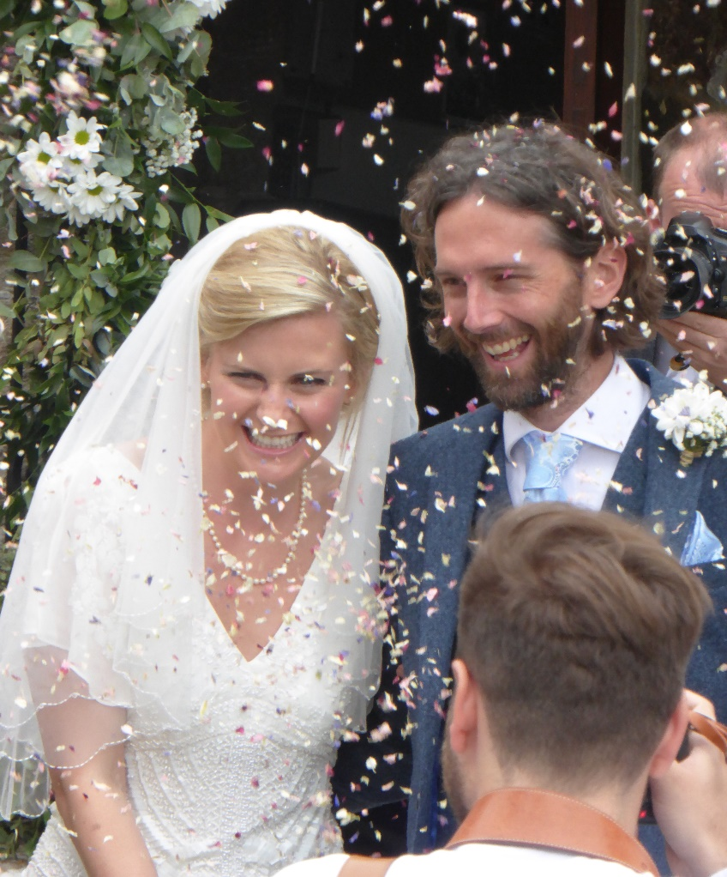
in
the Church of
St Nicholas, Studland

Contacts:
Team Rector: Rev’d Dr Ian Bird 07733 213535
Email:- revianbird@gmail.com

Associate Minister: Rev’d Dr Tony Edmonds 07837 009147
Email: revtonyedmonds@outlook.com

Church Warden: Mrs Barbara Matthews tel. 01929 450218
Email: - barmat18@btinternet.com

The Parish Office tel. 01929 421117
Email:- swanage.team@btconnect.com

Contents

Can we be married in St Nicholas Church Studland if we do not live in Studland?

What will it cost?

Legal aspects of marriage

Wedding Preparation

Who will conduct our wedding?

What music can we have at our wedding?

Who do we contact?

How big is the church? How many guests can the church accommodate?

The Service:

What & how many hymns can we choose?

What readings should we have?

Flowers, who do we contact? What can we do?

Parking and access for people with special needs

Taking Photographs and Video

Can we have wedding bells?

Confetti & Mobile phones

Can we be married in St Nicholas Church Studland if we do not live in Studland?

If you live in the Parish of Swanage you can, by
“The Bishops instrument” be married in the Parish of Studland

If you live outside the Parishes of Swanage and Studland

You can marry in a Church of England church if you can show: -
That one of you:
- has at any time lived in the parish for a period of at least 6 months or
- was baptized in the parish concerned or
- was prepared for confirmation in the parish or
- has at any time regularly gone to normal church services in the parish church for a period of at least 6 months or
That one of your parents, at any time after you were born:
- has lived in the parish for a period of at least 6 months or
- has regularly gone to normal church services in the parish church for a period of at least 6 months or
That one of your parents or grandparents:
- was married in the parish
If you move to a new house, you’re immediately connected to the church there. That means you can marry in the church of your new parish.
In all cases involving church services - i.e. going to normal church services, baptism, confirmation or marriage - this applies only to Church of England services.

How much will it cost?
See Current Fees list separately available

Video/Copyright fee £60.00

A deposit of £100 is required when the wedding is booked.
Balance of fees if paid by cheque/BACS must be paid not less than twenty-eight days prior to the wedding.
Please make cheques out to: PCC of Studland.
The BACS details are:
Account name: PCC of Studland
Sort Code: 55-61-19
Account no. 69056935
Please use one or both surnames as the reference – thanks!

You will no doubt, appreciate that the upkeep of a beautiful and ancient church is considerable. If you feel you would like to make a larger donation gift aided, it would be received with gratitude.

Legal aspects of marriage
In marriage you take on a whole new legal status as man and wife and this can have many benefits. To ensure the marriage complies with both UK Civil and Church law, there are certain aspects of a church wedding that must be fulfilled.
Reading of Banns
Banns are an announcement in church of your intention to marry and a chance for anyone to put forward a reason why the marriage may not lawfully take place. Banns must be read in the parish church where each of you lives as well as the parish church in which you are to be married, if that is somewhere else. We can help you identify your parish church if you don’t live in Studland. You must have your banns read out in church for three Sundays during the three months before the wedding. This is often done over three consecutive Sundays.

If there is not enough notice given for the Banns to be read before the marriage is due to take place, or in the case of the marriage of people whose nationality is not British, or if one or both of you do not live in England, you will need to use the License Procedure rather than Banns. This is especially recommended if there is any doubt as to the legal requirements of the home country of a non-British person for recognition of an English Church marriage. We can advise you on all of this.
You must be old enough
In England and Wales you need to be 18 years old to marry.
Time of wedding
It is a legal requirement that weddings in the Church of England take place between 8am and 6pm
Licenses
There are some circumstances in which you may need a Common Licence or Archbishops Special Licence to marry in church. Your Vicar will let you know if these apply to you.

"Is marriage preparation compulsory for a church wedding?"

It is part of the Vicar's job to ensure that you receive some basic preparation before your wedding day. It is recommended you attend but not compulsory. You will never make such important promises to each other as you will in church on your wedding day. A church wedding uniquely offers time and space to think through the vows you will make and the difference they will make for you both as individual as a couple and to society.

Who will conduct our wedding?
In order that your marriage is legal, your service must be conducted by a Licensed Minister or a Minister with permission to officiate. If you wish someone to conduct your service, you should ask the Rector or Associate Minister when booking your service.

What music can we have at our wedding? Who do we contact?

St Nicholas Church has a resident organist, Angus Murray-Brown. Angus is always happy to discuss music with you prior to your wedding. If you attend a Sunday morning service you can speak to Angus after the service or you can telephone him, his telephone phone number is 07425 902075. Angus will also arrange for the Choir if you would like them to sing at your wedding. You will also have an opportunity to discuss wedding music at the Wedding Preparation Day

How big is the church? How many guests can the church accommodate?

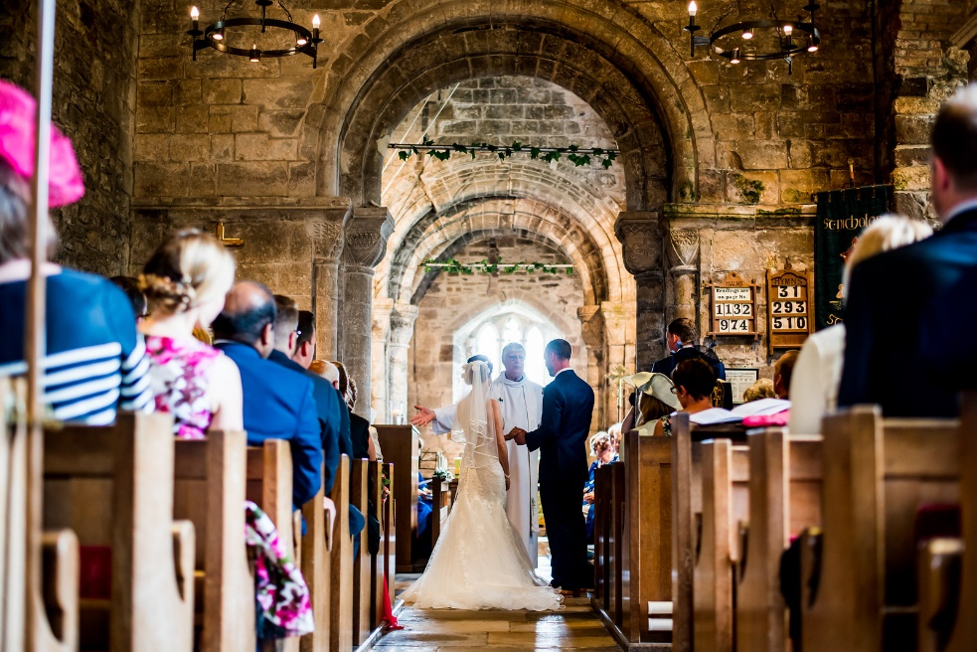
The Norman Church will hold a maximum to 120 (please note we cannot exceed this figure and if exceeded reserve the right to refuse entry) if the Gallery is used. The Choir stalls are not available for guests. There are ramps available to assist wheelchair access if this is necessary for the main body of the Church.

The Service: What & how many hymns can we choose?

A suggested Service Outline

Entrance of Bride (usually to music)

The Welcome

First Hymn

The Preface & Declarations

Reading(s)

The Address

(Second Hymn)

The Marriage:
Vows, exchange of rings & proclamation

Prayers

Third Hymn

Blessing

Signing the Register

Departure of Bride & Groom (usually to music)

We want the service to be special to you both, so discussing the service details with your Minister is crucial. Having friends and relations involved in the service is fine. The Number of hymns you have is your choice. It is a requirement that the Liturgy of The Church of England is used, but there is a lot of flexibility possible to make it a personal service for you both.

What readings should we have?

It is a requirement that there is at least one reading from The Bible. Your Minister will be happy to guide you if you are not sure what you would like to choose for your wedding. Other readings, may be included such as poems too.

Flowers: Whom do we contact? What can we do?

We hope your wedding day will be special for you. Flowers may be an important part of your day Please contact our Church Flower coordinator Wendy Hammersley (01929 421023 – wendyhammersley@aol.com) who will be happy to assist you in any enquiries. For your wedding you will need to appoint your own Florist (or family member) and they should contact the Church flower coordinator at least 4 weeks before the wedding to arrange access to the church. You must ensure that flowers are left in the North Door, behind the Altar and on the shelf under the St Nicholas Banner. Any other flowers you should remove within 3 days of the wedding.

During Lent and Advent we do not have flowers in the church. If your wedding is during Lent or Advent we are happy for you to have the flowers you would like for your wedding, but they should be removed immediately after the wedding.
Your arranger must leave the Church and Hall, if used, in a tidy condition after arranging and after removing the flowers. There is a hire charge for the Church Hall.

Parking and access for people with special needs

Parking at St Nicholas’ is generally not a problem. We are on good terms with our neighbours The National Trust who own the yard next to the Church, however there is no guarantee this will be available. It should also be remembered this is a working yard at weekends as well as weekdays and access for large agricultural vehicles is required at all times. You could contact Steve or Julie Smith at the farm as they have a charged parking facility or use the National Trust car park. There are parking restrictions in force from March to September in Studland, please make sure you have parked legally as the restrictions are rigorously enforced.

Toilets

The Church hall adjacent to the church has toilets but there is limited disabled access.

Taking Photographs and Video

Photographers should be unobtrusive and are asked to refrain from using flash or artificial lighting during the service. If video is used there is a copyright fee charged. There is also a fee if streaming is used for showing at a later date.

Can we have wedding bells?

St Nicholas’ has a peel of four bells and a bell ringer can be requested. There is a fee payable to the bell ringer

Confetti

We welcome the use of confetti which is biodegradable but would request that it is thrown outside the church.

Mobile phones

Please ensure that Mobile phones and pagers are switched off or in
silent mode whilst in the church.

Other Useful Resources

Lots of useful information on the Church of England weddings website: www.yourchurchwedding.org

Much useful information can be found in the Swanage and Studland Team Wedding Resources Booklet.

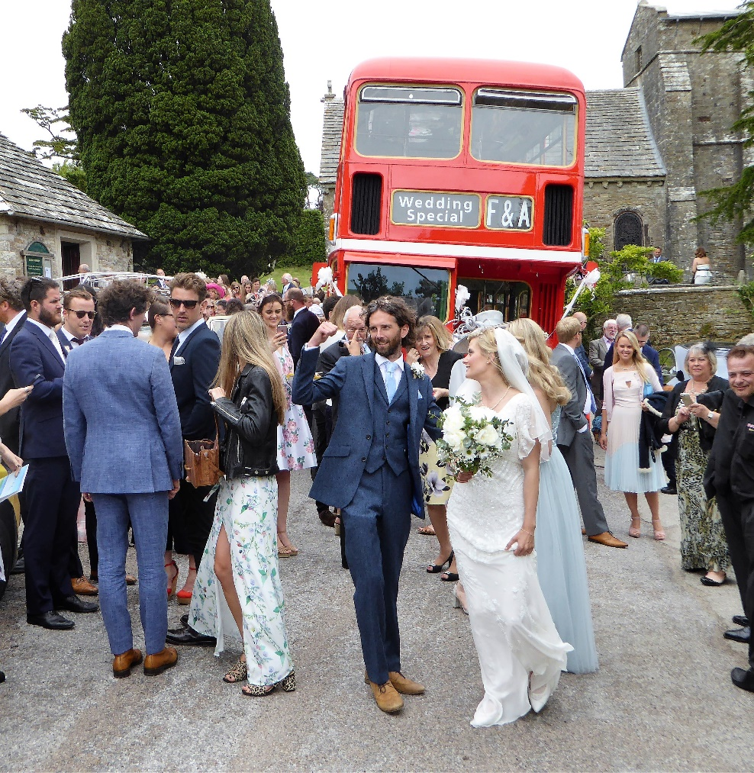

We hope you will have a blessed and happy day

Rev 1/26

