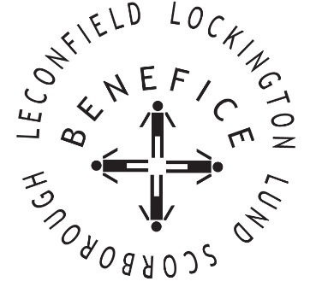

Church Services for
April 2026
Wherever you are from, you are welcome to join us for any of these services

March 30th/ 31st & April 1st
7:00pm Compline Night Prayer St Mary’s Lockington

Thursday 2nd 7:00pm Maundy Thursday St Mary’s Lockington

Friday 3rd 11:00am Stations of the Cross St Mary’s Lockington 2:00pm Good Friday Service All Saints Lund

Sunday 5th 6:30am Easter Sunrise Service St Catherine’s Leconfield

10:00 am Easter Benefice
Communion St Leonard’s Scorborough

Sunday 12th 9.30am Holy Communion All Saints Lund

Wednesday 15th 9:30am Mid Week Service
With healing prayers St Catherine’s Leconfield

Sunday 19th 9:30am Holy Communion St Mary’s Lockington

Thursday 23rd 7:00pm Celtic Communion Catherine’s Leconfield

Sunday 26th 9:30am Holy Communion All Saints Lund

11:00am Contemporary Worship St Mary’s Lockington

Service times, events and Messenger can also be found at:
http://www.achurchnearyou.com for the four churches

