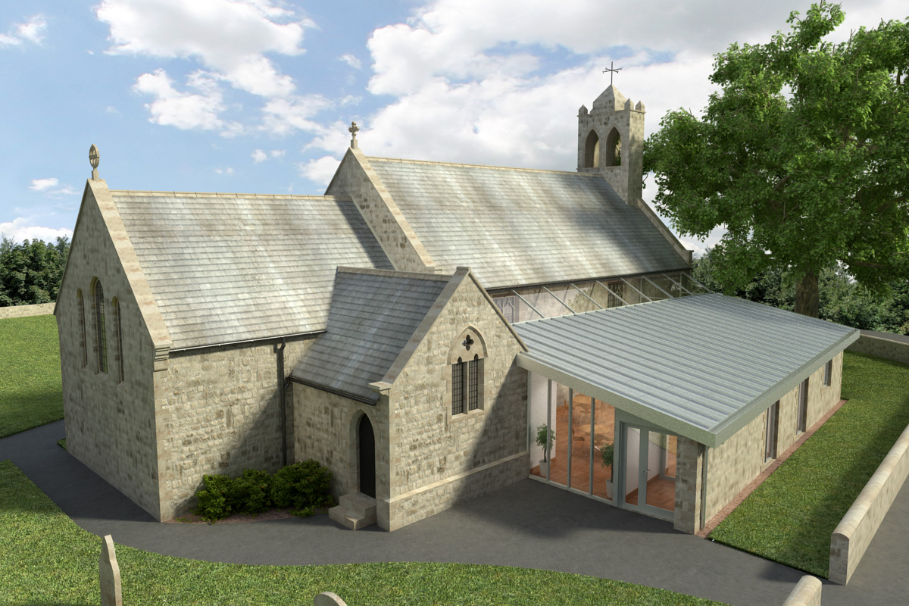
St Mary’s Parish Church, Longframlington

Welcome to our Sunday Morning Prayer. On Sunday 29 March, which is Palm Sunday, when our Officiant will be The Right Rev Bishop Mark, Bishop of Berwick, Rev Rich his Deacon and Veronica on the music. Next week, Easter Sunday our Officiant will be Rev Rich and Steve playing the organ. Mary Hipwell will be licensed as an Authorised Lay Minister during the service today.
Coming up at St Mary’s and our sister parishes+- Morning Prayer in St Mary’s – and on Zoom – usually every Wednesday morning at 9.30 am followed by coffee in the Community Room. The Link can be made using Meeting ID889 6133 2870, Password 093043. New people always welcome either on screen or in church. There will be no service next Wednesday in Holy Week.
Confirmation – There will be a Confirmation on the 10th May and anyone interested please contact Rev Rich, email at foot of page.
Easter Services:
Maundy Thursday, 7 pm, Washing of the feet, St Michael, Felton, Good Friday Walk of Witness through village, 10.30 am meet at URC, coffee and hot cross buns following the walk. 3 pm Service of Reflection, St Mary, Easter Sunday 9.15 am Holy Communion St Mary.
URC Coffee morning – Monday 4 May, 10-12pm St Mary’s – all welcome.
Electoral Roll – The Electoral Roll will be open for new entries from 26 March until 11 April. If you would like your name to be added (which entitles you to attend the Annual Parochial Church Meeting and to take part in the proceedings) application forms available from Cath or at the back of the church.
URC Clearance Items – Please get in touch with Aileen on norskwood.aileen@gmail.com or Pat, telephone 01665 570 820. Various items include tables, chairs, bookshelves, electronic piano/organ, large White board, hymn books varied, crockery, cutlery, wine glasses, water jugs, trays, small snooker table with balls, children’s craft materials, toys and books. Purchase by donation to church funds. Includes: Church, Hall, Vestry and Kitchen.
Thank you for your giving to the life and work of our church. Our offering is taken during the third hymn, and there is a collection giving point at the back of the church for use after the service if you prefer. Regular giving by Standing Order with Gift Aid is particularly valuable to the church – speak to Audrey (01665 570 922) for more information and blank forms. All our news and much more available on our Facebook page https:www.facebook.com/SMCLongfram/?ti=as and You Tubechannelhttps:www.youtube.com/@stmichaelsfeltonstmaryslonPriest in Charge: Rev Rich Townend Phone 01670 719470 Email:revrichtea@gmail.com Regular day off is Monday, for St Mary’s information contact Veronica Thomson (01665 570 807) or Audrey Truman (01665 570922).

