LONDON 2026 PILGRIMAGE ROUTE

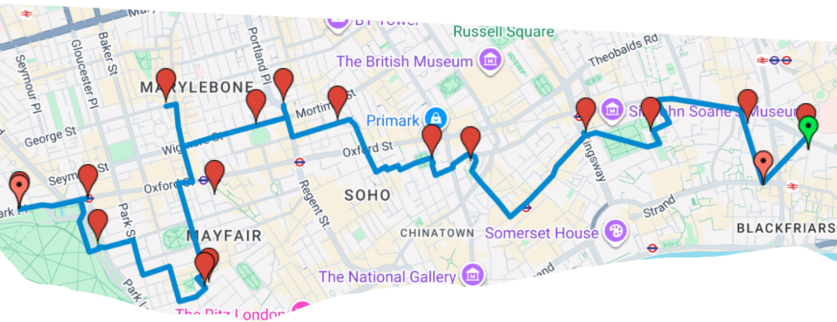

Tyburn Convent Tyburn Tree 350m
Tyburn Tree Animals in War Memorial 350m
Animals in War Memorial Bowl Inn 900m
Bowl Inn Church of Immaculate Conception 25m
Church of Immaculate Conception Tyburn @ Gray’s Mews 600m
Tyburn @ Gray’s Mews St. James, Spanish Place 670m
St. James, Spanish Place Epstein Madonna and Child 700m
Epstein Madonna and Child All Souls, Langham Place 250m
All Souls, Langham Place All Saints, Margaret Street 450m
All Saints, Margaret Street St Patricks RC Church 700m
St Patricks RC Church St. Giles in the Fields Church 300m
St. Giles in the Fields Church St. Cecilia and St. Anselm 950m
St. Cecilia and St. Anselm Lincoln’s Inn 500m
Lincoln’s Inn St Andrew Holborn 800m
St Andrew Holborn St Brides Church 320m
St. Brides Church St. Sepulchre’s Church 350m

FELLOWSHIP MEAL @ YE OLDE WATLING, 29 Watling Street, EC4M 9BR 700m

