Framilode Riverside Retreats
St Peter’s Church, Framilode GL2 7LJ
Allowing Ourselves Space for God
Monthly Quiet Days
Dates for 2026
All Wednesday’s 10.00 am – 3.00pm
4th March Gill Pennington
1st April Rev’d Felicity Walker
6th May Rev’d Judy Howard
3rd June Rev’d David VonBerg
1st July Rev’d Anne Spargo
5th August Rev’d Mandy Briggs
2nd September tbc
7th October tbc
4th November Bishop Bob Evens
2nd December tbc

10.00 a.m. – 3.00 p.m.

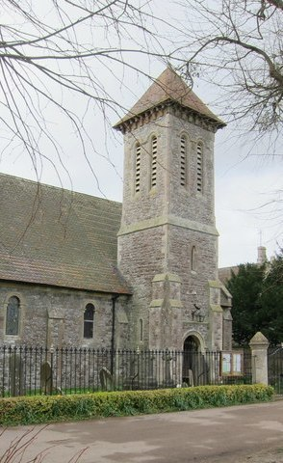

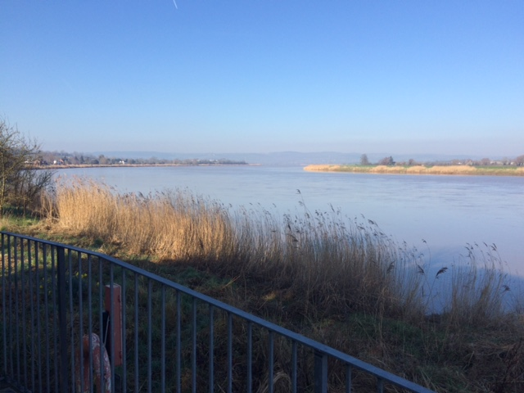
Cost of the Day
£20 to include all refreshments and lunch.
Booking
Please e-mail
framiloderiversideretreats@gmail.com

Or phone 07432256742


