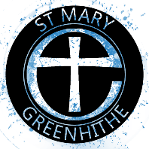
The Church of St Mary
Greenhithe

Church marriage with calling of Banns

Statutory:
Calling of Banns £ 39.00
Church Service £566.00 £605.00
Church Fees:
Church costs Nil
Verger £ 30.00 £ 30.00

Basic Total: £635.00

Optional:
Organist/Musician £ 75.00
Singers (Each) £ 20.00
Flowers* POA
Heating** £ 15.00
Vision £ 20
Sound £ 20

*Flowers. If you would like the church to provide church flowers the minimum contribution is £75. This may increase if you have specific colour/bloom choices.
** Heating. Most weddings take place when it is warm. If you
think that you may require heating, £15 would help to cover the costs.

NB: If either the bride or groom lives outside the parish of Swanscombe, then Banns will have to be called in their own
parish, and a fee payable to the appropriate incumbent.

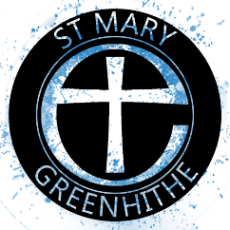
The Church of St Mary
Greenhithe

The marriage of:

Groom

Bride

Date Time

Contact number and email

Basic Cost of Marriage: £635.00

Options: (please indicate)

Organist/Musician £ 75……………………
Singers £ 20 each
Flowers £ POA……………………
Sound £ 20
Vision £ 20……………………
Heating £ 15…………………
Other

Total Cost £

A £150 deposit is payable in advance (non-refundable).
This is deducted from the overall cost, which is payable
no later than 21 days before the date of the wedding.

Please return this form to the Priest-in-Charge
January 2026

