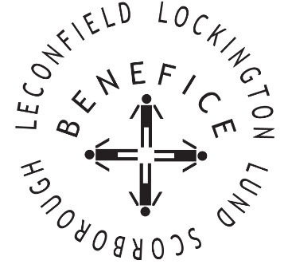

Church Services for
March 2026
Wherever you are from, you are welcome to join us for any of these services

Sunday 1st 9:30am Holy Communion St Leonard’s Scorborough

11:00am Morning Worship St Mary’s Lockington

Wednesday 4th . 9:30am Mid Week Service
With healing prayers St Mary’s Lockington

Sunday 8th 9:30am Holy Communion St Catherine’s Leconfield

11:00am Morning Worship All Saint’s Lund

Sunday 15th 9:30am Holy Communion St Mary’s Lockington
Mothering Sunday

Wednesday 18th 9:30am Mid Week Service
With healing prayers St Catherine’s Leconfield

Thursday 19th 7:00pm Celtic Prayers St Catherine’s Leconfield

Sunday 22nd 9:30am Holy Communion All Saints Lund

11:00am Contemporary Worship St Mary’s Lockington

Sunday 29th 10:00am Palm Sunday Benefice Holy Communion St Catherine’s Leconfield

Monday 30th
Tuesday 31st 7:00pm Compline (Night Prayer) St Mary’s Lockington

Service times, events and Messenger can also be found at:
http://www.achurchnearyou.com for the four churches

