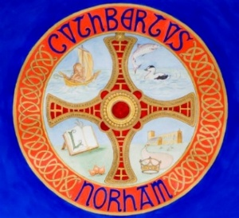 | The St Cuthbert’s Project  Bulletin No. 10  February 2026

The St Cuthbert’s Project aims to improve the heating, lighting, seating and heritage interpretation at Norham Church, to make the church building more user-friendly and more useful to the wider community.

The total budget for the first phase of the project is £369,000, which is a huge sum of money. But, on Christmas Day, the Vicar announced the good news that we have now received a conditional offer of £245,000 from The National Lottery Heritage Fund (subject to contract and final conditions). That’s nearly a quarter of a million pounds, for the benefit of Norham Church and the wider community. It’s an amazing achievement, and an important milestone, which gives us confidence to proceed with the remaining approvals and fundraising.

We now have about 73% of the necessary funding in the pipeline. The offers of grants received to date are not just about the money – they are also an investment in, and thus a vote of confidence in, what Norham Church is trying to achieve in our local community. And the funding is not an end in itself, but a new beginning, because the St Cuthbert's Project comprises two aspects:

- Improving the facilities at the church (heating, lighting, seating, etc).
- Putting those facilities to good use (events and activities, heritage interpretation, etc).

Both aspects are inextricably linked, because there's no point improving the facilities if they're not put to good use, and the current usefulness of Norham Church is constrained by the existing facilities.

The first aspect is a quantitative, easily measurable change that might take about six months. The second aspect is a qualitative, less tangible change that is planned for the next two years. Both aspects should have a lasting legacy, in terms of the life of the church (which is more than what happens on a Sunday morning) and the wider community (of which the church is an integral part).

- Churchwarden, Lucy Carroll, 07974 416692
- Churchwarden, Nick Ellis, (01289) 382754
- The Vicar, the Revd Rob Kelsey, (01289) 382325

