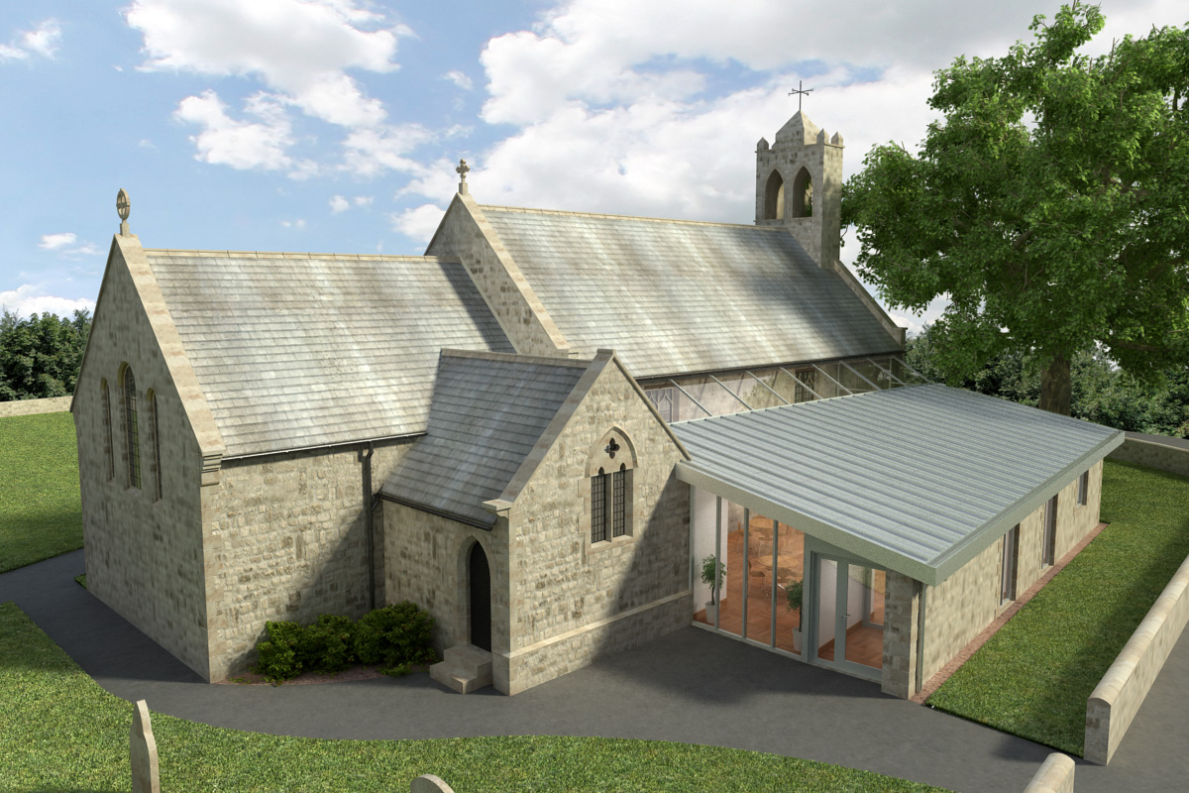
St Mary’s Parish Church, Longframlington

Welcome to our Sunday Morning Prayer. On Sunday 15th February, which is Sunday next before Lent (Proper 3), the church will be closed and our members will be attending the final service at the URC Church at the north end of the village at 10.30 am. This will be followed by a light lunch, finger buffet style, and we are asked to take something with us to share. We look forward to welcoming our URC friends to St Mary’s on Sunday 22nd February. Trevor Thorne has said there will be parking available at the Hall for those who wish to take up parking there. Next week our Officiant will be Rev Michael and Gisele on the music. There will be no Zoom on Wednesday.
Ash Wednesday – coming up on Wednesday 18th February the service and Imposition of Ashes will be held at 9.30 am in St Mary’s, all welcome. The Officiant will be Rev Michael.
Coming up at St Mary’s and our sister parishes+- Morning Prayer in St Mary’s – and on Zoom – usually every Wednesday morning at 9.30 am followed by coffee in the Community Room. The Link can be made using Meeting ID889 6133 2870, Password 093043.
ALPHA – The ALPHA Mini Course begins 25 February in St Mary’s for 5 weeks during Lent, 11am until 12 noon. This will be a series of videos and general discussion.
Future-Confirmation – there will be a service in May anyone interested should contact Rev Rich for further details.
The Bereavement Journey – A course to be run in April/May at Acklington Village Hall and looking for helpers (and participants from the local churches (6 or 7 sessions) (depending on whether people attend the final faith session) and the charity who leads it will be announced. It is hoped to run the course twice a year with our support. There is a fuller explanation on a leaflet which Rev Rich has but he would like to know if anyone would be interested. This is organised by Warkworth parish churches.
Audrey is still looking for names of people who have a Children’s Society box as we would like to update our records.
Thank you for your giving to the life and work of our church. Our offering is taken during the third hymn, and there is a collection giving point at the back of the church for use after the service if you prefer. Regular giving by Standing Order with Gift Aid is particularly valuable to the church – speak to Audrey (01665 570 922) for more information and blank forms. All our news and much more available on our Facebook page https:www.facebook.com/SMCLongfram/?ti=as and You Tube channelhttps:www.youtube.com/@stmichaelsfeltonstmaryslonPriest in Charge: Rev Rich Townend Phone 01670 719470 Email:revrichtea@gmail.com Regular day off is Monday, for St Mary’s information contact Veronica Thomson (01665 570 807) or Audrey Truman
( 01665 570922).

