The Rector's Ramblings
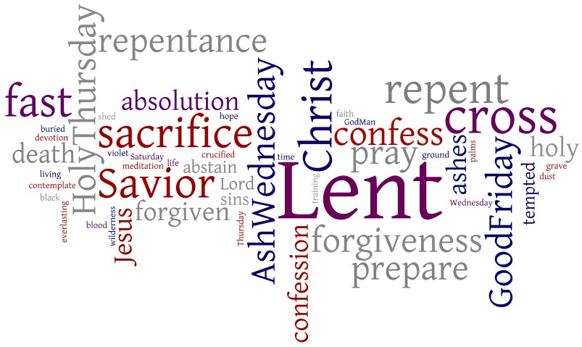

It's been a funny year so far at the Rectory, to put it mildly, and it seems that it was only yesterday that we were celebrating the joy of Christmas, and now here we are about to start the season of Lent. Although in recent years there has been a move away from 'what are you giving up for Lent' to a more proactive and productive 'What are you taking on for Lent', it is still a time that most of us think of as a time of sacrifice. Whether it is declaring we will give up our favourite food, be it chocolate, cheese, or pizza, or whether we decide to deny ourselves our favourite TV show, that is the traditional Lenten idea that most of us grew up with.
But Lent is more than a chance to see how long we can hold out from grabbing that sneaky chunk of cheese, or waiting till everyone is out before catching up on the TV drama we have missed. Lent invites us into forty days of reflection, repentance, and spiritual renewal as we prepare for Easter. It echoes the forty days Jesus Christ spent in the wilderness—praying, fasting, and facing temptation. While most of us are not being tempted by the devil on a mountaintop, it's amazing how we may find ourselves staring at the last biscuit in the tin with surprising intensity.
Traditionally within the church Lent is marked by us prayer, fasting, and almsgiving. In theory, this sounds beautifully simple. In practice, it means discovering just how often we reach for the chocolate, the cheese, or the remote control. Last week in church we reflected on Jesus calling us The light of the World, and Lent has a way of shining a gentle (and occasionally glaring) light on our habits, good and bad.
But as we approach Lent, we need to remember that it isn't a divine diet plan. It’s not about proving our willpower or winning a spiritual endurance contest. Lent is about making room—clearing space in our busy, noisy lives so we can hear God more clearly.
When we give something up, it’s not to become holier-than-thou (or holier-than-chocolate). It’s to remind ourselves that our deepest hunger is for God. And sometimes, in the absence of our usual comforts, we rediscover the simple joy of prayer, the quiet strength of scripture, or the blessing of serving someone else.
Of course, there will be moments when we slip. The cheese may mysteriously vanish. We may know more about what happened in our favourite show than we should, and that's okay. Lent is also a season of grace. Each day is a fresh invitation to begin again.
There’s something wonderfully human about this journey. We try. We falter. We laugh at ourselves. And through it all, God patiently shapes our hearts.
So as we walk these forty days together, let’s embrace Lent with sincerity—but also with a smile. Let’s fast thoughtfully, pray earnestly, give generously, and perhaps hold our chocolate a little more loosely.
After all, Easter joy shines brightest when we’ve journeyed through the wilderness together—and maybe learned a thing or two about ourselves along the way.
Rev Sarah
Worship in the Valley Parish
15th February
Sunday next before Lent
Holy Communion
10am
West Dean
Rev Sarah Manouch
07468 854864 priestvalleyparish@gmail.com
Please note that I am part-time. My principal working days are Friday and Saturday as well as Sunday. I am not available on a Thursday.

