The Ruby Country Benefice.
Holywell Joint Council
Black Torrington with Highampton, Clawton and Halwill,
Safeguarding Officers Report April 2026
Throughout the churches of the Benefice we recognise that the few who are determined to harm children or adults deliberately seek out groups or organisations where they can meet children or other vulnerable people. The Church is particularly vulnerable to these people. Creating and maintaining a safeguarding culture will discourage them from becoming involved for the wrong reasons and make it difficult for them to harm or abuse children or adults if they do.
In order to assist with the creation of a safeguarding culture, Holywell and Ashwater, Beaworthy and Tetcott within the Benefice has or will be-
- Appointed a Parish safeguarding Officer – Mrs R V Letheren for Holywell.
- Adopted the latest version of the diocesan safeguarding Policy. APCMs 2026
- Adopted safer recruitment procedures (see Appendix 1) which include an application form for volunteers, a DBS check for those working with children or vulnerable adults, and completion of a confidential disclosure.
- Displayed safeguarding information in each church including contact details – this also appears on a regular page in the monthly Bulletin.
- Created an environment which is welcoming and respectful and enables safeguarding concerns to be raised and responded to openly, promptly, consistently and confidentially.
- Clear procedures in place for responding to safeguarding allegations –(see Appendix 2)
- Regularly review and report progress on safeguarding in the parish by including safeguarding as a standing agenda item on each PCC/Joint Council agenda, completing the safeguarding checklist of Benefices and Parishes (Appendix 3) and the PSO reports to the APCM annually.
DBS checks. All Members of the Joint Council are DBS checked. If any one new takes on the role at the 2026 APCM’s they will be checked as a matter of urgency.
Training A log has been kept of who has attended safeguarding training- Basic Awareness and Foundation are both now on line and needed by all members of the Joint Council. Holywell Joint council use the Dashboard system and the safeguarding Officer, Mrs Val Letheren will keep it up to date. Holywell joint council renewed their training this past year, Just one member is required to update their training this coming year.
Policy and checklist. The Holywell Joint Council will sign the safeguarding policy 2026 at the APCM along with the raising concern document. All other policies will be reviewed at the first meeting after the APCM
The Diocesan have also informed the safeguarding Officer of issues to look out for.
Apendix 1.
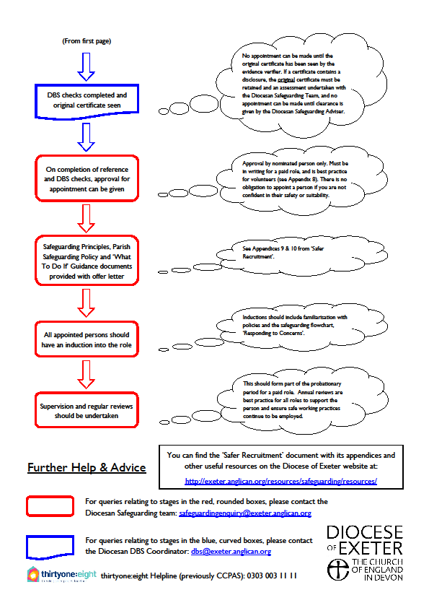

Appendix 2.

Appendix 3
Check list and Action Plan
The Joint Council must adopt and promote a safeguarding policy, and approve an action plan to implement it.
Requirement | Question | Action
Safeguarding Policy Approval  The Joint Council must approve a parish safeguarding policy statement which complies with Church of England requirements. | Which safeguarding policy statement has the Joint Council approved?  The Joint Council approve the Church of England safeguarding Policy  When did they approve it? It is approve each year at APCMs | This will be done at APCMs, for Joint Council
Safeguarding Policy Promotion  Promoting a Safer Church must be published and promoted, and all Church Officers must have access to it. | Do all Church Officers have access to Promoting a Safer Church?  Yes Each church has been give a copy 2022  Is Promoting a Safer Church published and promoted?  It should be displayed on a notice board somewhere within the church. | Each Church to check they are still displaying the poster given to them back in 2022  New posters can be ordered from the church of England website if needed.
Safeguarding Action Plan  The Joint Council must approve a parish action plan and review it regularly. | When did the Joint Council last approve or review this safeguarding action plan? The safeguarding Officer is updating the Information onto the Parish Dashboard and will Email the Joint Council the action Plan ASAP after the APCM, ready for the next Joint Council meeting | Each Member to read the action plan once sent before the next meeting after the APCM

Safeguarding Procedures
The Joint Council must approve procedures which explain how national guidance will be implemented within their local context.
Requirement | Question | Action
Responding to Concerns or Allegations  The Joint Council must approve a procedure to deal promptly with any safeguarding concern or allegation (including any suspicion of abuse). This procedure is to be reviewed annually. | When did the Joint Council last approve or review their procedure for dealing with safeguarding allegations or concerns?  Each year The responding to concerns is re agreed along with signing then Safeguarding Policy. | This will be done at the APCM.

Safeguarding Roles
The Joint Council must appoint people to key safeguarding roles.
Parish Safeguarding Representative  The Joint Council must safely recruit a lay person, not related to the incumbent, to the role of Parish Safeguarding Representative. The appointment is to be made in accordance with national 'safer recruitment' guidance. | When was the current Parish Safeguarding Representative appointed? Val Letheren was appointed in October 2020  Have all the 'safer recruitment' steps been completed? Yes | Each Church with in the Joint Council to agree that they are still happy for Val Letheren to be Safeguarding Office
Churchwardens  The churchwardens must be made aware of their safeguarding responsibilities. | Are the churchwardens aware of their safeguarding responsibilities?  All Churches were given a copy of the Safeguarding Booklet in 2022, which should be available for all to read. | To Inform the safeguarding offer that Church Wardens have seen and read the Booklet.
DBS Verifier  The Joint Council must appoint at least one DBS Verifier who is responsible for the administration of DBS applications. This role may be carried out by the Parish Safeguarding Representative, but can be a separate role. | Has at least one DBS Verifier been appointed?  Yes. Val Letheren was appointed as DBS Verifier in October 2022. She covers all 6 Churches with the Benefice | All Members of the Joint Council have up to date DBS.

Training for Key Roles
Everyone who plays a key safeguarding role must complete the relevant training.
Parish Safeguarding Representative  The Parish Safeguarding Representative must complete Basic Awareness, Foundation, Leadership and Safer Recruitment training. | Has the PSR completed:  - Basic Awareness training?  - Foundation training?  - Leadership training?  - Safer Recruitment training?  - Domestic Abuse Training?  All Training is logged on the Parish Dash Board | All Training was updated in 2025
Churchwardens  All churchwardens must complete Basic Awareness, Foundation and Domestic Abuse Training | Have churchwardens completed:  - Basic Awareness training?  - Foundation training?  - Domestic Abuse training? | All Churchwardens are up to date 2025
DBS Verifier  Every DBS Verifier must complete Safer Recruitment training. | Has every DBS Verifier completed Safer Recruitment training? | Safer Recruitment training  Updated 2025
Joint Council Members  All Joint Council members must complete training. | Have all Joint Council members completed Basic Awareness training?  Foundation Training?  Domestic Abuse Training? | All Joint Council Members have completed Basic Awareness  One member still has FT and DA to do

Displayed Information
Church buildings and websites must display important safeguarding information.
Safeguarding Policy Notice  Each church building must display a notice about its safeguarding policy. | Is each church building displaying a notice about its safeguarding policy?  Yes / No | Each church will replace last years with a copy of this year after their APCM
Safeguarding Who’s Who  Each church building must display contact details for people who have safeguarding roles. | Is each church building displaying contact details for people who have safeguarding roles?  Yes / No  (The Diocese of Exeter Safeguarding Team has produced a template Parish Contact poster for sharing Safeguarding contact details in church buildings.) | Each church had new details added to the list.  The Bulletin has been updated.
Safeguarding Poster  Each church building must display a Promoting a Safer Church poster. | Is each church building displaying a 'Promoting a Safer Church' poster?  Yes / No
Parish Website  Safeguarding arrangements must be clearly visible on the front page of your parish website. | Are safeguarding arrangements clearly visible on the front page of your parish website (or your ‘A Church Near You’ page)?  Yes / No | Using “A Church Near You” updated March 2023

Reviews and Reports
Safeguarding must be regularly reviewed and reported upon.
Joint Council Agendas  Safeguarding must be a standing agenda item at every Joint Council meeting. | Is 'Safeguarding' a standing agenda item at every Joint Council meeting?  Yes / No | As of the 2026 APCM this is on every Joint Council Meeting agenda
Reports to the Joint Council  The Parish Safeguarding Representative must give regular reports to the Joint Council regarding safeguarding in the parish. | When did the Joint Council last receive a report from the Parish Safeguarding Representative? | This is now a standard item on the agenda and a report/update is given at every meeting  .
Reports to the APCM  At the Annual Parochial Church Meeting, the Joint Council must report on safeguarding in the parish. | When did the APCM last receive a safeguarding report? Report was received at APCM 2025 | A report will be give at Joint Council APCMs 2026.  Each church will receive the report by email

