February 2026


News from the Diocese of Hereford and the 17 parishes around Ditton Priors, Stottesdon and Highley

Table of Contents

Contents 2
Editorial 3
Wheatland Diary 4
Brown Clee Benefice 5
February Reflection 5
Brown Clee Benefice News 6
Brown Clee Benefice Forthcoming Events 7
Brown Clee C.E. Primary School 12
Brown Clee Surgery P.P.G 12
Brown Clee Young Farmers Club 12
Brown Clee Benefice Readings & Services 13
Ditton Priors News& Forthcoming Events 7-9
Ditton Priors Ladies’ Fellowship Group 11
Wheathill & Loughton News 9
Aston Botterell News 9
Cleobury North & Burwarton News 10
Cleobury North Village Hall 13
Neenton News 10
Chetton News 10-11
Chetton Village Hall Events 14-15
Cllr George Hollyhead News & Views 17
Burwarton & District Gardening Club 18
Daddy’s Hat Concerts 14
Candlemas 17
The Year of the Horse 2026 16
Heavy Horses Article 15
Stottesdon & District Benefice News 20
Stottesdon Heritage Website 20
Stottesdon & District W.I. 21
Stottesdon, St Mary’s Font 22
Cleeton St Mary News 21
Farlow News 22
Sidbury News 23
Middleton Scriven News 23
Middleton Scriven Services & Events 23
The Severn Valley Group of Parishes 24
Chelmarsh News 24
Billingsley News 25
Glazeley News 26
Green Page New Year Quiz 27
Obituary Canon Rose Lawley 28
Bereavement Education Article 29
New Year Quiz Answers 30
Wheatland News-What you need to know 31-32
Wheatland News Subscription Information 33
Useful Contact List 34

Editorial

Welcome to the first edition of Wheatland News with our new team.

This edition features all the usual news and views from our parishes as well as some interesting articles and even a tricky quiz to test that our ‘little grey cells’ are functioning well.

In recognition of the Chinese New Year, we feature an article on the Chinese zodiac, which follows a 12-year cycle, with each year governed by a different animal.

On the 17th of February we welcome the Year of the Horse & note that the horse is considered a lucky creature in Chinese culture, admired for its strength, spirit & sociable nature. Many believe that the Year of the Horse brings opportunities for progress, exploration & positive change so let’s all keep our fingers crossed for 2026!

For the horse lovers amongst us, we will also be featuring a series of articles on the role of horses in our village lives. If you have any stories about horses in your life, we would love to include them in future editions so please do get in touch. See page 33 for how to send in your local news

Do look at the many events listed in the Wheatland Diary & mark them in your own diaries as many are very popular & get booked up early. We are so lucky to have ‘flicks in the sticks’ in our area so please support this if you can.

Although a very sad topic for all & especially children, I was interested to read about the Government’s decision to include bereavement education in our national curriculum, especially as this initiative was prompted by a petition by John Adams here in Bridgnorth, see page 29.
The wonderful obituary to Canon Rose Lawley – see page 28 also got me to thinking that we often don’t appreciate the people around us until we read their obituaries & discover little known facts about them. I’d be especially keen to hear about any local heroes/heroines or just downright interesting people that we could feature in future editions so that we can fully appreciate them whilst they’re still alive! Please do get in touch via your local coordinators. See page 33

It would also be great to feature as many local clubs and societies as possible in future editions of Wheatland News & we’d be particularly interested to hear about your plans & successes along with your photographs.

As I write this page, I can see some early daffodils in the garden and hope that we’ve seen the last of the recent snow, rain & storms

Keep warm and enjoy the early Spring bulbs in our green spaces, gardens & on your windowsills.

Ed

WHEATLAND DIARY
SUBSCRIPTIONS DUE FOR YOUR 2026 WHEATLAND NEWS!!!
75% of previous subscribers have already paid for 2026.
If you’re reading this & have not yet paid please can you do so asap (See page 32)
Wed | 4 | Feb | DP Ladies Friendship – “My Life as an Author” – 7:30 pm, the Pavilion – see page 11
Sat | 7 | Feb | Coffee morning, St John’s Church, Ditton Priors, 10:00 – 12:00. All welcome – see page 8
Wed | 11 | Feb | Chetton & Glazeley WI – 7:00 for 7.30 pm Chetton Village Hall - Genealogy
Thu | 12 | Feb | Burwarton Gardening Club ‘Secret Life of the Soil’ Stoke St Milborough VH 2.30pm-see page 18
Sat | 14 | Feb | Coffee Morning/Soup & Roll (New) Middleton Scriven - see page 23
Sun | 15 | Feb | Flicks in the Sticks – Chetton VH – “Downton Abbey – the Finale” – 12:30 pm – see page 14
Sat | 17 | Feb | Breakfast at The Down Inn. 9am. - see page 26 Glazeley
Wed | 18 | Feb | Stottesdon & District W.I. Creative Writing. Chorley VH – see page 21
Thu | 19 | Feb | Brown Clee LENT course starts
Sat | 21 | Feb | Brown Clee Vision Afternoon. Ditton Priors Pavillion 2-4pm
Wed | 4 | Mar | DP Ladies Friendship – Favourite Recipe – share and taste-7:30 pm, the Pavilion – see page 11
Thu | 5 | Mar | Ditton Priors Lent Lunch, 12:30 pm, DP Village Hall – see page 8
Sat | 7 | Mar | Coffee morning, St John’s Church, Ditton Priors, 10:00 – 12:00. All welcome – see page 8
Wed | 11 | Mar | Chetton & Glazeley WI – 7:00 for 7.30 pm Chetton Village Hall – Midlands Air Ambulance
Wed | 18 | Mar | Stottesdon & District W.I. Indian Spices Farlow VH – see page 21
Sat | 21 | Mar | Quiz Night. Middleton Scriven – see page 23
Sat | 21 | Mar | Daddy’s Hat Concert. Billingsley. 3pm - see page 14
Mon | 23 | Mar | Brown Clee Young Farmers. Quiz & Curry Ditton Priors Village Hall. 7.30pm - see page 12
Sat | 28 | Mar | Ditton Priors Easter Coffee Morning – the Pavilion, 10:30 am – see page 11
Wed | 1 | Apr | DP Ladies Friendship - Intro to Tai Chi – 7:30 pm, the Pavilion – see page 11
Sat | 4 | Apr | Coffee morning, St John’s Church, Ditton Priors, 10:00 – 12:00. All welcome – see page 8
Wed | 15 | Apr | Stottesdon & District W.I. Mystery Tasting. Chorley VH – see page 21
Sat | 18 | Apr | Daddy’s Hat Concert. St Mary Magdalene Church Bridgnorth. 3pm - see page 14
Sat | 16 | May | DP Church Fete – see page 8
Wed | 20 | May | Stottesdon & District W.I. A.I. Chorley VH – see page 21
Wed | 3 | June | DP Ladies Friendship – Garden visit – 2:00 pm, Ruthall Manor – see page 11
Wed | 17 | June | Stottesdon & District W.I. Intro to Homeopathy. Farlow VH – see page 21
Sat | 20 | June | Neenton Duck Race & Village Fete – see page 10
Wed | 1 | July | DP Ladies Friendship – Treasure Hunt – 7:30 pm, the Pavilion – see page 11
Wed | 15 | July | Stottesdon & District W.I. History of Severn Valley Railway. Chorley VH – see page 21

Reflection for the month of February by Revd Joe Simons

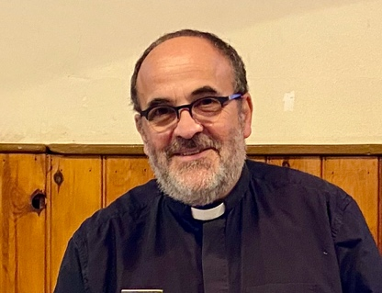
It seems that we are bombarded with bad news, news that seems to question what humanity has become and how we bring back some stability, compassion, and love to a fractured world.

Even in the midst of all that seeks to derail us I would urge you to give yourself fully to the adventure of 2026.

Walk boldly along the path of Life. I say this because in that we can find life, real life. For me and all Christians we have every reason to be confident, because in Jesus and his Holy Spirit we are accompanied all the days of our life and on into eternity.

There are so many fears and worries that seek to derail us from living life in its fullness. But in our faith we face problems as they arise, not anticipating them. In the letter to the Hebrews the author writes:

‘Look to Jesus, the author and perfecter of our faith, who for the joy set before him endured the cross and has taken his seat at the right hand of the throne of God….so that you may not grow weary or lose heart.’

In fixing our eyes on Jesus, the author and perfecter of our faith, many difficulties we anticipate will vanish or become less important before we reach them. I do not know what 2026 will hold for you and for your loved ones but whenever you start to feel afraid know that God is with you and holding you by your right hand. And in that famous letter from Paul (one of the earliest disciples of Jesus) to the early church in Rome, nothing can separate us from his presence and his love for us.

Have a happy and peaceful 2026.

Brown Clee Benefice News

The season of Advent is always a busy time, and this year was no exception. With services and social events held throughout December. We were delighted to host Brown Clee School for their Christmas service, it was lovely to welcome them to worship in church, with such wonderful singing and prayers.

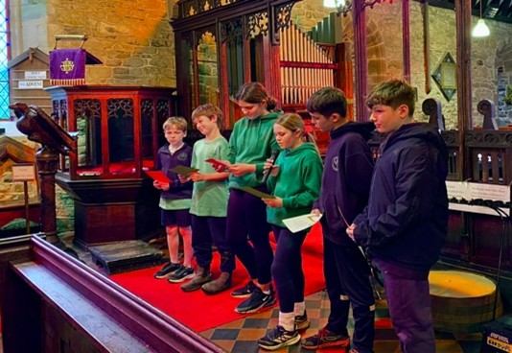
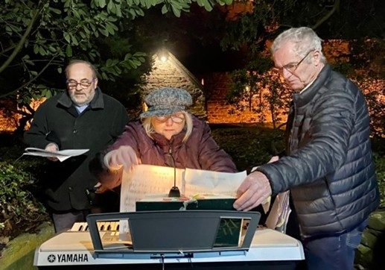
The Impact of Participation
As always, the enthusiasm, passion, and joy displayed by our participants were truly infectious. Their spirited involvement uplifted everyone present, creating a warm and welcoming atmosphere throughout our Advent and Christmas events. The energy they brought to each gathering inspired both newcomers and long-term members alike, making every service and celebration even more memorable. Their joy set the tone for a season filled with togetherness and festive cheer, reminding us of all of the special role that community plays in our worship and celebrations.
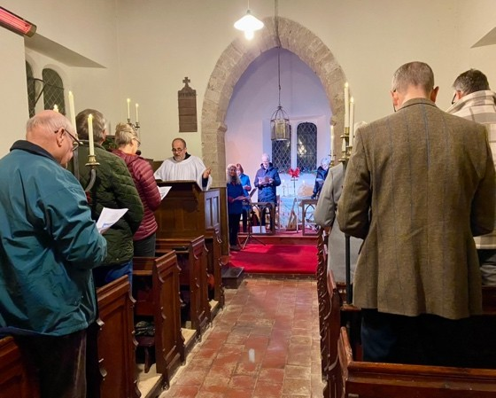
Now a regular event in our benefice, we hosted carols with Brown Clee Young Farmers. It was great to spend time in worship and prayer but also to exercise our vocal cords singing carols in the street. The mulled wine and mince pies were a fitting addition and once again made for a memorable evening. Every year we are getting better and better at the ‘Twelve days of Christmas.’

Carol services took place across all our churches, from our first at the small Loughton Chapel of Ease to the last at Wheathill, we were treated to some wonderful hospitality at each of the churches across our Benefice.
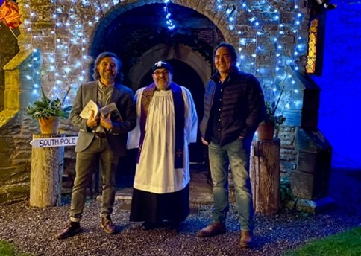
A huge thank you to our choir, and their leader Ragni, for the varied repertoire and staying power. We had a choir at all the services across our seven churches! We should also thank all of those who read so beautifully about the Christian story leading up to the birth of Christ. It was a time of reflection, joy and bonhomie. We had our Christingle and Crib Services at St John the Baptist, Ditton Priors once again this year, a huge thank you to Marjorie and Carole. The transition from sweets to fruit for the Christingle’s was without incident, with the children eating healthily and remembering Jesus at the same time! Christmas would not be complete without our Christmas Festival service at Aston Botterell. Once again, we had a fantastic turn out, and as promised Father Christmas made a surprise appearance!! The light show and decorations were brilliant setting the scene on a wonderful evening. A huge thank you to Anne, Tim, Ben and all the Aston Botterell team for such a lovely event. After a really well attended Midnight Mass at Ditton Priors, we celebrated Christmas Day at Chetton with a church full of happy families and the Chetton Clangers ringing us in. Across all of our churches so much effort went into getting them decorated to look their best and we know this doesn’t just happen without a lot of hard work, so thanks to all of you. Finally, a huge thank you to all who came, young and old, it would be great to see you again and do please get in touch with Revd Joe or Emma if you would like a chat.

Brown Clee Benefice – Forthcoming Events



We are holding our Lent Courses this year weekly on a Thursday evening at The Pavilion, Ditton Priors. These will start on Thursday 19th February and if you are interested in joining us then please let us know at Church Services or at The Vicarage – 01746 599217 browncleebenefice@outlook.com Thank you.
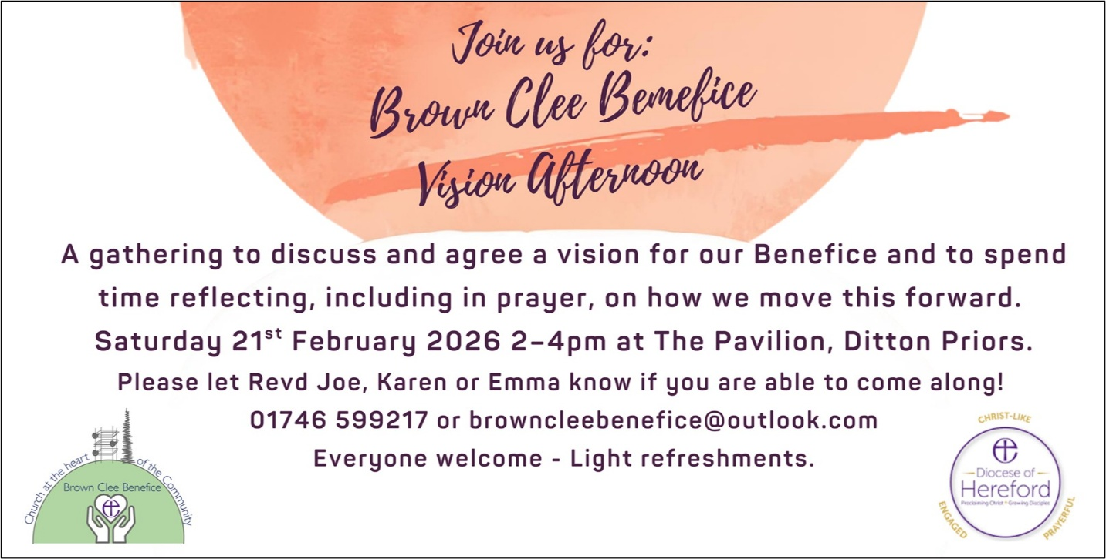

Marjorie Jones writes:
Ditton Priors News

Marjorie Jones writes:
Here’s wishing a Happy New Year to everyone. Whilst we give thanks for our past year and all the joy that Christmas brought us, we look forward to new days and new opportunities to serve our Lord and to serve one another. We ask God’s Blessings on all that we do and all that we plan, both in our collective Worship and in our homes.
Attendance was good at all our Christmas Services and it was good to see so many joining in the spirit of the season. It’s seemed like a slow start to 2026, due to nasty bugs spreading and the snowstorms, but things are now looking up.

PARISH GIVING
A very big ‘Thank You’ to all who make contributions to Church Funds on a regular basis, either by Standing Order, the Envelope Scheme or the Collection Plates. These funds are vital to pay for Insurance, Electricity, Churchyard maintenance, Repairs etc. and are much appreciated. We also have great generosity shown with all our Fundraising Events. We know that giving comes in many forms - Church cleaning, tidying the Churchyard, providing Refreshments, together with many ‘unseen’ jobs, and perhaps most importantly Good Neighbourliness - looking out for one another in the community. Hopefully we are all able to continue playing our part in the coming days and months.
FIRST SATURDAY COFFEE MORNINGS
From 10am – 12 noon in Church, 7th February 7th March and 4th April. There is no charge for this popular community event, and everyone is welcome.I would like to give grateful thanks to the ladies who organize this event. They happily offer their time and their refreshments month by month, managing the lack of facilities cheerfully. The Donations offered on these Saturdays last year were over £400! A very useful addition to Church Funds, helping us in turn with the hospitality we offer.
RESIDENTIAL HOMES
A group of us went to sing Carols at the homes before Christmas. We were joined by Ragni on guitar and some of the Group Choir members. The residents joined in the singing, and it was most enjoyable. We shall be taking a Service again on 16th February.
Church Services in February
- 9.30am Sunday 1st February - Holy Communion.
- 9.30am Sunday 8th February – Holy Communion.
- 9.30am Sunday 15th February – Holy Communion.
ASH WEDNESDAY On Wednesday 18th February the season of Lent begins.
There will be a 10am Service of Communion with Ashing.
- 9.30am Sunday 22nd February – Holy Communion.
- 10.00am Wednesday 25th February – Morning Prayer.
- 9.30am Sunday 1st March – Holy Communion.
LENT LUNCH
Thursday 5th March, 12.30pm at Ditton Priors Village Hall.

Homemade Soups will be served with Bread Rolls, followed by Cheese and Crackers. There is no charge for this meal, but donations for a Charity will be welcomed.

Please let me know if you are coming, for catering purposes. (01746 712 423)

EASTER COFFEE MORNING

Saturday 28th March, 10.30am at the Pavilion

Easter Egg Hunt in Church and Easter Bonnet Competition.

FUTURE EVENTS

Church Fete - Saturday 16th May.

Cleaning rota for February

• Sunday 1st February. Mr and Mrs John Ballard

• Sunday 8th February. Mr and Mrs Tony Brown

• Sunday 15th February. Mrs Jutta Langham and Mr Steve Allen

• Sunday 22nd February. Mrs Carole Hancox and Mrs Maureen Lloyd

• Sunday 1st March. Mr and Mrs Graham Russell

St John the Baptist 100 Club results for December 2025 and January 2026
December 2025
• £100. Dennis Griffiths
• £20. Revd Jenny Rowland
• £10. Sally Green
• £5 each to Neil Colebatch, Frances Andrews, Annie Bamford
January 2026
• £20. Adrian Massey
• £10. Rev’d Joe Simons
• £5 each to Mark Childs, Lynda Clarke, Gwen Evans

WHEATHILL AND LOUGHTON NEWS

We had two lovely Carol Services in December, supported by Ragni and the Group Choir members.
Next Services:
2.30pm Sunday 15th February. Evening Prayer at Wheathill Church
2.30pm Sunday 22nd March. Evening Prayer at Loughton Chapel

Aston Botterell News

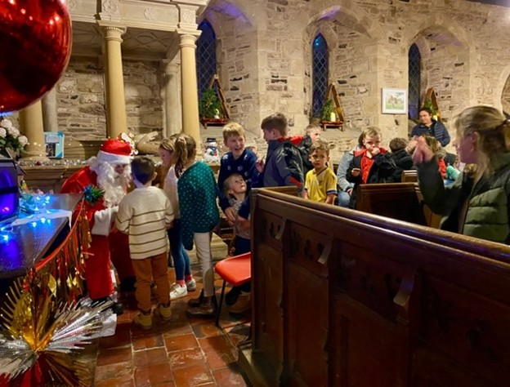
Anne Preece writes: Our Carol Concert was well attended and enjoyed, featuring The Cleobury Mortimer Brass Band, the choir, Father Christmas, plus refreshments and conversation. Thanks to everyone for the prizes, refreshments, and help with chairs. Special appreciation to those who decorated outside the church, organized parking, and to Revd Joe for leading the service. It was a wonderful start to Christmas—thank you all and Team Aston.

Church Services in February

We are holding a Coffee and Prayer morning at Middle House Farm, Aston Botterell in the warm, on Sunday February 1st.
- 11.30am Sunday 1st March – Holy Communion
Church lottery
If anyone would like to purchase a ticket, please contact me:
£12 for the year. It all helps to keep our beautiful church in good repair, thank you.

If you would like to be involved in the church cleaning or flowers for instance, once a year, we are looking for volunteers to help please.

Events to follow in the next issue.

Results for December 2025 and January 2026
December 2025  • £20 - Maggie Lloyd – No. 105  • £20 - David Wright – No. 55  • £10 - Walter Steele – No. 77  • £10 - Andy Roe – No. 252  • £10 - Reg & Christine Steele - No .120  • £10 - Des Preece – No. 149 | January 2026  • £20.00 - Angela Upton - No. 249  • £10.00 - Jaquie Derricutt - No. 28  • £5.00 - James Brassington - No. 219  • £5.00 - Janet E Preece – No. 153

Cleobury North and Burwarton News

Jane Bufton writes:

Best wishes to you all for a good year. The initial works of repair on our church have been completed, and the roof is now wind and watertight. Before we can re-open, we need to check other parts of the ceiling are secure, and once this is done, we can remove the sheeting and fully reopen. Many thanks to all those people who have helped with fundraising and organizing the church repair project - in particular to Penny and David for the fundraising coffee morning in December, which raised £354 and to Lord Boyne for his donation and also for Cleobury North Village Stores who have carried a donation tin for Church Repairs.

Church Services in February

11.30am Sunday 22nd February - Holy Communion.
Church lottery

Results for December 2025
• £100.00 Archie Hamilton-Russell
• £30.00 Dot Cartwright
• £20.00 Karen Evans

Thanks to all who support our lottery as this is the main income to run our lovely little church

Cleaning and Flowers – February – Jane
Neenton News
Dot Cartwright writes:
Hopefully, by now, the weather has improved a bit, as I write this, we have a foot of snow in the garden. The carol services are probably a distant memory, but all the services went well, and I’m sure they were enjoyed by everyone that attended.
A date to remember for everyone is June 20th when we will be holding our annual Duck Race and Village Fete.
Church Services in February
11.30am Sunday 15th February - Holy Communion.

At Neenton, we’re still finding our feet after the sad death of Bobbie Jarvis, and so we are re-vamping our church tote. We will now only draw 4 times a year, but with larger prizes. The amount to enter is £12, if anyone would like to join our tote, please contact Dot Cartwright on 07854 559474. Thank you.

We hope you are all enjoying the start of 2026.
Chetton News
Shelia Millington writes:
I hope you have all had a happy and peaceful New Year. It was a delight to see over 80 at our Christmas morning service, along with at least a dozen children, some just toddlers.
We sadly had to cancel our first January service due to the snow and ice, but coffee and a chat was enjoyed at Church House instead.
The snow brought down more branches from one of our Cedar trees, fortunately no damage was done in the Churchyard. We held another Church breakfast at The Down Inn in January. The February breakfast will be organized by Marion from Glazeley Church next month.
Church Services in February
11.30am Sunday 8th February - Holy Communion.

Flowers and Cleaning - Sheila.
St Giles’s Hundred Club
Results for January 2026
• £15.00 Nick Tofiluk no 58.
• £10.00 June Preece no 84.
The Hundred Club subs are now due, please can you send these to Lisa, there are two prizes every month! We will be holding a PCC meeting soon to arrange our 2026 social calendar, if you have any ideas or wish to get involved, please contact Sheila or Lisa.

St Giles Church Bells
Charles Gill writes:
The Bicentenary of the Bells 1827 -2027 project at St Giles Church, Chetton is aiming at a restoration of the 6 bells in time for the 200th anniversary. The bells were last restored in 1938 and at that time the 4th bell was re-cast as had been made in 1827 but was no longer in good condition by the 1930’s. The bells were made by the firm Rudhall from Gloucester, and the same firm had made the famous ‘Liberty Bell’ that was installed in Philadelphia USA. We are hoping that this restoration will enable the Chetton Clangers to reach out to involve more people in ringing the bells in Chetton and across the wider Brown Clee Benefice.
Fortunately, the ringing chamber is close to the floor level of the church, and this makes us more accessible than many local towers. At present we are seeking support from external grant-making organizations to assist with the funding of this work that could cost up to £30,000.
It’s a big ask but it’s a big tower and we are keen that the 6 bells ring out a welcome peal for services for many years to come.
Funerals
Thursday 4th December – The Funeral Service of the late Mrs Hilda Marion Garratt at Telford Crematorium and St. John the Baptist, Ditton Priors.
Saturday 27th December – The Funeral Service and celebration of life of the late Mr Reginald ‘Reg’ May at St. John the Baptist, Ditton Priors.
Reg May - Margaret, Nick, Richard, Ettie and family wish to thank everyone for their kindness, messages, sympathy and cards on the loss of Reg. Thank you all.

 | Ditton Priors Ladies’ Friendship Group – Programme 2025 - 2026  Meetings begin at 7.30 unless otherwise stated, usually on the first Wednesday of the month at The Pavilion, Ditton Priors Playing Field.
4th February – ‘My life as an author - so far!’ by local author Rob McNeil. Raffle Night  4th March – Favourite recipe, sharing and tasting. Raffle Night  1st April – An introduction to Tai Chi with Jenny Joyner. Raffle Night |  | 6th May – To be arranged  3rd June – Visit to Linda Clarke’s Garden, Ruthall Manor, WV16 6TN. Meet at 2.00  1st July – Treasure Hunt, led by Margaret and Gill. Bring & Share supper & raffle
Membership for 2025-26 is £15 plus £2 per meeting to include refreshments and raffle when applicable. Visitors always welcome - £3 per evening. Outings to be paid for on booking, payment may be forfeited for late cancellations.
Group contacts: Gill Severn: 01746-712231 or Margaret Bill: 01746-712030

Brown Clee Benefice Readings for February 2026
Sunday 1st February  The Fourth Sunday of Epiphany – Septuagesima  Presentation of Christ in the Temple (Candlemas) | White | Psalm 24. (1-6)7-end; Malachi 3. 1-5; Hebrews 2. 14-end; Luke 2. 22-40
Sunday 8th February  The Second Sunday before Lent - Sexagesima | Green | Psalm 136 or 136. 1-9, 23-end; Genesis 1. 1-2.3; Romans 8. 18-25; Mathew 6. 25-end
Sunday 15th February  The Sunday next before Lent - Quinquagesima | Green | Psalm 2 or 99; Exodus 24. 12-end; 2 Peter 1. 16-end; Matthew 17. 1-9
Wednesday 18th February  Ash Wednesday | Purple  or Lent array | Psalm 51. 1-18; Joel 2. 1-2, 12-17; or Isaiah 58. 1-12; 2 Corinthians 5. 20b-6. 10; Matthew 6. 1-6, 16-21; or John 8. 1-11
Sunday 22nd February  The First Sunday of Lent | Purple  or Lent array | Psalm 32; Genesis 2. 15-17; 3. 1-7; Romans 5. 12-19; Matthew 4. 1-11
Wednesday 25th February  Ember Day | Purple  or Lent array | Psalm 51. 1-5, 17-18; Jonah 3; Luke 11. 29-32
Sunday 1st March  The Second Sunday in Lent | Purple  or Lent array | Psalm 121; Genesis 12. 1-4a; Romans 4. 1-5, 13-17; John 3. 1-17

Chetton Village Hall Diary for 2026


- Pam’s Pilates Monday 9.30-10-30 am (Mixed Ability)
Tuesday 9.30-10.30 am (Mixed Ability) and 11-11.45 (Older Adults)
Tuesday 12.15 – 1.00 pm Supported & Seated (New Class)
- Chetton Active Friends from 2pm on Monday
- Zumba with Lisa Beards, 2.30 pm Tuesday
- Indoor cricket for the disabled 5-6pm Tuesday.
- Ballroom and sequence dance instruction 7pm Tuesday.
- Billingsley Parish Council, first Wednesday of the month, January, March, May, July, September and November.
- Chetton and Glazeley WI, 7pm second Wednesday of the month.
- Chetton Parish Council, third Wednesday of the month, January, March, May, July, September and November.

All enquiries to Sue on 01746 789239.

Daddy’s Hat Concerts 2026

The Daddy’s Hat series of concerts starts on Saturday 21st March at Billingsley at 3pm

On Saturday 18th April, Daddy’s Hat will be hosted by St Mary Magdalene Church, Bridgnorth, also at 3pm

Concerts are usually just over an hour, with refreshments afterwards

The concerts are free of charge but if you would like to leave a donation in the hat it would be appreciated

The Heavy Horses by David Poyner
In recognition of the year of the horse, I have been researching the roles that horses formerly played in village life, above and below ground. A working horse conjures up images of majestic shire horses, often seen at a summer fair or the Morville Heath ploughing match. Indeed, for much of history, the farms in Highley relied on horsepower.
Horses were not always the main power on farms. In the Middle Ages, the ox was the draught animal of choice. Use of oxen in Highley continued one farm into the Victorian era, although by then it must have seemed outdated. On light soils, horses replaced oxen in the 17th Century, but on heavy coal measure clays in Highley and surrounding parishes the main changeover may have been in the 18th Century when improvements in breeding, often using animals imported from Low Countries, meant that sufficiently powerful animals were available.
Farm sales give little clues as to the exact nature of the heavy horses at work on Highley’s farms in the 18th and 19th Centuries. They are normally referred to as “draught” horses. Thus in 1813, four such horses were sold at the Heath Farm (now demolished, but very close to the railway by Coomby’s Farm), as well as a “four-year-old pony, a very good goer”. The horses were all “proved and good workers”. Later in the century we start to get some details about the animals. In 1859 there was a 4-year-old bay mare at Woodhill. In 1864 a sale at Greenhall farm included a brown cart gelding. It is not clear if these were the only horses on these two farms; Woodhill at this time was very small but a cart gelding would have struggled single-handed with the “several ploughs, harrows [and] scuffles” that were also part of the stock of the farm.
Towards the end of the 19th Century the formation of both national and local breeding societies meant some very fine animals were produced. Whilst these no doubt did help raise the standard of farm horse, the heavy horses on the village farm remained a very mixed bunch, some closer to the classic shire than others.
A survey of village farms in 1940 paints a picture of horse husbandry just before it was seriously challenged by the tractor. The 14 farms and small holdings in the survey kept 51 horses. Of these, 8 were not yet broken in, 5 were foals and 3 were ponies, meaning that on average each farm had about 3 working horses. Mares outnumbered geldings by over two to one. There were no stallions in the survey; the farmers who did breed their own horses presumably used the services of travelling stallions and I suspect many bought their animals from dealers.
On the large village farms, the head waggoner would be in overall charge of the horses; on the smaller farms the farmer himself probably had to do the work, perhaps with the help of family or a part-time assistant The horsemen worked long hours, preparing the animals before work, doing a day’s work in the field and then feeding and grooming at the end of the day. The term “farm labourer” hardly does justice to the skill required to work a team of horses, ploughing straight and even furrows on a heavy clay soil or springy turf.
By the 1940’s, the writing was on the wall for the heavy horses. Already several farms had tractors. Frank Breakwell has described to me his first encounter with a tractor. He was working with horses at Crumpsend Farm in Kinlet; the neighbouring farmer had just purchased a tractor and was trying it out. He drove it over to the fence and called out to Frank, “hear her tick over, my boy”. It was the sound of the future. The last farm in Highley to use horses was Coomby’s and by the 1960s it too had switched over to a tractor.
The Year of the Horse 2026, Zodiac and horoscope by Clive Jackson

Horse is the 7th animal in the 12-year cycle of the Chinese zodiac signs, coming after the Snake and before the Goat. Recent years of the Horse include 2014, 2002, 1990, 1978, 1966, 1954, and 1942, with the next Horse year in 2026 (Year of the Fire Horse) beginning on Feb 17th. It is associated with the earthly branch sign of wu. The Chinese zodiacs, like many aspects of traditional Chinese culture, are derived from the Chinese lunar calendar, which does not correspond exactly with the Gregorian calendar. The Chinese Five Elements Theory assigns one of the five elements—Metal, Water, Wood, Fire, and Earth—to each year, in addition to the zodiacs, so Horses born in different years will have different personalities.

According to Chinese astrology, Horse is confident, agreeable, and responsible, although they also tend to dislike being reined in by others. They’re fit and intelligent, adoring physical and mental exertion; they’re decisive but also easily swayed and impatient. In their zodiac year, Horses experience highs and lows in love, work, and health. Breakthroughs are possible through persistence, while balanced self-care and steady finances ensure long-term success. Horses are leaders who rarely accept defeat, so they can motivate themselves to put up an active fight in everything they do. This can come off as tenacity, endurance, stubbornness, or even foolhardiness in certain situations. They’re enthusiastic and candid, appearing as a hero to many when they decide to take up a good cause and battle on behalf of the underprivileged with passion. Once Horse matures and learns to harness this energy, they’ll be unstoppable since they’re agile and shrewd thinkers who innately understand human nature. They’re also principled, so their efforts will be put toward a good cause. Socially, Horse has an outgoing and agreeable personality. They speak as quickly as they think and act, and they aren’t shy about showing off their talents and capabilities because to be falsely self-effacing wouldn’t be authentic. They are widely liked for their natural sociability and openness, as well as their courage and passion, which, when coupled with their eloquence and moral uprightness, makes Horses exceptional leaders and social advocates. However, Horses can tend to give up halfway through when their quick passion runs out of steam. It’s not that they fear failure, but they can get bored easily. They can also be vain and self-glorifying, prone to seeking attention and applause. Because of this, they’ll often ignore others’ contributions to their team or family, brewing resentment in those closest to their capricious heart. In love, who else can better soothe the passionate Horse when they’re riled up than the gentle and mild Goat? A few well-chosen words and a knowing touch from their better half, and Horse will magically settle down. Horse’s luck is associated with 2 and 7, southeast, and the colours of red, pink, and purple. They should avoid black and blue colours, 1 and 6, north and northwest, and keeping any pet rodents (in my opinion that last comment applies to absolutely everyone!).
And if you think this is all made up, Clint Eastwood was born under the sign of the Metal Horse. If you don’t believe it…

Go Ahead and Make My Day!

Cllr George Hollyhead – Jan 2026

Firstly, I would like to wish everyone a Happy New Year and I hope you all had a restful and enjoyable festive period. As we step into 2026, I want to thank everyone who has taken the time to speak with me at local events, gatherings, and community activities since my election in May. I’ve had the pleasure of meeting so many residents, and I’m genuinely grateful for how welcoming, kind, and supportive you have all been. Those conversations help guide my work, and it’s been wonderful to feel so much community spirit wherever I go.

When I was elected, potholes and the general state of our roads were the biggest issues raised with me. This month I have been working hard with the newly appointed Local Area Highways Technician, and together we’ve already begun pushing forward on several longstanding problems across the ward. Please report any new issues through FixMyStreet, and then if nothing moves after a month, contact me directly or ask your Parish clerk to do so and I will follow it up.

I have also been working closely with St John the Baptist Church, Ditton Priors, to help secure permission for the much-needed toilet block. This addition would make a tremendous difference to visitors and worshippers alike, supporting attendance and helping ensure that this superb community asset continues to flourish. I hope you will all join me in supporting their application.

I look forward to meeting many more of you this year and continuing to work hard on your behalf. If you ever need help or have concerns, please don’t hesitate to get in touch.

Cllr. George Hollyhead
Brown Clee
george.hollyhead@shropshire.gov.uk
07484 541513

Cleobury North Village Hall
Sharon Jenkins writes:
On behalf of my colleagues on the Cleobury North Village Hall Committee, I would like to wish everyone a peaceful. prosperous and healthy new year.

January bookings include meetings, Shropshire Community Health Trust and the Brown Clee Football Club. In addition, I would like to welcome Chetton & Glazeley WI , who used our hall in January while Chetton’s Village Hall is being decorated.

As we move forward to 2026, the Village Hall is looking to put on some local craft events, to support local crafters and makers and will continue to fundraise to ensure that the village hall continues to thrive.
In addition, we are looking to arrange a special evening in honor of our late friend Bobbie, who loved everything about France – watch this space for updates!!

May I take this opportunity to thank all our regular and new customers whose bookings help keep this vital service for the local community.
I look forward to seeing where 2026 will take us.

Remember if you wish to book the hall, please contact Sharon on sharonjenkins1605@yahoo.com or 07854538645.
Burwarton and District Gardening Club
Bev Harris writes:
A sociable start to 2026

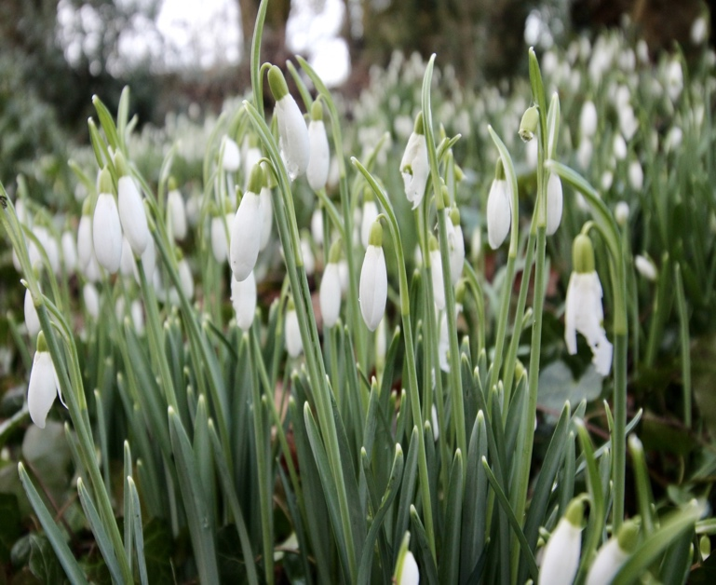
The first meeting of 2026 for the gardening club is our annual luncheon which is always a joyous occasion. It is lovely to have something to look forward to after the Christmas decorations have been taken down and the days are still short and this year’s event is being held at a new location; The Swan in Aston Munslow. Around twenty five members and their guests will be gathering on 22nd January for what promises to be a delicious three course meal. This is a lovely occasion and a chance to relax and catch up with friends and fellow gardeners. It is also the start of an exciting new year for our gardening club with lots to look forward to. The next club meeting at Stoke St Milborough village hall is on February 12th when Nancy Lowe will be talking about ‘The Secret Life of the Soil’. We first met Nancy last February, when she gave her talk on ‘Gardening with Wildflowers’. We enjoyed it so much that we are looking forward to welcoming her back again this year.
January and February are difficult months for the gardener, but you might, like me, have been eagerly searching the borders for the first signs of spring. I am always delighted by the first snowdrops of the year, which this year I spotted two days before Christmas. I also adore the wonderful spidery, bright yellow blossoms of the witch hazel (Hamamelis) with its wonderful fragrance. Do remember, if you are not fortunate enough to have snowdrops in your own garden, there are stunning displays that can be seen at the National Trust gardens at Attingham Park and Dudmaston Hall. If you have never been to St Peter’s Church in Stanton Lacy, I can highly recommend a visit as the magnificent display of snowdrops throughout the churchyard during February is guaranteed to lift your spirits. This year the snowdrop weekend is the 7th and 8th February at 2.00 until 4.30, where a nice cup of tea and a slice of homemade cake is also on offer.

If you would like to join us at our next gardening club meeting, then please come along to Stoke St Milborough Village Hall on Thursday 12th February. Nancy’s talk will begin at 2.30pm, but there is tea, coffee, cake and biscuits available beforehand and a chance to chat with other gardeners, so do come early. The hall is open at 2.00pm.
If you would like more information about our gardening club please contact me.
Bev Harris
Secretary
burwartonanddistrictgardening@gmail.com
01584 841845
Chetton Village Hall
Pam Downing writes:

We have our first event of the year in our newly decorated hall on Sunday 15th February, showing the film ‘Downton Abbey’ The Grand Finale.’ It is essential to book this. Tickets are £15.00 to include lunch served during the interval. Licensed bar and raffle. Please inform of any dietary requirements when booking. Doors open at 12.15 pm for a 12.30 pm start
Candlemas
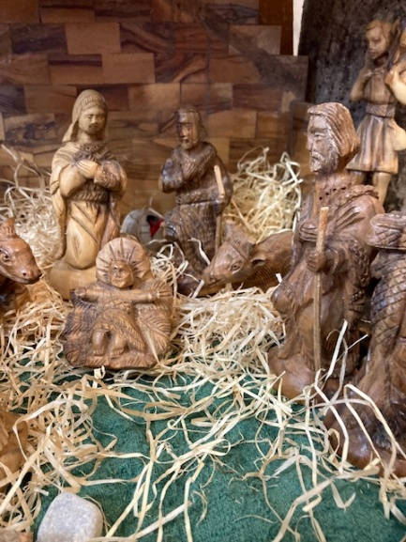
Ten years ago, a tradition was started by the executive panel of the Shropshire Churches Tourism Group. Unable to find a date in December for a pre -Christmas get together, we decided to have a post-Christmas lunch at my house in January instead. That has continued and we enjoyed our latest event last month. We do the whole thing, turkey and all the trimmings and crackers with paper hats. This year it was a week later than usual so Twelfth Night passed me by and the decorations, tree and crib stayed in place! Now this got me thinking about days gone by. Christmas decorations in medieval times meant lots of greenery from the land around. Holly and ivy and green fir not only looked nice but they kept the bad spirits at bay too. In Church terms, Christmastide lasted until Candlemas, (and still does!), celebrated 40 days later on the 2nd February, which is where we are now. Many a church will be celebrating one of the loveliest services in the religious calendar. And it happens in Christian countries all over the world. It recalls the time that Mary and Joseph took their newborn child to the Temple to present him to God, as was the custom.
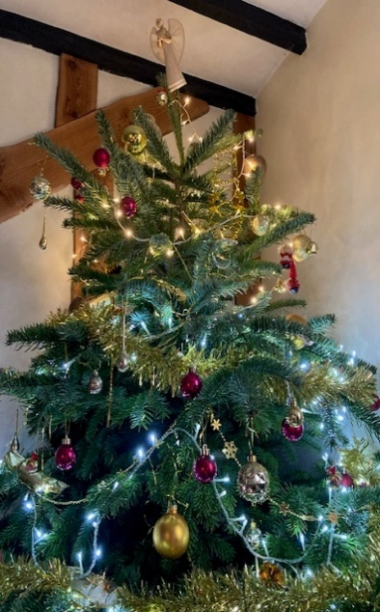
The celebration dates to the beginnings of Christianity but really took off around the year 380 when people got involved with processions and taking their candles to be blessed. It was a time for joy and, like many rituals, it was built on Pagan practice. The Romans marked the feast of Lupercalia in mid- February, in honour of Lupercus, the god of fertility and shepherds. It gradually became a feast of purification and the blessing of candles spread across Europe. In Germany, people decided that if the sun appeared on Candlemas day, a hedgehog would cast a shadow, making a second winter. This is the origin of the American festival of Groundhog Day, as many early settlers were German.
So this year I am sticking to the old ways and am keeping the trappings until Candlemas. Watering a tree is now part of a daily routine and visitors to the house love the snowman guarding the bathroom door. The crib, which I collected over my journalist days from Palestine, has kept well for 40 days with new greenery too. So, I might have to repeat this next year! What do you think?

Anni Holden Calver, Secretary of Shropshire Churches Tourism Group (SCTG)
www.discovershropshirechurches.co.uk
Trustee of Caring for God’s Acre and Churchyard Task Team cheerleader!
www.caringforgodsacre.org.uk

Stottesdon & District Benefice news
As you may have seen in the Wheatland News published at the beginning of December, we are delighted to be able to announce that the Rev’d Dr Sally Wallace-Jones has accepted the combined post of Rector of the Stottesdon Benefice and Rural Church Missioner in the Severn Borders Deanery.
Sally is currently Vicar of Hartshead, Hightown, Roberttown and Scholes in the Diocese of Leeds, and prior to that served in a large rural multi-parish benefice in the Diocese of Norwich.
Sally and her husband are moving to the Rectory in Stottesdon early in February 2026.
Sally is very much looking forward to leading the parishes of the Stottesdon Benefice in the next phase of our life and witness and to working with clergy and laity across the Severn Borders Deanery as Rural Church Missioner.
- For January and February services in February please see ‘A church near you’ for the Stottesdon Benefice parishes as these may change as Sally takes up her role.
The Rev’d Sally’s Licensing for the Benefice will take place on 17th February at 7pm at St Mary’s Church, Stottesdon on behalf of all 6 parishes of the Benefice and promises to be quite an occasion. Both serious and joyful in approach it seeks to not only formally record the arrival of the new Rector but together for all present to welcome her to her new role and her new parishes. It’s understood that it will be led by Bishop Richard who will be ably supported by not only office holders from the Diocese but also from the Deanery and most importantly our own parishes.
Whilst 17th February seems a while away at time of writing by the time you read this is will be less than 17 short days away. There is a lot of planning to be made and heads to be scratched but no doubt the parishes together will rise to the occasion! The key issue is that everyone is so very welcome to this service as indeed they are at all events and service in the parishes. We don’t get many Licensing services (so it’s new for all of us) and so it is worth coming along to in order to welcome our new Rector.
Lord-Lieutenant’s ‘Together at Christmas’ carol service was held at St. Mary the Virgin, Cleobury Mortimer.
His Majesty’s Lord-Lieutenant of Shropshire, Anna Turner, invited the Stottesdon bell-ringers to a “Together at Christmas” carol service, inspired by HRH the Princess of Wales to recognize those who support their community.
St. Mary the Virgin church in Cleobury Mortimer was chosen this year to celebrate this service. This is one of the biggest churches in the area and it was filled. It was wonderful to hear carols being sung in this space by several hundred people, special thanks must go to the soloist and choirs of the Cleobury Mortimer Primary and Secondary schools and the church, as well as the readers and organist.

Stottesdon Heritage Website – https://www.stottyheritage.co.uk
Did you know a website that was set up when the main restoration of St. Mary’s church was completed in 2024. Much of the background research and editing of the site was done by the late Chris Tibbits.
In addition to the church there are details and a history of the village and surrounding area. There’s even a link to the Doomsday book where Stottesdon had a recorded population of 50 households in 1086, putting it in the largest 20% of settlements recorded in Domesday.

If you haven’t visited the site before it really is worth having a look!
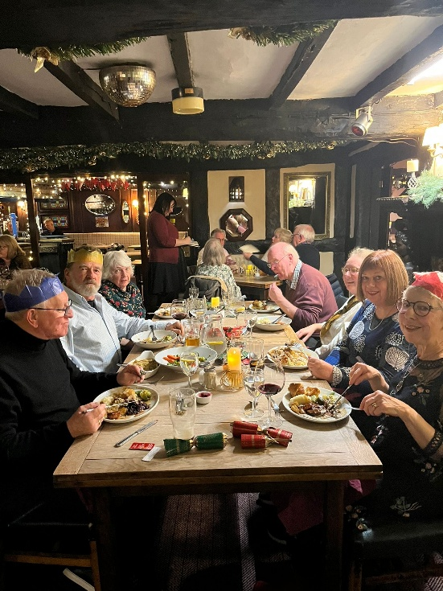
Stottesdon and District WI
Stottesdon and District WI had their annual Christmas meal on 10th December 2025.
We had our meal at the Live and Let Live (or the ‘Liv’ as the locals call it) in Neen Sollars, it seems a bit out of the way but it’s well worth a visit and at the time we were there was magnificently decorated for Christmas. Di and her brother who run the pub did a great job of providing hot meals for 21 of us, all at the same time, that was some effort! The food was very good (scrumptious) and all home-made which is always a plus.
It was a lovely evening to catch up with one another and spend a bit more time than usual chatting and meeting friends old and new.
Looking to 2026 we have a fabulous programme (see below) booked thanks to Clare Tibbits. New members always welcome.
so, if you’re interested in joining the WI then please contact Debbie Haynes (07780 113869) who will be happy to give you more information.
18th February - Creative Writing - Chorley Village Hall
18th March - Indian Spices - Farlow Village Hall
15th April - Mystery Tasting - Chorley Village Hall
20th May - A.I. - Chorley Village Hall
17th June - Introduction to Homeopathy - Farlow Village Hall
15th July - History of Severn Valley Railway - Chorley Village
Hall
19th August - Outing
16th September - Air Ambulance - Farlow Village Hall
21st October - Yoga – TBC
18th November – Craft & AGM- Farlow Village Hall
16th December - Our Christmas Meal
Happy new year!
Debbie Haynes
debbiehaynesflp@hotmail.co.uk
President of Stottesdon and District WI

News from Cleeton St Mary
The PCC are very pleased to announce that they have received a grant from Historic England for emergency repairs to the church roof. This will prevent any further water damage to the Gothic Revival interior. We are extremely grateful to Historic England for this support which will also boost our Heritage Lottery bid for a complete renewal of the roof along with a fascinating project to explore our village history.
If anyone would like to make a donation it would be much appreciated:
https://givealittle.co/c/672bvXBN0Ijqi78QdASWSn
Sue Dolphin

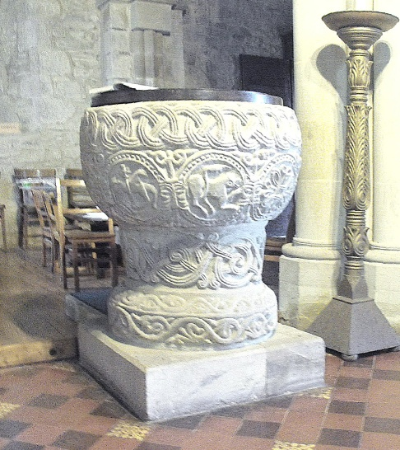
Stottesdon, St. Mary’s Font
We get a huge range of visitors coming to visit the wonders of Stottesdon church. One evening whilst locking up the church we had a gentleman from Tokyo come into the church to look around. He was particularly fascinated by the large and beautiful font and was taking many pictures from all angles. The font is a marvel of early English stone carving and makes the idea of heritage, in all sorts of ways, very visible.
The font is thought to be the work of the Herefordshire School of Romanesque Carving, active during the reign of King Stephen (1135-54). Malcolm Thurlby describes this as having ‘a chalice-shaped bowl decorated with loosely spiralled two-strand stems, and a chamfered base carved on both the upright and the chamfer with a simple undulating foliage trail’ he goes onto say that ‘the frieze is decorated with symmetrical three-strand interlace with three-strand roundels at the intersections whilst below the frieze are eight beaded roundels joined, in all but one case, by grotesque masks and with stylized plants in the spandrels’ (The Herefordshire School of Romanesque Carving, Woonton, Logaston Press, 2013, pp. 236-238).
What the published text doesn’t say is that it is full of mysterious and joyful images, in one case a lion (dog?) chewing its tail. Braiding in stone is a miraculous thing to have achieved and the overall glory of the piece is made even more so by being delivered to us more or less intact, having escaped, amongst other things, the destruction of the Civil war and the enthusiasm of the Victorians. Moreover, it’s more than 8 centuries since some unknown but definitely superb master craftsman got to work on a monumental block of stone. It’s a thing of utility but also of delight. Do come and see it!
News from Farlow
Happy new year to everyone!
Here are the results for the Farlow and Oreton 100 Club
DECEMBER 100 CLUB WINNERS
Graham Kirkpatrick 87 £20
Marcelle & Simon 32 £10
Rachael & Bill Brown 84 £10
Terry Price 48 £5
Neville Carter 81 £5
JANUARY 100 CLUB WINNERS
Dave Spruce 36 £20
Ben & Emily Innes 86 £10
Mike Hepworth 59 £10
Jessica & Facility 66 £5
Brian Beddoes 60 £5
Caroline Billson writes: Thank you to everyone who came to our Carol Service on the 18th of December and to Ruth Downes for taking the service, Rachael Smith for music and all the Readers. Thanks to everyone who made mince pies. An enjoyable evening was had by all.
The roof storm damage repairs have been completed thanks to T L Poyner and Mr Corey Lane of Hawksmoor Stuart. We are now looking forward to some inside repairs being done.

News from Sidbury
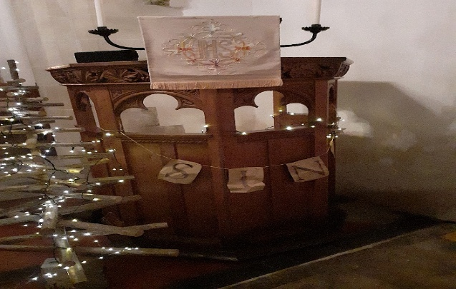
We held our Christmas service on the evening of 22nd December, when 32 people joined us for carols, Bible readings and poetry, followed by refreshments in the church. This was an excellent turnout! The newly refurbished bell was put to good use to summon the faithful and possibly even disturb some of the dead! The church was tastefully decorated, although I was a little surprised by the exhortation on the pulpit. I assumed behind this was some missive from the Bishop that gluttony was not to be considered a deadly sin over the Christmas period. It was a bit disappointing to see the full banner was an encouragement to sing.
Our next service will be Holy Communion on the 3rd Sunday in February, after which Sidbury has the excitement of welcoming the new vicar!

Rev’d David Poyner

News from Middleton Scriven
Church services:
Our Lent service in February /March - date and time to be arranged, once the new Rector is in post.
Community event:
Saturday February 14: Coffee morning: please note a slightly different time: 11-1pm .
We are trialing Soup and Roll (£5 )in addition to Tea/Coffee and Cake ( £2). Come and enjoy delicious homemade soup!
Date for your diary: Quiz Night: Saturday 21 March
Ann Constable writes: Thank you to everyone who supported our Christmas Eve carol service. It was wonderful to have a full church, and to share Christmas Eve with so many.
Services in the Stottesdon Benefice

1st February Rev’d Neil Dunlop
Holy Communion Farlow
Morning Prayer Stottesdon
8 February Rev’d John Daniels
Holy Communion Cleeton St. Mary
Holy Communion Stottesdon
15 February Rev’d Neil Dunlop at Stottesdon and Revd David Poyner at Sidbury
Informal Worship Stottesdon
Holy Communion Sidbury
Tues 17 February The Right Rev’d Richard Jackson Bishop of Hereford
Licensing of Rev’d Sally Wallace-Jones Stottesdon All are Welcome
22 February Rev’d Sally Wallace-Jones (provisional check “A Church Near You” to confirm
Holy Communion Silvington
Holy Communion Stottesdon
1 March Rev’d Sally Wallace-Jones (provisional check “A Church Near You” to confirm
Holy Communion Farlow
Morning Prayer Stottesdon
Date to be arranged during Lent: Rev’d Sally Wallace-Jones (check “A Church Near You”)
Holy Communion Middleton Scriven

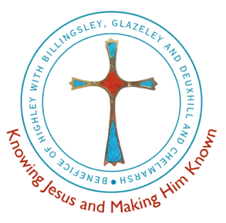 | The Severn Valley Group of Parishes  Rector: Revd Kina Robertshaw - Revkinarobertshaw@gmail.com  www.stmaryshighley.co.uk/st-marys-highley  Revd David Poyner, Assistant Curate - email D.R.Poyner@aston.ac.uk,  Tel 0780-100-9693 (mobile) or 01746-861121  Revd Angie Foster – Assistant Curate (in training) revangieforster@icloud.com
St Mary, Highley  CHURCHWARDEN  Carl Hinkinson | St Mary, Billingsley  CHURCHWARDEN  Vacant | St Peter, Chelmarsh  CHURCHWARDEN  Vacant | St Bartholomew, Glazeley  CHURCHWARDEN  Vacant

Chelmarsh News:
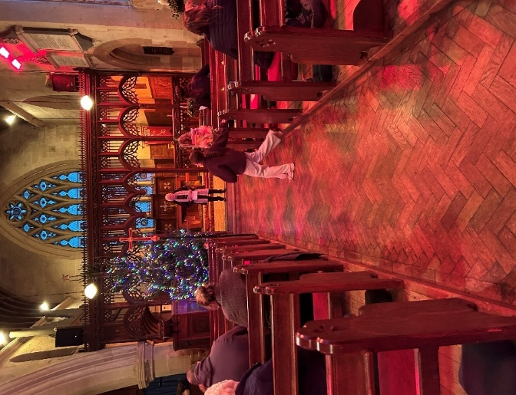
The Christmas services at Chelmarsh were well attended. On Saturday
14th December, at a crib service led by Glenys Williams and
Sheila Bebb, we had 17 people attend. Here Glenys and Sheila
invited the children to view the nativity set whilst explaining the
events that it shows. The next evening was the main village carol
service, where 75 people came, to enjoy a traditional service of
carols and Bible readings , with mulled wine and mince pies afterwards.
The midnight service on Christmas Eve attracted 35 communicants.
The final 100 Club Draw of the year took place after the midnight service. The results are below:
No. 102 Terry Kenny £100
No. 80 Bill Yeomans £50
No. 23 John Roberts £25
No. 120 Cathy Gill £25
No. 22 Mary Lee £25
No. 115 Jess Maiden - Billy £25
This year the 100 Club has raised over £900 for the church. This is much needed income, as we have had to do safety work on tower and on trees in the churchyard. I will write more about the tower work next month; suffice it to say, it is now safe to walk under it again! We have been able to claim some of the costs of this back in grants, but we cannot do this for work to make the trees in the churchyard safe, which has run into several thousand pounds, so we much appreciate all those who support us financially.

Chelmarsh sadly lost one of our oldest inhabitants before Christmas, Avis Link from Woodcock Farm, Hampton Loade. Avis came from traditional yeoman stock and died shortly before her 90th birthday. We send condolences to daughter Anthea, grandson Robert and sister Sheila. After a cremation, a memorial service in Chelmarsh was attended by 65 people, where Robert and Anthea gave touching tributes. We left church to “Galloping Home” from Black Beauty and a blast on the hunting horn!

Billingsley News:
Over Christmas we had two services at Billingsley. On Friday 19th we had our evening carol service. The church was beautifully decorated; I particularly liked the candle-lit path, which was also extremely useful in helping us find our way out after the service. We had a mixture of carols, Bible readings and poems, followed by mulled wine, mince pies and cake/biscuits. We had 25 people in the church, which was a very good turnout.
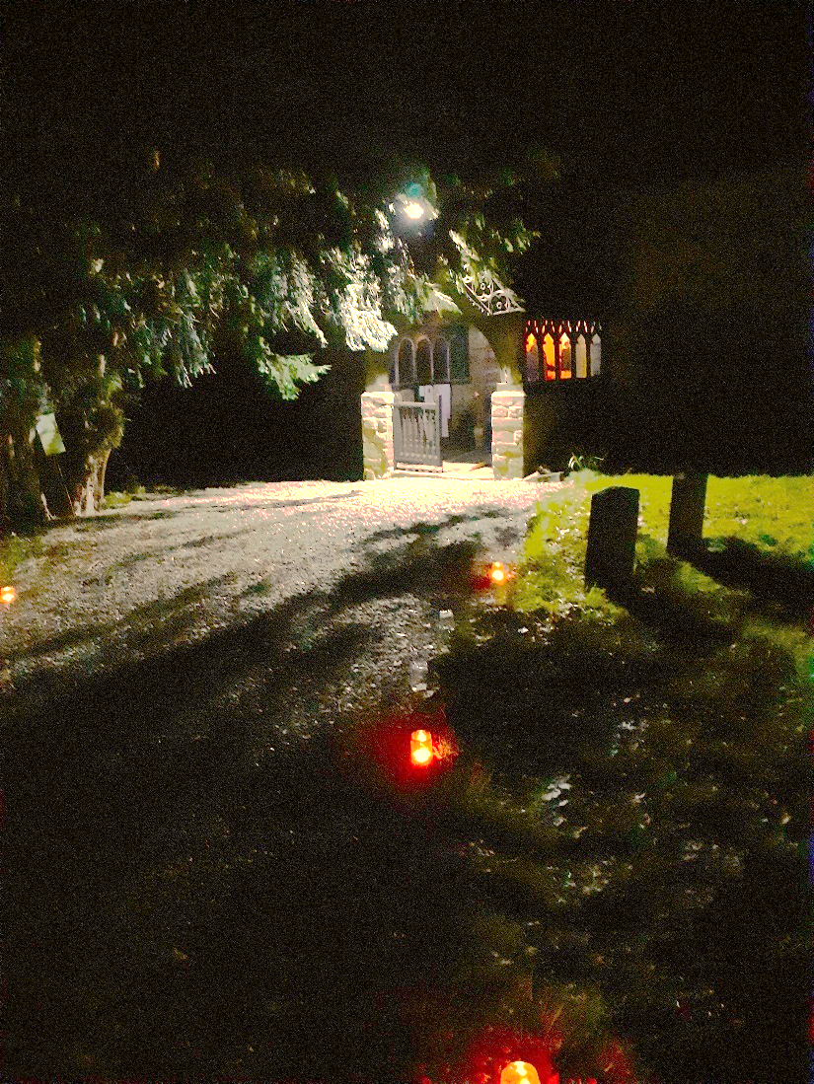
On Christmas Day we had a communion service at 10am. This again followed the format of carols and readings, with a brief celebration of communion. After the service, the congregation were treated to a celebratory Quality Street chocolate as an aperitif before heading off for Christmas Dinner. This time we had 17 worshippers: another very good congregation.

Compared to previous years, both services were made much more comfortable by the new under-pew heating that was recently installed. I am optimistic that in January, February and March, the glacier that normally greets me at the altar at the 8am communion service may have retreated, and I no longer have to worry about losing fingers to frostbite.

For next year, we are looking at ways we might be able to attract more families with children to our services; Christmas is not just for adults…
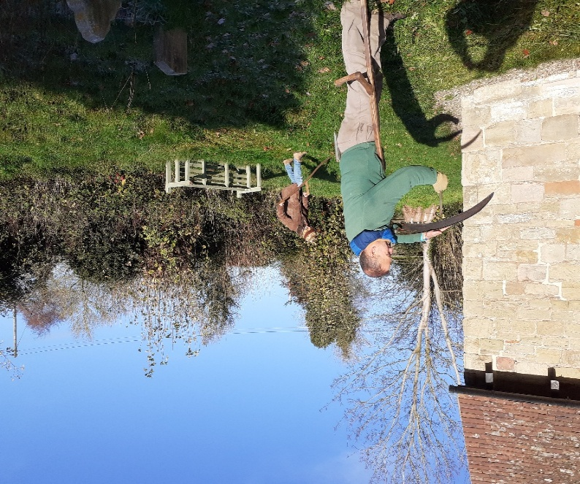
Outside of services, at the end of November we were visited by Alex and his volunteers from Caring for Gods Acre, to give the churchyard its late autumn trim. They much appreciated the Welsh Cakes provided by Ellen, as did your roving correspondent. In the spring we want to do some maintenance on the benches in the churchyard and ensure they are put in the best positions for visitors.
Looking ahead, we are also planning speakers and themes for the evening services, which take place from April to September. For June we have booked a speaker from the Shropshire Historic Churches Trust, who have helped us and Glazeley with the new heating. We are also gathering material, especially photographs, for a local history exhibition. If anyone has old photos of Billingsley and would allow us to copy them, please contact me (David Poyner).

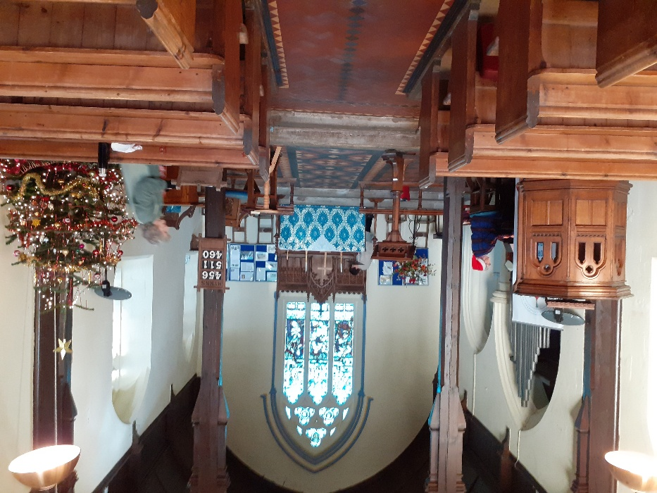
Glazeley News:
As at our other services in the benefice, the Christmas showing at Glazeley was excellent, with 45 people attending our service on Sunday 21st December.
This set a record in recent times. The church was prepared a few days before when the loyal helpers were rewarded with Damson brandy and mince pies, as well as an impromptu recital of carols on the organ.
Sadly, Rachael, our organist on the occasion, was ill for the service itself; the congregation coped resourcefully with music played over my computer.
The assembled congregation much appreciated the new heating system installed in the church back in September. The service itself combined carols, Bible readings and Holy Communion. The quality of the wine attracted especial comment, but I feel it my duty to remind people that the service took place in Advent, which is a penitential season.
After the service we were invited for refreshments at the Old Rectory by Laura and Andrew; a couple of glasses of mulled wine washed the taste of the communion away…. After the service, the Christmas Tree was donated to a local care home.

The regular monthly breakfasts resume on Saturday 17th February at 9am at The Down Inn, All are welcome, whether a church-goer or not; the aim is to allow people to meet and talk to each other.
Please contact myself (David Poyner), Sheila Millington (Chetton) or Marion Corfield (01746 764585, marion.corfield@talktalk.net) if you would like to come. The cost is £8 per person.

Whilst the church is open, we now are using wooden candle holders. The brass candle holders have recently been repaired by Lawrence Archer, whose skills with soldering iron are much appreciated. When all the candles are lit, the effect is quite spectacular!
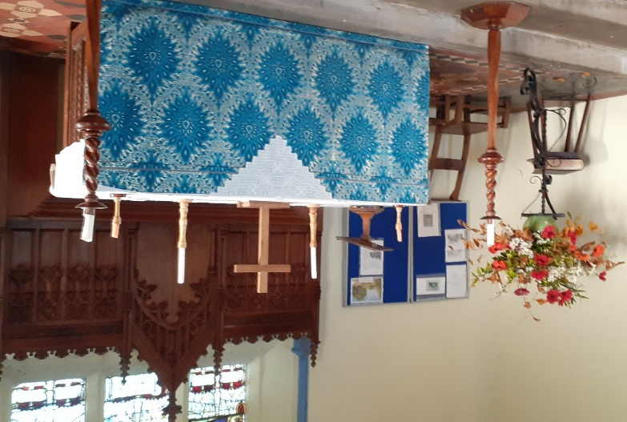
As I write, we have just had the first heavy snowfall of the year. Many thanks to all our local farmers and contractors who have been busy clearing the roads.

GREEN PAGE NEW YEAR QUIZ 2026

SOILS
- What are the three main types of British soil?
- Approximately how many micro-organisms are there in a teaspoon of soil ?
- What do you call the layers when you dig a deep hole through soil?

WATER
- What is meant by the freshwater cycle?
- Which river in England is known as the Holy River?
- What is the biggest fish ever caught in the River Severn with rod and line?

PLANTS
- What is thought to be the oldest tree in Shropshire?
- What is another common name for the plant known as ransoms?
- What plant was used in the textile industry for raising the nap in wool?

INSECTS
- What percentage of all the species in the world are insects?
- What is the Caterpillar food plant of the red Admiral butterfly?
- How many days on average does a bumblebee live for?

BIRDS
- What is the common name for the bird known as passer domesticus?
- How many species of owl breed in Britain?
- What is the collective noun for puffins?

MAMMALS
- When were grey squirrels introduced into Britain?
- Approximately how many spines are there on an adult hedgehog?
- What is considered to be the rarest native mammal to be found in Shropshire?

GENERAL
- If an animal is described as crepuscular, what does it mean?
- Which three English counties are famous for producing Stilton cheese?
- Which breed of dog is named after a Scottish island?
- Which British beach is home to durdle door?
- The name of the full moon in September?
- What unusual weather event is statistically more likely at Easter than at Christmas in the UK?
- What is the traditional English folk dance performed with bells and stick?

Answers on page 31

Canon Rose Lawley

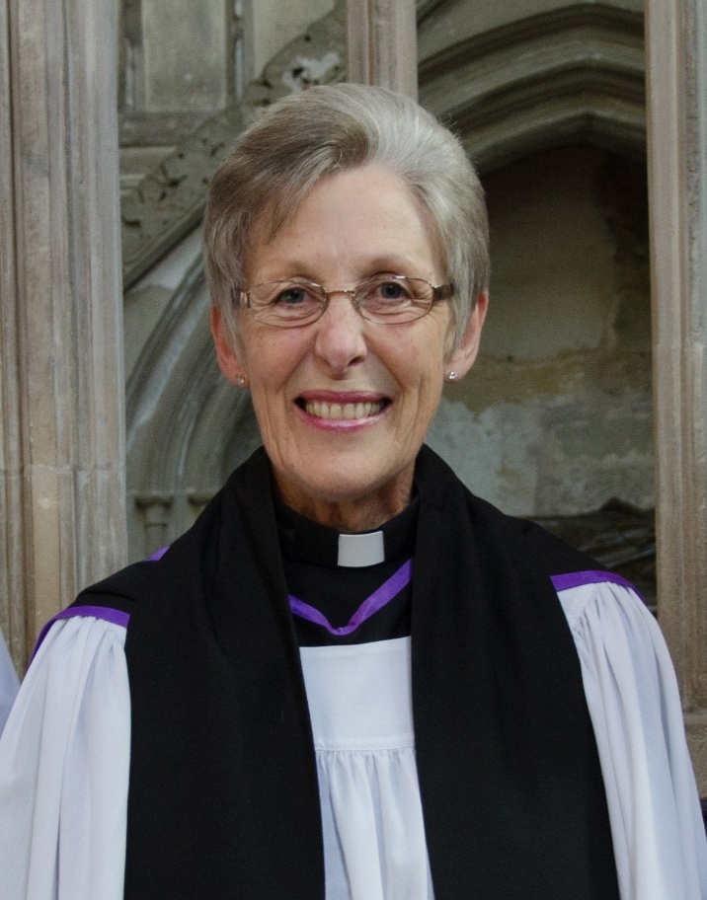
The Rev’d Rose Lawley died peacefully just after 9am on Sunday 11th January. Rose was a retired priest who came to live in Highley after her retirement. Rose came from the Black Country and did several jobs before answering the call to ministry. She was ordained in Lichfield Cathedral in 2003, initially as a non-stipendiary priest. After serving her curacy, she ministered in Kidderminster, eventually moving into full-time ministry as a parish priest and industrial chaplain. She was much loved and respected in Kidderminster and was made an honorary Canon of Worcester Cathedral in 2015. She was also a chaplain to the Royal British Legion, a service that gave her great satisfaction.
On retirement she and husband John moved to Highley, much to the delight of the benefice who benefitted from her ministry. She helped our incumbent, Rev'd Mike Harris, as secretary to the PCC in Highley. After Mike's retirement, both the Rev’d Val Smith and I were extremely grateful for the help and leadership she provided as we managed without an incumbent. She chaired Chelmarsh PCC and played a very significant role in guiding Highley PCC, as well as leading services. She retained her role at Chelmarsh after the arrival of our current incumbent, the Rev'd Kina Robertshaw.
Sadly, Rose's ministry was cut short by motor neuron disease. Towards the end of her illness, I had the privilege of bringing her Holy Communion and keeping her informed of all that was happening in the benefice. Even at the very last communion I gave her, just a few days before she died, it was clear how pleased she was to see me. Perhaps she did not realize that she was ministering to me just as much as I was ministering to her.

Rest in peace, Rose, and rise in glory!

David Poyner, Assistant Curate, Severn Valley Benefice



LANDMARK CURRICULUM CHANGE SPARKS GLOBAL INTEREST FOR LOCAL CAMPAIGNER

A landmark government announcement on 15th July 2025 has confirmed that bereavement education will be included in the national curriculum for both primary and secondary school pupils in England—a breakthrough moment driven in part by the efforts of John Adams, a local funeral director from Bridgnorth and well-known campaigner for grief literacy.
This significant development follows a Parliamentary debate on 2nd December 2024, which was triggered after John's national petition calling for grief, death, and bereavement to be taught in schools gathered over 11,000 signatures—a number officially recognised as the equivalent of 100,000 signatures due to the influence it had across the education and health sectors.
Now, with the Department for Education confirming the new statutory guidance as part of RSHE (Relationships, Sex and Health Education), this change is being hailed as a potential cultural shift in how society approaches one of the last great taboos in the Western world: death.
John Adams, a fourth-generation funeral director at Perry & Phillips, has long campaigned to ensure young people are better prepared for the emotional realities of grief, having witnessed first-hand the long-term effects of silence and societal discomfort around the topic. His efforts have been supported by organisations such as the National Association of Funeral Directors, Child Bereavement UK, and a growing number of schools, mental health professionals, and community leaders.
This success has not gone unnoticed internationally. John has received invitations from countries such as Australia and New Zealand, where conversations around grief literacy are also gaining momentum. In response, he travelled to Australia on 8th September 2025, where he was invited to speak at the Australian Cemeteries and Crematoria Association’s national conference in Sydney, sharing the story of the campaign and exploring how other nations can follow suit.
What began as a local campaign, inspired by community values and a belief in better care for the bereaved, has now sparked a global conversation—placing Shropshire, at the heart of a movement set to shape how future generations understand and support each other through life’s most difficult moments.


ANSWERS TO GREEN QUIZ

- Podzol, brown earth and gley
- 4 billion
- Soil horizon or profile
- The continuous movement of water on above and below the surface of the earth
- River Thames
- A sturgeon weighing 414lbs in 1903
- The yew in Norbury churchyard thought to be around 2700 years old
- Wild garlic
- Teasel
- 80%
- Nettle
- 28 days
- House sparrow
- 5 barn, tawny, little, long eared and short eared
- A circus
- 1876 at Henbury Hall in Cheshire
- 7,000
- Pine marten
- An animal active during the twilight hours
- Derbyshire Leicestershire and Nottinghamshire
- Skye terrier
- Lulworth Cove Dorset
- Harvest
- Snowfall
- Morris dancing

Scores
20 ~25. Amazing, what a wealth of knowledge you have.
15-20. Well done, your understanding of the Natural World is impressive.
10~15. You have a good awareness of the Natural World. Well done.
5~10. You have learnt a lot already about the Natural World, isn’t it interesting finding out more.
1-5. Brilliant, you gave it a go. Hope you have enjoyed learning more. Stay inspired.

Wheatland News – What you need to know for 2026
As many WN readers will already know, Denise Knightley is taking on the role of WN Editor as from the February 2026 edition, supported by the newly reformed Committee and the revised arrangements. The information set out here may well change as things settle down during 2026!
SUBSCRIPTIONS – a note to ALL our readers – we hope a growing number for 2026!
Please ﬁnd your subscription form for 2026 on page. The form also contains some revisions to the subscription information that appeared on the back cover of the November WN – information that was not to hand when we went to print. The bank account name is very long-winded but has been tested and it does work for setting up payment from phone app or online banking! Please complete the form and submit it – as set out on the form. Charles Gill is now Treasurer for Wheatland News – but if you have any questions or problems about your WN subscription then please contact your LOCAL DISTRIBUTOR in the ﬁrst instance – see Distribution, below.
DISTRIBUTION
Printed hard copies – Tony Brown will continue to collect these from Badger Print, package them in parish-sized bundles and deliver to the appropriate places. Tony can be contacted at anthonybrown100@icloud.com.
For now, until clarified, please assume that either Tony is your distributor, or that the current person will continue with the role.

Parish / Beneﬁce | Distributors – as known | Electronic versions
Severn Valley  - Billingsley  - Glazeley  - Chelmarsh  - Highley | Glazeley – Marion Corﬁeld Billingsley – Julia Evans | https://www.achurchnearyou.com/church/10415/page/72249/view/ https://www.achurchnearyou.com/church/10533/page/72247/view/ https://www.achurchnearyou.com/church/10462/page/84233/view/ https://www.achurchnearyou.com/church/10558/page/55350/view/  The Highley Forum is also on these web pages
Stottesdon | Stottesdon – Julia Evans | A Church Near You - Stottesdon  https://www.achurchnearyou.com/church/10731/page/44749/view/
Brown Clee | Chetton – Charles Gill  Aston Botterell – Anne Preece Neenton / Cleobury North / Burwarton – Sue Hale  Ditton Priors – Tony Brown | A Church Near You – Ditton Priors https://www.achurchnearyou.com/church/10502/page/83071/view/

Wheatland News

So just a reminder about what’s happening from February 2026 and the part we all need to play in keeping the Wheatland News in its current fine shape.
The new Wheatland News committee members are;
- Revd Joe Simons, also acting as Chair of the Wheatlands News committee and Rector of the Brown Clee Benefice.
- Mrs Julia Evans, also acting as co-ordinator for the Stottesdon Group.
- Mrs Karen Simons, also acting as co-ordinator for the Brown Clee Benefice.
- Revd David Poyner, also acting as co-ordinator for the Highley Group parishes of Chelmarsh, Glazeley & Billingsley.
- Mr Cliff Gutteridge – photography adviser
- Mrs Denise Knightley who is the incoming Editor.
- Mr Charles Gill - Treasurer.

We will be working in a different way because we cannot replace the knowledge and experience of Bobbie or Caroline so please bear with us and we hope that you can help us to make this truly community wide magazine with YOUR active help and support.

The new arrangements mean a few things including the need to send material for inclusion
to your co-ordinator by at the latest the cut-off date, which is usually about the 15th of every month for inclusion in the following month’s edition. It may not be possible to add any material received late.
Then co-ordinators need to assemble material for onward transmission to the Editor who in turn has the task of assembling the magazine in the most streamlined way before it goes off to the printers. Printers then return material which goes to churches and other distribution points and a wonderful team of people who kindly get the Wheatland news out to readers. Wheatland News should be in churches and communities by the first Sunday in every month, so time is always tight.

“YES PLEASE – I WANT TO RECEIVE A PRINTED COPY OF THE WHEATLAND NEWS EACH MONTH DURING 2026!”
Please fill in the form and follow the instructions below!
Payment: The minimum subscription for this year is £18. Please pay either
By direct transfer – eg from your phone or online (PREFERRED) or
By cheque – please post to Charles Gill, Church House, Chetton,
Bridgnorth, WV16 6UF or contact him at CharlesEGill@aol.com or contact
your Distributor if known
Barclays Bank
Account number = 50 94 20 65 Sort code = 20 53 22
‘Wheatland Group of Parishes Wheatland News Account’ (Business account)
Insert YOUR NAME AND SURNAME as payment reference
Please print – then cut along the dotted line and return the completed form to Charles Gill CharlesEGill@aol.com or to your Distributor:
75% of previous subscribers have already paid for 2026.
If you’re reading this & have not yet paid, please can you do so asap
------------------------------------------------------------------------------------------------------------------------------
Your name (as per payment reference)
……………………………………………………………………..………………
Email Address………………………………………………………………
Address & postcode…………………………………………………………….
………………………………………………………………………………
Tel Number/s………………………………………………………………….
Are you a new subscriber? Y / N. or
Re-newing? Y / N.
With which Church or Group are you connected?...............................................
Your Distributor – ie the person and their phone number or email address from whom you receive the Wheatland News – if known………………………………………….
-------------------------------------------------------------------------------------------------
Electronic copies will continue to be available on parish and beneﬁce websites, and by email on request to your Distributor.
CONTRIBUTORS
Please send your reports and photos to your Beneﬁce Coordinator, who will prepare them for submission to the Editor. The coordinators are:

Beneﬁce | Coordinator and contact information
Severn Valley | Revd David Poyner - d.r.poyner@aston.ac.uk
Stottesdon | Julia Evans - juliaevans278@googlemail.com
Brown Clee | Karen Simons - walkthedogs@mac.com
The DEADLINE for contributions for the MARCH 2026 edition is NOON on 14th FEBRUARY 2026.
Any contributor who is not aligned with a speciﬁc Beneﬁce – please send your items direct to the Editor, Denise Knightley, denwills1@aol.com
Brown Clee Shrops Councillor | George Hollyhead - george.hollyhead@shropshire.gov.uk. – Shropshire Council.
Brown Clee Surgery PPG | Brown Clee Surgery Patient Participation Group (PPG) - email BrownCleePPG@gmail.com, or call Chair Tina Ranson on 01584-878707.
Brown Clee Walkers | Meeting Place for walks - Ditton Priors Church. 01746-712662
Burwarton & District Garden Club | Meets on the 2nd Thursday of each month from October to June at 2:15pm at Stoke St Milborough VH. Contact burwartonanddistrictgardening@gmail.com, or Sec Bev Harris on 07933-724728
Burwarton & District WI | Contact the Secretary, Helen Groves, on 01746-712466
Chelmarsh Bowling | Outdoor bowling in summer (Tuesday evening & Wednesday afternoon), indoor during the winter (Tuesday evenings 7:00 – 9:00pm) at Chelmarsh Parish Hall. Further details from Stan Chapman, 01746-862424
Chelmarsh Games Group | Mainly Canasta and Scrabble! Thursdays at 2:00pm in the Parish Hall. Contact Sue Jakeman on 07531-008876.
Chelmarsh Jubilee Club | Meet at Chelmarsh Sports & Social Club – contact Shell Russon on 07903-162408 for more information
Chelmarsh Parent & Toddler  Group | Every Tuesday during term time 9.30 – 11.30 Chelmarsh Parish Hall. Contact Pam Baker 07846-692323
Chelmarsh Parish Hall | Available for hire - booking@chelmarshparishhall.co.uk
Chelmarsh Walking Group | Contact Jen Everitt on 01746-862858 for more information.
Chetton & Glazeley WI | Meets in Chetton Village Hall on the 2nd Wednesday of the month 7.30pm. For enquiries re trying a session or two and membership please contact Elisabeth Buggins, Secretary - Phone: 07855 018288 Email: elisabeth@buggins.com
Chetton Village Hall | Enquiries - Sue on 01746-789239
Chorley Village Hall | Available for Hire (fully equipped kitchen, digital projection equipment and large screen) contact 07726-763883 – NEW DEDICATED NUMBER DECEMBER 2022
Cleobury North Village Hall | Enquiries and Bookings – NEW CONTACT - Sharon Jenkins - Tel no: 07854-538645 or 01746-787220
 | National Centre for Domestic Violence https://www.ncdv.org.uk/contact/ Call 08448-044999. Website gives advice and other means of getting help.
Daddy’s Hat Music & Poetry | Contact on 01746-787419 – leave a message and you will get a call-back!
Ditton Priors Art Group | Village Hall Wednesday morning (except Christmas) 9.30 – 12.30pm all welcome Various visual art forms eg Water Colour, Oils & Acrylics. Contact Gloria Blair on 07794-225532
Ditton Priors History Group | Please contact paul.wilson8992@gmail.com
Ditton Priors Ladies’  Friendship Group | Please contact Jo on 07837-048525
Ditton Priors Village Hall | Bookings - 07766 392 105 - dittonpriorshalls@gmail.com
Knowle Sports Club | Second-hand sales held every first Saturday of the month, 7.30am – 11am proceeds to Children’s Football Field 01584-890644
  Little Explorers Pre-School  Ditton Priors | Open Monday to Friday 9.00am – 3.00pm. Contact 01746-712506 littleexplorers.ditton@gmail.com
 | Shrewsbury Dial-a-Ride Transport Services https://www.shrewsbury-dialaride.co.uk – 01743-450270 Mon-Fri 09:30 – 15:00, Corvedale Buzzard – 01584-700907
Short Mat Bowling – Ditton Priors | Ditton Priors Village Hall Every Tuesday afternoon 2.00 - 4.00pm Wednesday 7.30-10.00pm. Everyone is welcome - try at no charge. Contact Clive Jackson on 01746-718046
Stottesdon & District W.I. | Meets in various venues on the third Wednesday in each month details from Helena Hale 01746-718012 or Clare Tibbits 01746-718007
Stottesdon Gateway Nursery | Pre-school, holiday club and wraparound sessions. An integral part of Stottesdon Primary School, Contact 01746-718769
Tae kwon-do | Eardington Village Hall Thursday, 5:15pm. Contact Neil Morris 07969-996055

