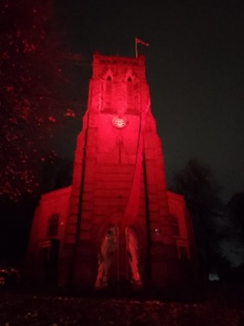
Would you like to
Floodlight S. Peter’s Tower

in celebration or remembrance?

Name_______________________________________________

Address & email / phone number ________________________ ____________________________________________________________________________________________________________________________________________________________________

I would like to sponsor the floodlighting as follows
PLEASE NOTE we need two week’s notice for bookings as our lights are manually set by a small number of volunteers
Dates from _____________ to _______________
Please check the date is available by emailing mthrvictoria@halasteam.org.uk or texting on 07585264050 BEFORE MAKING ANY PAYMENT.

Colour (please delete as appropriate)

Red / green/ blue / pink /purple/ white / warm white

To celebrate / in remembrance of
_______________________________________________________________________________________________________________________________________________________________
The dedication of the sponsorship will usually be shared on our Facebook page, are you happy for this to happen?
Yes / No *please delete as appropriate

I enclose a cheque / cash / commit to making a bank transfer (details below) for the sponsorship
The cost is £10 per night, but there is no upper limit to donations if you would like to give more. 100% of your donation will go to furthering the work of the church in the community.
**Dates need to be booked at least one week in advance and are on a first come, first served basis. We reserve the right to light the tower for national and local events, so your date may not be available

If you are a UK taxpayer you might like to fill in the following details to enable us to reclaim tax on your gift from the government
“I am a UK taxpayer and understand that if I pay less income tax and/or capital gains tax than the amount of gift aid claimed on all my donations in that tax year it is my responsibility to pay any difference”

Signature______________________ date _____________

Please return this form and any cheques to James Brookes, c/o The Vicarage, 55 Quarry Lane, Halesowen B63 4PD or by email to mthrvictoria@halasteam.org.uk

Details for payment
CHEQUE – please make payable to HALAS PCC ST PETER’S CHURCH, CRADLEY. On the back, write ‘Tower Lights’ and the dates you wish the tower lit. Please return to the address above
BANK TRANSFER – a/c name HALAS PCC ST PETER’s CHURCH, CRADLEY Lloyds bank, sort code 30-92-35, a/c number 00076644. Please put ‘Tower lights’ and the date you wish the tower to be lit in the reference section

