SUNDAY 11th January 2026.




Loving God and Loving our Neighbour

Although we are currently without a permanent Rector, services in the Benefice continue with the assistance of visiting clergy. Please do join us – you will be made very Welcome!!


Sunday 11th January Epiphany 1 The baptism of Jesus
9.30am Watton Holy Communion
11am Watton Contemporary service
11am Aston Family service
11.15am Bramfield Holy Communion
11.15am Stapleford Prayer and Praise

Sunday 18th January Epiphany 2. Week of Prayer for Christian unity begins.
11am Watton Contemporary service
11am Aston Holy Communion

11.15am Stapleford Prayer and Praise
11.15am Waterford Morning Prayer

Please can you let Denise have details of any baptisms, funerals, burial of ashes that have taken place in your churches since the beginning of December, for the February Parish News. The deadline is 12 January.
to Denise by JANUARY 12th at parish.news.beane@gmail.com

MIDWEEK

Fortnightly MONDAY 2pm ASTON Bible Study Fellowship 3 Long Ridge Aston with tea and biscuits. All are welcome. Next meeting Monday 19th January Contact Pauline at pauline.manley1966@gmail.com

NIGHT PRAYER Alternate WEDNESDAYS at 7.30pm on ZOOM. Next meeting Wednesday 21st January on ZOOM. Contact Tim Alexander for link tim_alexander3@hotmail.com


Wednesday 21st January 2.30pm Stapleford village Tea afternoon in Church. All are welcome for tea, coffee cake and chat.


THANK YOU to the ministry team, churchwardens, treasurers, secretaries and PCC’s of our churches and to everyone who helps maintain the churchyards and buildings.
THANK YOU to everyone who brought joy in decorating all the churches and our villages for Christmas.

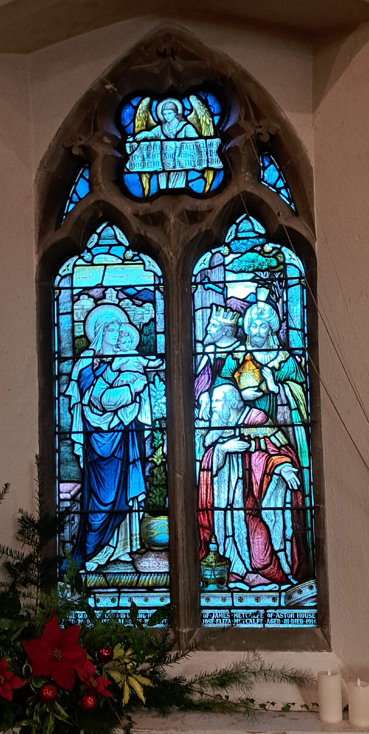

Collect Prayer for 1st Sunday of Epiphany
Eternal Father, who at the baptism of Jesus revealed him to be your Son, anointing him with the Holy Spirit: grant to us, who are born again by water and the Spirit, that we may be faithful to our calling as your adopted children; through Jesus Christ your Son our Lord, who is alive and reigns with you, in the unity of the Holy Spirit, one God, now and for ever. Amen.

Another north west facing window in St Mary’s Church, Aston, showing the three Kings visiting the baby Jesus. Inscription(The Gentiles shall come to thy light and Kings to the brightness of thy rising).


MISSING YOU TREE ribbons are available in each church under the Missing You Tree. There is a pen for you to write your loved ones’ names and any messages to remember those we love who are with God.

From All Souls 2nd NOV 2025 to Candlemas 2nd FEB 2026
They whom we love and lose are no longer where they were before.
They are now wherever we are. (St. John Chrysostom)

PRAY for PEACE in ISRAEL and GAZA, UKRAINE and all areas of conflict


Lord God, though peace seems humanly impossible,

we continue to pray for an end to violence and bloodshed.

We pray your comfort for the fearful and broken – hearted.


Change the hearts of those set on revenge and destruction.

Give wisdom to world leaders as they respond to aggression.

Bless all who work for understanding, reconciliation and justice which alone bring lasting peace. Amen.

‘God give us peace that lasts, not through the fear of might, but through the force of love, and love of life and right’. Amen


As we remember Jesus’ baptism in the River Jordan on Sunday
we give thanks for our own baptism, for the people and churches who have helped us grow in faith and love.
We pray for everyone who has been baptised in our village churches. May they know they are loved by their Heavenly Father, whatever they achieve or don’t achieve, whatever they believe or don’t believe.
Some Prayers from the Baptism Service
God our Creator,
We thank you for the wonder of new life and the mystery of human love.
We give thanks for all whose support and skill surround the beginning of life.
As Jesus knew love and discipline within a human family, may our children grow in strength and wisdom. As Mary knew the joys and pains of motherhood, give parents your sustaining grace and love; through Jesus Christ our Lord. Amen.
'Lord, teach me to know you more, to love you more and serve you more faithfully in my life.' (St Ignatius' prayer)

Hymn 376 HAM. In Christ there is no east or west. Author John Oxenham

1. In Christ there is no east or west,  In him no south or north,  But one great fellowship of love  Thru'out the whole wide Earth.  2. In him shall true hearts everywhere  Their high communion find.  His service is the golden cord  Close binding humankind | 3. Join hands, then, children of the faith,  Whate'er your race may be!  Who serves my Father as a child  Is surely kin to me.  4. In Christ now meet both east and west,  In him meet south and north;  All Christly souls are one in him,  Thru'out the whole wide Earth.

We believe that responding to the climate crisis is an essential part of our responsibility to safeguard God's creation and achieve a just world. Climate change hits hardest the poorest countries and poorest people of the world. Meantime, the widespread destruction of the natural world is a crisis for creation.

Our Environment Programme exists to enable the whole Church to address this — in faith, practice and mission. This includes tackling our own carbon emissions (aiming for Net Zero Carbon by 2030) and our wider work. More information can be found using the following web-link: http://www.churchofengland.org/about/church-england-environment-programme#na

Energy Hub Funded by UK Government: Find out how to:

1. Save energy

2. Save money. Reduce energy bills

3. Reduce carbon. Improve energy footprint

4.Increase comfort

For useful resources and guidance on where to get started visit: linktr.ee/energy_hub



https://app.ecochurch.org/user/21703/summary

As the days start to get longer prepare your home for cooler days and nights. Research suggests an average 40% of home heating is lost through gaps around windows, doors, loft hatches and floorboards. Extra insulation, and fixing drafts saves energy. Put some draft excluder around windows and outside doors. Fit a weather proof letter box. Fit thermal linings for some thin curtains. They are cheap and really easy to clip in. Try to think of one thing to do – it saves energy and is good for the planet too.

NEW RECTOR RECRUITMENT UPDATE – Sadly it was not possible to appoint a new Rector to the Benefice following our initial advertisement which closed at the end of October. A second recruitment drive will take place early in 2026 supported, as before, by the Diocese. In the meantime, services in each of our churches continue so please JOIN US this Christmastime to celebrate the Festive Season!

CARING for our CHURCHYARDS

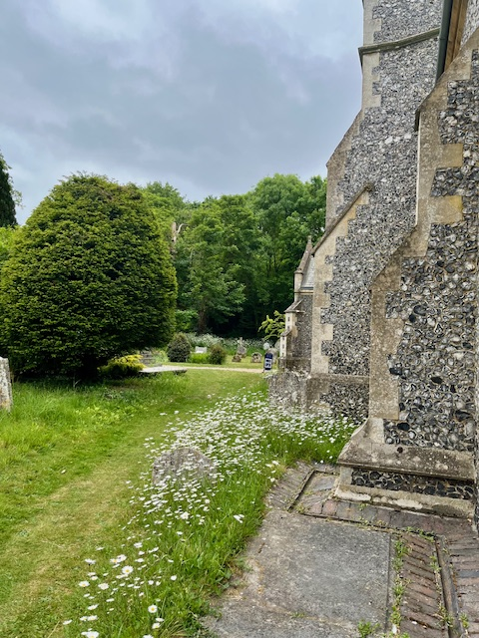
TUESDAYS Waterford Working Parties – Contact Churchwarden Malcolm Wandrag to offer help m.t.wandrag@gmail.com
To help in Stapleford or Watton or Bramfield please contact the Churchwardens.ASTON church open Sundays 12.00-16.00 and Wednesdays 10.00 -17.00 Church and churchyard working parties first Tuesday of month 10am to 12 noon. Contact Churchwarden Sara wardenstmarys@gmail.com
All our churchyards are cared for by volunteers.
Donations and offers of help are welcomed.
To include a loved one in the Book of Remembrance contact the churchwardens

Prayer for Growth for Aston, Bramfield, Stapleford, Waterford and Watton at Stone
Jesus teaches us to pray for our churches to grow. Jesus says: ‘Ask the Lord of the harvest, therefore, to send out workers into his harvest field’ (Matthew 9:38). In ways we don’t understand, God uses all our prayers.

Heavenly Father, you call us to sow seeds of faith in our communities. We ask you to fill us with your Holy Spirit that our lives may show the joy and new life we have in you. Guide our speaking and actions that others may be drawn to know your love. Lord Jesus, bless our churches that we may grow in numbers, love and service. We ask this in your name. Amen.
We pray for others to know God’s love.

Tie 5 knots in a piece of string - let each knot represent a friend or family member. Keep the string in your pocket and, as you feel the string, pray for those people to know God’s love. Set an alert on your phone to remind you to pray for those 5 people every day.

A prayer for those who seek to know God.
Lord Jesus, when your followers walked the Emmaus road wondering what was true and what was not, you came alongside them and revealed yourself in Scripture and in broken bread. Come alongside those we know and love who may wonder or seek at this time. Reveal yourself in your love and make us ready to walk alongside them too, until they see your face and know your presence. Amen.
Heavenly father we pray for guidance for our Beane valley benefice churches during the vacancy. Amen.
Our prayers are also with the new Archbishop of Canterbury designate, The Rt Revd and Rt Hon Dame Sarah Mullally DBE as she becomes the 106th Archbishop of Canterbury and the first woman to lead the Anglican Church.

In Touch Age UK Hertfordshire
offer confidential, non-judgemental emotional and practical support on bereavement, physical & mental health issues, cancer, end of life, a partner with dementia or any other problem. Call 01992 634964/630623 or email intouch@ageukherts.org.uk Web page Age UK Hertfordshire | Our Services
Bereavement Support You can access online help at griefshare.org











thebereavementjourney.org cruse.org.uk teardropgrief.co.uk ataloss.org
’s
afternoon
Tea

rty
at 64 Rivershill
Sunday 24th July 2.00-5.oopm

Bring & Buy <> Raffle <> Jams
Proceeds to Both

TAKE AWAY AVAILABLE

