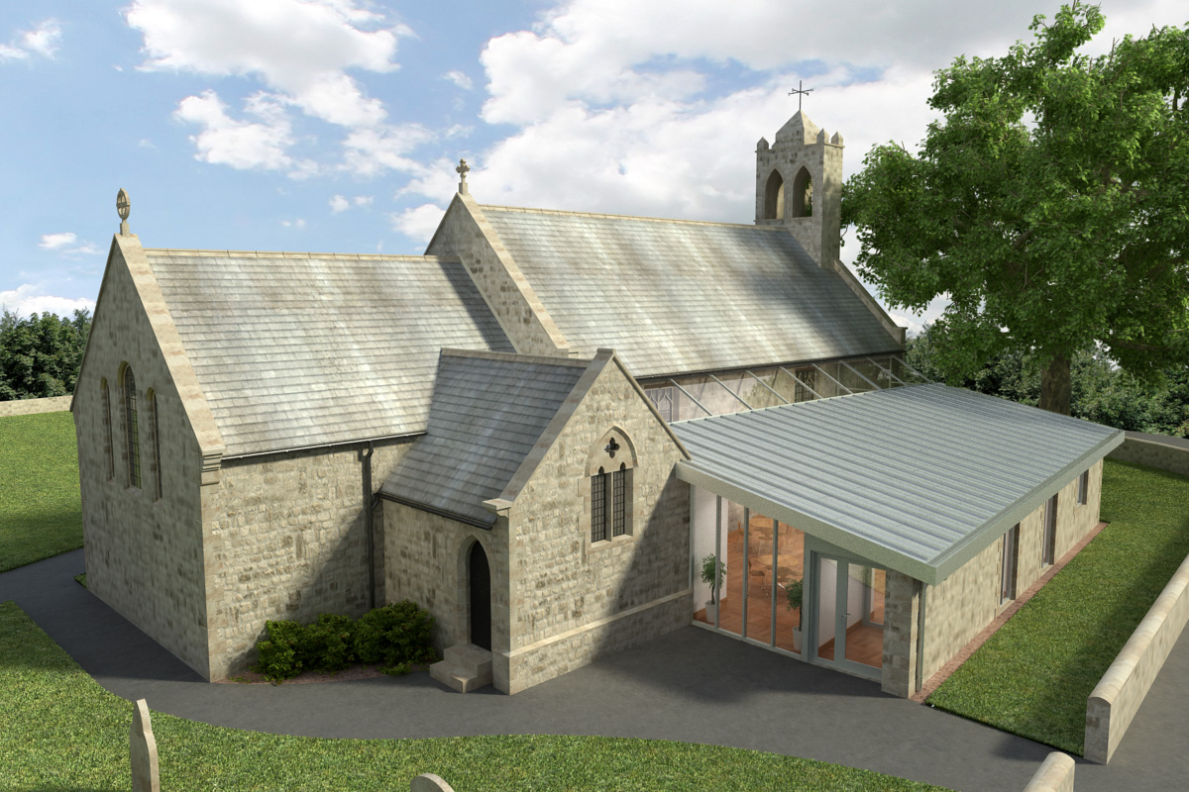
St Mary’s Parish Church, Longframlington

Welcome to our Sunday Morning Prayer. This morning, on Sunday11th January which is Epiphany 1 (The Baptism of Christ), our Officiant today is the Rev Rich, and Tony playing the organ. Our officiant next week will be the Rev Gabby Llewelyn (good to have her back with us) and Steve playing the organ.
We are now going to welcome our friends from the URC church who are joining us permanently, postponed to 15th February. Their service will be at 11.15 am following shared coffee after our service and we look forward to them being with us.
Our church is open all weekdays from 9 am – 4 pm in the winter for a quiet time and prayer. Candles may be lit.
Coming up at St Mary’s and our sister parishes+- Morning Prayer in St Mary’s – and on Zoom – usually every Wednesday morning at 9.30 am followed by coffee in the Community Room. The Link can be accessible using Meeting ID 889 6133 2870, Password 093043. There will be the normal service on Wednesday next the 30th December at 9.30 am..
ALPHA – starting Thursday January 15th 7 pm weekly in St Mary’s Community Room please contact Rev Rich for more details and notice if you wish to attend. RevRichtea@gmail.com
January 23rd from 4 pm – 5 pm a Baptism preparation Session for those seeking more information.
Candlemas – first Sunday in February service with candles and prayers in St Mary’s.
Due to various reasons the list of people who are prepared to read lessons in church and/or prepare Intercessions is getting a bit sparse. If you are interested in taking part please get in touch with Audrey who will talk you through it.
The next Warm Hub Lunch is on Thursday 22nd January at 12 noon, please contact Pat.
The Epistle reading to be shown in the service sheet for those who wish to use it.
Thank you for your giving to the life and work of our church. Our offering is taken during the third hymn, and there is a collection giving point at the back of the church for use after the service if you prefer. Regular giving by Standing Order with Gift Aid is particularly valuable to the church – speak to Audrey (01665 570 922) for more information and blank forms. All our news and much more available on our Facebook page https:www.facebook.com/SMCLongfram/?ti=as and
You Tube channelhttps:www.youtube.com/@stmichaelsfeltonstmaryslon4157
Priest in Charge: Rev Rich Townend Phone 01670 719470 Email:revrichtea@gmail.com Regular day off: Monday, for St Mary’s information contact Veronica Thomson (01665 570 807) or Audrey Truman ( 01665 570922).

