SUNDAY 1st February 2026.




Loving God and Loving our Neighbour

Although we are currently without a permanent Rector, services in the Benefice continue with the assistance of visiting clergy. Please do join us – you will be made very Welcome!!

Sunday 1st February Epiphany 4
Candlemas End of missing you ribbons.

11am Watton Contemporary service
11am Aston Prayer and Praise
11.15am Stapleford Prayer and Praise
11.15am Waterford Holy Communion

Sunday 8th February 2 Before Lent.
9.30am Watton Holy Communion
11am Watton Contemporary service
11am Aston Family Service
11.15am Bramfield Holy Communion
11.15am Stapleford Prayer and Praise


Snowdrops are ‘Candlemas Bells’. The white flowers on an upright green stem remind us of Jesus, the Light of the World.
White traditionally is the colour of purity. The white flowers remind us of Mary, Jesus’ mother, who brings baby Jesus to the Temple to give thanks and be cleansed, according to Jewish Law.

MIDWEEK
Fortnightly MONDAY 2pm ASTON Bible Study Fellowship 3 Long Ridge Aston with tea and biscuits. All are welcome. Next meeting Monday 2nd February Contact Pauline at pauline.manley1966@gmail.com

NIGHT PRAYER Alternate WEDNESDAYS at 7.30pm on ZOOM. Next meeting Wednesday 4th February. Contact Tim Alexander for link tim_alexander3@hotmail.com


Wednesday 18th February 2.30pm Stapleford village Tea afternoon in Church. All are welcome for tea, coffee cake and chat.


Collect Prayer for 4rd Sunday of Epiphany
God our creator, who in the beginning commanded the light to shine out of darkness: we pray that the light of the glorious gospel of Christ may dispel the darkness of ignorance and unbelief, shine into the hearts of all your people, and reveal the knowledge of your glory in the face of Jesus Christ your Son our Lord, who is alive and reigns with you, in the unity of the Holy Spirit, one God, now and for ever. Amen.

Another north west facing window in St Mary’s Church, Aston, showing the three Kings visiting the baby Jesus. Inscription(The Gentiles shall come to thy light and Kings to the brightness of thy rising).

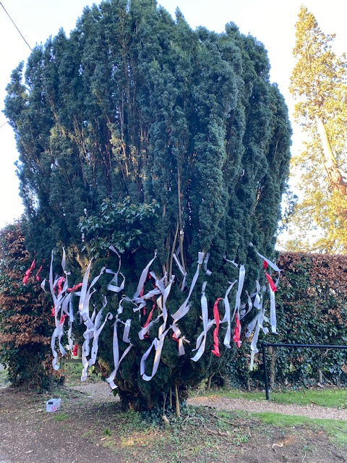
MISSING YOU TREE ribbons are available in each church under the Missing You Tree. There is a pen for you to write your loved ones’ names and any messages to remember those we love who are with God.

From All Souls 2nd NOV 2025 to Candlemas 2nd FEB 2026

Ribbons will be removed on Sunday February 1st and blessed in church.
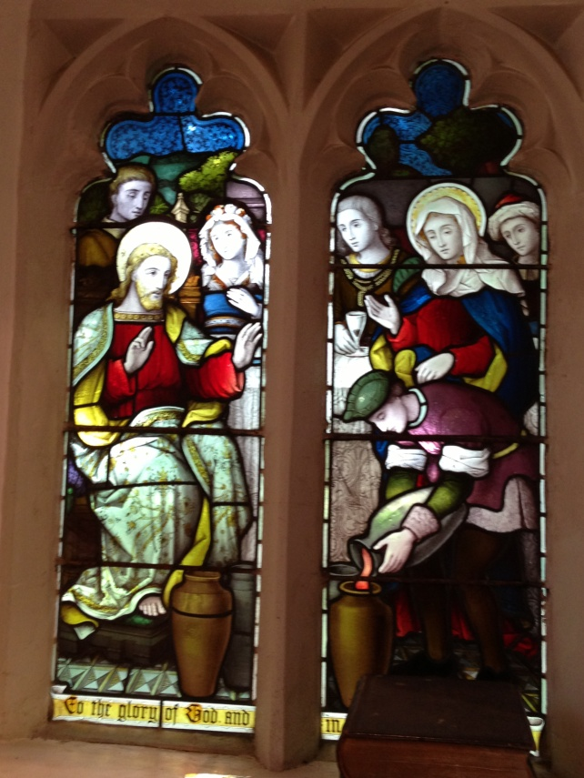

PRAY for PEACE in ISRAEL and GAZA, UKRAINE and all areas of conflict


Lord God, though peace seems humanly impossible,

we continue to pray for an end to violence and bloodshed.

We pray your comfort for the fearful and broken – hearted.


Change the hearts of those set on revenge and destruction.

Give wisdom to world leaders as they respond to aggression.

Bless all who work for understanding, reconciliation and justice which alone bring lasting peace. Amen.

‘God give us peace that lasts, not through the fear of might, but through the force of love, and love of life and right’. Amen

A Poem for Candlemas
When candles are lighted on Candlemas Day
the dark is behind us and Spring's on the way.
The kings have departed, the shepherds have gone,
the child and his parents are left on their own.
They gaze at God's wonderful answer to prayer,
the joy of the Jews and the Gentiles' desire.

They go to the Temple, obeying the law,
and offer two pigeons, the gift of the poor.
But Anna and Simeon recognise there
the Christ-child who came at the turn of the year.
The old who have suffered and waited so long
see hope for the world as they welcome the young.

O Spirit of God, with like courage inspire
us everyday saints who face up to despair.
As we pass through temptation, through failure, through death,
when darkness descends may we plod on in faith.
Like Anna, like Simeon, may we have trust,
the eyes to see Jesus and peace at the last.
Our candles invite us to praise and to pray
When Christmas greets Easter on Candlemas day.

Hymn 212 HAM. All who would valiant be. Author: John Bunyan
The son of a mechanic, he was born at Elstow, 1628; was a Baptist minister at Bedford; and died in London, Aug. 1688
1. All who would valiant be  'Gainst all disaster,  Let them in constancy  Follow the master.  There's no discouragement  Shall make them once relent  Their first avowed intent  To be true pilgrims.  2. Who so beset them round  With dismal stories,  Do but themselves confound;  Their strength the more is.  No foes shall stay their might;  Though they with giants fight,  They will make good their right  To be true pilgrims. | 3. Since, Lord, you will defend  Us with your Spirit,  We know we at the end  Shall life inherit.  Then fancies flee away!  We'll fear not what they say,  We'll labor night and day  To be true pilgrims.

We believe that responding to the climate crisis is an essential part of our responsibility to safeguard God's creation and achieve a just world. Climate change hits hardest the poorest countries and poorest people of the world. Meantime, the widespread destruction of the natural world is a crisis for creation.

Our Environment Programme exists to enable the whole Church to address this — in faith, practice and mission. This includes tackling our own carbon emissions (aiming for Net Zero Carbon by 2030) and our wider work. More information can be found using the following web-link: http://www.churchofengland.org/about/church-england-environment-programme#na

Energy Hub Funded by UK Government: Find out how to:

1. Save energy

2. Save money. Reduce energy bills

3. Reduce carbon. Improve energy footprint

4.Increase comfort

For useful resources and guidance on where to get started visit: linktr.ee/energy_hub



https://app.ecochurch.org/user/21703/summary

EcoChurch - Tip for January
Are you planning to travel in 2026? Can you do so in a way that is good for our planet? We all know major sources of carbon and pollutants are cars and planes, with flying having a huge impact. We know it's best to walk, cycle, go by bus, take the train, or at least car share. For your holiday this year - can you travel by boat, or train? Could you cut out one flight? Why not challenge yourself to making a holiday, or work trip, more eco-friendly in 2026.
NEW RECTOR RECRUITMENT UPDATE – Rector for the Beane Valley Benefice
Vacancy advert is now on the St Albans website
https://www.stalbansdiocese.org/vacancies/rector-for-the-beane-valley-benefice/

CARING for our CHURCHYARDS


TUESDAYS Waterford Working Parties – Contact Churchwarden Malcolm Wandrag to offer help m.t.wandrag@gmail.com
To help in Stapleford or Watton or Bramfield please contact the Churchwardens.ASTON church open Sundays 12.00-16.00 and Wednesdays 10.00 -17.00 Church and churchyard working parties first Tuesday of month 10am to 12 noon. Contact Churchwarden Sara wardenstmarys@gmail.com
All our churchyards are cared for by volunteers.
Donations and offers of help are welcomed.
To include a loved one in the Book of Remembrance contact the churchwardens

Prayer for Growth for Aston, Bramfield, Stapleford, Waterford and Watton at Stone
Jesus teaches us to pray for our churches to grow. Jesus says: ‘Ask the Lord of the harvest, therefore, to send out workers into his harvest field’ (Matthew 9:38). In ways we don’t understand, God uses all our prayers.

Heavenly Father, you call us to sow seeds of faith in our communities. We ask you to fill us with your Holy Spirit that our lives may show the joy and new life we have in you. Guide our speaking and actions that others may be drawn to know your love. Lord Jesus, bless our churches that we may grow in numbers, love and service. We ask this in your name. Amen.
We pray for others to know God’s love.

Tie 5 knots in a piece of string - let each knot represent a friend or family member. Keep the string in your pocket and, as you feel the string, pray for those people to know God’s love. Set an alert on your phone to remind you to pray for those 5 people every day.

A prayer for those who seek to know God.
Lord Jesus, when your followers walked the Emmaus road wondering what was true and what was not, you came alongside them and revealed yourself in Scripture and in broken bread. Come alongside those we know and love who may wonder or seek at this time. Reveal yourself in your love and make us ready to walk alongside them too, until they see your face and know your presence. Amen.
Heavenly father we pray for guidance for our Beane valley benefice churches during the vacancy. Amen.

Our prayers are also with the new Archbishop of Canterbury, the Rt Revd and Rt Hon Dame Sara Mullally DBE as she becomes the 106th Archbishop of Canterbury. Confirmation of the Election of The Archbishop of Canterbury service was held on Wednesday 28th January at St Paul’s Cathedral.

Prayers for the next Bishop of St Albans
Thank you for your prayers for the interviews held last week for the next Bishop of St Albans. A message from Archdeacon Dave, one of the six on the Crown Nominations Commission (CNC), said last week:
“Thank you for your prayers and support. We are conscious of the many prayers from across the diocese, especially in the last week or so, and very much feel supported. We will endeavour to discern, under God and led by His Holy Spirit, who God is calling to be the next Bishop of St Albans.”
We ask you to continue to join us in prayer as the process continues. A reminder of the timeline can be found on the diocese website here.

In Touch Age UK Hertfordshire
offer confidential, non-judgemental emotional and practical support on bereavement, physical & mental health issues, cancer, end of life, a partner with dementia or any other problem. Call 01992 634964/630623 or email intouch@ageukherts.org.uk Web page Age UK Hertfordshire | Our Services
Bereavement Support You can access online help at griefshare.org











thebereavementjourney.org cruse.org.uk teardropgrief.co.uk ataloss.org
’s
afternoon
Tea

rty
at 64 Rivershill
Sunday 24th July 2.00-5.oopm

Bring & Buy <> Raffle <> Jams
Proceeds to Both

TAKE AWAY AVAILABLE

