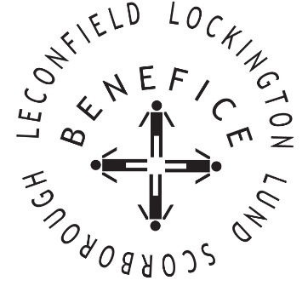

Church Services for
February 2026
Wherever you are from, you are welcome to join us for any of these services

Sunday 1st 9:30am Holy Communion St Leonard’s Scorborough

11:00am Morning Worship St Mary’s Lockington

Wednesday 4th . 9:30am Mid Week Service
With healing prayers St Mary’s Lockington

Sunday 8th 9:30am Holy Communion St Mary’s Lockington

11:00am Morning Worship All Saint’s Lund

Sunday 15th 9:30am Holy Communion St Mary’s Lockington

Wednesday 18th 9:30am Mid Week Service
With healing prayers St Catherine’s Leconfield

Wednesday 18th 7:00pm Ash Wednesday
Communion St Mary’s Lockington

Sunday 22nd 9:30am Holy Communion All Saints Lund

11:00am Contemporary Worship St Mary’s Lockington

Thursday 26th 7:00pm Celtic Communion St Catherine’s Leconfield

Service times, events and Messenger can also be found at:
http://www.achurchnearyou.com for the four churches

