ORGANISATIONS & ACTIVITIES
Some meetings are term-time only - please check with organisers.
Meetings are held at St Mary’s church unless otherwise stated.

MONDAY

48th Nottingham Beavers (boys & girls, 6-8 years)
6.15pm – 7.15pm Tel: 0115 877 6569 or 07976 300013

TUESDAY

87th Nottingham Brownies (7-10 years)
6pm -7.30pm Tel: 07596 758440.

WEDNESDAY

Bestwood & Bulwell Foodbank
1pm – 3.00pm
Tel: 07527 048226
Email: info@bestwoodbulwell.foodbank.org.uk

Polish Speaking Al-Anon Group ‘Spokoj’
6.30pm – 8.30pm
https://al-anonuk.org.uk/about-us/

THURSDAY

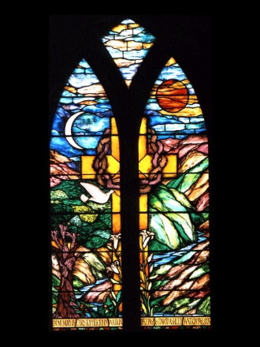
88th Nottingham Brownies (7-10 years)
6.00pm – 7.30pm
Tel: 07817 3786543

87th Nottingham Guides (10-15 years)
7.00-9.00pm
Tel: 07793 823440

Rangers (age 14+)
7.00pm to 9.00pm
Tel: 07786 226663

FRIDAY

Rainbows
5.15pm to 6.15pm
Tel: 07812 160455 (Ed. Jan 2026)
WHAT’S ON
at
St Mary the Virgin & All Souls Church
Highbury Road, Bulwell, Nottingham, NG6 9AD

Find us on Facebook, YouTube and
www.achurchnearyou.com

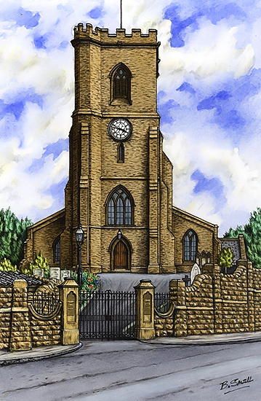






MINISTERS

VICAR

Fr Andrew Fisher AOJN BA(Min), MTh(Dist)
Tel: 0115 975 5358 Email: a.j.fisher@outlook.com

HONORARY ASSOCIATE PRIEST

The Revd. Bob Stephens Tel: 07775 422260 Email: revbob63@sky.com

LICENSED LAY MINISTER

Juliet Twumasi Email: Jto2025@hotmail.com

Baptisms, wedding and funeral enquiries welcome, as are requests for prayer.
Home visits and House Blessings by appointment.

CHURCH SERVICES & GROUPS

WEDNESDAY

Little Acorns Toddler Group 9.30am – 11am
Email Zoe Elliott at: zoejackson000@gmail.com for more information

Bellringing (Practice Night)
(all ages from 11 years, under 18s must be accompanied by an adult)
8pm – 9pm
Tel: Tower Captain, Michael Varney 07858 653002

THURSDAY

Midweek Mass
9.30am – 10am First Thurs of the month follows the Book of Common Prayer.
Last Thursday of the month Walsingham Mass)

Care Home Service
11am – 11.30am at one of the local Care Homes

Bible Study/Nurture Courses
2pm Please contact the Vicar for more information

Pub Social
7.30pm First Thursday of the Month
at the William Peveril (Wetherspoons) in Bulwell
FRIDAY

Choir Practice
3pm Saturday. Email: Alan Jackson (Choirmaster) vivid.blue63@yahoo.co.uk

SATURDAY

Church Open for Prayer
10am – 12pm with Terce, Exposition of the Blessed Sacrament, the Rosary and the Angelus
every second Saturday of the month.

Muddy Church
11.30am Third Saturday of the month during term time
Email Zoe Elliott at: zoejackson000@gmail.com for more information

SUNDAY – SERVICES

10am – 11am First Sunday of the Month – Family Mass (and Baptisms)
4pm – 4.30pm First Sunday of the month, Service of Holy Communion at Highbury Hospital.
10am – 11am Second Sunday of the month - Parish Mass (sung) with Whiz Kids Sunday
School during Mass
10am – 11am Third Sunday of the Month – Family Mass (led by our Whiz Kids Sunday
School)
10am – 11am Fourth Sunday of the month - Parish Mass (sung) with Whiz Kids Sunday
School during Mass
10am – 11am Fifth Sunday of the Month – Healing Service (with Communion and Anointing)
with Whiz Kids Sunday School during the service
6pm occasional Sundays, Healing Service and Benediction

Please see notice sheets / magazine for any additional and seasonal services.

BELLRINGING
Sunday Service Ringing 9.30am – 10am.
Practice Evening (Weds) 7.30pm – 9.00pm
(all ages from 11 years, under 18s must be accompanied by an adult)
Tel: Tower Captain, Michael Varney 07858 653002

SERVERS & EUCHARISTIC MINISTERS
Please contact the Vicar for more information

CHURCH CHOIR
(Ages 11 and upwards)
Please contact: Alan Jackson (Choirmaster) at: vivid.blue63@yahoo.co.uk

