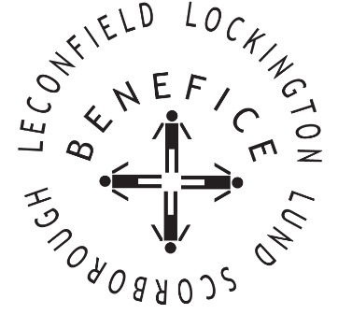

Church Services for
January 2026
Wherever you are from, you are welcome to join us for any of these services

Sunday 4th 9:30am Holy Communion St Catherine’s Leconfield

11:00am Morning Worship St Mary’s Lockington

Wednesday 7th . 9:30am Mid Week Service
With healing prayers St Mary’s Lockington

Sunday 11th 9:30am Holy Communion St Leonard’s Scorborough

11:00am Morning Worship All Saint’s Lund

Sunday 18th 9:30am Holy Communion St Mary’s Lockington

Wednesday 21st 9:30am Mid Week Service
With healing prayers St Catherine’s Leconfield

Thursday 22ned 7:00pm Celtic Evening Prayers St Catherine’s Leconfield

Sunday25th 9:30am Holy Communion All Saints Lund

11:00am Contemporary Worship St Mary’s Lockington

Service times, events and Messenger can also be found at:
http://www.achurchnearyou.com for the four churches

