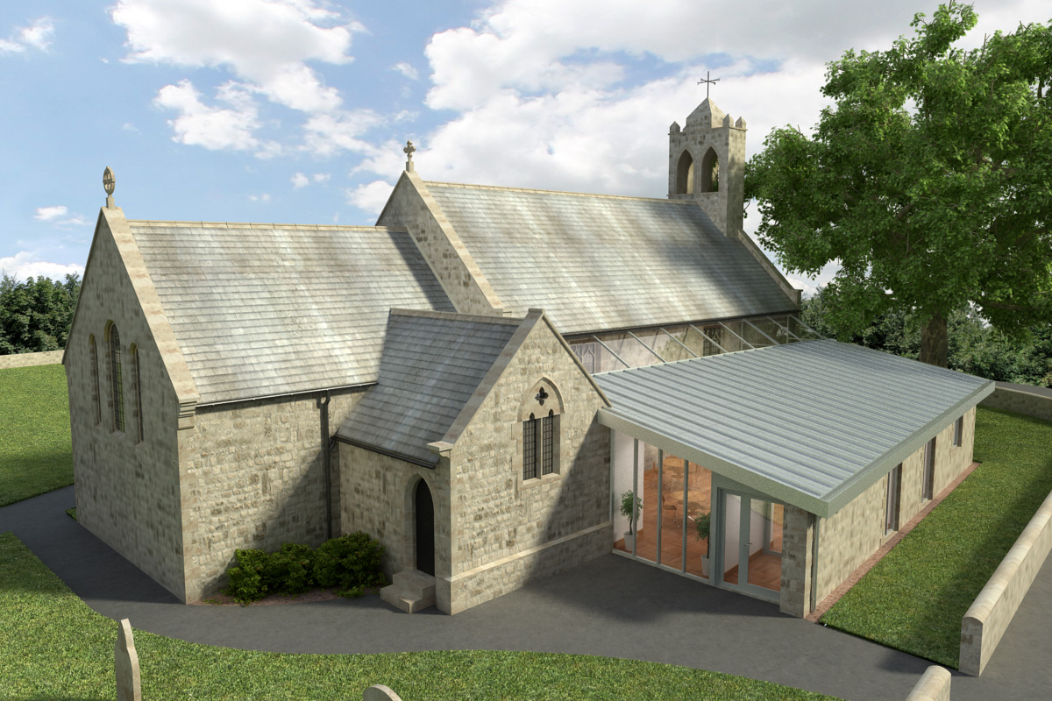
St Mary’s Parish Church, Longframlington

Welcome to our Sunday Morning Prayer. On Sunday 14 December, which is Advent 3, our Officiant today is the Rev Michael, and Tony playing the organ. Our Officiant next week will be the Rev Rich, and Steve playing the organ.
Coming up at St Mary’s and our sister parishes+- Morning Prayer in St Mary’s – and on Zoom – usually every Wednesday morning at 9.30 am followed by coffee in the Community Room. The Link can be using Meeting ID889 6133 2870, Password 093043. There is no service on Wednesdays 17th December or 24th December.
The last of the Reflections will be on Tuesday 16th December at 7 pm in the URC Church.
The Carol Service will be on Wednesday 17th December at 7 pm. There will be a choir and several members of the congregation will be reading Lessons. Followed by Mulled
Wine and Mince pies after the service. Gifts welcome.
Audrey still collecting monies for the Christmas Flowers and other Sundays in the year.
Cards are being delivered to houses around the village, any on the Font please see if you can help in any way.
Church clean to come, date to be advertised please watch out for.
This year there will be a Crib Service (Christmas Eve) before the Midnight Service and Christmas morning service, at 4 pm in church.
Future Notice: ALPHA – There will be an Alpha course starting in Longframlington on Thursday 15 January. Please contact Rich for more details. Rich’s details at foot of Pew Sheet.
Thank you for your giving to the life and work of our church. Our offering is taken during the third hymn, and there is a collection giving point at the back of the church for use after the service if you prefer. Regular giving by Standing Order with Gift Aid is particularly valuable to the church – speak to Audrey (01665 570 922) for more information and blank forms. All our news and much more available on our Facebook page https:www.facebook.com/SMCLongfram/?ti=as and You Tube channelhttps:www.youtube.com/@stmichaelsfeltonstmaryslonPriest in Charge: Rev Rich Townend Phone 01670 719470 Email:revrichtea@gmail.com Regular day oMonday, for St Mary’s information contact Veronica Thomson (01665 570 807) or Audrey Truman ( 01665 570922).

