Advent week 1 – Building a Peace:
Lighting of a candle:
We light our candle to remind us that the light of Christ is always present amongst us as meet together.

Opening Prayer
God of hope, be with us in our Advent journey to the stable and beyond; be with us in our worship and our praying together; be with us in our Advent journey to the stable and beyond, our God of hope. Amen

Opening Thoughts
We meet to reflect on the theme of PEACE. We will use a passage from the letter to Philippians 4 as our guide. We will read the passage a couple of times, and then share what arises for us and reflect on PEACE in our own lives.

Lectio Divina
1. We ask the Holy Spirit to guide our reading, our listening, and our sharing.
2. We read the passage and share a single word or phrase that speaks to us.
3. We re-read the passage and share a word or phrase that speaks. After hearing all people we share a bit more about what the word or phrase is saying to us.
4. We hear the passage a final time and then have a period of silent prayer in which we open ourselves up to what God wants us to take away from this time.

Passage
Rejoice in the Lord always; again I will say, Rejoice. Let your gentleness be known to everyone. The Lord is near. Do not worry about anything, but in everything by prayer and supplication with thanksgiving let your requests be made known to God. And the peace of God, which surpasses all understanding, will guard your hearts and your minds in Christ Jesus. Finally, beloved, whatever is true, whatever is honourable, whatever is just, whatever is pure, whatever is pleasing, whatever is commendable, if there is any excellence and if there is anything worthy of praise, think about these things. Keep on doing the things that you have learned and received and heard and seen in me, and the God of peace will be with you.
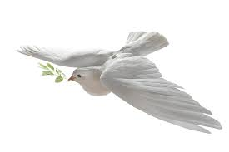
Questions
How might we nurture peace within our own lives every day?
What is this world’s biggest obstacle to peace? What is our biggest obstacle?
When does the God of Peace call us to ‘turn over the tables’ in the temple, or challenge the Pharisees of our day?
How does peace differ from Resignation, or from Surrender?
Is peace a gift from God? If so, what is our role in making peace?

Activity
We listen to Dona Nobis Pacem (Grant us Peace) sung by 6 young Ukrainians (https://www.youtube.com/watch?v=xozf8-SRHi0&list=RDxozf8-SRHi0&start_radio=1)
And whilst listening there is an invitation to take a tea light and place it in front of the candle and annunciation of Mary painting. Each light represents our desire for the peace of God which passes all understanding to be present in this place, and in our lives.

Final Prayer
God of Peace, help each one of us to be a peacemaker in our relationships, our community, and the world around us. Give us a heart that values unity over division, humility over pride, and love over resentment. Teach us to listen before we speak, to seek understanding over being right, and to extend grace even when it is undeserved. Let our actions reflect your everlasting peace, so that others may see you in us and be drawn to the true peace that only you can give. In Jesus’ name we pray. Amen.

We close with the words of the Grace
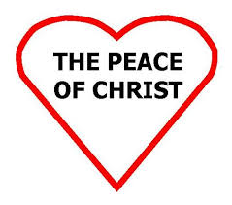
May the grace of our Lord Jesus Christ, and the love of God, and the fellowship of the Holy Spirit, be with us all evermore. Amen

