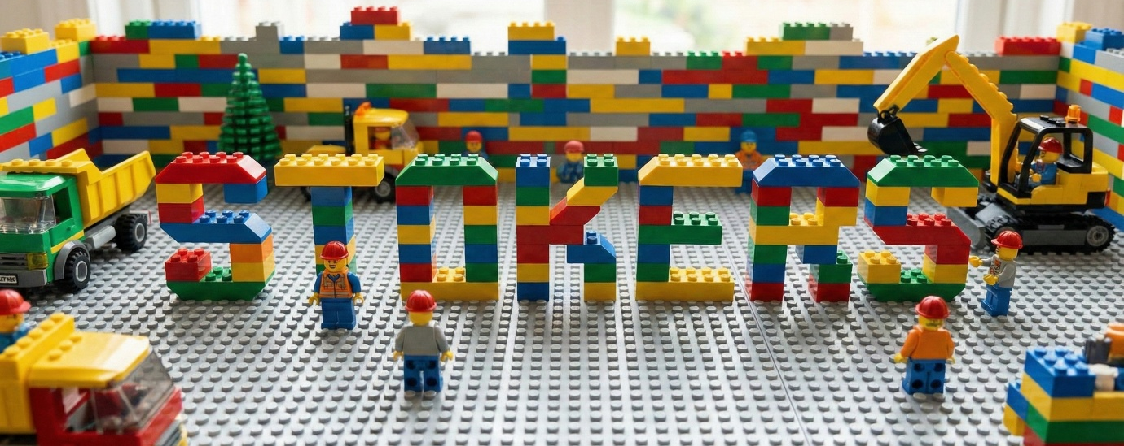
Are you between 4 and 12 years old?

Join us for a special ‘Lego’ themed Stokers!

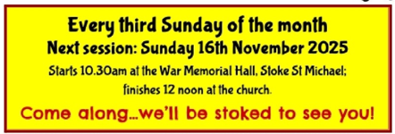
Sunday 18th January, 10.30 in the Hall

Email: sundaystokers@gmail.com for more information

