SUNDAY 7th December 2025.



Loving God and Loving our Neighbour

Although we are currently without a permanent Rector,

services in the Benefice continue with the assistance of

visiting clergy. Please do join us – you will be made very

welcome!!

Sunday 7th December ADVENT 2
11.00am Watton Contemporary service
11.00am Aston Prayer and Praise
11.15am Waterford Holy Communion
4pm Stapleford Gifts and Carols service

LOOKING AHEAD

Sunday 14th December Advent 3
9.30am Watton Holy Communion
11am Watton Contemporary Service
11am Aston Family Service
11.15am Bramfield Holy Communion
11.15am Stapleford Prayer and Praise

You are welcome to attend ANY church

MIDWEEK

Fortnightly MONDAY 2pm ASTON Bible Study Fellowship 3 Long Ridge Aston with tea and biscuits. All are welcome. Next meeting Monday 15th December Contact Pauline at pauline.manley1966@gmail.com

St Andrew’s Bramfield Wednesday's 10am Morning Prayer – No service until further notice.

NIGHT PRAYER Alternate WEDNESDAYS at 7.30pm on ZOOM. Next meeting Wednesday 10th December on ZOOM. Contact Tim Alexander for link tim_alexander3@hotmail.com


7pm Wednesday 17th Dec Join the Watton church choir as we lead CAROL
SINGING at The Bull.

The Magic of Waterford Christmas Bazar Saturday 6th December. Fun starts at 1pm till 4pm. Christmas gifts and crafts


Collect Prayer for 2nd Sunday of Advent.
O Lord, raise up, we pray, your power and come among us,
and with great might succour us; that whereas, through our sins and wickedness we are grievously hindered
in running the race that is set before us, your bountiful grace and mercy may speedily help and deliver us;
through Jesus Christ your Son our Lord, to whom with you and the Holy Spirit, be honour and glory, now and for ever.
Amen.

The North west window in St Mary’s Church, Aston, showing the birth of Jesus with Mary and Joseph and the three shepherds in the back ground. (Inscription: Glory to God in the highest on earth peace goodwill toward men).

THE ADVENT RING
‘Come and light the candles on the advent ring
scattering the darkness while the world shall sing.

We are all God’s people, waiting in this place,
hoping that in Jesus we shall see God’s face.’

The Advent Ring has 5 candles for the 4 Sundays in Advent (usually 4 red or purple) and 1 for Jesus on Christmas day (white). The 4 candles represent the People of God, the Prophets, John the Baptist and Mary OR Hope, Peace, Joy and Love. The Green ring symbolises God’s everlasting love. Advent is the Church’s New Year – a good time for Advent resolutions: Worship more fully Spend less Give more Love all.


MISSING YOU TREE ribbons are available in each church under the Missing You Tree. There is a pen for you to write your loved ones’ names and any messages to remember those we love who are with God.

From All Souls 2nd NOV 2025 to Candlemas 2nd FEB 2026
They whom we love and lose are no longer where they were before.
They are now wherever we are. (St. John Chrysostom)

PRAY for PEACE in ISRAEL and GAZA, UKRAINE and all areas of conflict


Lord God, though peace seems humanly impossible,

we continue to pray for an end to violence and bloodshed.

We pray your comfort for the fearful and broken – hearted.


Change the hearts of those set on revenge and destruction.

Give wisdom to world leaders as they respond to aggression.

Bless all who work for understanding, reconciliation and justice which alone bring lasting peace. Amen.

‘God give us peace that lasts, not through the fear of might, but through the force of love, and love of life and right’. Amen

Hymn for 3nd Sunday of Advent (HAM 470) Author:Charles Edward Oakley

1 Hills of the North, rejoice,  river and mountain-spring,  hark to the advent voice;  valley and lowland, sing.  Christ comes in righteousness and love,  he brings salvation from above.  2 Isles of the Southern seas,  sing to the listening earth,  carry on every breeze  hope of a world's new birth:  In Christ shall all be made anew,  his word is sure, his promise true. | 4 Shores of the utmost West,  lands of the setting sun,  welcome the heavenly guest  in whom the dawn has come:  he brings a never-ending light  who triumphed o'er our darkest night.  5 Shout, as you journey home,  songs be in every mouth,  lo, from the North they come,  from East and West and South:  in Jesus all shall find their rest,  in him the universe be blest.

We believe that responding to the climate crisis is an essential part of our responsibility to safeguard God's creation and achieve a just world. Climate change hits hardest the poorest countries and poorest people of the world. Meantime, the widespread destruction of the natural world is a crisis for creation.
Our Environment Programme exists to enable the whole Church to address this — in faith, practice and mission. This includes tackling our own carbon emissions (aiming for Net Zero Carbon by 2030) and our wider work. More information can be found using the following web-link: http://www.churchofengland.org/about/church-england-environment-programme#na

Energy Hub Funded by UK Government: Find out how to:

1. Save energy

2. Save money. Reduce energy bills

3. Reduce carbon. Improve energy footprint

4.Increase comfort

For useful resources and guidance on where to get started visit: linktr.ee/energy_hub



https://app.ecochurch.org/user/21703/summary

In these autumn months don't forget to leave some water out for wildlife. A shallow dish of fresh water is good for birds, hedgehogs and many insects, keeping them hydrated and cool. If you have the space, a bigger long term project might be to create a pond in your garden.

As the days get shorter prepare your home for cooler days and nights. Research suggests an average 40% of home heating is lost through gaps around windows, doors, loft hatches and floorboards. Extra insulation, and fixing drafts saves energy. Put some draft excluder around windows and outside doors. Fit a weather proof letter box. Fit thermal linings for some thin curtains. They are cheap and really easy to clip in. Try to think of one thing to do - it saves energy and is good for the planet too.

NEW RECTOR RECRUITMENT UPDATE – Sadly it was not possible to appoint a new Rector to the Benefice following our initial advertisement which closed at the end of October. A second recruitment drive will take place early in 2026 supported, as before, by the Diocese. In the meantime, services in each of our churches continue so please JOIN US this Christmastime to celebrate the Festive Season!

CARING for our CHURCHYARDS

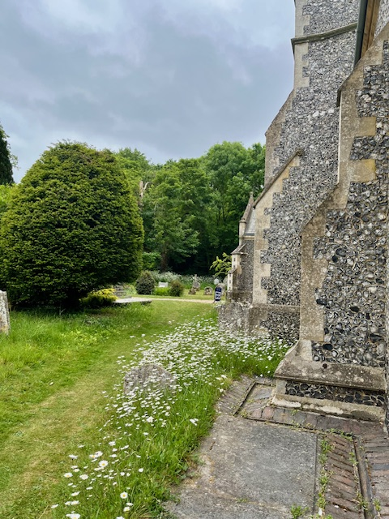
TUESDAYS Waterford Working Parties – Contact Churchwarden Malcolm Wandrag to offer help m.t.wandrag@gmail.com
To help in Stapleford or Watton or Bramfield please contact the Churchwardens.ASTON church open Sundays 12.00-16.00 and Wednesdays 10.00 -17.00 Church and churchyard working parties first Tuesday of month 10am to 12 noon. Contact Churchwarden Sara wardenstmarys@gmail.com
All our churchyards are cared for by volunteers.
Donations and offers of help are welcomed.
To include a loved one in the Book of Remembrance contact the churchwardens

Prayer for Growth for Aston, Bramfield, Stapleford, Waterford and Watton at Stone
Jesus teaches us to pray for our churches to grow. Jesus says: ‘Ask the Lord of the harvest, therefore, to send out workers into his harvest field’ (Matthew 9:38). In ways we don’t understand, God uses all our prayers.

Heavenly Father, you call us to sow seeds of faith in our communities. We ask you to fill us with your Holy Spirit that our lives may show the joy and new life we have in you. Guide our speaking and actions that others may be drawn to know your love. Lord Jesus, bless our churches that we may grow in numbers, love and service. We ask this in your name. Amen.
We pray for others to know God’s love.

Tie 5 knots in a piece of string - let each knot represent a friend or family member. Keep the string in your pocket and, as you feel the string, pray for those people to know God’s love. Set an alert on your phone to remind you to pray for those 5 people every day.

A prayer for those who seek to know God.
Lord Jesus, when your followers walked the Emmaus road wondering what was true and what was not, you came alongside them and revealed yourself in Scripture and in broken bread. Come alongside those we know and love who may wonder or seek at this time. Reveal yourself in your love and make us ready to walk alongside them too, until they see your face and know your presence. Amen.
Heavenly father we pray for guidance for our Beane valley benefice churches during the vacancy. Amen.
Our prayers are also with the new Archbishop of Canterbury designate, The Rt Revd and Rt Hon Dame Sarah Mullally DBE as she becomes the 106th Archbishop of Canterbury and the first woman to lead the Anglican Church.

InTouch Age UK Hertfordshire
offer confidential, non-judgemental emotional and practical support on bereavement, physical & mental health issues, cancer, end of life, a partner with dementia or any other problem. Call 01992 634964/630623 or email intouch@ageukherts.org.uk Web page Age UK Hertfordshire | Our Services
Bereavement Support You can access online help at griefshare.org
thebereavementjourney.org cruse.org.uk teardropgrief.co.uk ataloss.org












’s
afternoon
Tea

rty
at 64 Rivershill
Sunday 24th July 2.00-5.oopm

Bring & Buy <> Raffle <> Jams
Proceeds to Both

TAKE AWAY AVAILABLE

