SUNDAY 4th January 2026.




Loving God and Loving our Neighbour

Although we are currently without a permanent Rector, services in the Benefice continue with the assistance of visiting clergy. Please do join us – you will be made very Welcome!!

A VERY HAPPY NEW YEAR to ALL!
‘For surely I know the plans I have for you, says the Lord, plans for your welfare and not for harm, to give you a future with hope.’ (Jeremiah 29:11)
“What the New Year brings to you will depend a great deal
on what you bring to the New Year.” (Vern McLellan)

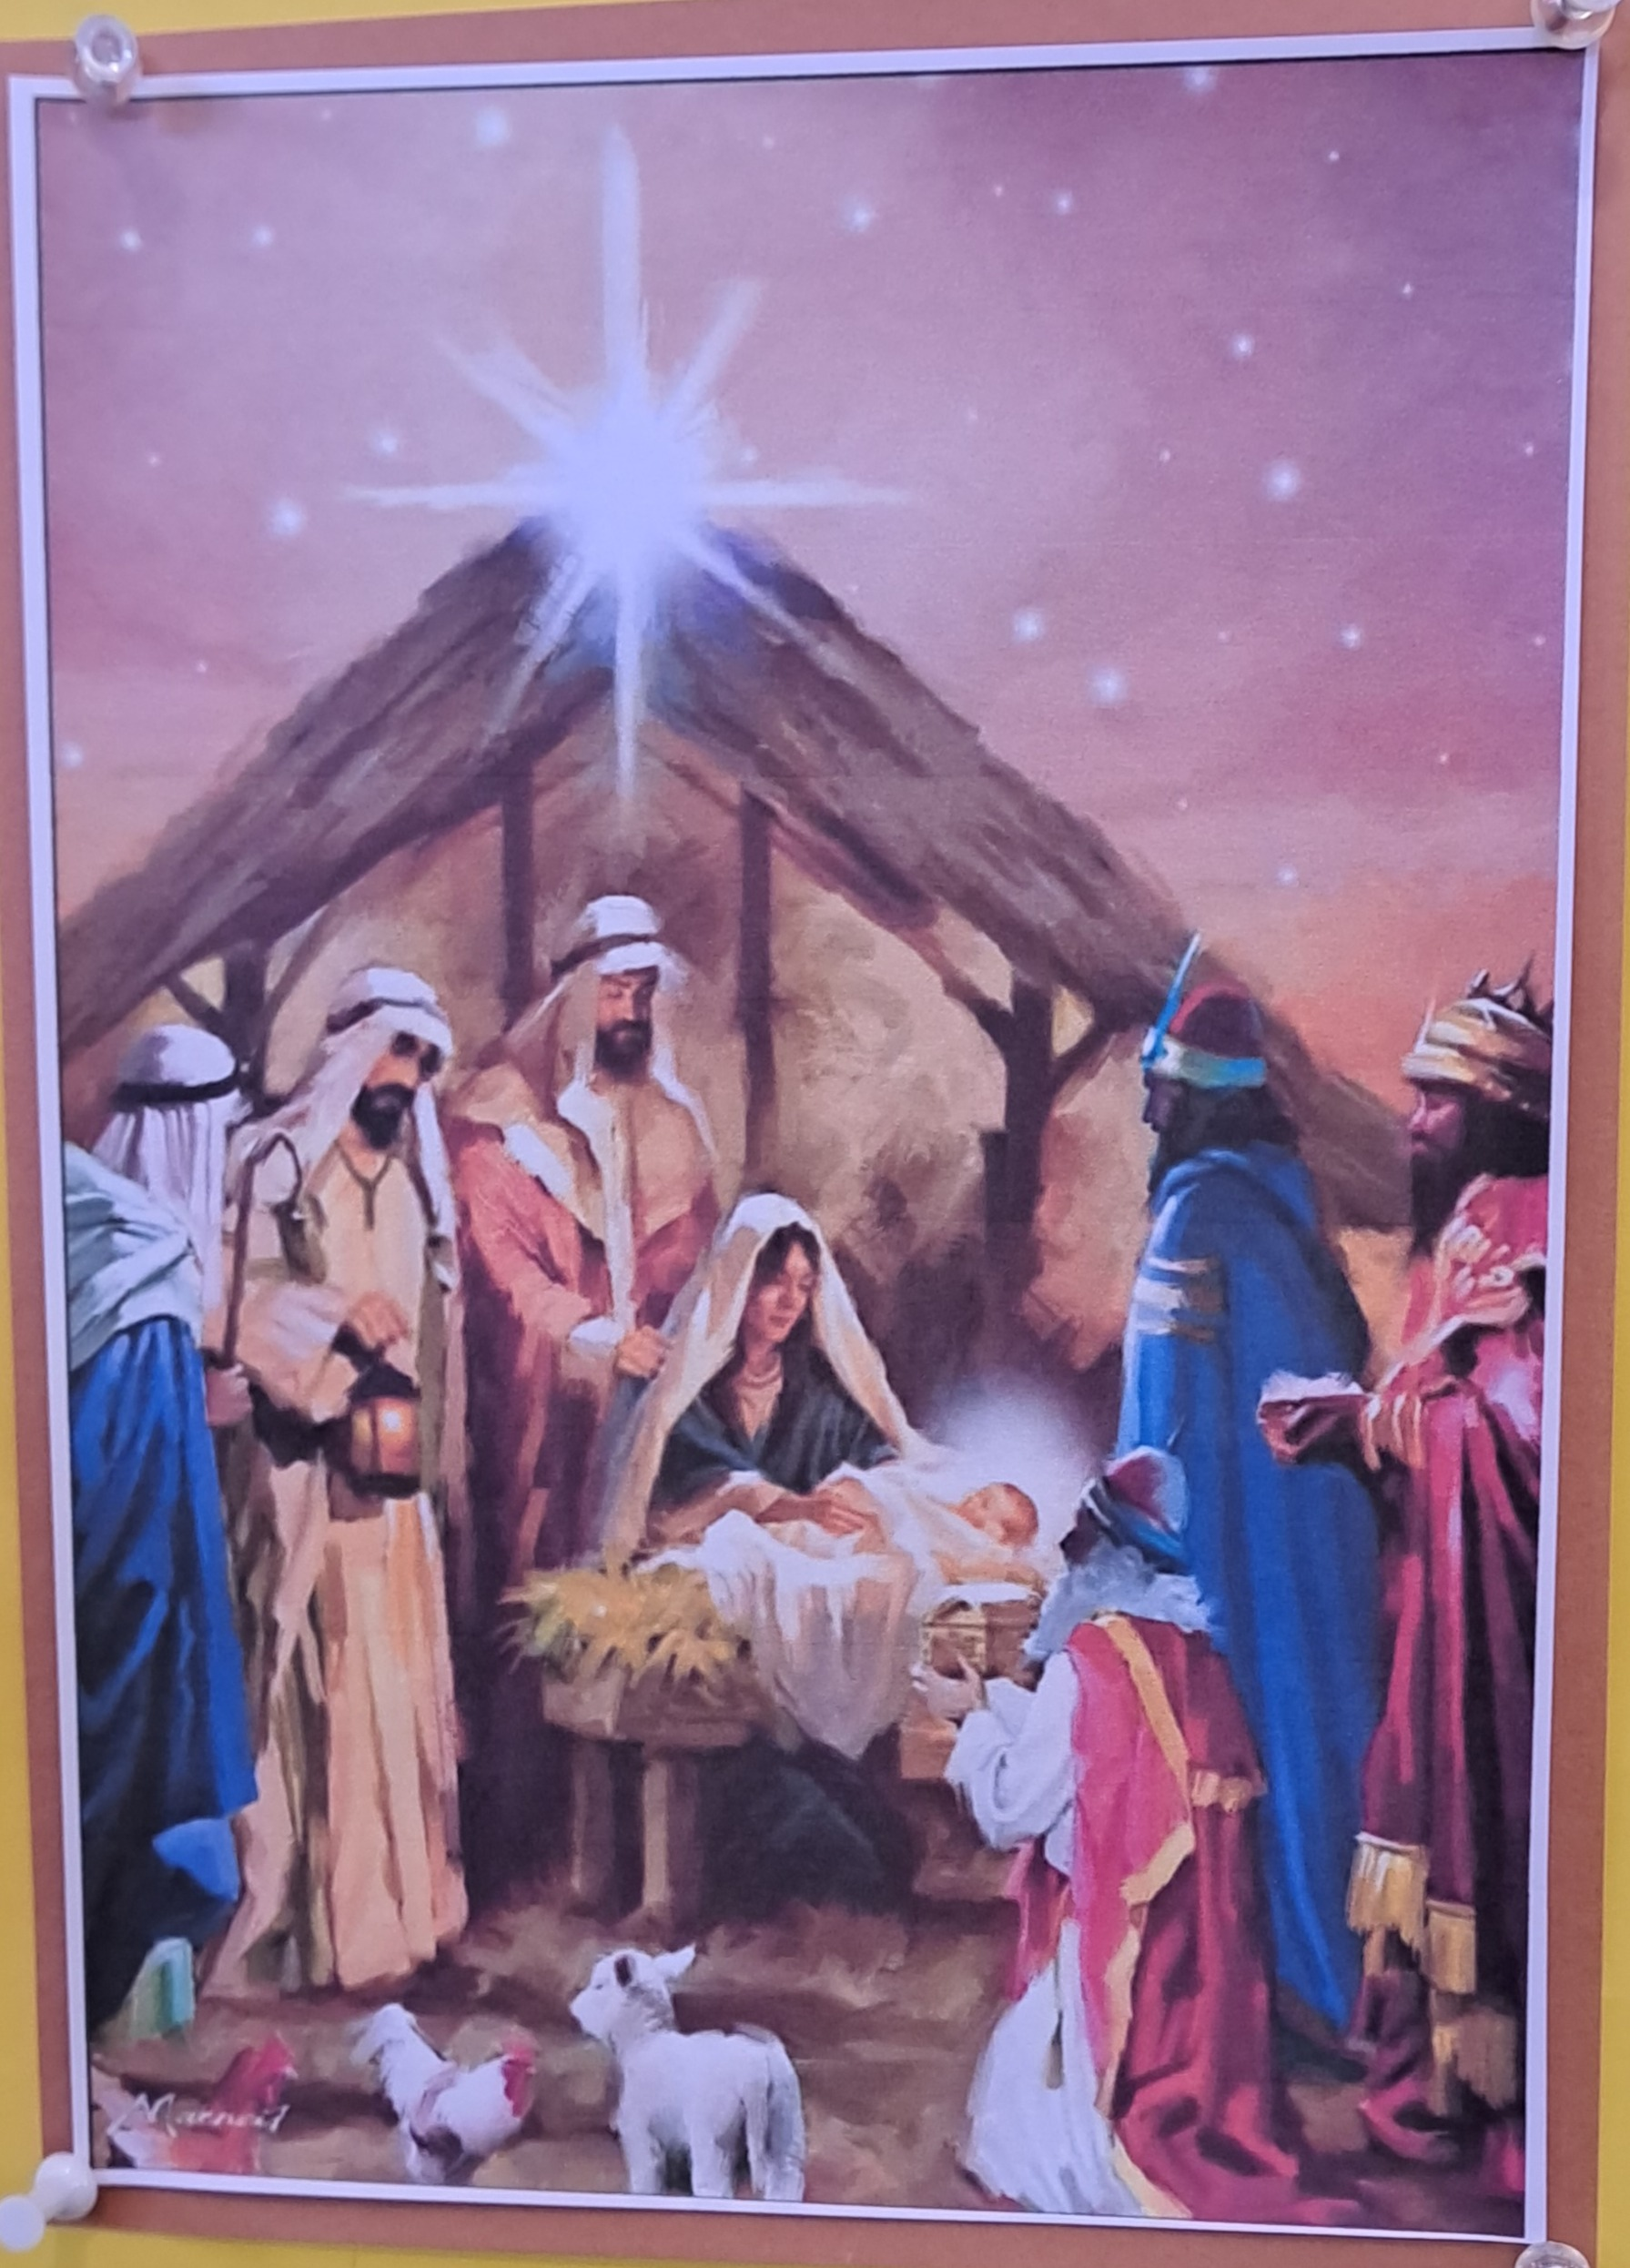
Sunday 4th January Christmas 2
11am Watton Contemporary service
11am Aston Prayer and Praise
11.15am Stapleford Prayer and Praise
11.15am Waterford Holy Communion

Sunday 11th January Epiphany 1
9.30am Watton Holy Communion
11am Watton Contemporary service
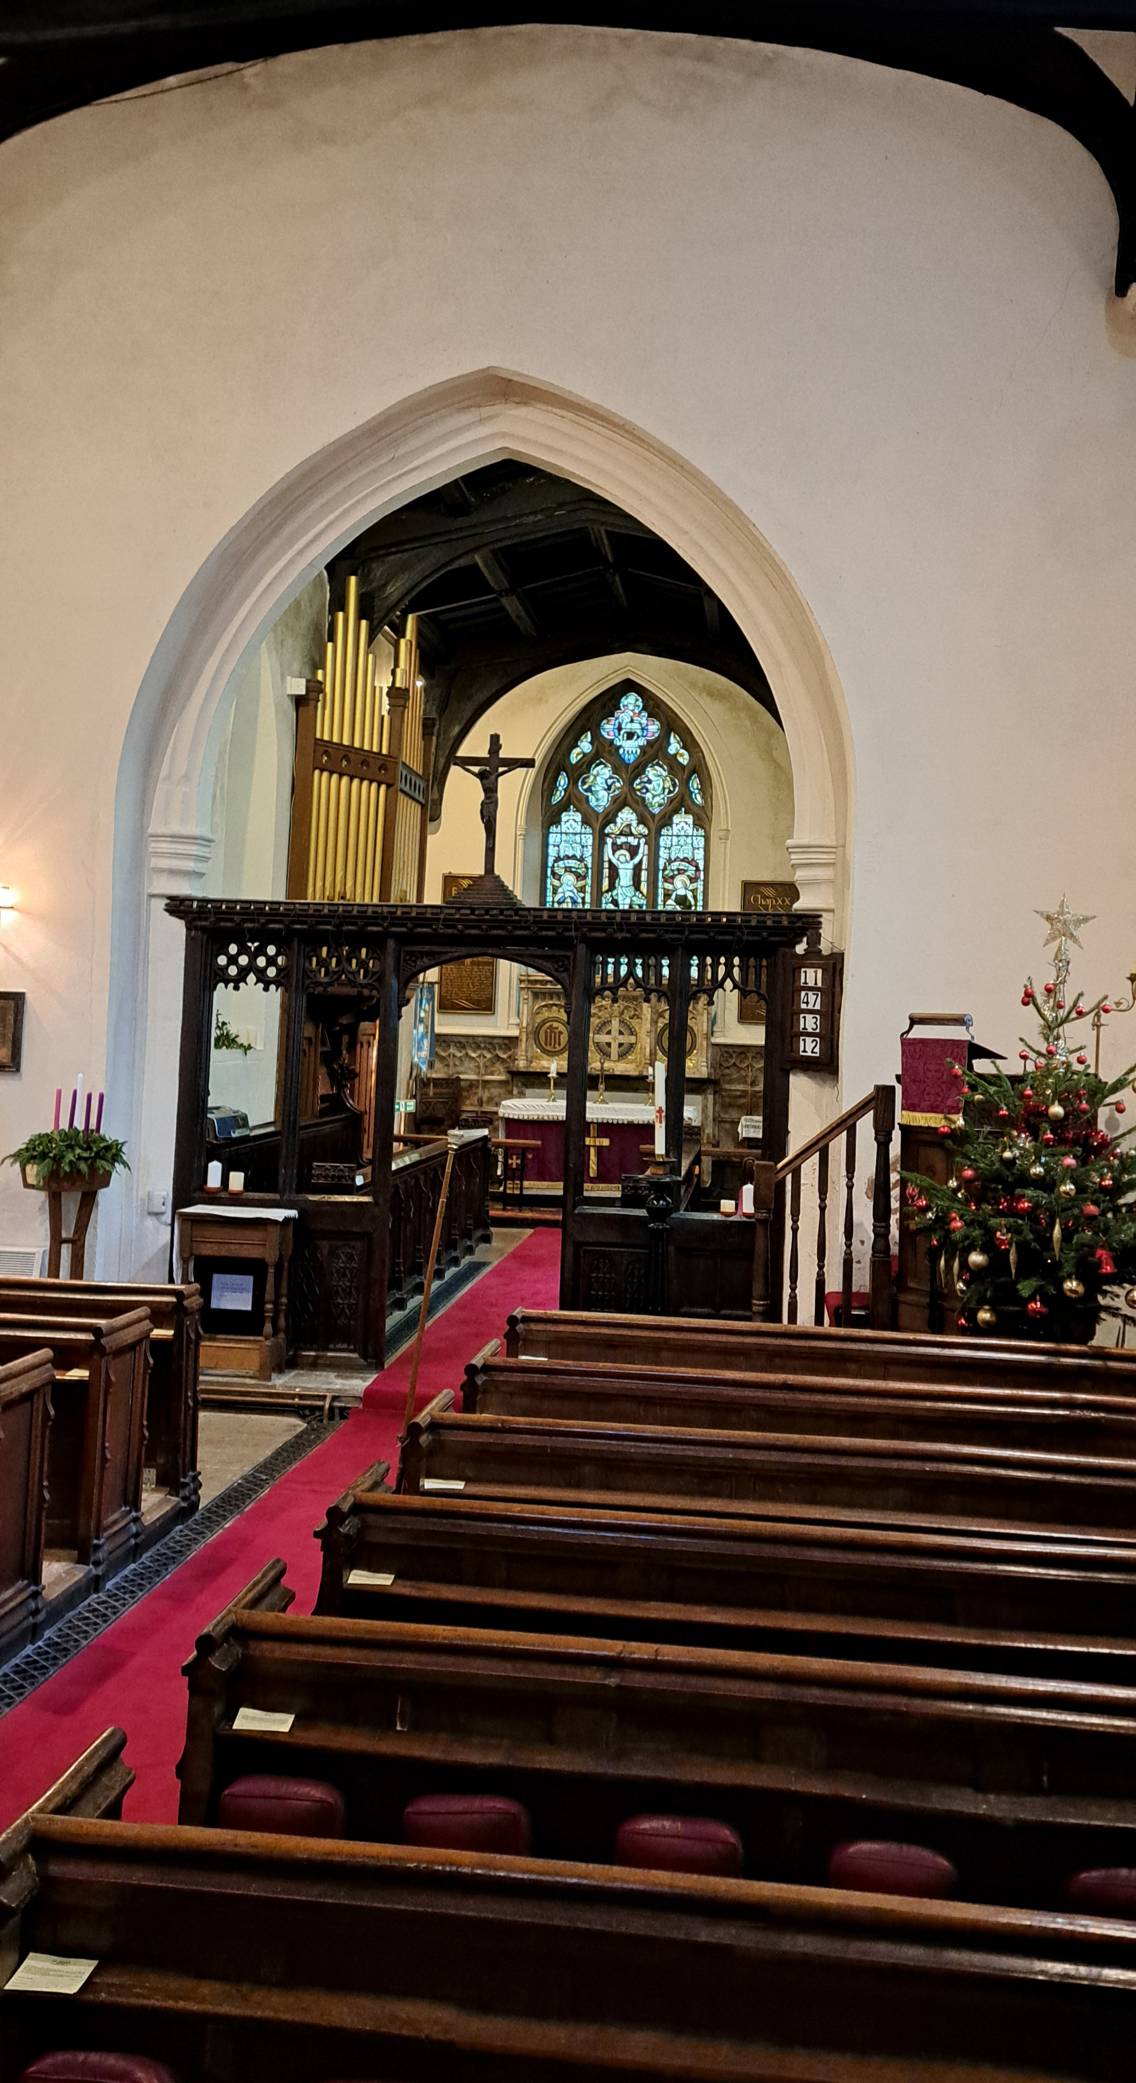
11am Aston Family service
11.15am Bramfield Holy Communion
11.15am Stapleford Prayer and Praise

St Mary’s Aston
at Christmas

MIDWEEK

Fortnightly MONDAY 2pm ASTON Bible Study Fellowship 3 Long Ridge Aston with tea and biscuits. All are welcome. Next meeting Monday 5th January Contact Pauline at pauline.manley1966@gmail.com

NIGHT PRAYER Alternate WEDNESDAYS at 7.30pm on ZOOM. Next meeting Wednesday 7th January on ZOOM. Contact Tim Alexander for link tim_alexander3@hotmail.com


Wednesday 21st January 2.30pm Stapleford village Tea afternoon in Church. All are welcome for tea, coffee cake and chat.

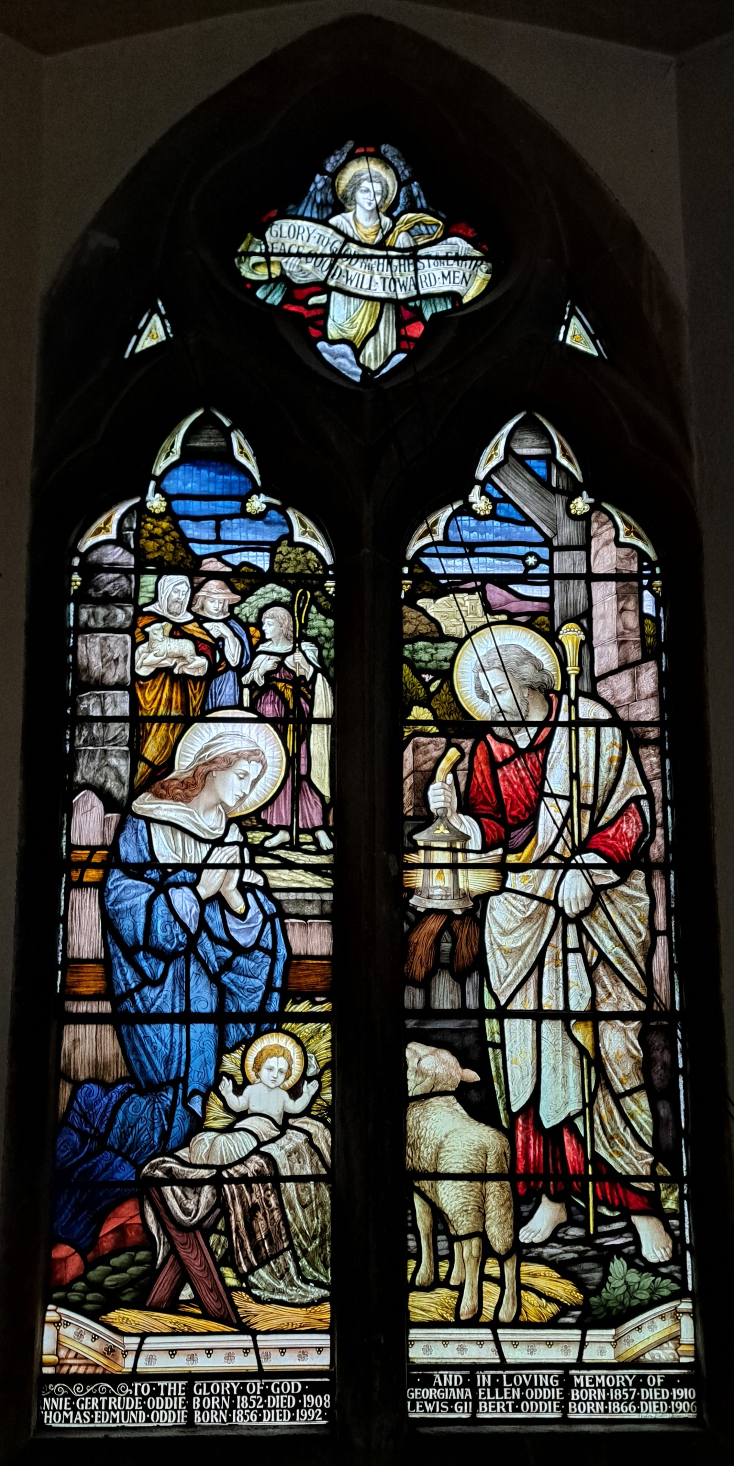

Collect Prayer for 2nd Sunday of Christmas
Almighty God, in the birth of your Son you have poured on us the new light of your incarnate Word, and shown us the fullness of your love:
help us to walk in his light and dwell in his love that we may know the fullness of his joy; who is alive and reigns with you, in the unity of the Holy Spirit, one God, now and for ever. Amen.

The North west window in St Mary’s Church, Aston, showing the birth of Jesus with Mary and Joseph and the three shepherds in the back ground. (Inscription: Glory to God in the highest on earth peace goodwill toward men).


MISSING YOU TREE ribbons are available in each church under the Missing You Tree. There is a pen for you to write your loved ones’ names and any messages to remember those we love who are with God.

From All Souls 2nd NOV 2025 to Candlemas 2nd FEB 2026
They whom we love and lose are no longer where they were before.
They are now wherever we are. (St. John Chrysostom)

PRAY for PEACE in ISRAEL and GAZA, UKRAINE and all areas of conflict


Lord God, though peace seems humanly impossible,

we continue to pray for an end to violence and bloodshed.

We pray your comfort for the fearful and broken – hearted.


Change the hearts of those set on revenge and destruction.

Give wisdom to world leaders as they respond to aggression.

Bless all who work for understanding, reconciliation and justice which alone bring lasting peace. Amen.

‘God give us peace that lasts, not through the fear of might, but through the force of love, and love of life and right’. Amen

Poem Seers by M. Anne Alexander
Seers I’d say they were, not kings:  kings would’ve been too frantically  defending their borders, to traipse for years  at camels’ pace, through the Middle East.  Wise Men? To approach Herod?  Yet, despite Herod’s dark powers,  ancient insights into what was to come,  pulled through, nudging dreams.  Why did they come? Why did it matter  to them? What had propelled them?  What had they hoped for, and why  had the time seemed right, now? | Why were Jerusalem’s leaders telling Herod  of their expectations? Why was he asking?  Despite confidence of Empire and Pax Romanos,  was tension palpable in the air, then, as now?  Why did they assume, that a prospective King of Kings required a gift of gold, and was also a priest, requiring incense, and myrrh for a path through death? Did they sense the beat of a cosmic heart, ultimately immune  to Herodian strategies of human control…?

Hymn 33 HAM. Of the father’s love begotten. Translator J. M. Neale

1. Of the Father's love begotten,  Ere the worlds began to be,  He is Alpha and Omega,  He the source, the ending He,  Of the things that are, that have been,  And that future years shall see,  Evermore and evermore.  2. At his word the worlds were framèd;  He commanded, it was done:  Heav’n and earth and depths of ocean,  In their threefold order one;  All that grows beneath the shining  Of the moon and burning sun—  [Evermore and evermore.] | 6. O ye heights of Heav’n adore him!  Angel hosts his praises sing!  All dominions bow before him  And exalt our God and King.  Let no tongue on Earth be silent,  Every voice in concert ring—  [Evermore and evermore.]  7. Christ! to thee with God the Father,  And O Holy Ghost, to thee,  Hymn and chant and high thanksgiving  And unwearied praises be,  Honor, glory, and dominion,  And eternal victory—  [Evermore and evermore.]

We believe that responding to the climate crisis is an essential part of our responsibility to safeguard God's creation and achieve a just world. Climate change hits hardest the poorest countries and poorest people of the world. Meantime, the widespread destruction of the natural world is a crisis for creation.

Our Environment Programme exists to enable the whole Church to address this — in faith, practice and mission. This includes tackling our own carbon emissions (aiming for Net Zero Carbon by 2030) and our wider work. More information can be found using the following web-link: http://www.churchofengland.org/about/church-england-environment-programme#na

Energy Hub Funded by UK Government: Find out how to:

1. Save energy

2. Save money. Reduce energy bills

3. Reduce carbon. Improve energy footprint

4.Increase comfort

For useful resources and guidance on where to get started visit: linktr.ee/energy_hub



https://app.ecochurch.org/user/21703/summary

As the days start to get longer prepare your home for cooler days and nights. Research suggests an average 40% of home heating is lost through gaps around windows, doors, loft hatches and floorboards. Extra insulation, and fixing drafts saves energy. Put some draft excluder around windows and outside doors. Fit a weather proof letter box. Fit thermal linings for some thin curtains. They are cheap and really easy to clip in. Try to think of one thing to do – it saves energy and is good for the planet too.

Eco Christmas
Is there one thing you can change this year, to make your Christmas more sustainable?
- Reuse existing decorations and avoid new plastic ones like tinsel. You could make your own decorations from natural materials, like wood, or fabric.
- Shop sustainably: Buy second-hand, refurbished, or handmade natural items. Gift seeds, or plants.
- Look out for wrapping paper and crackers that are recyclable – usually made from non shiny materials.
- Buy local food. Plan for some vegetarian meals.

NEW RECTOR RECRUITMENT UPDATE – Sadly it was not possible to appoint a new Rector to the Benefice following our initial advertisement which closed at the end of October. A second recruitment drive will take place early in 2026 supported, as before, by the Diocese. In the meantime, services in each of our churches continue so please JOIN US this Christmastime to celebrate the Festive Season!

CARING for our CHURCHYARDS


TUESDAYS Waterford Working Parties – Contact Churchwarden Malcolm Wandrag to offer help m.t.wandrag@gmail.com
To help in Stapleford or Watton or Bramfield please contact the Churchwardens.ASTON church open Sundays 12.00-16.00 and Wednesdays 10.00 -17.00 Church and churchyard working parties first Tuesday of month 10am to 12 noon. Contact Churchwarden Sara wardenstmarys@gmail.com
All our churchyards are cared for by volunteers.
Donations and offers of help are welcomed.
To include a loved one in the Book of Remembrance contact the churchwardens

Prayer for Growth for Aston, Bramfield, Stapleford, Waterford and Watton at Stone
Jesus teaches us to pray for our churches to grow. Jesus says: ‘Ask the Lord of the harvest, therefore, to send out workers into his harvest field’ (Matthew 9:38). In ways we don’t understand, God uses all our prayers.

Heavenly Father, you call us to sow seeds of faith in our communities. We ask you to fill us with your Holy Spirit that our lives may show the joy and new life we have in you. Guide our speaking and actions that others may be drawn to know your love. Lord Jesus, bless our churches that we may grow in numbers, love and service. We ask this in your name. Amen.

We pray for others to know God’s love.

Tie 5 knots in a piece of string - let each knot represent a friend or family member. Keep the string in your pocket and, as you feel the string, pray for those people to know God’s love. Set an alert on your phone to remind you to pray for those 5 people every day.

A prayer for those who seek to know God.
Lord Jesus, when your followers walked the Emmaus road wondering what was true and what was not, you came alongside them and revealed yourself in Scripture and in broken bread. Come alongside those we know and love who may wonder or seek at this time. Reveal yourself in your love and make us ready to walk alongside them too, until they see your face and know your presence. Amen.
Heavenly father we pray for guidance for our Beane valley benefice churches during the vacancy. Amen.
Our prayers are also with the new Archbishop of Canterbury designate, The Rt Revd and Rt Hon Dame Sarah Mullally DBE as she becomes the 106th Archbishop of Canterbury and the first woman to lead the Anglican Church.

InTouch Age UK Hertfordshire
offer confidential, non-judgemental emotional and practical support on bereavement, physical & mental health issues, cancer, end of life, a partner with dementia or any other problem. Call 01992 634964/630623 or email intouch@ageukherts.org.uk Web page Age UK Hertfordshire | Our Services
Bereavement Support You can access online help at griefshare.org
thebereavementjourney.org cruse.org.uk teardropgrief.co.uk ataloss.org












’s
afternoon
Tea

rty
at 64 Rivershill
Sunday 24th July 2.00-5.oopm

Bring & Buy <> Raffle <> Jams
Proceeds to Both

TAKE AWAY AVAILABLE

