From: Alister Barclay <Alister.Barclay@hertfordshire.gov.uk>
Sent: 17 March 2025 17:05
To: Emma Critchley <ecritchley@stalbans.anglican.org>
Cc: Helen McCormick <Helen.McCormick@hertfordshire.gov.uk>; Dylan Keenan1 <Dylan.Keenan1@hertfordshire.gov.uk>
Subject: FW: All Saints Church, Urban Realm Enhancements - DAC case ref 020470-1024G - Borehamwood, All Saints
Importance: High

Dear Emma,

Thanks for your message and I am pleased the Diocesan Advisory Committee has started reviewing the proposal.

In response to the points raised:

Please could you provide existing drawings so that the planned changes are clear?

Hertfordshire County Council has not prepared a drawing showing the existing layout and we do not hold records of the existing design from the 1990s. The scheme drawing sets out the features to be retained or modified and any new features to be introduced.

In summary the works include:
- Lifting, re-setting and laying the block paving within the area (replacing any broken or damaged and filling in with pre-cast concrete paving slabs to match existing).
- Retaining and protecting the existing trees (4 no) and tree guards. Some trimming may be undertaken and tree guards re-set.
- Remove existing seating and replace with new, at location shown on the drawing.
- New landscaped areas edged using silver grey conservation kerb.
- Existing bin, electricity feeder pillar and utility covers to be retained and protected during the works.
- Light columns are to be retained in current position.
- Existing drainage is to be broken out and relocated with a fluted drainage channel using existing gully connection.

There is no reference to the requirements of the Licence Agreement page 5, clauses 2(i) & 2(ii) regarding the marking of the boundary and display of notices regarding Rights of Way.

Clause 2(i) of the new agreement replicates clause 2(ii) of the original agreement except for the wording has been modified slightly. The new wording was recommended as it limits the notice to the period of the license and also refers to the new drawing we are using as part of the draft licence (with the references to the Green Land). Clause 2(i) of the original agreement was not included as the construction works had already taken place.

However, we could incorporate the following from the original 1993 licence with a suggested slight modification if this is a particular issue for the Committee:

2(i) Delineate the boundary between the Green Land and the public highway with either studs or coloured bricks on the ground and maintain the delineation at all times during the period of the Licence

Regarding Clause 2(i), the current design guide (extract below) allows the highway boundary to demarcated by either contrasting paving or brass studs. HCC would prefer to demarcate the highway boundary with a contrasting line of paving only.

Regarding Clause 2 (ii), HCC would be happy to erect appropriate noticing (sign-plate erected to existing street furniture), and suggest wording to the effect;

'Private Land, no public right of way. Highways Act 1980, section 31.3. Public access by permission of the landowner'

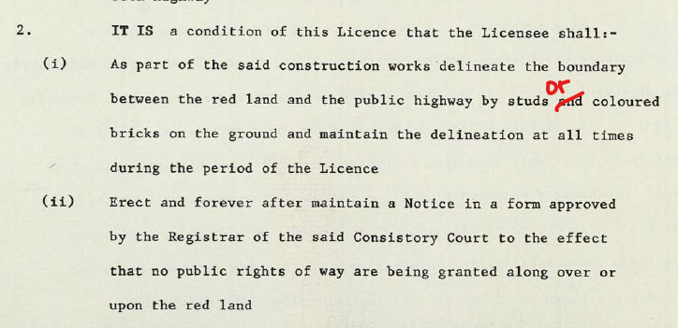

Extract from the Hertfordshire’s Place & Movement Design Guide.

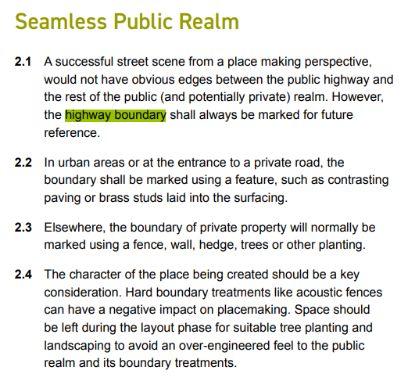

I trust this addresses our concerns but happy to discuss further.

Regards

Alister

