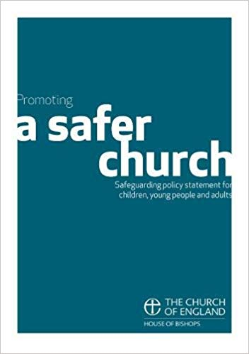
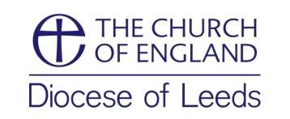
Safeguarding Policy Statement
Promoting a Safer Church,
House of Bishops, 2017

This Policy Statement on Safeguarding in the Church was adopted by
St Michael the Archangel, Kirkby-in-Malhamdale
...................................................................................................................................................
(Parish/Benefice)

at a Parochial Church Council meeting held on .......17th March 2025.......................................

Each person who works within this church will agree to abide by these recommendations and the guidelines
established by this church. This church appoints ……Jen Rowlands ........ as the
Parish Safeguarding Officer.

The application of this policy will be reviewed each year and a report provided by the Parish Safeguarding Officer to the PCC.

Signed on behalf of the PCC by:
Name………Revd Sue McWhinney……………………………………........ Role……Associate Priest..…………………

Signature……………………………………….............................................. Date………………………………………………..

