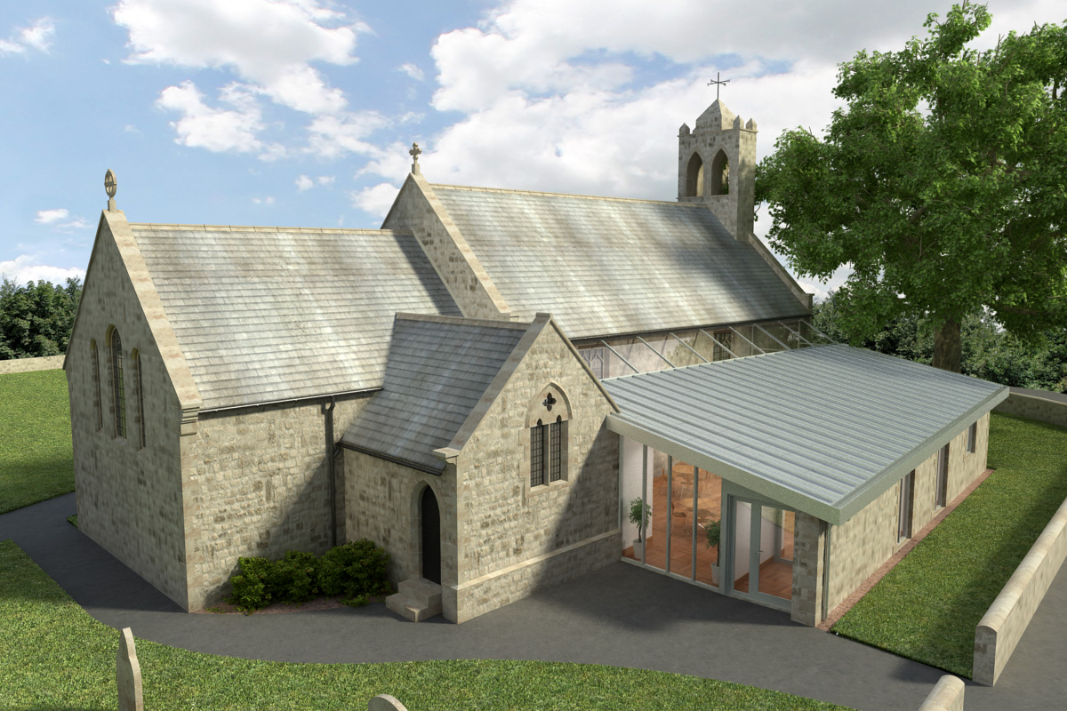
St Mary’s Parish Church, Longframlington

Welcome to our Sunday Morning Prayer. This morning, on Sunday 23rd November which is Christ the King, our Officiant today is the Rev David Wood, and Michael playing the music. Our officiant next week will be the Rev Rich, Rev Robert leading the Homily, and Michael playing the music.
Coming up at St Mary’s and our sister parishes+- Morning Prayer in St Mary’s – and on Zoom – usually every Wednesday morning at 9.30 am followed by coffee in the Community Room. The Link can be accessible from our website
https//www.achurchnearyou.com/church/16291 from “More Info on the services and Events” page.
Our Advent Reflections will be on Tuesdays, 2nd, 9th and 16th December at 7 pm in the URC Church, all welcome.
Walking Together the Augustinian Way – Saturday 22nd November, Berwick Parish Centre led by Rev Nicholas Sagovsky, 10 am for refreshments, 10.30 am start, finishing at 2.30 pm. Poster at back of the church giving details etc. Poster at back of the church.
Men’s Breakfast on 29 November £12 per head for cooked breakfast included. Cash at the door. Anglers Arms, Weldon Bridge be seated for 8.30 am start, finishes at 10 am. Subject: The Unseen Cost - Pornography and the Erosion of intimacy, the speaker is Paul Smith. To register email: jim.cockburn@btinternet.com
Advent Sunday, 30 November at 3 pm an Advent Sunday Celebration in Bolton Chapel all welcome.
Christmas Concert with the Coquet Concert Band, Wednesday 3rd December at 7 pm in St Michael and All Angels, Felton tickets £5 (children free). Refreshments available. A mini bus shuttle service will be available to and from the bridge to the church from 6 pm.
The new Volunteer Associate of Village Hope for evangelistic ministry to north Northumberland farmers is Richard Higginbottom, 07857 263675, richwhigg@gmail.com richard@farmgatenet.org.uk, www.farmgatenet.org.uk
Thank you for your giving to the life and work of our church. Our offering is taken during the third hymn, and there is a collection giving point at the back of the church for use after the service if you prefer. Regular giving by Standing Order with Gift Aid is particularly valuable to the church – speak to Audrey (01665 570 922) for more information and blank forms. All our news and much more available on our Facebook page https:www.facebook.com/SMCLongfram/?ti=as and
You Tube channelhttps:www.youtube.com/@stmichaelsfeltonstmaryslon4157
Priest in Charge: Rev Rich Townend Phone 01670 719470 Email:revrichtea@gmail.com Regular day off: Monday, for St Mary’s information contact Veronica Thomson (01665 570 807) or Audrey Truman ( 01665 570922).

