SUNDAY 16th November 2025.



Loving God and Loving our Neighbour
Sunday 16th November. 2nd before Advent
11.00am Aston Holy Communion
11.00am Watton Contemporary Service
11.15am Stapleford Prayer and Praise
11.15am Waterford Morning prayer

LOOKING AHEAD
Sunday 23rd November Next before Advent
9.30am Watton Holy Communion
11.00am Watton Contemporary Service
11.15am Bramfield Prayer and Praise
11.15am Stapleford Holy Communion

Sunday 30th November ADVENT SUNDAY (Countdown to Christmas)
11am Watton Contemporary service
11.15am Bramfield Holy Communion
4pm WATTON CHRISTINGLE with blessing of oranges and collection for the CHILDREN’s SOCIETY.


You are welcome to attend ANY church

MIDWEEK

Fortnightly MONDAY 2pm ASTON Bible Study Fellowship 3 Long Ridge Aston with tea and biscuit. All are welcome. Next meeting Monday 17th November Contact Pauline at pauline.manley1966@gmail.com

St Andrew’s Bramfield Wednesday's 10am Morning Prayer - short said service followed by coffee and chat. No service until further notice.

NIGHT PRAYER Alternate WEDNESDAYS at 7.30pm on ZOOM. Next meeting Wednesday 26th November on ZOOM. Contact Tim Alexander for link tim_alexander3@hotmail.com


Take Away Church Saturday 15th November 7.00pm Big Quiz Night. War Memorial Hall, Watton. TAC would like to invite you to a fun Quiz evening. A fundraising event for the charity Tearfund and for TAC helping to fund our work for Watton Village children’s groups. Tickets: £10.00 per person to include light refreshments. Bring your own drinks. Raffle. To book contact Richard: 07780452478
Wednesday 19th November 2.30pm Stapleford village Tea afternoon in Church. All are welcome for tea, coffee cake and chat

Christmas Fayre Saturday 22nd November 11am – 4pm. Watton Memorial Hall, 118 High street. See and talk with father Christmas. Many different stalls. Tea coffee cake and mince pies.

Bramfield Christmas Bazaar Sunday 30th November 2pm – 4pm. Bramfield Village Hall.

The Magic of Waterford Christmas Bazar Saturday 6th December. Fun starts at 1pm till 4pm. Christmas gifts and crafts

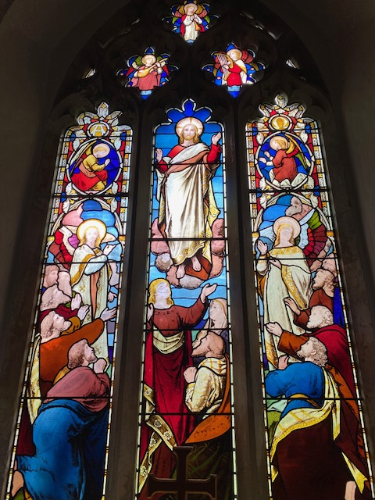
Collect Prayer for the Twenty-first Sunday after Trinity.
Grant, we beseech you, merciful Lord,
to your faithful people pardon and peace,
that they may be cleansed from all their sins
and serve you with a quiet mind;
through Jesus Christ your Son our Lord,
who is alive and reigns with you,
in the unity of the Holy Spirit,
one God, now and for ever. Amen.
(The east window in St Andrew’s Church, Bramfield behind the altar shows Jesus lifted up to heaven, the end of his earthly life, his return to God’s right hand on high)
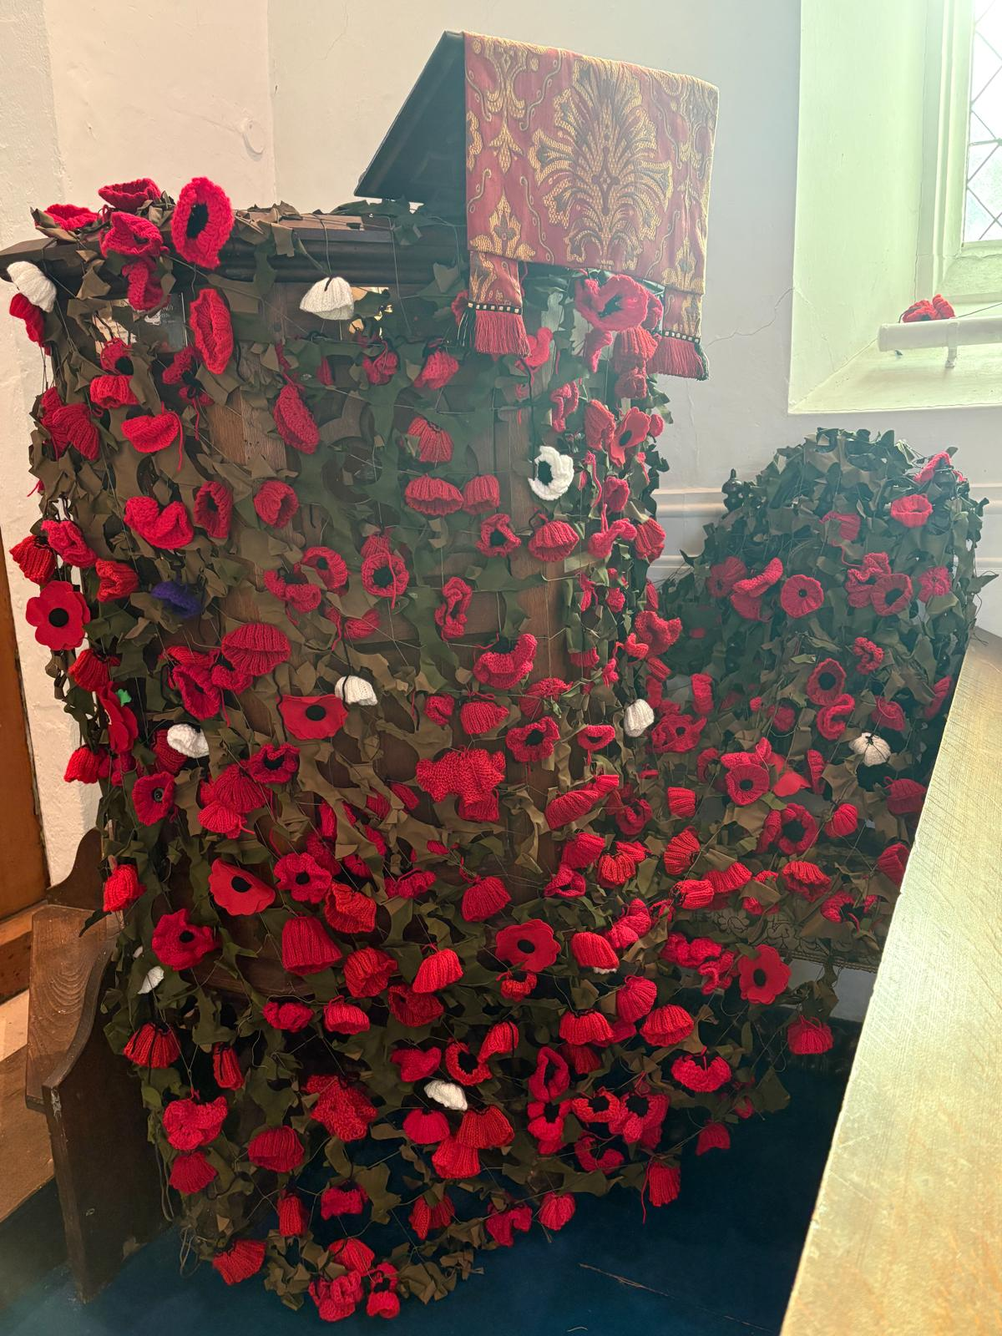
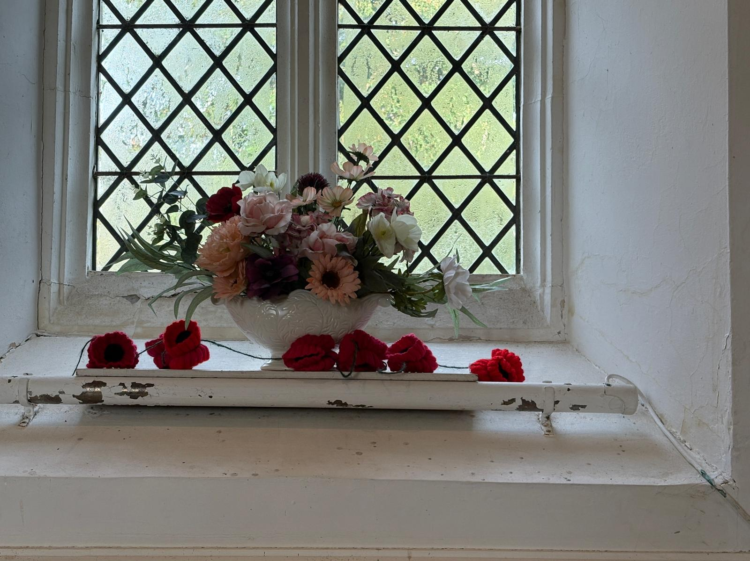

Thank you very much for the beautiful Poppy displays at Bramfield church made by the ladies of Waterford WI.

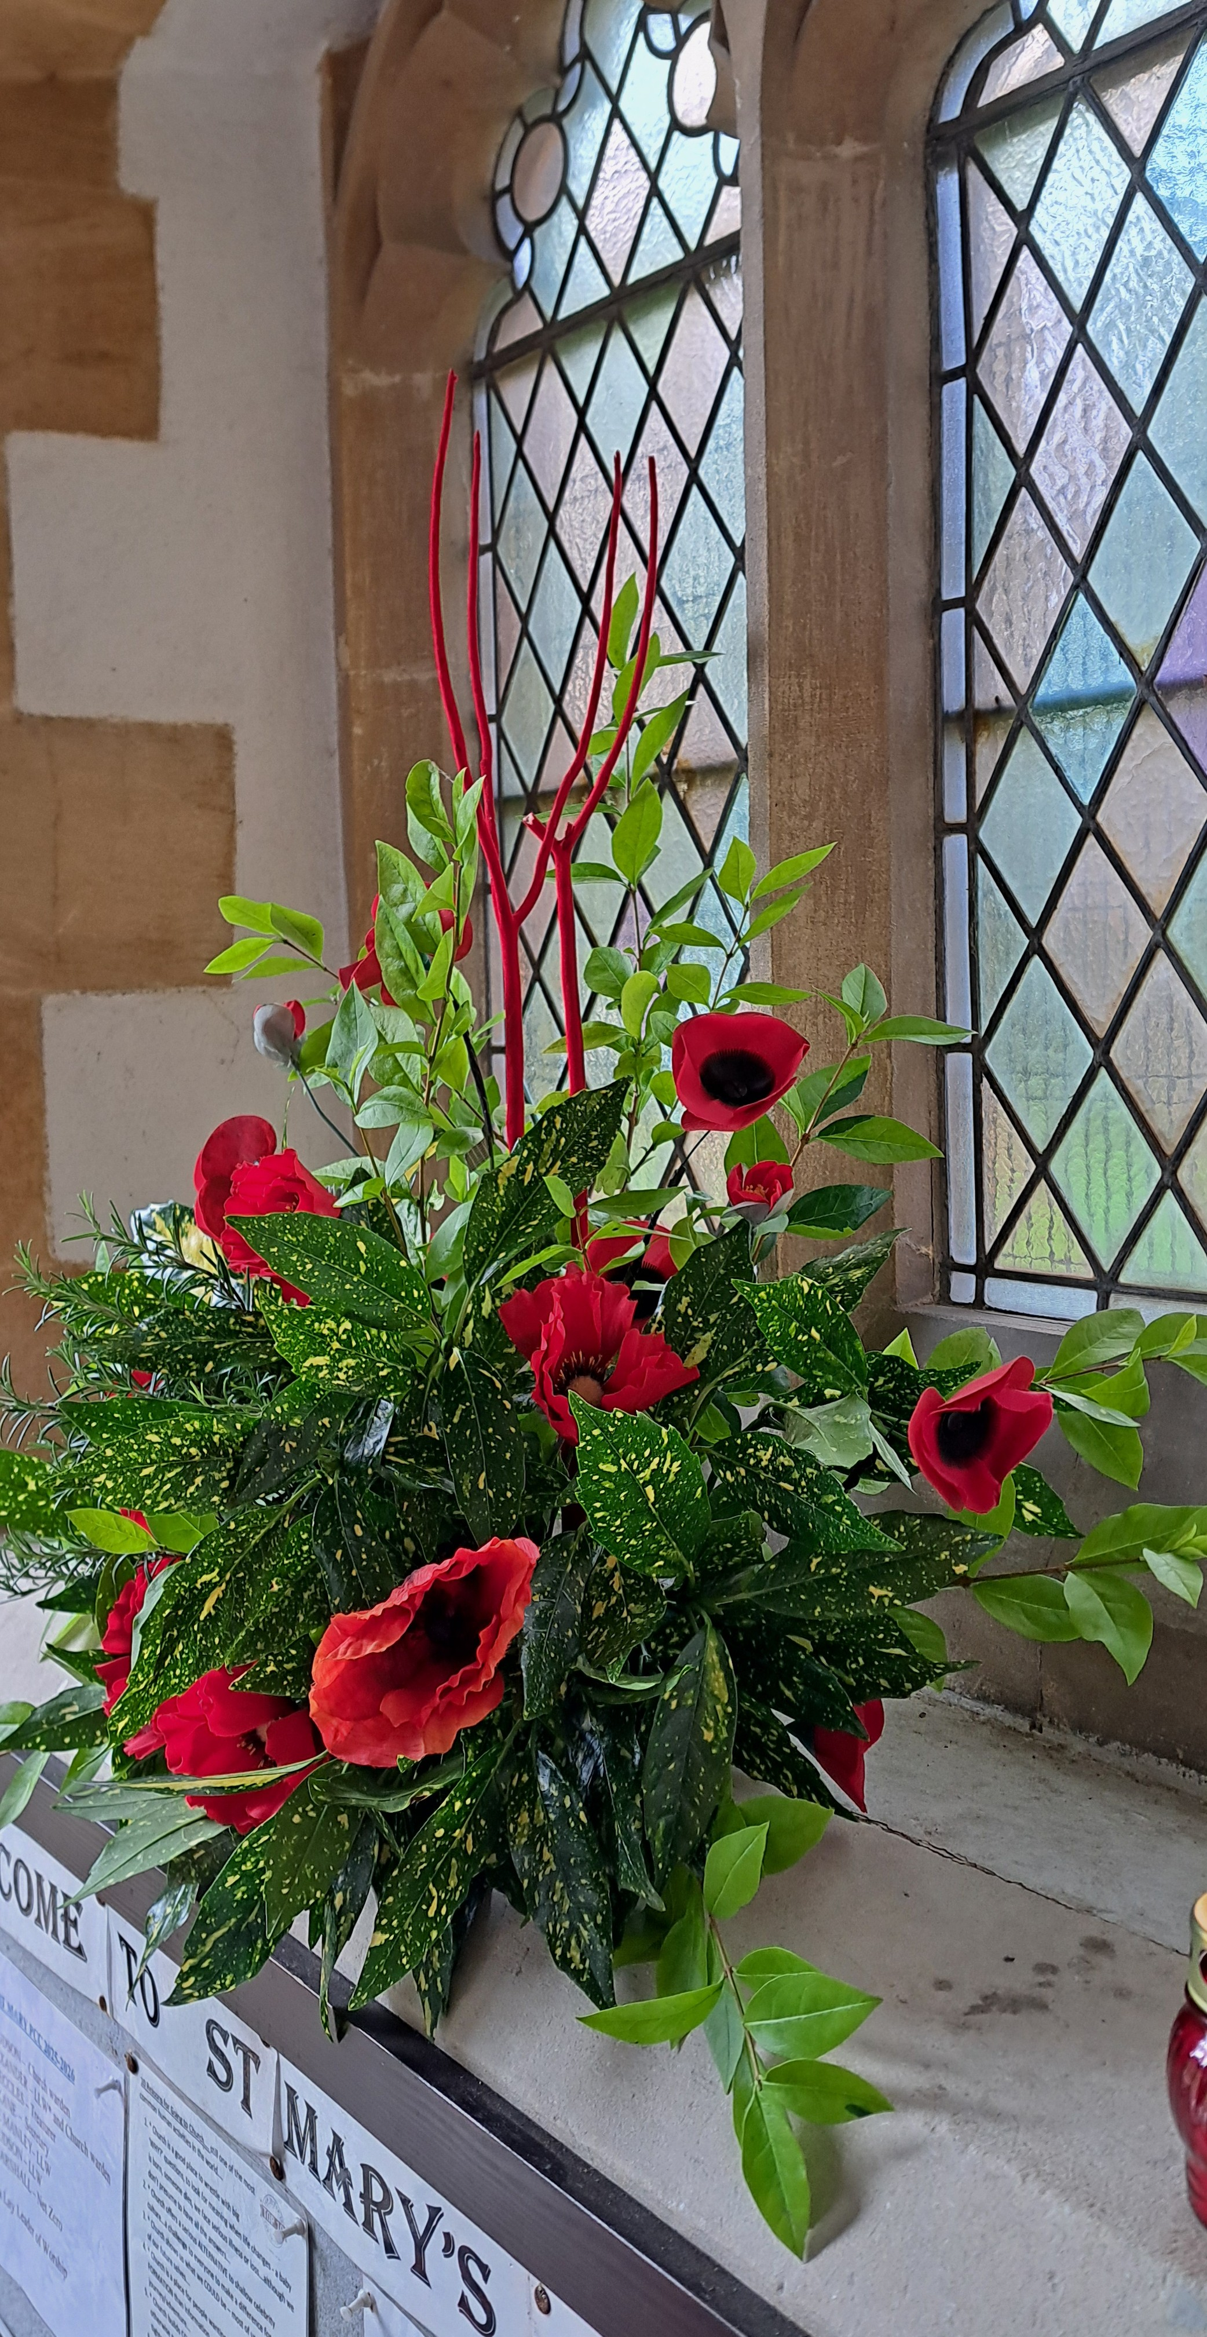
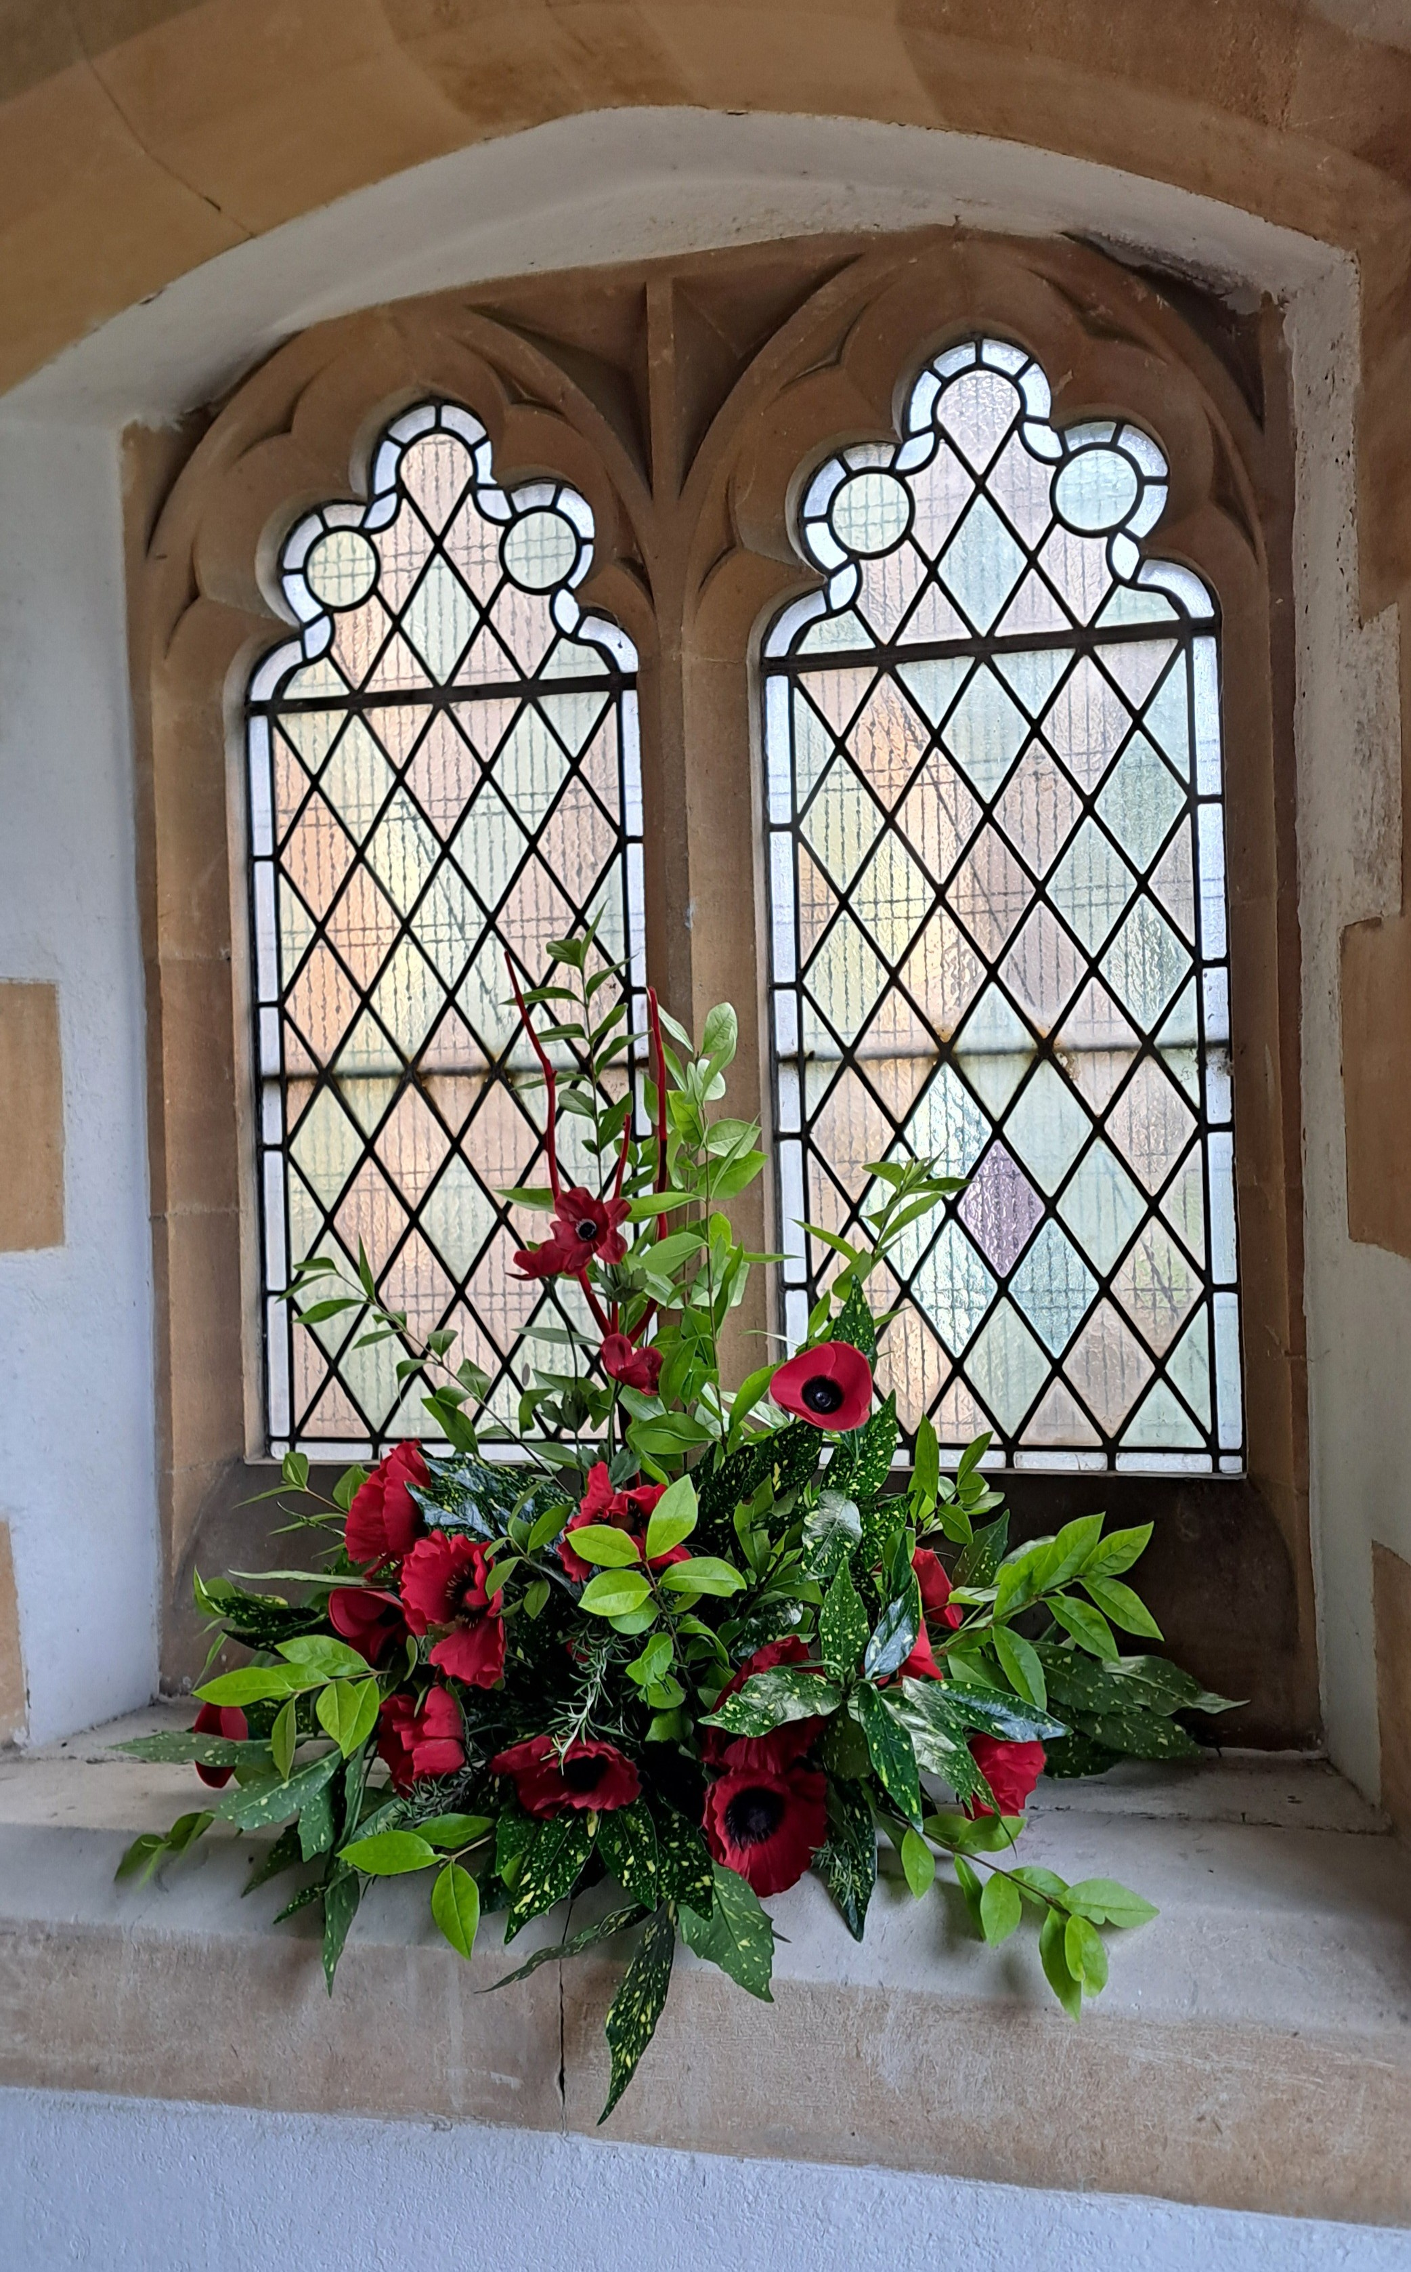

Thank you also for the Poppy displays at Aston church


MISSING YOU TREE ribbons are available in each church under the Missing You Tree. There is a pen for you to write your loved ones’ names and any messages to remember those we love who are with God.

From All Souls 2nd NOV 2025 to Candlemas 2nd FEB 2026
They whom we love and lose are no longer where they were before.
They are now wherever we are. (St. John Chrysostom)

PRAY for PEACE in ISRAEL and GAZA, UKRAINE and all areas of conflict


Lord God, though peace seems humanly impossible,

we continue to pray for an end to violence and bloodshed.

We pray your comfort for the fearful and broken – hearted.


Change the hearts of those set on revenge and destruction.

Give wisdom to world leaders as they respond to aggression.

Bless all who work for understanding, reconciliation and justice which alone bring lasting peace. Amen.

‘God give us peace that lasts, not through the fear of might, but through the force of love, and love of life and right’. Amen

Hymn for Trinity 22. (HAM 247) Author: Horatius Bonar
1. I heard the voice of Jesus say,  “Come unto Me and rest;  Lay down, O weary one, lay down  Thy head upon My breast.”  I came to Jesus as I was,  Weary, and worn, and sad;  I found in him a resting-place,  And he has made me glad.  2. I heard the voice of Jesus say,  “Behold, I freely give  The living water; thirsty one,  Stoop down, and drink, and live.”  I came to Jesus, and I drank  Of that life-giving stream;  My thirst was quench'd, my soul revived,  And now I live in him. | 3. I heard the voice of Jesus say,  “I am this dark world’s Light;  Look unto me, your morn shall rise,  And all your day be bright.”  I looked to Jesus, and I found  In him my Star, my Sun;  And in that Light of life I’ll walk,  Till trav'ling days are done.
We believe that responding to the climate crisis is an essential part of our responsibility to safeguard God's creation and achieve a just world. Climate change hits hardest the poorest countries and poorest people of the world. Meantime, the widespread destruction of the natural world is a crisis for creation.
Our Environment Programme exists to enable the whole Church to address this — in faith, practice and mission. This includes tackling our own carbon emissions (aiming for Net Zero Carbon by 2030) and our wider work. More information can be found using the following web-link: http://www.churchofengland.org/about/church-england-environment-programme#na

Energy Hub Funded by UK Government: Find out how to:

1. Save energy

2. Save money. Reduce energy bills

3. Reduce carbon. Improve energy footprint

4.Increase comfort

For useful resources and guidance on where to get started visit: linktr.ee/energy_hub


https://app.ecochurch.org/user/21703/summary

In these autumn months don't forget to leave some water out for wildlife. A shallow dish of fresh water is good for birds, hedgehogs and many insects, keeping them hydrated and cool. If you have the space, a bigger long term project might be to create a pond in your garden.

As the days get shorter prepare your home for cooler days and nights. Research suggests an average 40% of home heating is lost through gaps around windows, doors, loft hatches and floorboards. Extra insulation, and fixing drafts saves energy. Put some draft excluder around windows and outside doors. Fit a weather proof letter box. Fit thermal linings for some thin curtains. They are cheap and really easy to clip in. Try to think of one thing to do - it saves energy and is good for the planet too.

We pray for World leaders meeting in Belem, Brazil for COP30. They will discuss climate change, and accountability and their decisions will affect all our lives.

Our prayers are also with the new Archbishop of Canterbury designate, The Rt Revd and Rt Hon Dame Sarah Mullally DBE as she becomes the 106th Archbishop of Canterbury and the first woman to lead the Anglican Church.

CARING for our CHURCHYARDS

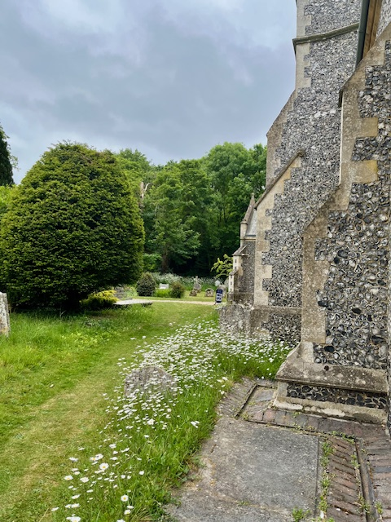
TUESDAYS Waterford Working Parties – Contact Churchwarden Malcolm Wandrag to offer help m.t.wandrag@gmail.com
To help in Stapleford or Watton or Bramfield please contact the Churchwardens.ASTON church open Sundays 12.00-16.00 and Wednesdays 10.00 -17.00 Church and churchyard working parties first Tuesday of month 10am to 12 noon. Contact Churchwarden Sara wardenstmarys@gmail.com
All our churchyards are cared for by volunteers.
Donations and offers of help are welcomed.
To include a loved one in the Book of Remembrance contact the churchwardens

Prayer for Growth for Aston, Bramfield, Stapleford, Waterford and Watton at Stone
Jesus teaches us to pray for our churches to grow. Jesus says: ‘Ask the Lord of the harvest, therefore, to send out workers into his harvest field’ (Matthew 9:38). In ways we don’t understand, God uses all our prayers.

Heavenly Father, you call us to sow seeds of faith in our communities. We ask you to fill us with your Holy Spirit that our lives may show the joy and new life we have in you. Guide our speaking and actions that others may be drawn to know your love. Lord Jesus, bless our churches that we may grow in numbers, love and service. We ask this in your name. Amen.
We pray for others to know God’s love.

Tie 5 knots in a piece of string - let each knot represent a friend or family member. Keep the string in your pocket and, as you feel the string, pray for those people to know God’s love. Set an alert on your phone to remind you to pray for those 5 people every day.

A prayer for those who seek to know God.
Lord Jesus, when your followers walked the Emmaus road wondering what was true and what was not, you came alongside them and revealed yourself in Scripture and in broken bread. Come alongside those we know and love who may wonder or seek at this time. Reveal yourself in your love and make us ready to walk alongside them too, until they see your face and know your presence. Amen.
Heavenly father we pray for guidance for our Beane valley benefice churches during the vacancy. Amen.

InTouch Age UK Hertfordshire
offer confidential, non-judgemental emotional and practical support on bereavement, physical & mental health issues, cancer, end of life, a partner with dementia or any other problem. Call 01992 634964/630623 or email intouch@ageukherts.org.uk Web page Age UK Hertfordshire | Our Services
Bereavement Support You can access online help at griefshare.org
thebereavementjourney.org cruse.org.uk teardropgrief.co.uk ataloss.org












’s
afternoon
Tea

rty
at 64 Rivershill
Sunday 24th July 2.00-5.oopm

Bring & Buy <> Raffle <> Jams
Proceeds to Both

TAKE AWAY AVAILABLE

