The Rector's Ramblings
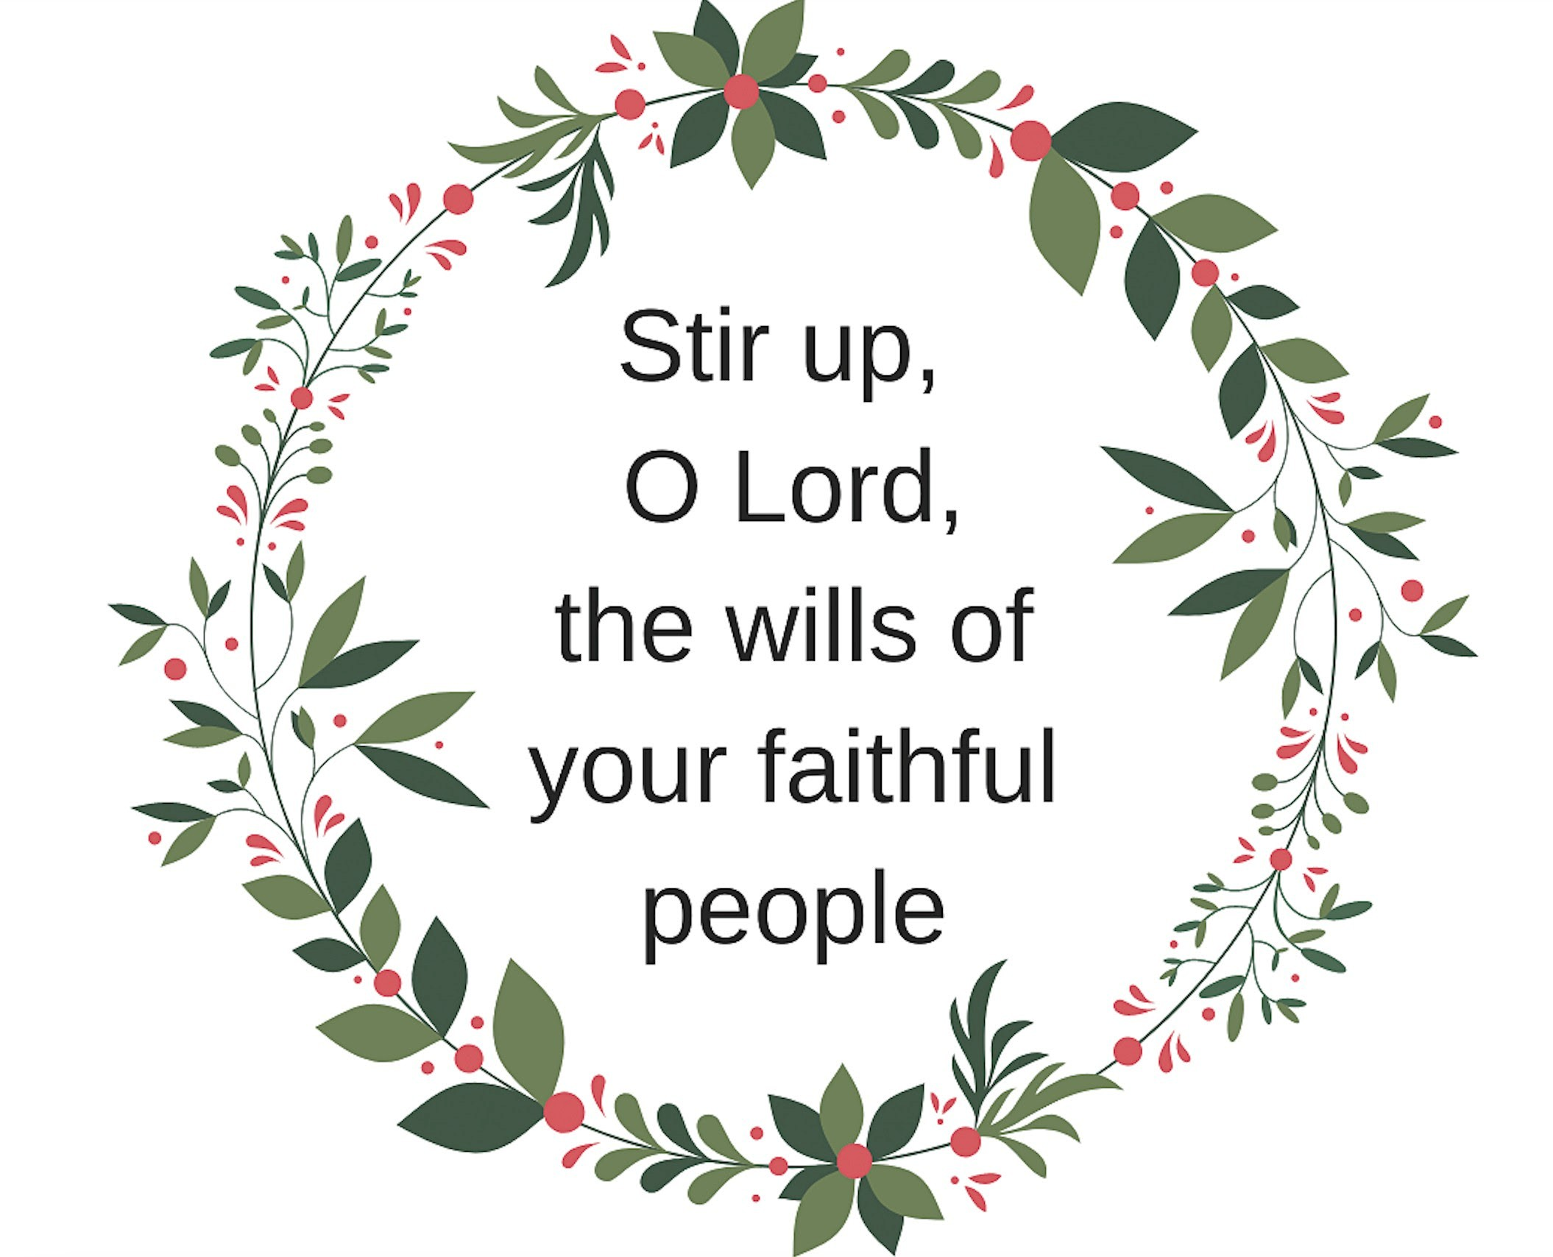
This Sunday is, in the Church Calendar, the Last Sunday before Advent, or Christ the King. Next week we will light the first candle in our Advent Ring and begin our preparation for Christmas (just as a heads up, Christmas Day is 33 days from today, 21st November – scarily close and approaching fast!). The colour of the vestments will change from red to purple, and our readings will reflect the season, and the people remembered by each candle, the Prophets, the Patriarchs, John the Baptist, and the Blessed Virgin Mary. But that is for next week, what of this Sunday?
Well, for many people, this Sunday is better known as Stir-Up Sunday, the day traditionally set aside by many to make their Christmas puddings. Now I have Rambled before on Stir Up Sunday and how, as children, we would help our Mum as she weighed out the ingredients, substituted one spice for another (she was a great one for making do), and then each took our turn in stirring the mixture and making a wish. At Children’s Church this weekend we will be following that tradition, albeit with a slightly, well actually very, different style of pudding to the one my Mum made. But the children, and the adults, will still be invited to stir the mixture and make a wish, or offer a prayer, just as we did all those years ago.
But the roots of Stir Up Sunday don’t lie in the kitchen but in the liturgy of the Church. They go way back to the 1662 Book of Common Prayer when the collect for the day, the collecting together of all of our silent and personal prayers, begins with the line “Stir up, we beseech thee, O Lord, the wills of thy faithful people.”. In our service on Sunday those words will be said as the Post Communion Prayer, after we have received either the bread and wine, a blessing, at the Lord’s Table.
But whenever the words are said the meaning is the same, and it isn’t a call to head to the kitchen, it is a call to our hearts, an invitation to begin our preparation for the coming of Christ. But does Stir Up Sunday need to be one or the other? Is it a day to come to worship or a day to make the puddings? Can it be both, and can the act of making the pudding also somehow deepen our faith, and start us on the path of preparation for Christmas?
Well, yes, I think it can be both. Stir Up Sunday as the day to make the puddings began in Victorian times, when the family would return from church and make the puddings before sitting down to dinner. For most people the luxurious ingredients, expensive and bought especially for the occasion, were a reminder of the gifts and blessings of God in creation. The coming together to stir the pudding was a moment of unity for the family, especially for those in service who were often given this Sunday off to return home before the busyness of Christmas preparation began. The use of a wooden spoon was a reminder of the manger, and the tradition of stirring clockwise symbolised the direction the Wise Men travelled from the East, and the making of a wish? That was rarely for the latest fad, or expensive Christmas present, but for health and long life to those they loved, and may have included repeating the opening line of the collect, “Stir up, we beseech thee, O Lord, the wills of thy faithful people.”.
Stir up, O Lord, the wills of thy faithful people, and make us into something new. Just as spices, fruit, and flour are stirred and transformed into something else, something rich and celebratory, this Sunday is a reminder to us that God can stir up our hearts and make our lives into something fuller and holier. It is a call for us to look honestly at ourselves and ask, what needs to be changed, mended, or confessed before we welcome the light of the world on Christmas Day? What gifts do we have that we can offer to others and enrich their lives, as well as ours? What habits need letting go of that bring us, and others, pain? What old grievances are we holding on to that need to be put to one side and forgiven? It will take time, because just like the pudding that needs four weeks to mature, so transforming our lives takes time, patience, and prayer, but the results will be worth it and will be savoured not just by us but by God.
As we head into Advent, this Sunday is a reminder that we need to slow down. We need to pause and reflect on all that is good in our lives and give thanks. We need to stop and ask, what does Christmas really mean to us, and what do we need to change, or embrace, to enable us to be stirred up and made into something new, so that when Christ comes we are ready.
Stir-Up Sunday is both a domestic celebration and a sacred moment—a reminder that beneath the laughter, the stirring, and the warm smells of fruit and spice, Christ is coming and we need to be willing to be made new, to be stirred up, and to welcome him not just for one day, but for a lifetime.
Rev Sarah

Worship in the Valley Parish
23rd November
Christ the King

Holy Communion
10am
West Dean
Children’s Church
11am
West Dean
Rev Sarah Manouch
07468 854864 priestvalleyparish@gmail.com
Please note that I am part-time. My principal working days are Friday and Saturday as well as Sunday. I am not available on a Thursday.

