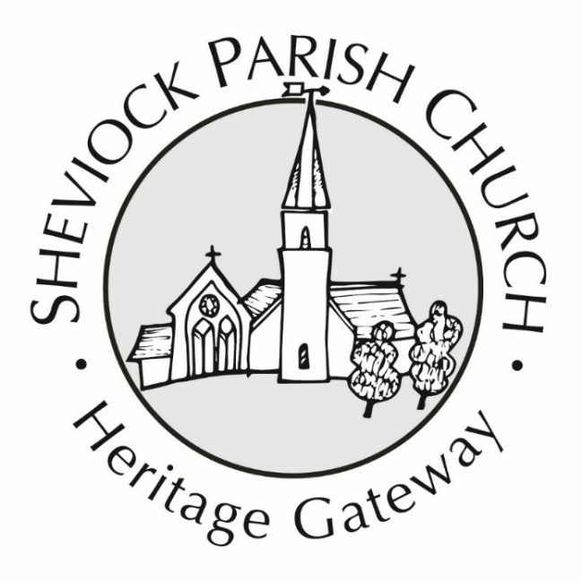


Crib Festival & Concert 2025
 with Reflections Choir

Saturday 6th December
10 am – 2:00 pm Crib Exhibition & Cafe Open
2:00 pm – 4:00 pm Concert with Reflections Choir
Concert Tickets £5 on the door

Sunday 7th December
10 am – 11 am Morning Worship
11 am – noon Crib Exhibition Open

Heritage Gateway funds are dedicated funds for the upkeep & maintenance of Sheviock Parish Church & Churchyard & heritage information & materials

