The Rector's Ramblings
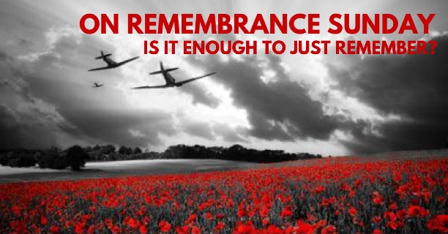

I have, in the past, commented in my Ramble (not always favourably) about those people who rush into the shop the day before Advent Sunday to buy the candles for their Advent Ring. Why didn’t they realise the date, how could they be so disorganised? Well now I have to eat humble pie because I find myself in the same position, not with the Advent Candles, they are sorted, but in relation to Remembrance Sunday. The planning and organising that usually starts 2 or 3 weeks earlier is now on my ‘to do list’ for today. Asking people to read the Kohima Text or The Exhortation at our two Acts of Remembrance, usually all sorted at least a week before, will be done with a lot of grovelling today. But why am I so disorganised? Well, I could put it down to the long-term effects of a really bad cold that has lasted 3 weeks, which has meant I am exhausted at the end of the day. I could blame, although with gratitude, an incredibly busy time in the shop. Or I could, with all honesty, simply say I dropped the ball. I’m not as prepared, as organised, as I would wish.
Now just to reassure you, our Acts of Remembrance will take place, and they will be, thanks to the help and support of others, a right remembering of all those who have lost their lives in all conflicts since the First World War, because as important as it is to have the right texts read, to sing the National Anthem and to observe the 2 Minutes Silence, right remembering is about us. It’s about what we think, feel, and do, on Remembrance Sunday and on Armistice Day. Right remembering is about acknowledging the sacrifices that were made on the War Front and on the Home Front. It is about supporting those who still carry the scars, external and internal, from recent conflicts. It is about not taking our freedoms for granted and it is about learning the lessons of the past, to do all we can to make sure they doesn’t happen again.
This week saw people gather up and down the country to celebrate the 5th of November, the successful foiling of The Gunpowder Plot. At the monthly Evensong in St Olav’s, which coincided with Firework Night, we reflected on what had caused the men behind the plot to decide that mass murder was their only option. It wasn’t on a whim, it wasn’t because they felt they had the right, or that right was on their side. The Gunpowder Plot was the result of decades of persecution, oppression, exclusion and executions. All the men behind the plot had wanted, all they had asked the King for, was the right to worship. The right to practise their Catholic faith. But their appeals fell on deaf ears. The more they asked, the harsher the penalties for being Catholic became, until in the end they became so desperate that they could see no other way out. In the end, the failure of the Gunpowder Plot made the situation of Catholics in this country even worse. For 200 years they couldn’t vote, hold public office or join the army, and the long-term effects of the Gunpowder Plot are still felt today with, sadly, an almost ingrained distrust of Catholics in the English DNA.
You may be wondering where I am going with this as we prepare for Remembrance Sunday. Well, the Gunpowder Plot and Remembrance Sunday both carry the same message – we must learn from the past. We must work together to prevent wars, to stop dictators and tyrants from persecuting and oppressing countries and peoples, but we also need to understand our own prejudices and conscious and unconscious bias and the effect it has on the people around us. We need to understand how adversely ‘labelling’ a whole group of people simply because of their race, their religion, or their ethnicity, can, over time, lead to individuals feeling persecuted, oppressed and desperate. We need to remember that words can, and do, hurt just as much as actions. We need to remember that excluding someone for no other reason than they look different or speak with a different accent, is a form of persecution.
As we come together on Sunday we will be remembering people from multiple faiths, and none, who died in the service of this country. We will be remembering people from nations around the world who joined us in the fight for freedom, and lost their lives for the freedom that we now enjoy. And I hope we will commit ourselves to sharing our freedom, and our blessings, by helping others, as they helped us.
Because as it says at the top of the Ramble – Is it enough to just remember, or do we need to ensure that the lessons of the past are learnt today and pray that in the future the words of the Prophet Isaiah will come true
“They will beat their swords into ploughshares and their spears into pruning hooks.
Nation will not take up sword against nation, nor will they train for war anymore.”
Rev Sarah
Worship in the Valley Parish

9th November

Holy Communion with Act of Remembrance
10am
St Andrew’s, West Dean
Act of Remembrance
3pm
The War Memorial, Singleton

Rev Sarah Manouch
07468 854864 priestvalleyparish@gmail.com
Please note that I am part-time. My principal working days are Friday and Saturday as well as Sunday. I am not available on a Thursday.

