The Rector's Ramblings
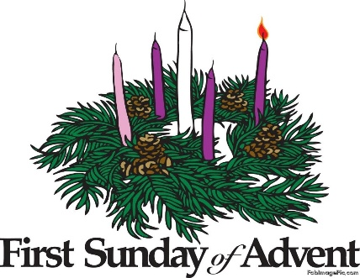

This Sunday the church celebrates the first Sunday of Advent, and the fourth Sunday before Christmas. The colour of the vestments and altar frontal will change to purple; we will light the first of the Advent Candles and begin our preparation for the coming of the light of the world. It is also the day, for some, when mild panic sets in.
I don’t work in St Olav’s on a Friday or Saturday, but I know that when I get in next week the other staff will have lots of stories to tell of clergy, churchwardens, or parish administrators rushing in to see if we have any Advent Candle sets left, because they either totally forgot, or assumed (always dangerous) that someone else had bought them. I must admit that I am feeling a little smug as after being, sort of, caught out by Remembrance Sunday, the new Advent Candles for our three churches were purchased 3 weeks ago.
But having said I will miss the panic rush for Advent Candles, I will be in the shop on Monday when there will probably, based on previous years, be a rush to buy Advent Calendars. Parents and Grandparents who assumed their now grown-up offspring wouldn’t want to open a small cardboard window every day to reveal part of the Christmas Story, will have had a call or text pleading for them to buy one, because it is traditional. It is also, for some, a link to home. For University students or those setting up their first home, an Advent Calendar is reassuring and a link to the family they have, temporarily, left behind.
But it isn’t just Advent Calendars and Candles that people will be panic buying next week, it will also be cards. Now our Christmas cards have been on sale since the end of September, and although I know for some it is too early, we do, as a business, have to follow the High Street or lose sales. But for all the people that have already bought their cards (we’ve already sold 3/4’s of our stock, but there are still plenty left), there are also those who don’t buy until after Advent Sunday, and then realise that the last posting day for their cousin in Australia, or their brother in Canada, is approaching fast (for info they are the 5th and 12th December respectively).
Advent Sunday is also the day that many people sit down and plan Christmas. They write their shopping list, they start writing the cards they have already bought, and they wrack their brains for what to buy their nearest and dearest – or maybe that’s just me! Advent Sunday is, in so many ways, the beginning of our preparation for Christmas, be it practical or spiritual and the Advent Candles represent people who, in some cases, spent their whole lives longing for, and preparing for, the coming of the Messiah, the Light of the World, The Son of God.
We begin this Sunday with the Patriarchs, including Abraham and David. Men who spent their lives following God’s word and in doing so becoming the founding fathers of the faith. The second Sunday is for the Prophets, men like Isaiah and Jeremiah who predicted the coming of the Messiah and tried to prepare the people for his arrival. The third candle is for John the Baptist, sent out as a messenger to the ordinary people, to the towns and villages of Galilee, and finally the fourth candle is for The Virgin Mary, the woman who carried the light of the world and would ultimately stand at the foot of the cross.
All of these people spent their lives, and sometimes gave their lives, in the service of God preparing the people for the coming of Jesus, and in spreading the good news of the coming of the light of the world. But the Advent Candles also have other meanings, Hope, Peace, Joy, and Love.
As we all go about our busy lives, shopping, planning, wrapping presents, writing cards, I hope that we can spare a little time, either in worship or in prayer, to think about all the people who will struggle to provide a meal or a present for their children and pray that they may find hope, all the people who this year will be preparing for Christmas in bombed out cellars or in make shift huts and pray that they will know peace, and for all those who are searching and seeking a deeper meaning in their lives pray that they will find joy, and that all will know the love of God, the strength of the Holy Spirit, and on Christmas Day, when we lit the last candle, that they, and we, will be bathed in the Light of Christ.

Rev Sarah
Worship in the Valley Parish

30th November
Advent Sunday
Holy Communion from the Book of Common Prayer
10am
Singleton
Rev Sarah Manouch
07468 854864 priestvalleyparish@gmail.com
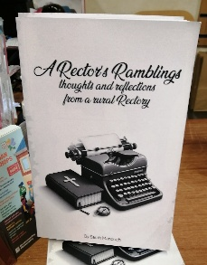
Please note that I am part-time. My principal working days are Friday and Saturday as well as Sunday. I am not available on a Thursday.
Yes, this is a blatant plug - but A Rectors Ramblings is now available from me, or from St Olav's Christian Bookshop (price £10). A compilation of some of the Rambles I have sent out over the past 4 years, some may make you smile, some may make you think, and one or two may make you cry (sorry).

