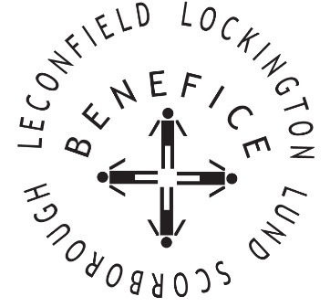

Church Services for
December 2025
Wherever you are from, you are welcome to join us for any of these services

Wednesday 3rd 9:30am Mid Week Service
With healing prayers St Mary’s Lockington

Sunday 7th 9:30am Holy Communion St Leonard’s Scorborough

11:00am Morning Worship St Mary’s Lockington

Sunday 14th 9:30am Holy Communion All Saints Lund

Wednesday 17th 9.30am Mid Week Service
With healing prayers St Catherine’s Leconfield

7:00pm Carol Concert All Saints Lund

Sunday 21st 9:30am Holy Communion St Mary’s Lockington

3:00pm Christingle & Carol
Concert St Catherin’s Leconfield

6:30pm Carol Service St Mary’s Lockington

Christmas Eve 6:00pm Traditional Lessons &
Carols St Leonard’s Scorborough

11:30pm Midnight Communion St Mary’s Lockington

Christmas Day 10:00am Christmas Day Commuion St Mary’s Lockington

Sunday 28th 9:30am Holy Communion All Saints Lund

11:00am Contemporary Worship St Mary’s Lockington

Merry Christmas and Happy New Year

