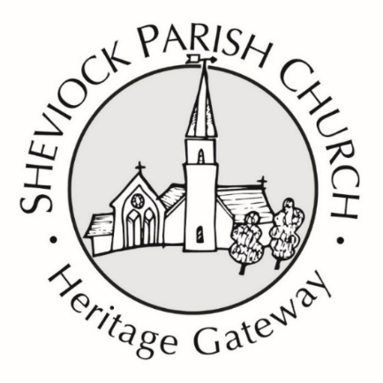
Winter Warmer Lunch
& Food Market at St Mary’s
10 am – 2 pm
on Saturday 22nd November



Producers include:
Eglarooze Vineyard; Great Kellow Farm – own reared meat;
Atlantic Distillery; Cornish Gouda Cheese; Sun Sea Sourdough; Lars & Margo Coffee Roasters;
Home made preserves and confectionery

Casseroles & Puddings
served from 12 noon
Heritage Gateway funds are dedicated funds for the upkeep & maintenance of Sheviock Parish Church & Churchyard & heritage information & materials

