Magazine December 2025
One of the greatest gifts of the church is the Calendar that shapes the church year. It’s a gift that had been sitting on the shelf of my Christian practice for a good many years and which I began to unwrap when I was training to be ordained.
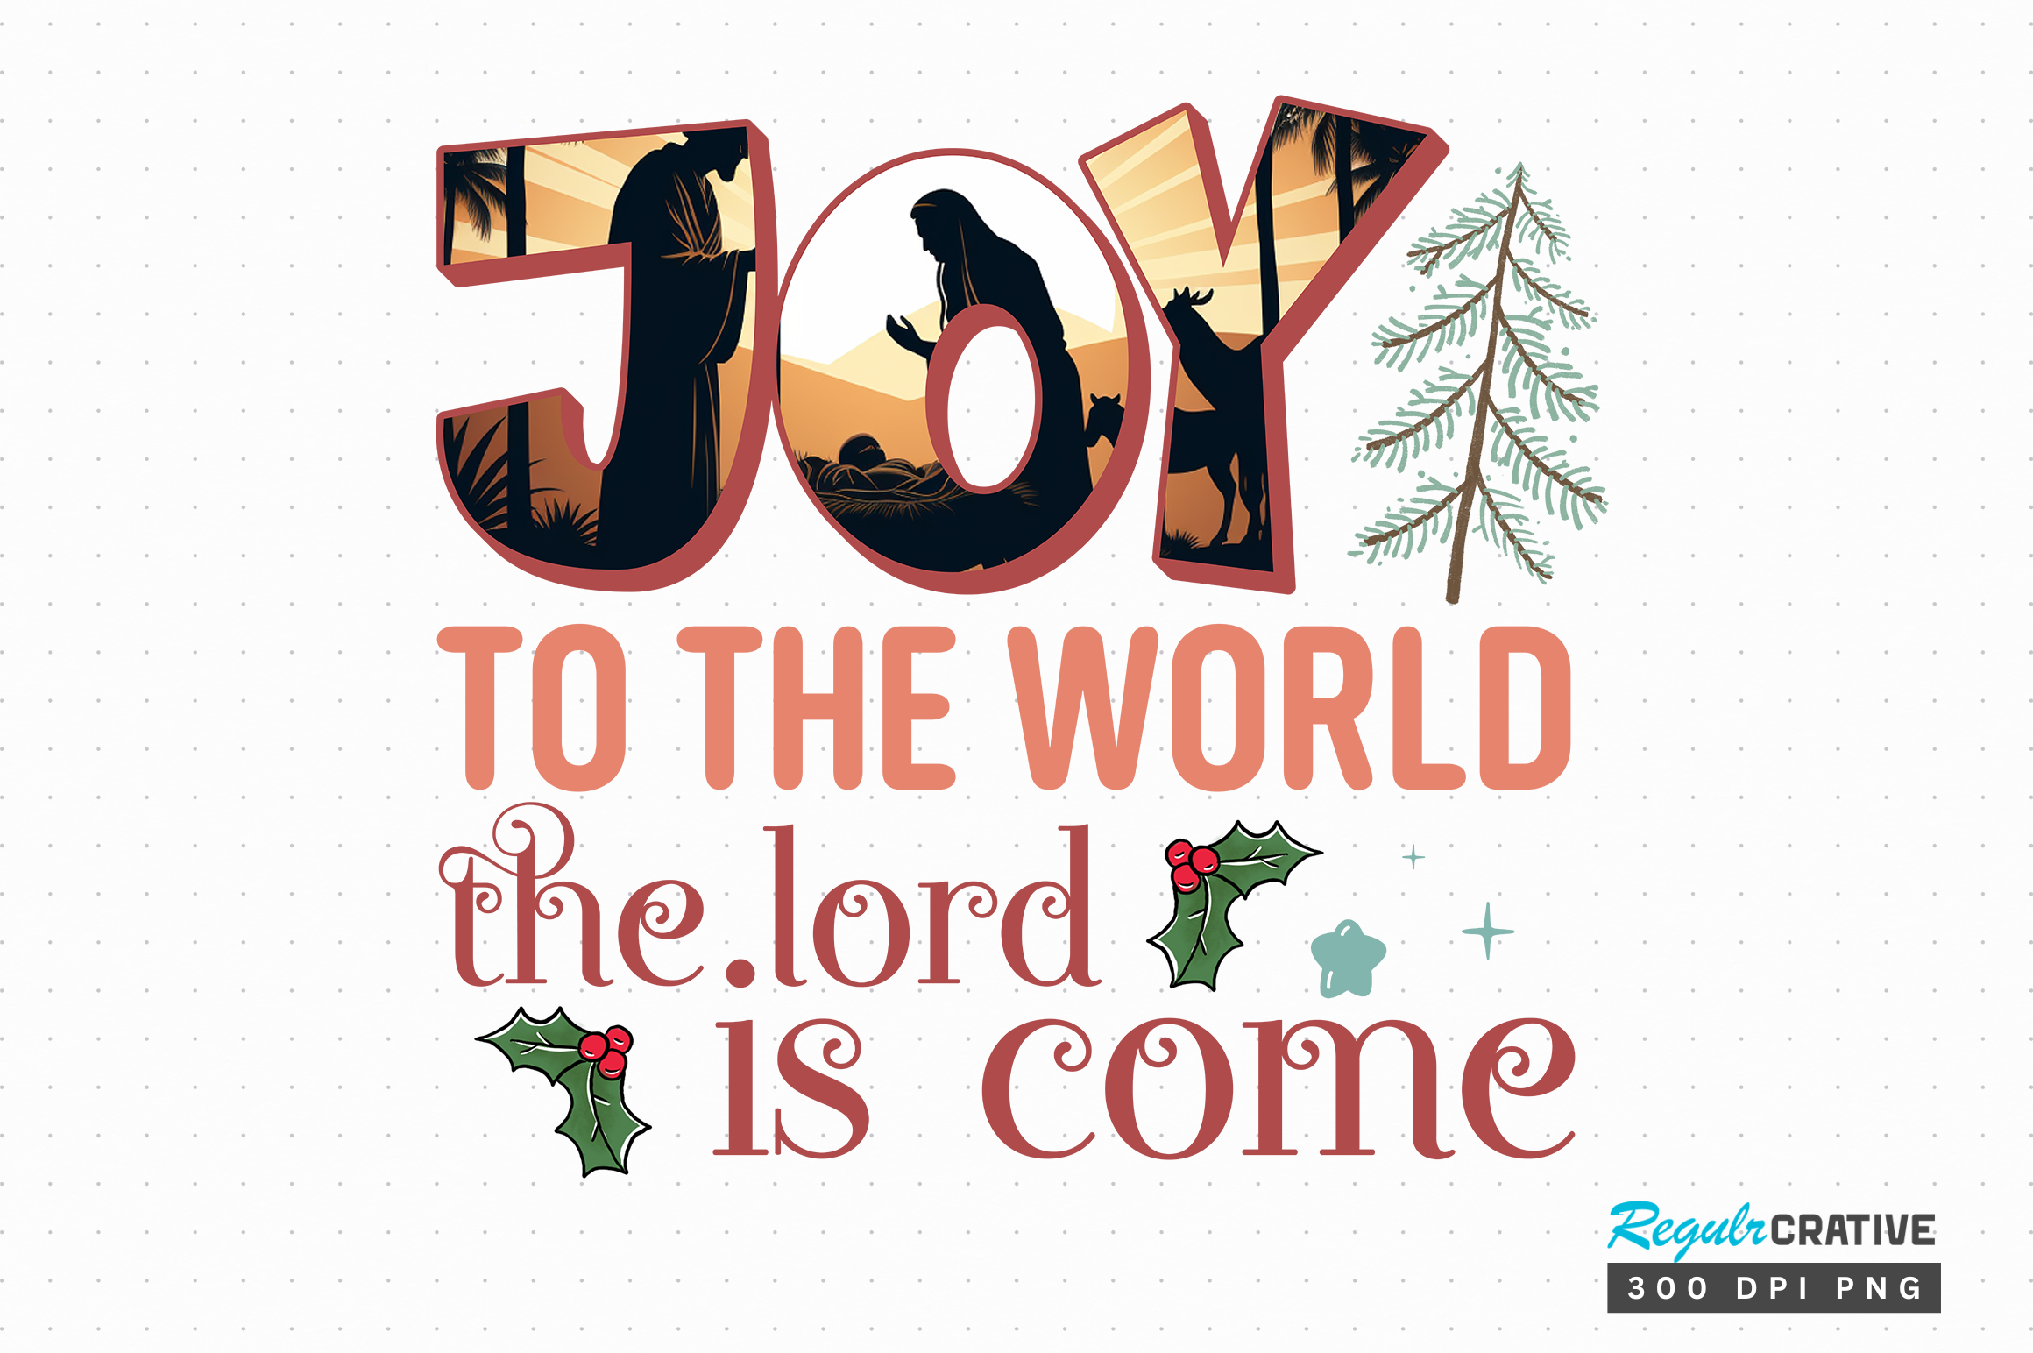
The Protestant background from which I came saw every Sunday as Easter Sunday, so following Jesus’ Passion through Holy Week leading to Easter was not a thing. Advent, the time of preparation and reflection for Christmas, that other great Festival of the Church was also not a thing. Thankfully, I did my on-the-job training (Curacy) in a Parish which did follow the Church Calendar and I was delighted with the multifaceted gift which emerged as we journeyed through the year together as five churches in one Parish.
I learnt that Christmastide didn’t end on Boxing Day. The Christmas season continued for the Twelve Days of Christmas, from 25 December to the day before the Feast of the Epiphany celebrated on the 6 January. A full twelve days of celebration and feasting. This observance began around 567 CE. Jesus, the Son of God, entering human history in order to break down all the barriers between the created and uncreated so that God and humanity and all creation might move towards peace and restored relationship was a BIG thing. It couldn’t be celebrated and absorbed in a day. So, twelve days were given to it so that we could rejoice in God’s great gift to us, reflect on its meaning and its impact on our lives and realign ourselves with God’s loving purposes for us, for humanity and the world.
Joy to the World is a Christmas song I love for the way it invites us to respond personally and as a church community to this extraordinary self-emptying and self-giving of God in Jesus the Christ: “Joy to the world the Lord is come! …Let every heart prepare him room. … No more let sins and sorrow grow! … He rules the world with truth and grace…”
Contemplating and living these truths will anchor us and give us hope in our fragile worlds.
Let us rejoice and be glad all the twelve days of Christmas,

Rev’d Katryn

