NOTICES FOR 2nd November

A SPECIAL CAROL CONCERT AT ALL SAINTS, SOUTH WINGFIELD

The newly renovated church hall at All Saints, South Wingfield, will be hosting a Carol Concert on Friday 19th at 7.30pm
The Shirland Brass Band, who are wonderful, will be playing favourite carols during an evening of celebration, with drinks and mince-pies. Tickets are £7. It would be wonderful for members of St Mary’s to celebrate with their sister church by supporting this event. For a ticket, either contact Jo Honour or contact Christine Walden chrissiewalden@hotmail.co.uk or phone Dennis Holmes 07827258740

REQUESTS

CHRISTINGLE

As you will have seen in the Newssheet, Christingle is being held on Advent Sunday, 30th November @ 4pm…..always the start of Christmas for me 😊
As always we need volunteers to help at this service. If you will have some free time and would be willing to help at this joyous service please contact me, Linda, on office@crichstmarys.org

ROTA LIST
We are looking for help in the following areas on the rota. If you would like to put your name forward, please let Linda know
Welcoming Powerpoint Prayers Wardening

FLOWERS IN CHURCH
Hilary was wondering if any of you has in your gardens any tall dry materials such as grasses, seed heads, twigs, hydrangea stems etc. especially as autumn tidy up is in progress, so that we could fill the big jugs which we usually use in the church porch. They wouldn't need much looking after and no watering, but would still be a nice welcome to those coming in to church.
Please bring anything suitable you might have into church, and Hilary and I will gather them up and display them. Many thanks. Sylvia
P.s. The flower rota is beginning to work and I hope you have enjoyed the displays so kindly produced by the volunteers during the year. I shall be putting a new list in church next month ready for next year. Please add your name to the list if you feel able to fill a vase or two to one month. It's a great welcome to visitors and we hope it makes them feel that St. Mary's is a church which is loved and cared for. Many thanks again.

POPPIES FOR REMEMBRANCE SUNDAY 2026

I had a thought about decorating the church for Remembrance Sunday, ran it past a few people who thought it was ok, and Serena has already made a start, which was an encouragement for me to put it to the good folk of St. Mary’s!
There won’t be time for this year, but I wondered whether we might be able to create a display of hand crafted poppies to decorate the church? I have knitting and crochet patterns, I can get some wool, and with willing volunteers we can produce either a fall of poppies, or perhaps a swatch. Of course poppies can be made with other fabrics too.
Please let me know if you think it’s an idea we might take up, and if you can help, then we’ll get going ready for next year!
Thank you. Sylvia



Throughout Autumn something special is happening in our night skies. Huge numbers of redwing are migrating from Northern European forests, which empty of most bird species before winter strikes. Coming from Scandinavia and Russia they migrate into the UK, Ireland and western France. Bird books describe the redwing call as seeih and once you have learned it, you may hear a redwing call overhead every few minutes, wherever you are in the UK, as they pass over in a wave of birds. There are a few pairs (about 80) of redwing breeding in Scotland but really, they are a winter visitor to our shores.

Redwings are a small thrush, of similar size to our song thrush but with darker brown plumage and the characteristic flash of colour from the red feathers on their under-wings as they fly. Look out for them feeding in the churchyard, you may be seeing birds fuelling up on migration or winter visitors who will stay for a few months. Redwings feed on berries, fallen fruit and will find soil invertebrates in short grass, pulling up worms or digging out leather jackets. They can be seen in flocks, with other thrushes such as fieldfare, mistle thrush and song thrush, feasting on yew berries and making a real mess! Winter thrushes descending on churchyard yews is one of the sights that chart the changing seasons.

You can help redwing and other thrushes by providing berry bearing shrubs and trees and thinking of your hedges as larders for weary travellers. Leave hedges untrimmed until February or early March so that birds may shelter within them and feed on hedge fruits such as hawthorn berries. Churchyards are usually free of pesticides which allows soil invertebrates to thrive, providing lots of nutritious meals. Yew trees provide both food and shelter and also give us the opportunity to really look at these lovely birds and think about the long journey they have made to reach us.

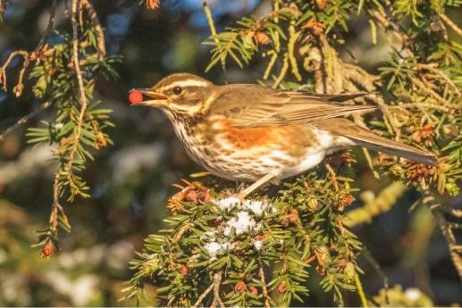

Octobers tip for the month from the ECO Church website
Provide food and shelter for wildlife, now and in preparation for next year. Clean all your bird feeders to avoid the spread of disease to winter migrants and put up a nest box well in advance of breeding season. A nest box could also prove a cosy spot for small birds to spend the night on particularly cold winter evenings ahead

REQUEST
Do you have a Eco tip to share for next weeks notice sheet? If so please send to me at office@crichstmarys.org

